Content and Capitalization Signals for Traditional Email Spam Detection: A Three-Algorithm Comparison on Spambase
Jon Emanuel V. Beltran
National University of the Philippines
Course: COM241ML
Instructor: Armida P. Salazar
Date: October 15, 2026

Abstract—Spam filtering is a binary classification problem in which a useful system must catch unwanted messages without hiding legitimate email. This study compares exactly three traditional machine-learning algorithms (Logistic Regression, Gaussian Naive Bayes, and Random Forest) on the UCI Spambase dataset, which describes 4,601 emails with 57 numeric word-frequency, character-frequency, and capital-run features. After removing 391 exact duplicate rows, the remaining 4,210 emails were divided by an 80/20 stratified split (3,368 training and 842 test rows). Hyperparameters and the final model were chosen using five-fold stratified cross-validation on the training partition only, with spam-class F1 as the primary metric. Random Forest achieved the highest cross-validated spam F1 (0.935 ± 0.016), ahead of Logistic Regression (0.906 ± 0.019) and Gaussian Naive Bayes (0.812 ± 0.017). On the held-out test partition, the selected model reached accuracy 0.945, spam F1 0.932, and ROC AUC 0.989, with 24 false positives and 22 false negatives. A feature-family ablation under training-only cross-validation and held-out permutation importance both indicate that word features carry most of the predictive signal, symbol features add useful information, and capital-letter features are weak alone but add some signal alongside words. These results describe a historical, mailbox-specific dataset; they do not show that the model works on modern spam.
Keywords—email spam, traditional machine learning, Random Forest, feature-family ablation, permutation importance

I. INTRODUCTION
Unwanted email consumes attention and can carry fraud, malware, and misleading offers. A practical spam filter must balance two errors. A false positive hides a legitimate message, and a false negative let spam reach the inbox. Early work on learned spam filters stressed that these two errors do not cost the same and argued for a decision-theoretic treatment of misclassification cost [1]. Later evaluations of Naive Bayes filters introduced cost-sensitive measures for the same reason and concluded that additional safeguards were needed for such filters to be viable in practice [2]. Machine learning suits the task because spam shows up as many weak signals at once, such as particular words, characters like $ and !, and long runs of capital letters, and no single hand-written rule captures them.
This project asks one question: what does a traditional model need to recognize spam, the content (words and symbols) or the style (capital-letter runs)? It addresses four sub-questions. RQ1 asks how much predictive signal each feature family carries on its own. RQ2 asks whether capital-letter features add anything once words and symbols are available. RQ3 asks whether capital-letter features remain weak when a scale-insensitive tree-based model is used. RQ4 asks which individual features the selected model relies on. The accompanying hypotheses were that words and symbols carry most of the signal (H1), that capitals add a small gain on top of them (H2), and that a tree-based model on capitals alone stays weak (H3).
The study is restricted to traditional supervised classification. It compares exactly three algorithms under the same split, preprocessing logic, cross-validation folds, and primary metric. It does not use neural networks, deep learning, transformers, large language models, pretrained models, or automated model search. The data is the UCI Spambase dataset [3]. The project also provides a Streamlit application that loads the saved model; the intended use is a second opinion for a person or small team, not automatic mailbox actions.

II. RELATED WORK AND BACKGROUND
Sahami et al. applied Bayesian classification to junk-mail filtering, using features beyond the message text and a cost-sensitive view of misclassification in which losing legitimate mail is treated as more costly than letting junk through [1]. Androutsopoulos et al. evaluated Naive Bayes filtering on a public corpus using cost-sensitive measures and concluded that additional safety nets were needed for practical use [2]. Both works motivate the present choice of a primary metric that penalizes false positives as well as false negatives, and both motivate including a Naive Bayes model as one of the three compared algorithms.
Spambase [3] is a widely used benchmark that represents each email as 57 pre-computed numeric features rather than as raw text. UCI describes typical misclassification error on this dataset as around 7% and notes that false positives are very undesirable [3]. That figure comes from the dataset documentation and is not directly comparable to the results here, which use a deduplicated dataset and a different split.
The three algorithms represent different inductive biases. Logistic Regression is a regularized linear model with interpretable coefficients; Gaussian Naive Bayes is a probabilistic model that assumes conditionally independent, normally distributed features; Random Forest is an ensemble of decision trees that can represent nonlinear interactions and does not depend on feature scaling [4], [5]. Model-based permutation importance, which measures how much a performance score falls when a feature's values are shuffled, was introduced in the context of Random Forests [4]. All models were implemented with scikit-learn [6].

III. METHODS

A. Problem definition
The task is binary classification of an email as spam (positive class, encoded 1) or not_spam (encoded 0). Spam-class F1, the harmonic mean of spam precision and recall, is the primary metric. It was chosen because it balances catching spam (recall) against not mislabeling legitimate email (precision), and because accuracy alone can hide the cost of the class imbalance. Supporting metrics are accuracy, spam precision, spam recall, ROC AUC, and the confusion matrix.

B. Dataset and data source
Spambase was created by Hopkins, Reeber, Forman, and Suermondt at Hewlett-Packard Labs and is distributed through the UCI Machine Learning Repository under a Creative Commons Attribution 4.0 International (CC BY 4.0) license [3]. It contains 4,601 emails (1,813 spam and 2,788 not spam) and 57 numeric features. According to UCI, the spam came from a postmaster and from individuals who had filed spam, and the non-spam came from filed work and personal emails, so terms such as "george" and the area code "650" are indicators of non-spam in this data [3]. The data is historical, reflects its original mailbox, and contains no raw email text. The original files are kept unmodified in data/original/; provenance is recorded in data/original/SOURCE.md.

C. Feature families
The 57 features fall into three families defined once by column prefix in src/spam_detection/config.py:
- *Words (48 features, `word_freq_`):** percentage of the email's words that match a listed word.
- *Symbols (6 features, `char_freq_):** percentage of the email's characters that are ;, (, [, !, $, or #`.
- *Capitals (3 features, `capital_run_length_`):** average length, longest length, and total length of uninterrupted runs of capital letters.

D. Data quality checks
Loading the data checks for 57 feature columns, a label column, missing values, labels outside spam/not_spam, and negative values. No violations were found. Capital-run totals are strongly right-skewed (Section IV); extreme values were retained because no evidence showed them to be data errors.

E. Duplicate policy
The file contained 391 exact duplicate rows (rows identical in all 58 columns, including the label). These were removed before any splitting, retaining the first occurrence, leaving 4,210 rows. Three groups of feature-identical rows carry conflicting labels. Because such rows differ in the label, they are not exact duplicates under this policy: they were counted and reported but not removed, so six rows from these groups remain in the cleaned data. The duplicate report is saved in models/training_metadata.json, and the cleaned data is saved as data/processed/spam_cleaned.csv.

F. Train/test split
The cleaned data was split once, 80% training and 20% test, with stratification on the label and random state 42. The training partition has 3,368 rows (2,025 not spam, 1,343 spam) and the test partition has 842 rows (506 not spam, 336 spam). The test partition was not used for tuning or model selection.

G. Cross-validation
All tuning and model selection used five-fold stratified cross-validation (StratifiedKFold, shuffled, random state 42) on the training partition only. The three algorithms and the feature-family ablation used the same folds. Reported cross-validation scores are the mean and standard deviation of spam F1 across the five folds.

H. Preprocessing
Preprocessing sits inside scikit-learn Pipeline objects so that it is fitted only on the training portion of each fold. Logistic Regression and Gaussian Naive Bayes use StandardScaler. Random Forest receives the original numeric values. Class weighting (class_weight="balanced") is used for Logistic Regression and Random Forest; scikit-learn's Gaussian Naive Bayes has no class_weight parameter, and none was applied. No synthetic oversampling is used.

I. The three algorithms
Exactly three algorithms were compared:
- Logistic Regression (max_iter=2000); the inverse regularization strength C was searched over {0.1, 1, 10}.
- Gaussian Naive Bayes; var_smoothing was searched over {1e-9, 1e-8, 1e-7}.
- Random Forest (300 trees); max_features was searched over {sqrt, 0.5} and min_samples_leaf over {1, 2}.
Each search used the common folds and spam F1 as the score. The model with the highest mean cross-validated spam F1 was selected.

J. Feature-family ablation and permutation importance
To address RQ1 to RQ3, the selected Random Forest configuration (max_features=sqrt, min_samples_leaf=1) was re-evaluated under the same training-only cross-validation on six feature sets: all features, words, symbols, capitals, words plus symbols, and words plus capitals. This experiment varies the features, not the algorithm.
To address RQ4, permutation importance was computed for the selected model after model selection and after the held-out performance metrics had been computed. Individual-feature importance is the mean decrease in test-partition spam F1 over 10 random permutations of one feature's values. Grouped importance permutes all columns of one feature family together using a single row permutation (random state 42) and reports the decrease in spam F1 relative to the unpermuted score. Grouped importance is therefore a single permutation, not an average over repeats, and carries no uncertainty estimate. These analyses explain the saved model; they did not influence any modeling decision. Permutation importance is a model-based measure of predictive reliance and is not evidence of a causal effect.

IV. EXPLORATORY DATA ANALYSIS
EDA was generated by src/spam_detection/eda.py and saved in data/processed/eda/. Five figures lead to the following findings and decisions.
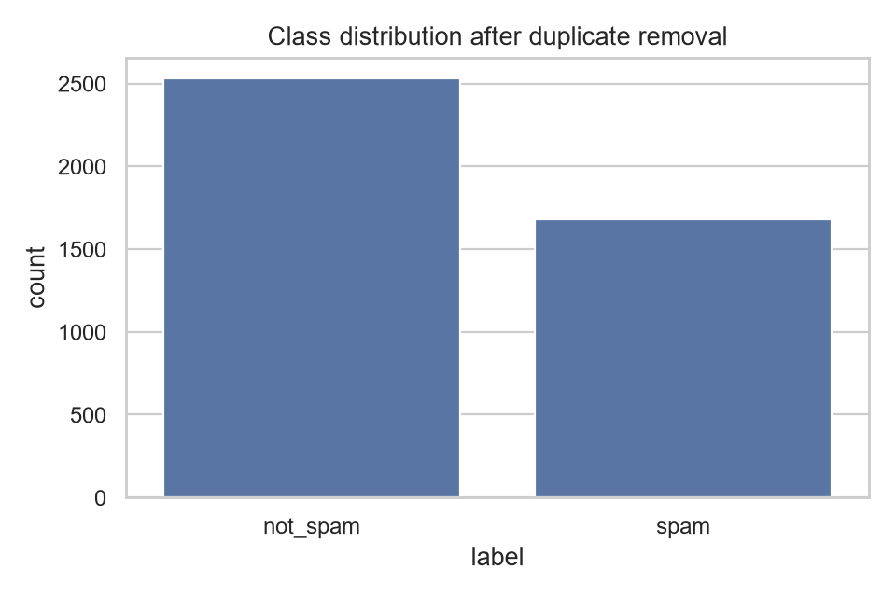
Fig. 1. Class distribution after duplicate removal (2,531 not spam, 1,679 spam).
After deduplication the data remains mildly imbalanced, with spam making up about 40% of rows (1,679 of 4,210). This motivates stratified splitting, stratified cross-validation, and spam-class F1 rather than accuracy. On the test partition, always predicting not_spam would give accuracy 0.601 (506 of 842), which is the baseline that accuracy should be read against.
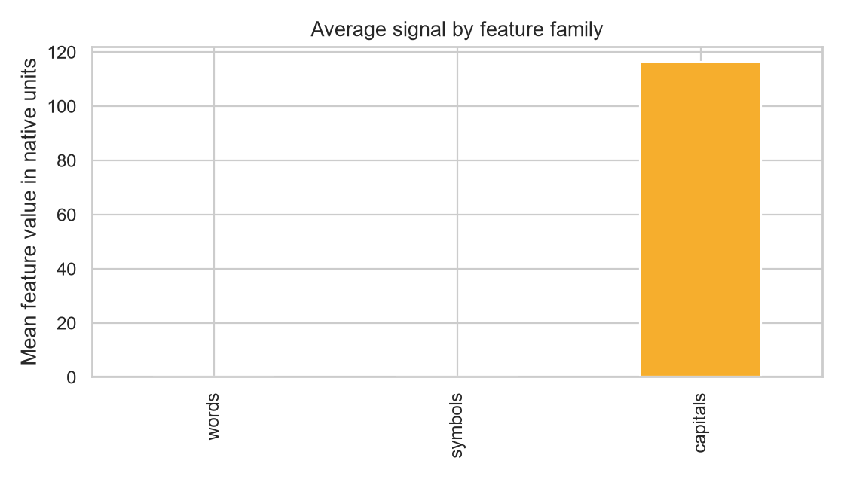
Fig. 2. Mean feature value in native units for each feature family.
The three families use very different native scales; capital-run lengths are much larger than percentages. This motivates scaling inside the Logistic Regression and Naive Bayes pipelines and is the reason Random Forest, which does not depend on scale, is a useful check for RQ3.
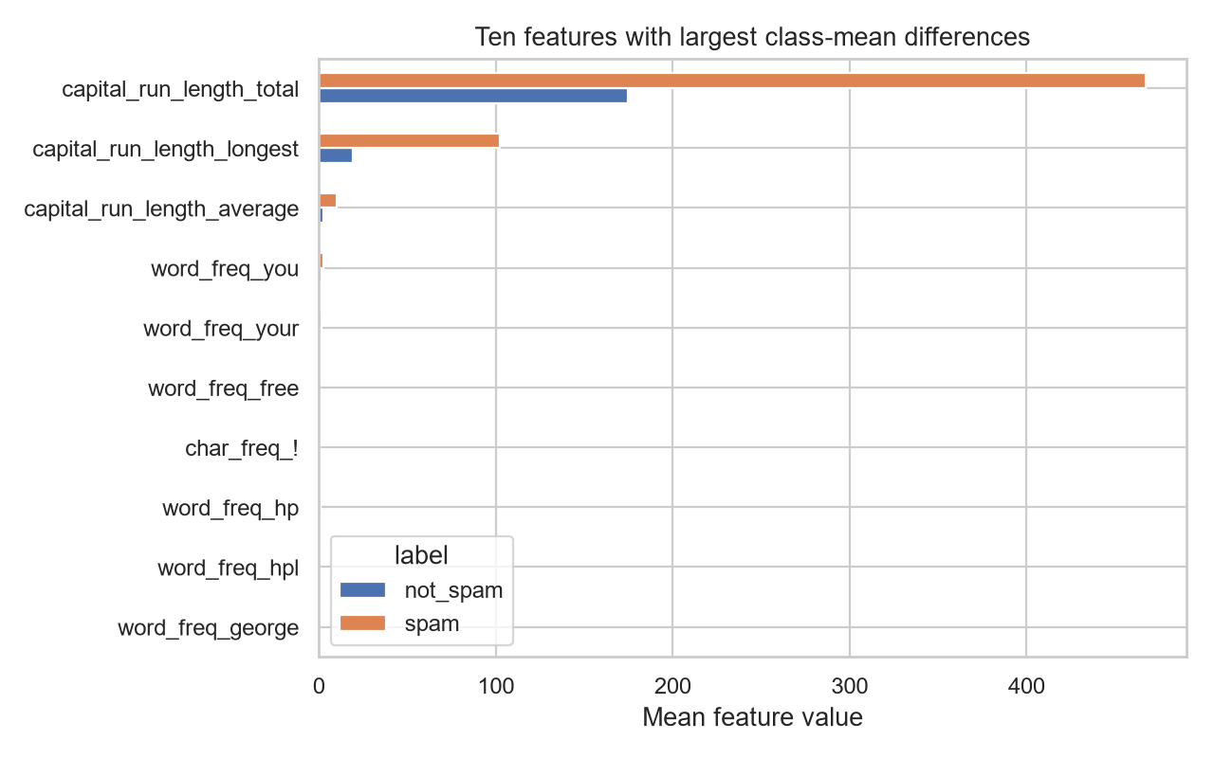
Fig. 3. Ten features with the largest class-mean differences, in native units.
Measured in native units, the largest class-mean differences are in the three capital-run features, with spam showing larger values than non-spam. Because the figure is not standardized, differences in word and symbol features are too small to read at this scale, so this figure does not by itself show how informative the word and symbol features are. That question is addressed by the ablation and permutation results in Section V.
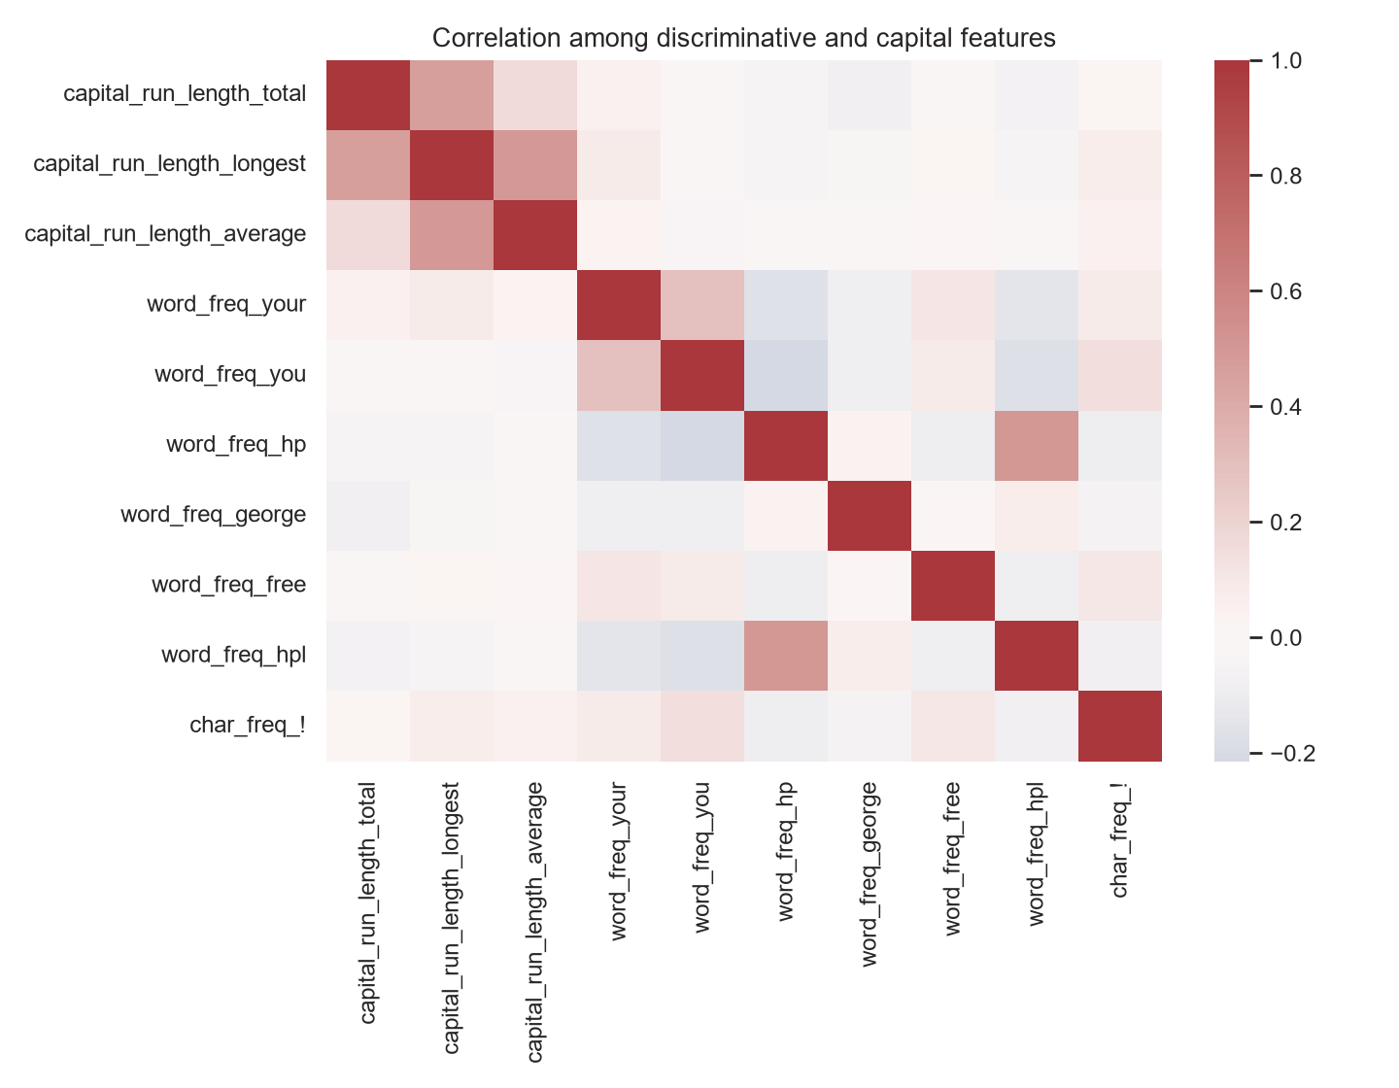
Fig. 4. Correlation among the features plotted in Fig. 3.
Most pairs among the plotted features are weakly correlated, with moderate correlation among the three capital-run features and between word_freq_hp and word_freq_hpl. Some correlated groups exist, which is one reason both a linear model and a tree ensemble are compared. It also means that permutation importance of single correlated features should be read cautiously.
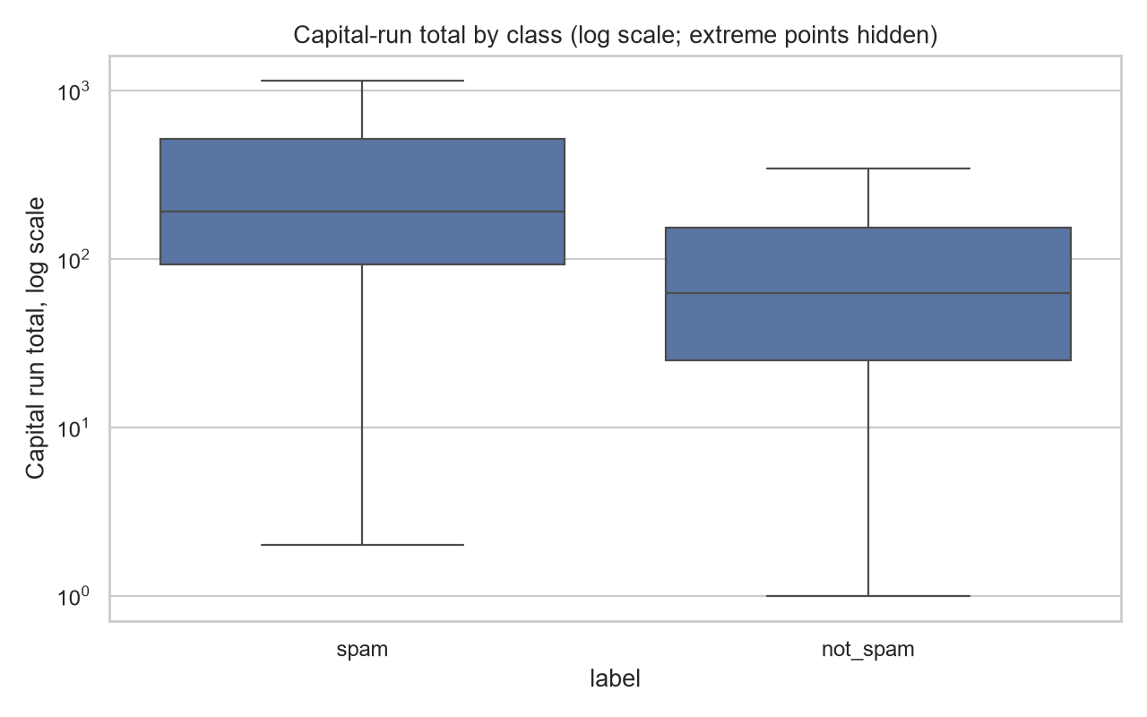
Fig. 5. Capital-run total by class on a log scale, extreme points hidden.
Capital-run totals are strongly right-skewed, and spam has a higher median than non-spam. Extreme values were retained as possibly legitimate email style rather than deleted without evidence, and the scale-insensitive Random Forest handles them without transformation.

V. RESULTS

A. Three-model comparison (training-only cross-validation)
TABLE I. FIVE-FOLD CROSS-VALIDATION ON THE TRAINING PARTITION (SPAM F1, MEAN ± STD)
Algorithm | Selected hyperparameters | Spam F1
Logistic Regression | C=10.0 | 0.906 ± 0.019
Gaussian Naive Bayes | var_smoothing=1e-8 | 0.812 ± 0.017
Random Forest | max_features=sqrt, min_samples_leaf=1 | 0.935 ± 0.016

Random Forest had the highest mean spam F1 and was selected. Its margin over Logistic Regression (0.028) is about 1.5 to 1.7 times the fold-to-fold standard deviations and is therefore moderate, not overwhelming. Its margin over Gaussian Naive Bayes (0.123) is much larger than the fold variation. The selected hyperparameters are saved in models/training_metadata.json. These are validation results and are kept separate from the test result below.

B. Feature-family ablation (training-only cross-validation)
TABLE II. FEATURE-FAMILY ABLATION WITH THE SELECTED RANDOM FOREST (SPAM F1, MEAN ± STD)
Feature set | Features | Spam F1
All | 57 | 0.935 ± 0.016
Words | 48 | 0.914 ± 0.018
Symbols | 6 | 0.791 ± 0.021
Capitals | 3 | 0.739 ± 0.013
Words + symbols | 54 | 0.921 ± 0.018
Words + capitals | 51 | 0.929 ± 0.018

Words alone reach 0.914, close to the full model (0.935), so words carry most of the predictive signal (H1). Symbols alone reach 0.791 and capitals alone 0.739, both well below the full model. Adding symbols to words raises the score from 0.914 to 0.921, and adding capitals to words raises it from 0.914 to 0.929. Using all three families gives the highest score. These increments (0.007 to 0.021) are comparable to or smaller than the fold standard deviations (about 0.016 to 0.018), so they suggest, but do not establish, that capitals add a small gain beyond words and symbols (H2). The capitals-only Random Forest stays weak even though trees do not depend on feature scale, which is consistent with H3 and with capital features lacking context on their own; this experiment does not isolate scaling effects directly.

C. Final held-out test evaluation
After model selection, the saved Random Forest was evaluated on the held-out test partition. The metrics in Table III were computed once and stored in models/final_test_metrics.json.
TABLE III. HELD-OUT TEST RESULTS FOR THE SELECTED RANDOM FOREST (842 EMAILS)
Metric | Value
Accuracy | 0.945
Spam precision | 0.929
Spam recall | 0.935
Spam F1 | 0.932
ROC AUC | 0.989

The test spam F1 (0.932) is consistent with the cross-validated value (0.935 ± 0.016). This agreement is reassuring, but because the same cross-validation was used both to tune hyperparameters and to compare models, the cross-validation figure is expected to be slightly optimistic and the test result is the less biased estimate.

D. Confusion matrix
TABLE IV. TEST-PARTITION CONFUSION MATRIX (ROWS: ACTUAL; COLUMNS: PREDICTED)
 | Predicted not_spam | Predicted spam
Actual not_spam | 482 | 24
Actual spam | 22 | 314

The model produced 24 false positives (legitimate emails predicted as spam, 4.7% of the 506 legitimate test emails) and 22 false negatives (spam predicted as legitimate, 6.5% of the 336 spam test emails). These rates are derived directly from the confusion matrix. The false positives matter most operationally because they correspond to legitimate email that could be hidden.

E. Permutation and grouped feature importance
TABLE V. GROUPED PERMUTATION IMPORTANCE ON THE TEST PARTITION (SINGLE PERMUTATION; BASELINE SPAM F1 = 0.932)
Feature family | Features | Spam F1 after permutation | Decrease in spam F1
Words | 48 | 0.535 | 0.397
Capitals | 3 | 0.855 | 0.077
Symbols | 6 | 0.884 | 0.047

Shuffling the word features alone cuts spam F1 from 0.932 to 0.535, far more than shuffling either of the other families, so the selected model relies most heavily on words. Shuffling the symbol and capital features also lowers performance, so the model uses both. The decrease for capitals (0.077) is larger than that for symbols (0.047) even though capitals alone are the weaker feature set in Table II. These two measures answer different questions: the ablation asks how well a family predicts on its own, while permutation importance asks how much the full model depends on a family. Group sizes also differ (48, 6, and 3 features), and each value is a single permutation, so the ordering of capitals and symbols should not be over-interpreted.
TABLE VI. TOP TEN INDIVIDUAL FEATURES BY PERMUTATION IMPORTANCE (DECREASE IN SPAM F1, MEAN ± STD OVER 10 PERMUTATIONS)
Rank | Feature | Decrease in spam F1
1 | word_freq_remove | 0.035 ± 0.005
2 | word_freq_hp | 0.027 ± 0.008
3 | char_freq_! | 0.014 ± 0.006
4 | word_freq_george | 0.010 ± 0.005
5 | word_freq_our | 0.009 ± 0.003
6 | word_freq_edu | 0.009 ± 0.004
7 | char_freq_$ | 0.009 ± 0.003
8 | word_freq_you | 0.008 ± 0.002
9 | word_freq_free | 0.008 ± 0.005
10 | word_freq_meeting | 0.006 ± 0.001

Individual decreases are small, partly because correlated or redundant features can compensate for one another when one is shuffled; several features have mean decreases at or slightly below zero, which should be read as no detectable reliance. The most important capital feature is capital_run_length_longest (rank 12, 0.005 ± 0.005). UCI explicitly names "george" as an indicator of non-spam from the original mailbox [3], and word_freq_hp may reflect the same collection context; this supports the caution in Section VII.

F. Application evidence
The Streamlit app loads models/spam_detector.joblib, the same saved pipeline evaluated above, and does not retrain.
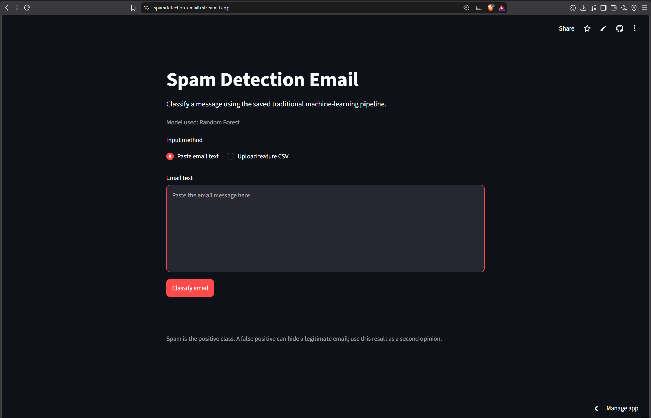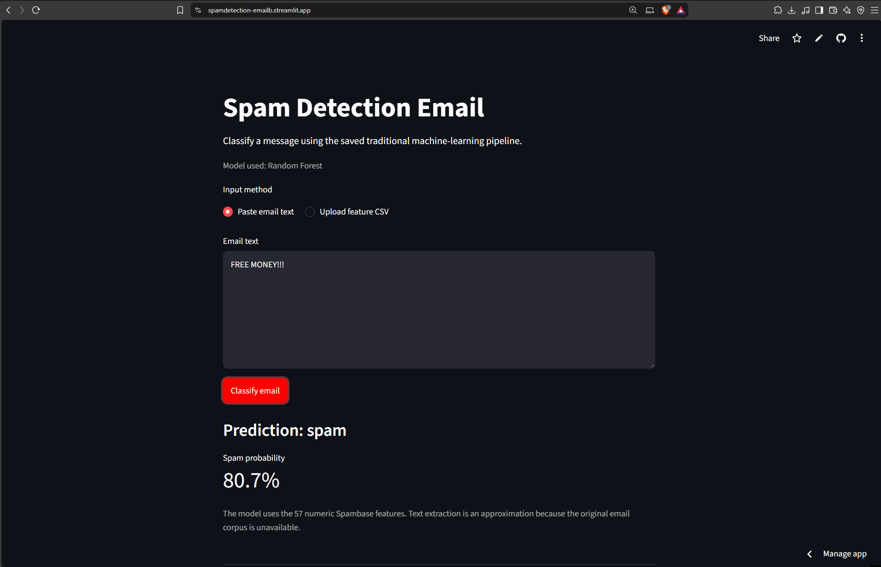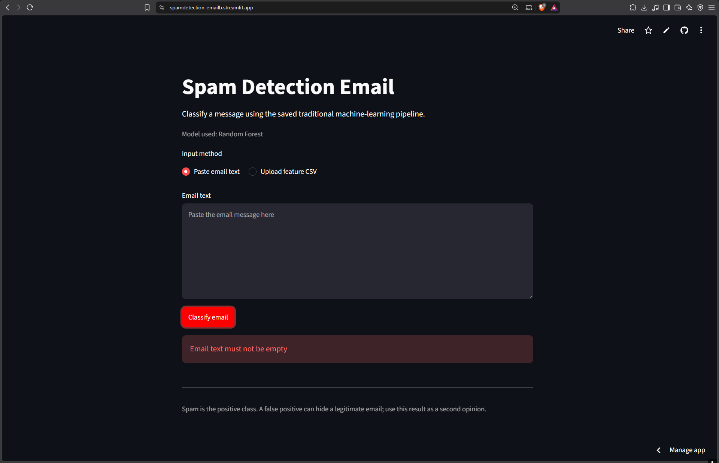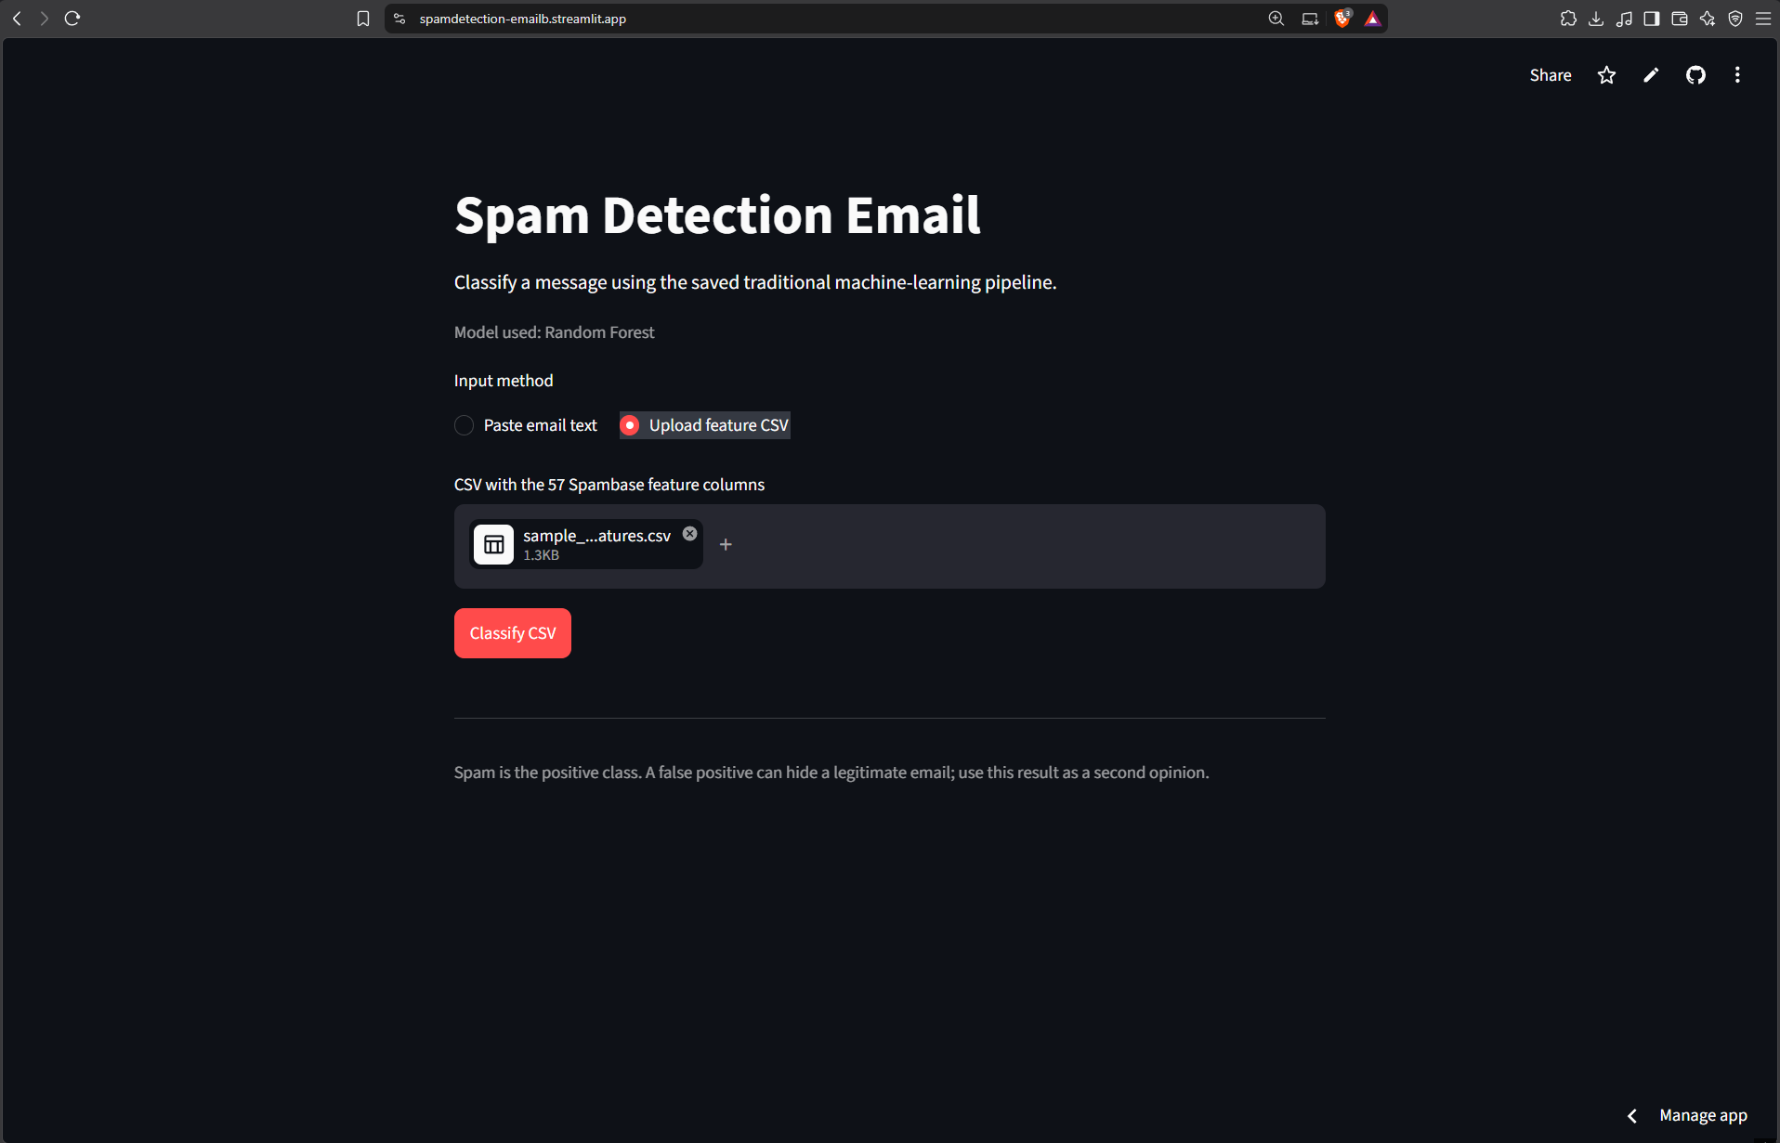
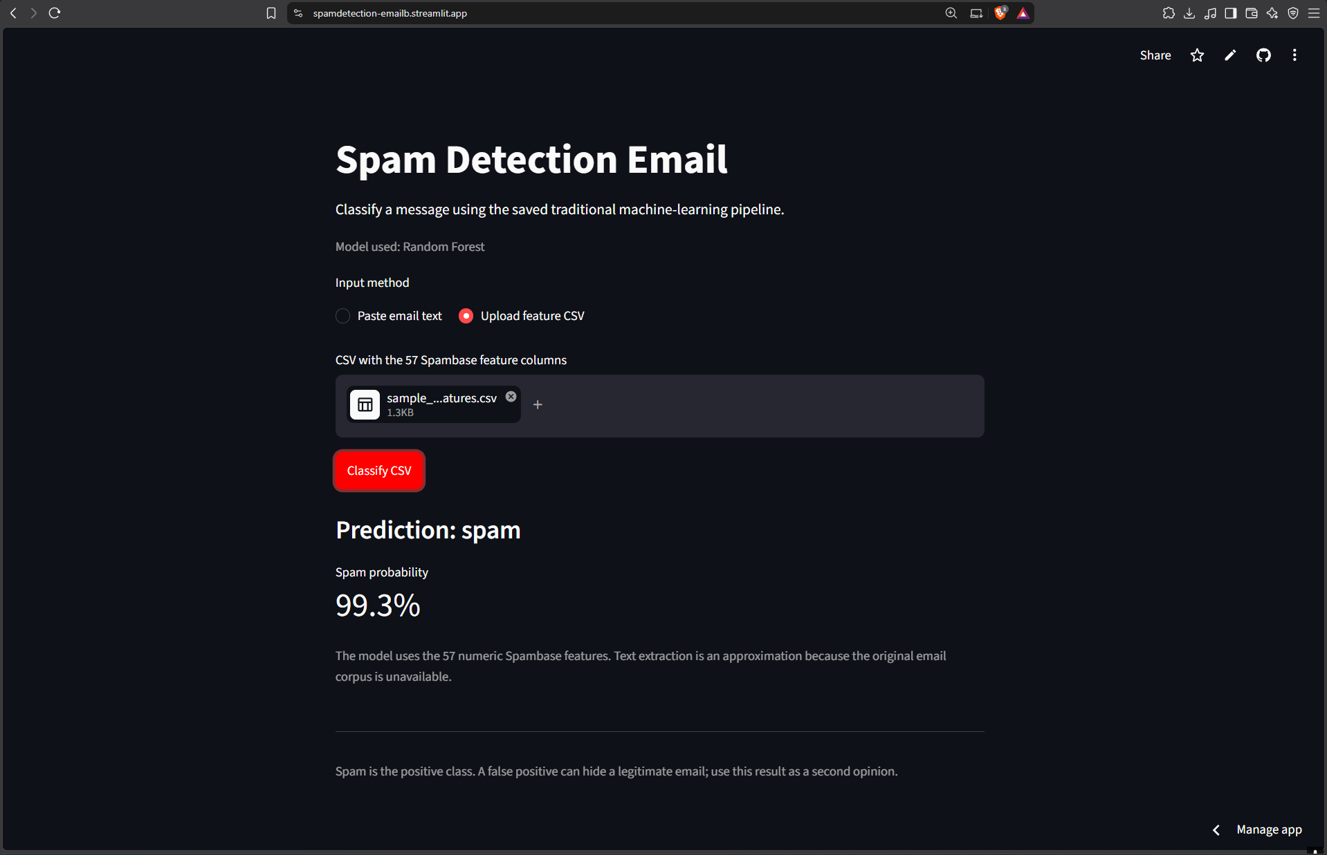
https://spamdetection-emailb.streamlit.app/

VI. DISCUSSION
The central finding is that on this dataset the content of a message, expressed as word frequencies, carries most of the predictive signal, while symbol and capital features add smaller amounts. Words alone reach a cross-validated spam F1 of 0.914 against 0.935 for all features, and shuffling the word features at test time causes by far the largest loss. Symbols are useful: they reach 0.791 on their own and their permutation lowers test F1. Capital-letter features are weak alone (0.739) but adding them to words is associated with a small gain (0.914 to 0.929), which fits the idea that capitalization is informative mainly in combination with content. Differences of this size are within the fold-to-fold variation, so they are suggestive, not conclusive.
Random Forest was selected because it had the highest mean cross-validated spam F1 and can represent nonlinear interactions among feature families. Logistic Regression was competitive and offers more transparent coefficients, so a user who values interpretability over a gap of about 0.03 in spam F1 could reasonably prefer it. Gaussian Naive Bayes performed clearly worse here, which is plausible given its assumption of independent, normally distributed features while the data are skewed percentages and heavy-tailed run lengths. The grid for Logistic Regression ended at its selected value of C=10, so a wider search might have improved it slightly.
The held-out result (accuracy 0.945, spam F1 0.932, ROC AUC 0.989) shows that the selection procedure generalized to unseen emails from the same dataset. The 24 false positives are the main operational concern; a deployment would need to choose a decision threshold and review workflow, and any threshold would have to be tuned on validation data rather than on the test partition. Permutation importance describes which features this model relies on to predict; it does not show that those features cause spam, and it is affected by correlations among features.

VII. LIMITATIONS AND RESPONSIBLE USE
- Historical, mailbox-specific data. Spambase dates from the late 1990s and was assembled from a particular postmaster's spam and particular individuals' filed work and personal email [3]. Some of the most important features (for example hp, george) reflect that context. The results do not show that the model works on modern spam or on other mailboxes.
- Fixed, pre-computed features. The raw emails and the exact original tokenization are unavailable. The vocabulary of 48 words cannot be extended, and new spam vocabulary cannot be discovered.
- App text path is an approximation. The pasted-text path in the app approximates the original features with its own tokenizer and capital-run counter. For example, it assigns capital-run features of 0 to text with no capital letters, whereas the original data defines these features with a minimum of 1 [3]. The CSV path, which accepts the 57 pre-computed features, is the reproducible path.
- Single dataset and split. Results come from one stratified 80/20 split of one dataset. The test set is small enough (842 emails) that a difference of a few errors changes the metrics noticeably.
- Selection optimism. The same cross-validation folds were used to tune hyperparameters and to choose among algorithms, without nested cross-validation, so the cross-validated scores are mildly optimistic.
- Supporting metrics. Cross-validated accuracy, precision, recall, and ROC AUC were not recorded for Logistic Regression and Gaussian Naive Bayes, and held-out test metrics are reported only for the selected model. Class-weighted models were used where supported; an unweighted comparison was not run.
- Conflicting-label rows. Six rows from three conflicting-label groups remain in the data, so a small amount of label noise is present.
- Held-out data used for explanation. Performance metrics were computed once after model selection. The same held-out partition was then used, without feeding back into any modeling decision, to compute permutation importance.
- Responsible use. The model is intended as a second opinion and not as an automatic filter. False positives can hide legitimate email, so any automated action would need human review and an evaluation on current data from the target mailbox.

VIII. CONCLUSION AND RECOMMENDATIONS
This project compared Logistic Regression, Gaussian Naive Bayes, and Random Forest for email spam classification on the deduplicated Spambase data. Random Forest was selected using training-only five-fold cross-validation (spam F1 0.935 ± 0.016) and then evaluated on the held-out test set, where it achieved accuracy 0.945, spam F1 0.932, and ROC AUC 0.989. Feature-family ablation and permutation importance indicate that words carry most of the predictive signal, symbols add useful information, and capitals are weak alone but add some signal alongside words. The practical value is a transparent, reproducible second-opinion classifier; its generalization to modern email is untested.
Realistic improvements are to train and evaluate on a raw-text corpus so that features can be computed from scratch and compared with TF-IDF features, to test robustness to obfuscated spelling and to current spam, to record cross-validated supporting metrics for all three algorithms, to use nested cross-validation or repeated splits to quantify selection uncertainty, and to tune a decision threshold on validation data that reflects the cost of false positives.

REFERENCES
[1] M. Sahami, S. Dumais, D. Heckerman, and E. Horvitz, "A Bayesian approach to filtering junk e-mail," in Learning for Text Categorization: Papers from the 1998 AAAI Workshop, Madison, WI, USA, Jul. 1998, pp. 55–62, AAAI Tech. Rep. WS-98-05.
[2] I. Androutsopoulos, J. Koutsias, K. V. Chandrinos, and C. D. Spyropoulos, "An evaluation of Naive Bayesian anti-spam filtering," in Proc. Workshop on Machine Learning in the New Information Age, 11th Eur. Conf. Mach. Learn. (ECML), Barcelona, Spain, 2000, pp. 9–17.
[3] M. Hopkins, E. Reeber, G. Forman, and J. Suermondt, "Spambase," UCI Machine Learning Repository, 1999. [Online]. Available: https://archive.ics.uci.edu/dataset/94/spambase. doi: 10.24432/C53G6X.
[4] L. Breiman, "Random forests," Machine Learning, vol. 45, no. 1, pp. 5–32, 2001.
[5] T. Hastie, R. Tibshirani, and J. Friedman, The Elements of Statistical Learning: Data Mining, Inference, and Prediction, 2nd ed. New York, NY, USA: Springer, 2009.
[6] F. Pedregosa et al., "Scikit-learn: Machine learning in Python," Journal of Machine Learning Research, vol. 12, pp. 2825–2830, 2011.

Appendix A: Ownership and Authorship Declaration
Project Information | Details
Project Title | Content and Capitalization Signals for Traditional Email Spam Detection: A Three-Algorithm Comparison on Spambase
Course and section | Introduction to Machine Learning - COM241ML
Group name or number
Date Submitted | October 15, 2026
Declaration Statement
We, Dr. Armida P. Salazar as the course instructor and the undersigned student group members, jointly
declare that we are the owners and authors of the submitted project output identified above. The project
output includes the application, source code, trained model and saved pipeline, exploratory data analysis,
visualizations, technical documentation, research paper, and original materials produced specifically for this
course project.
We affirm that the submitted work accurately represents our documented contributions and that all external
datasets, software libraries, code, models, frameworks, images, publications, and other third party materials
have been properly cited, licensed, or acknowledged using IEEE citation format where applicable. This
declaration does not transfer or claim ownership of pre-existing third party or institutional materials and
remains subject to applicable National University policies, intellectual property rules, licenses, and Philippine
law.

Signatories
Name and Role | Signature | Date
Dr. Armida P. Salazar
Course Instructor
Beltran, Jon Emanuel V.
Project Leader

