**Extreme Pong UI Documentation**

**Author: Lew Fortwangler**

**UI Functionality:**

* Powerup Collection

- Text Displayed on bottom of screen when a powerup is collected. This notifies the players when one is picked up, and what its effect is. These UI text elements are activated within the OnTriggerEnter functions of the powerups. A separate script will deactivate the text after 3 seconds.

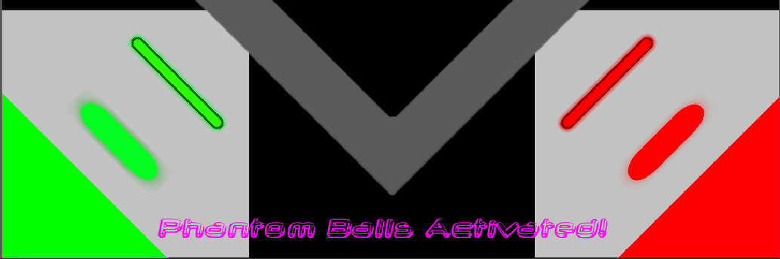

* Leaderboard

- Leaderboard at the end will display the current 10 highscores from the data base. Not currently functional. I will be discussing with team4 how to get the highscores from the database in the future.

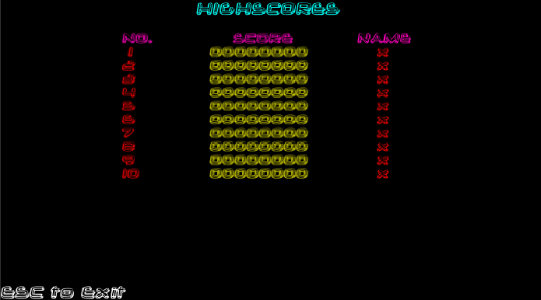

* Start Screen

- Initial screen displayed on load up. Once the player clicks to start they will be brought into the game and 2 tokens (quantity up for decision) will be taken from the player’s wallet. This will be implemented once the currency system is functional on the database.



* Gameover

- The gameover screen will display how many points you earned, and what place you came in. This will be fully functional once team3 finished the networking for the players. For now, the gameover screen displays how many points the red paddle earned and their place for proof of concept. Note: Some bugs with the placement and the UI scale need to still be corrected.

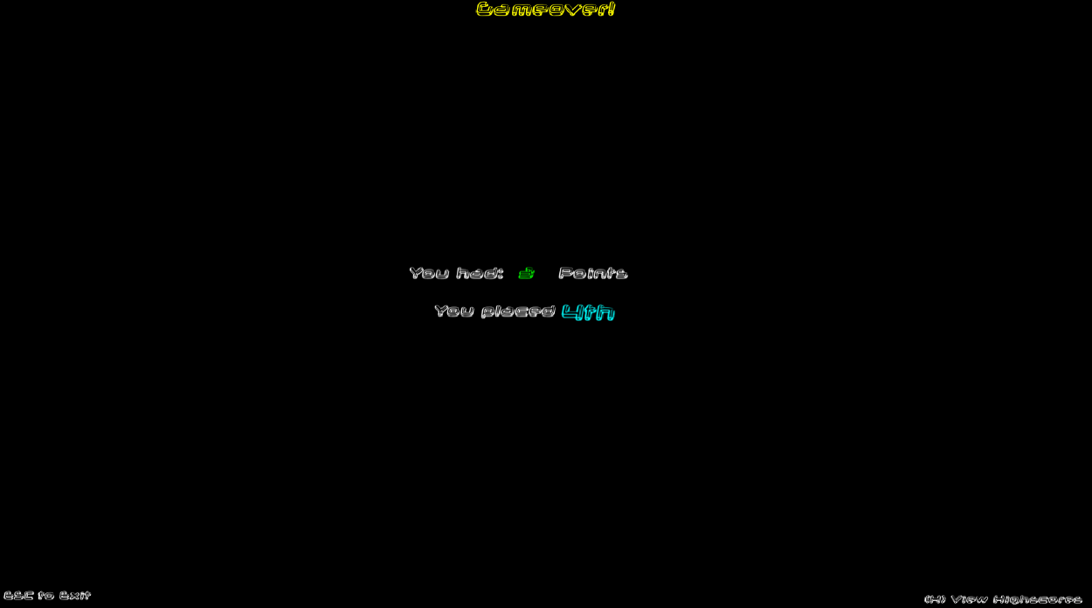

* 4p Gameplay

- On the gameplay screen, there are UI elements for the toggle control option, and the amount of time remaining in minutes and seconds. Gameplay example can be seen in the picture under the “controls” section

* Controls

- A toggleable UI text element will appear on the gameplay screen whenever the user presses “c”. This will display the controls on the right hand side of the screen

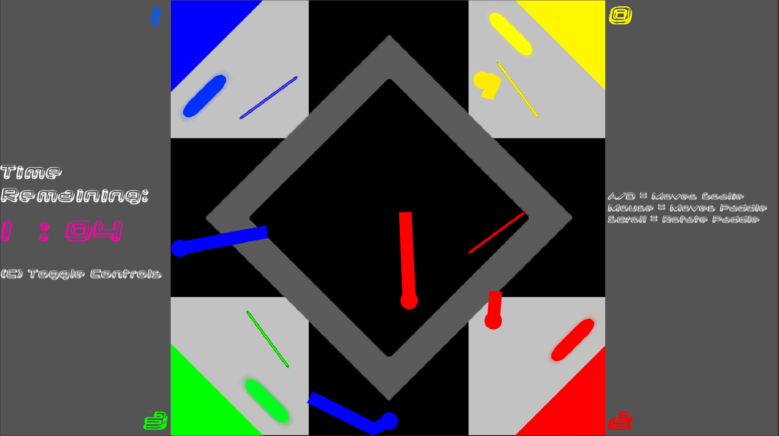

* Overtime

- If all scores are tied at when the time expires, a UI text element will appear notifying the players that the next score wins.

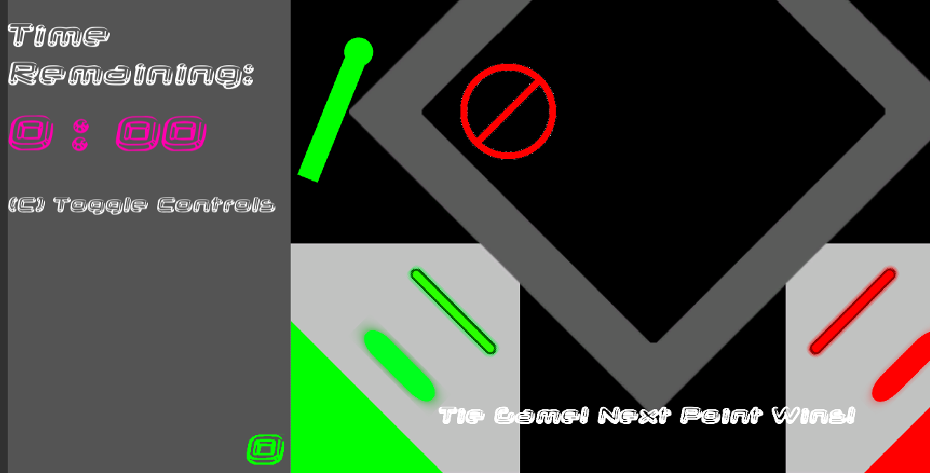

**UI Transitions:**

On startup, start screen is displayed. Player clicks to enter the game.

On click, the start screen is disabled and the gameplay UI is activated.

- If the player presses C to activate controls, controls are displayed

- If the game is tied when the time expires, a tie game notification pops up

Once the time runs out (or if tie game and the next player scores), the gameplay UI is deactivated, and the gameover screen is activated.

- If the user pushes “H” a leaderboard with the highscores are displayed

- If the user pushes “ESC” the user will go back to the arcade.

From the highscore screen, the player can also push “ESC” to return to the arcade.

**Scripts:**

PowerupNotification: This script takes a reference to a “Notification” GameObject, checks if it is currently displayed on the gameplay UI, and if it is currently active, will be deactivated after 3 seconds.

StartScreen: On startup, this UI will be displayed, and the gameplay UI will be deactivated. The timescale will also be set to 0 to prevent the game from playing in the background if all players have not entered.

Once the player clicks, it will deactivate the start screen UI and activate the gameplay UI. Once the currency system is fully functional, it will also take away tokens from the player. This script will also control the toggleable control prompt on the gameplay screen.

GameplayScreen: Uses a reference to the gameoverUI and the overtimeUI. It will also uses a reference to the text object of both the minutes and seconds to be displayed on screen. The length of the game can be set within this script by changing the minutesLeft_m variable.

On start of this script, the timer is initialized to “2:00”. The coroutine of Countdown is then started. In Update, the script will change the text elements of the minutes and seconds to display the correct values. This function will also check if the game is tied (within the last 5 seconds) and if the time has run out. It will display/change to the appropriate UI depending on which of the previous are true or false.

The coroutine Countdown will continuously decrement the minutes, and decrement and reset the seconds as you would expect a real minute and second count down to behave. (ex/ Time changed from 1:01 -> 1:00 -> 0:59 -> etc.)

GameoverScreen:

On start, gameover UI and highscoreUI are both set to false.

In update, the script will transition to the leaderboard, or back to the arcade depending on what the user has selected. If the highscoreUI is active, the script will call setValues function.

In SetValues, the players score and placement are calculated and displayed on the UI. It will find all of the paddles that are currently active, and sets the score associated with those paddles in an array. It will then use your paddle and compare it against the values of the others (waiting on team3’s networking to be finished for full implementation). Then it will set the UI text elements to display your score and they place you finished in based on those values.