**National Estimates of Homelessness**

Name___________________ID_________________________Major_____________________

### **Context**

The Continuum of Care (CoC) Program is designed to promote communitywide commitment to the goal of ending homelessness; provide funding for efforts by nonprofit providers, and State and local governments to quickly rehouse homeless individuals and families while minimizing the trauma and dislocation caused to homeless individuals, families, and communities by homelessness; promote access to and effect utilization of mainstream programs by homeless individuals and families; and optimize self-sufficiency among individuals and families experiencing homelessness. For more information on the Program, please visit <https://www.hudexchange.info/programs/coc/>

The U.S. Department of Housing and Urban Development (HUD) provides Point-in-Time (PIT) count reports of sheltered and unsheltered persons experiencing homelessness, by household type and subpopulation. This data is available at the national and state level, and for each CoC. HUD also provides Housing Inventory Count (HIC) reports, which provide a snapshot of a CoC’s inventory of beds and units available on the night designated for the count by program type, and include beds dedicated to serve persons who are homeless as well as persons in Permanent Supportive Housing.

This raw data set contains PIT estimates of homelessness, and the corresponding accompanying HIC data from 2021.

Attribution: Adapted from U.S. Department of Housing and Urban Development

### **About the Dataset**

This dataset contains 100 rows corresponding to a random sample of localities (typically counties or similar large regions) that received Continuum of Care funding from HUD. A total of 21 variables are provided as listed on the next page.

|  |  |
| --- | --- |
| **Variable Name(s)** | **Description** |
| CoC Number  CoC Name | CoC locality identifier |
| CoC Category | Community setting designation: Rural, Urban, etc |
| Type of Count | Description of whether fully or partially sheltered individuals (or both) are included |
| Overall Homeless, 2021 | Total homeless count in all facilities indicated by the “Type of Count” variable |
| HMIS Participation Rate for Year-Round Beds (ES,TH,SH) | Percentage of facilities in the locality that participate in the [Homeless Management Information System](https://www.hudexchange.info/programs/hmis/) (HMIS) |
| Total Year-Round Beds (ES, TH, SH)  Total Year-Round Beds (ES)  Total Year-Round Beds (TH)  Total Year-Round Beds (SH) | (all types combined)  ES = Emergency Shelter  TH = Transitional Housing  SH = Safe Haven |
| Total Units for Households with Children (ES, TH, SH)  Total Beds for Households with Children (ES, TH, SH) | Number of **units** and **beds** designated for households with children |
| Sheltered ES Homeless 2021 | Estimate of the number of individuals sheltered in an Emergency Facility at the time of the study |
| Sheltered ES Homeless - Age 18 to 24, 2021 | Estimate of the number of individuals sheltered in an Emergency Facility by age |
| Sheltered ES Homeless - Female, 2021  Sheltered ES Homeless - Male, 2021  Sheltered ES Homeless - Trans+, 2021 | Estimate of the number of individuals sheltered in an Emergency Facility by gender |
| Sheltered ES Homeless - Hispanic/Latino, 2021  Sheltered ES Homeless - White, 2021  Sheltered ES Homeless - Black or African American, 2021  Sheltered ES Homeless - Asian or Pacific Islander  Sheltered ES Homeless - American Indian or Alaska Native, 2021  Sheltered ES Homeless - Multiple Races, 2021 | Estimate of the number of individuals sheltered in an Emergency Facility by race/ethnicity |

A snippet of the data is below:

**Assignment 1**

**Descriptive Statistics – Graphical and Numerical Summary**

1. Determine whether the variables below are qualitative or quantitative. If they are quantitative, specify whether they are continuous or discrete.

CoC Category - QUALITATIVE

HMIS Participation Rate for Year-Round Beds (ES,TH,SH) - QUANTITATIVE CONTINUOUS

Sheltered ES Homeless - Age 18 to 24, 2021 – QUANTITATIVE DISCRETE

1. Construct a frequency table, relative frequency table, and bar chart to describe the distribution of the following variable based on your last name (pick the variable based on your last name). State any fact that jumps out to you.

|  |  |
| --- | --- |
| **Last Name** | **Variable** |
| A-M | CoC Category |
| N-Z | Type of Count |

BAR GRAPHS

|  |  |
| --- | --- |
| **CoC Category** | **Type of Count** |
|  |  |

FREQUENCY AND RELATIVE FREQUENCY TABLES

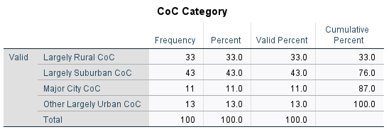

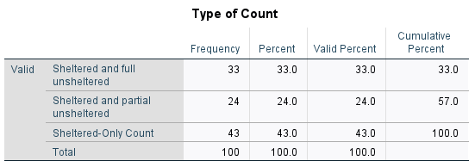

PIE CHARTS

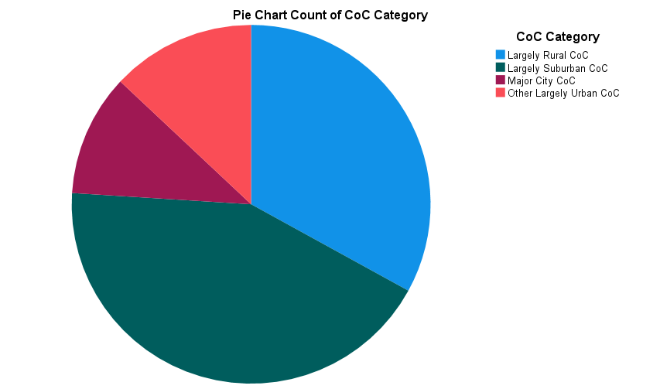

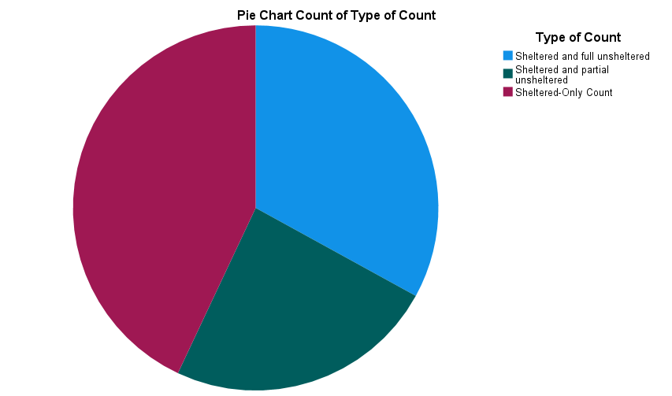

For questions 3-6: Find your variable based on your last name and use that variable when answering questions #3 to #6.

|  |  |
| --- | --- |
| **Last Name** | **Variable** |
| A-F | Sheltered ES Homeless - Hispanic/Latino, 2021 |
| G-M | Sheltered ES Homeless - White, 2021 |
| N-S | Sheltered ES Homeless - Black or African American, 2021 |
| T-Z | Sheltered ES Homeless - Asian or Pacific Islander |

1. Construct histograms for your variable. Use Number of Intervals = 12

|  |  |
| --- | --- |
| **Sheltered ES Homeless - Hispanic/Latino, 2021** | **Sheltered ES Homeless - White, 2021** |
|  |  |

|  |  |
| --- | --- |
| **Sheltered ES Homeless - Black or African American, 2021** | **Sheltered ES Homeless - Asian or Pacific Islander** |
|  |  |

1. Construct a boxplot of your variable from #3.

|  |  |
| --- | --- |
| **Sheltered ES Homeless - Hispanic/Latino, 2021** | **Sheltered ES Homeless - White, 2021** |
|  |  |

|  |  |
| --- | --- |
| **Sheltered ES Homeless - Black or African American, 2021** | **Sheltered ES Homeless - Asian or Pacific Islander** |
|  |  |

1. Find the following summary statistics for your variable from #3: minimum, maximum, mean, median, standard deviation, Q1, and Q3.

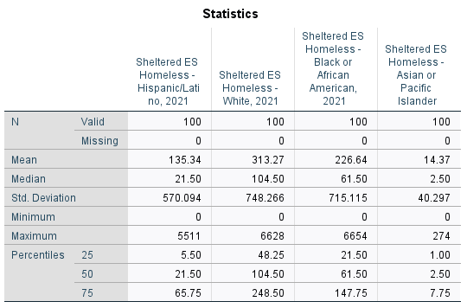

1. Use information from questions #3, #4, and #5 to describe your variable in terms of shape, center, spread, and outliers. Interpret your findings.

NOTE: OUTLIERS ARE HARD TO COUNT, GRADE WITH A +/-4 TOLERANCE

THE DISTRIBUTION OF **Sheltered ES Homeless - Hispanic/Latino, 2021** IS SKEWED RIGHT. THE MEDIAN IS 21.50 PEOPLE AND THE IQR IS 60.25. THERE ARE 12 OUTLIERS IN THE RIGHT TAIL.

THE DISTRIBUTION OF **Sheltered ES Homeless - White, 2021** IS SKEWED RIGHT. THE MEDIAN IS 104.50 PEOPLE AND THE IQR IS 200.25. THERE ARE 11 OUTLIERS IN THE RIGHT TAIL.

THE DISTRIBUTION OF **Sheltered ES Homeless - Black or African American, 2021** IS SKEWED RIGHT. THE MEDIAN IS 61.50 PEOPLE AND THE IQR IS 126.25. THERE ARE 11 OUTLIERS IN THE RIGHT TAIL.

THE DISTRIBUTION OF **Sheltered ES Homeless - Asian or Pacific Islander** IS SKEWED RIGHT. THE MEDIAN IS 2.50 AND THE IQR IS 6.75. THERE ARE 14 OUTLIERS IN THE RIGHT TAIL.

1. Calculate and state the mean Sheltered ES Homeless - White, 2021 for Major city CoC’s. Do the same for Largely Rural CoC’s. Compare the results.

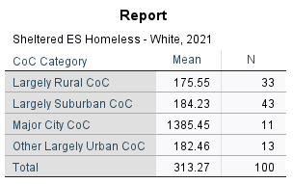

MUCH LARGER FOR MAJOR CITY, AS EXPECTED.

1. Generate a paragraph of at least 100 words to address one of the following questions:
2. Discuss how analyzing your chosen data set using statistical methods could help you become better prepared for future courses in your major?
3. Discuss how analyzing your chosen data set using statistical methods could be instrumental in becoming better prepared for your future career?
4. Discuss how analyzing your chosen data set using statistical methods could help you be aware of social issues, contribute to society, and advocate for marginalized communities.