Predicting and Understanding Customer Churn
A Data Mining Analysis of the IBM Telco Customer Churn Dataset
Kshitiz Subba
MSCS-634-B01: Advanced Big Data and Data Mining
Second Bi-term, Summer 2026
8/20/2026

1. Introduction
Customer churn the loss of subscribers to a competitor or to service cancellation is one of the most consequential and directly actionable problems in subscription-based businesses such as telecommunications. Even small reductions in churn compound over time into large differences in customer lifetime value, so understanding which customers are at risk and why is a high-value data mining problem.
This project applies a full data mining pipeline to the IBM Telco Customer Churn dataset: data cleaning and exploratory analysis, regression modeling, classification, clustering, and association rule mining, culminating in a cross-technique synthesis and set of practical recommendations. The project was completed across four deliverables, each building on the results and engineered features of the one before it, and is consolidated here into a single narrative.

1.1 Dataset and Justification
The dataset (sourced from Kaggle's IBM Telco Customer Churn sample) contains 7,043 records and 21 attributes describing customers of a fictional telecommunications company, including:
- Demographics: gender, senior citizen status, partner and dependents
- Account information: tenure, contract type, payment method, paperless billing, monthly and total charges
- Subscribed services: phone service, multiple lines, internet service type, online security, online backup, device protection, tech support, streaming TV and movies
- Target label: Churn (whether the customer left the company)
This dataset was selected because it comfortably exceeds the project's minimum size requirement (500+ records, 8-10+ attributes), mixes numerical and categorical feature types, and naturally supports every phase of the project: Churn as a classification target, MonthlyCharges as a regression target, service attributes for clustering-based segmentation, and the many categorical service columns for association rule mining.

1.2 Project Roadmap
The remainder of this report follows the same structure as the underlying notebook: data preparation (cleaning and feature engineering), exploratory data analysis, regression modeling, classification, clustering, association rule mining, evaluation results, cross-technique insights, ethical considerations, and practical recommendations.

2. Data Preparation

2.1 Data Cleaning
Three cleaning issues were identified and addressed:
- Hidden missing values: TotalCharges was stored as a text column and contained 11 blank-string entries. Inspection showed all 11 belonged to brand-new customers with tenure = 0, so the column was converted to numeric and these values imputed as 0 — a legitimate zero rather than missing data, since a new customer has not yet accrued charges.
- Duplicates: customerID and full-row duplicate checks found none.
- Inconsistent categories: several service columns encoded “No internet service” / “No phone service” as separate categories, even though this was fully implied by InternetService / PhoneService. These were consolidated into a single “No” category, and SeniorCitizen was recoded from 0/1 to No/Yes for consistency with the other binary categorical columns.
Boxplots of tenure, MonthlyCharges, and TotalCharges showed no implausible outliers; all values fell within expected business ranges, so no values were removed or capped.

2.2 Feature Engineering
Four engineered features were carried through every later modeling stage:
- NumAddOnServices — a count (0–6) of subscribed add-on services (online security, online backup, device protection, tech support, streaming TV, streaming movies), condensing six sparse binary columns into one informative count.
- HasInternet / HasPhone — binary flags derived from InternetService and PhoneService.
- TenureGroup — tenure binned into five lifecycle stages (0–12, 13–24, 25–48, 49–60, 61–72 months).
- ChurnFlag — a binary (1/0) encoding of the Churn target for modeling.

2.3 Exploratory Data Analysis
The target variable is moderately imbalanced: 26.5% of customers churned versus 73.5% who stayed. This directly informed the choice of evaluation metrics (F1 and ROC AUC rather than raw accuracy) in the classification stage.
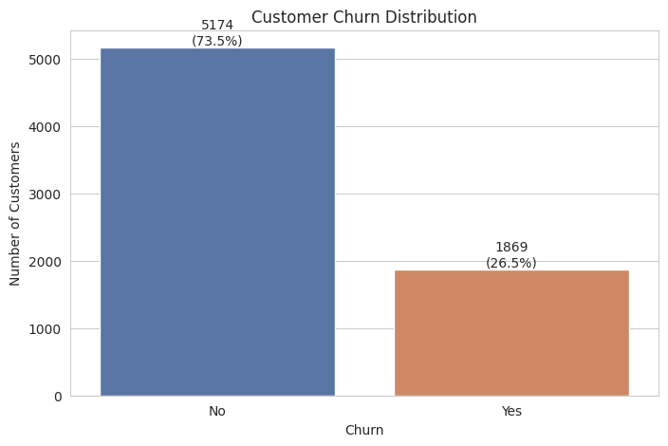
Figure 1. Customer churn distribution (26.5% churned).
A correlation analysis of the three numeric billing/tenure columns showed TotalCharges is strongly correlated with tenure and moderately correlated with MonthlyCharges — an expected relationship, since total charges accumulate over time, but one that flags a multicollinearity and data-leakage risk for later regression modeling.
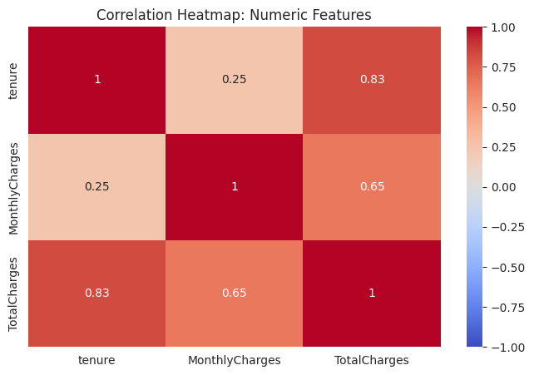
Figure 2. Correlation heatmap of tenure, MonthlyCharges, and TotalCharges.
Cross-tabulating churn against contract type, internet service type, tenure, and monthly charges revealed the strongest early churn signals in the dataset: month-to-month customers churn far more than one- or two-year contract customers; fiber-optic internet customers churn more than DSL or no-internet customers; and churners skew toward shorter tenure and higher monthly bills.
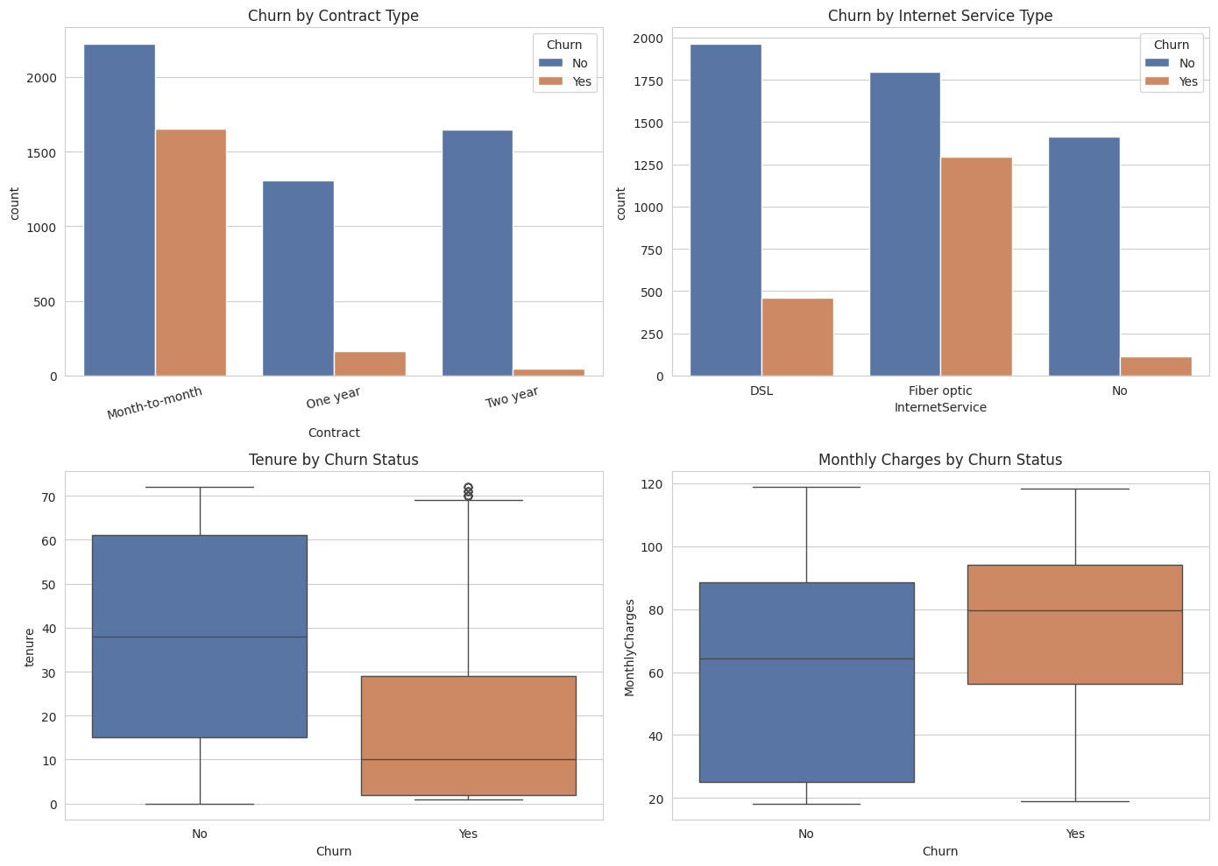
Figure 3. Churn by contract type, internet service type, tenure, and monthly charges.
These four attributes — contract type, internet service type, tenure, and pricing — reappear as the dominant signal in every later technique used in this project: as top classification predictors, as the primary axes separating customer clusters, and as the antecedents of the highest-lift association rules.

3. Modeling Details

3.1 Regression: Predicting Monthly Charges
Because TotalCharges is a poor, leakage-prone regression target (near-collinear with tenure and MonthlyCharges, as shown in Figure 2), the regression task instead predicts MonthlyCharges from a customer's subscribed services, contract terms, and demographics — a target with genuine predictive structure and clear business relevance for pricing and plan design. TotalCharges and raw tenure were excluded from the predictor set to avoid leakage.
Three models were trained on an 80/20 train/test split with standardized features: Multiple Linear Regression (baseline), Ridge Regression (L2 penalty, alpha = 1.0), and Lasso Regression (L1 penalty, alpha = 0.1).
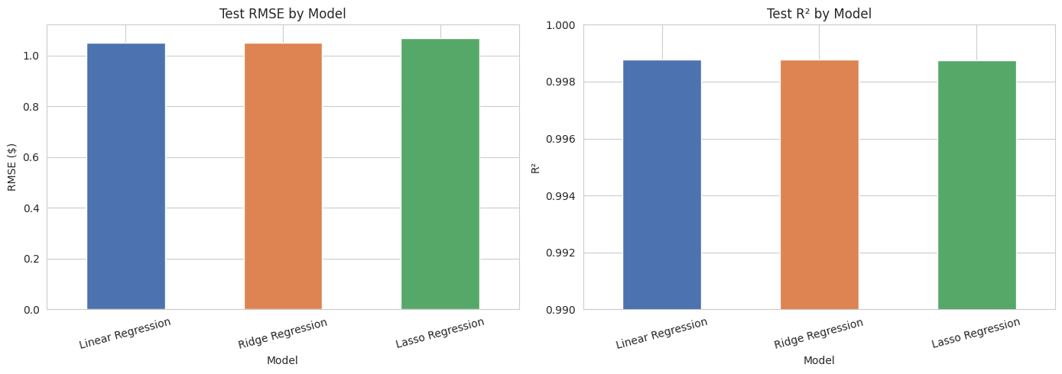
Figure 4. Test RMSE and R² across the three regression models.
All three models explain over 99.8% of the variance in MonthlyCharges, with RMSE around $1 on a variable ranging from $18 to $119. This is expected rather than suspicious: MonthlyCharges is nearly a deterministic sum of the prices of a customer's subscribed services, so a model that knows exactly which services a customer has can reconstruct their bill almost exactly. Cross-validation R² closely tracked test R² for every model, confirming the fit generalizes.
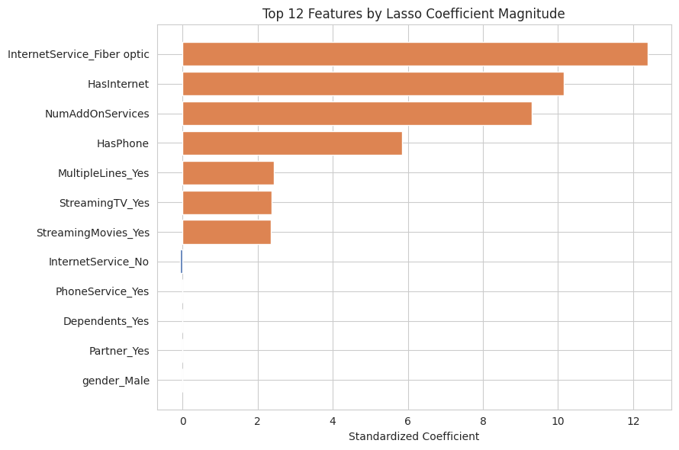
Figure 5. Top 12 features by Lasso coefficient magnitude.
Ridge Regression was selected as the preferred model: it is statistically tied with Linear Regression on accuracy, but its L2 penalty gives more stable coefficients if retrained on new data. Lasso's feature elimination confirmed that fiber-optic internet and add-on services are the largest positive price drivers, while having no internet service is the strongest negative driver — consistent with how telecom pricing plans are structured. This result carries an important implication forward: since MonthlyCharges mostly re-encodes information already present in the service columns, it was excluded as a churn predictor in the classification stage below, in favor of the more compact, non-redundant NumAddOnServices and Contract features.

3.2 Classification: Predicting Churn
Two classification models were built to predict Churn from demographic, account, contract, and service attributes plus the engineered features: a Decision Tree Classifier and a k-Nearest Neighbors (k-NN) classifier. The Decision Tree provides an interpretable, axis-aligned baseline well suited to the dataset's mixed categorical/numeric features; k-NN offers a fundamentally different, distance-based contrast.
Hyperparameter tuning was performed on the Decision Tree using GridSearchCV with 5-fold cross-validation, searching over max_depth (3, 5, 7, 10, None), min_samples_leaf (1, 5, 10, 20), and criterion (gini, entropy). The grid search was scored on F1 rather than accuracy, since accuracy alone can be misleadingly high on an imbalanced target (26.5% churn) by simply predicting the majority class. The best parameters found were criterion = entropy, max_depth = 3, min_samples_leaf = 1, achieving a cross-validated F1 of approximately 0.588.

Evaluation Results (Test Set)
Model | Accuracy | F1 Score | ROC AUC
Decision Tree (baseline) | 0.794 | 0.582 | 0.827
Decision Tree (tuned) | 0.751 | 0.558 | 0.787
k-NN (k = 5) | 0.752 | 0.522 | 0.770

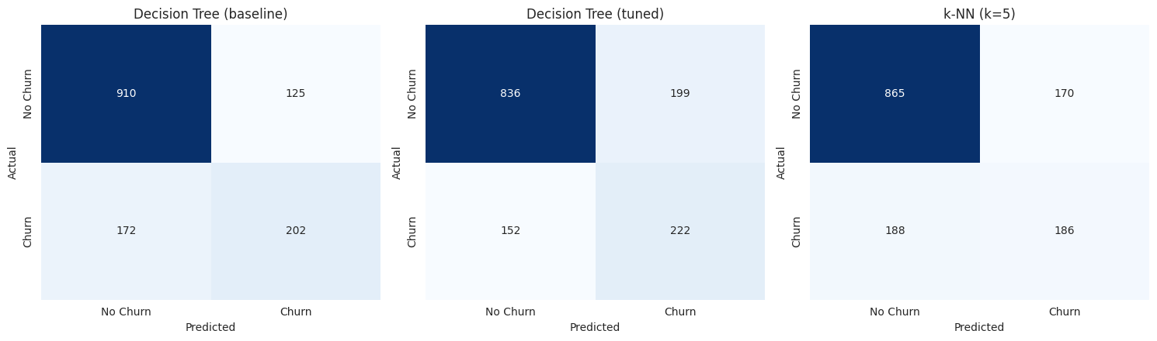
Figure 6. Confusion matrices for all three classification models.
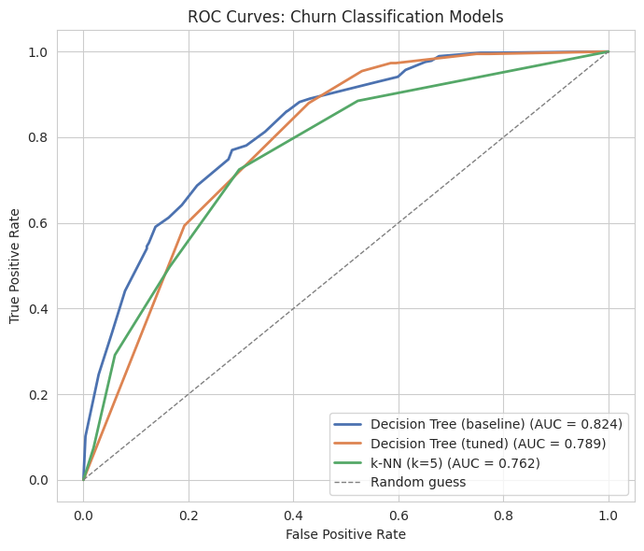
Figure 7. ROC curves for all three classification models.
Both Decision Tree variants outperformed k-NN on ROC AUC, since tree splits align naturally with strongly predictive categorical features (Contract, InternetService) that k-NN's raw Euclidean distance in one-hot-encoded space captures less cleanly. Notably, the tuned tree scored slightly lower than the untuned baseline on this specific test split, even though grid search selected it as the best cross-validated F1 performer on the training folds. This is not a modeling error: the grid search chose a shallower tree, based on 5-fold cross-validated evidence, that is less likely to overfit to any one particular training sample — a useful illustration that hyperparameter tuning optimizes for expected generalization across many splits, not for beating one specific train/test split.
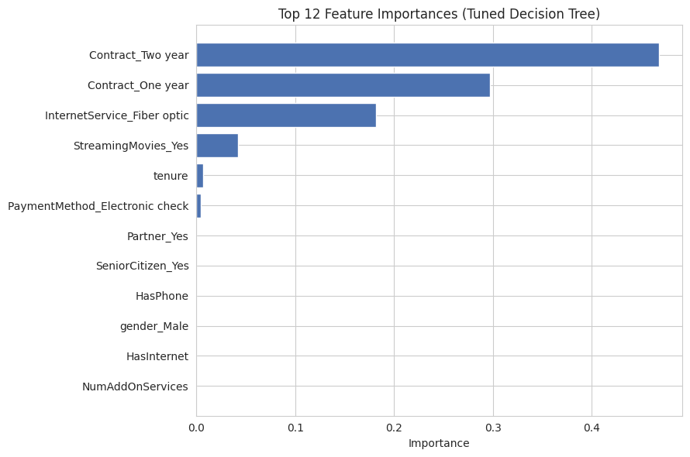
Figure 8. Top 12 feature importances for the tuned Decision Tree.

3.3 Clustering: Customer Segmentation
K-Means clustering was applied to group customers into behaviorally similar segments using tenure, MonthlyCharges, NumAddOnServices, HasInternet, HasPhone, and one-hot encoded Contract type — deliberately excluding demographics and the Churn label, so any resulting relationship between cluster and churn rate would be discovered rather than assumed. The number of clusters was chosen via the elbow method (inertia vs. k) and confirmed with silhouette score.
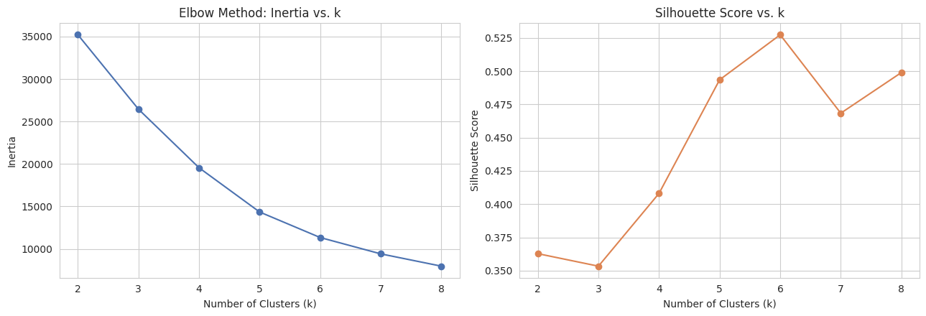
Figure 9. Elbow method and silhouette score used to select k = 4.
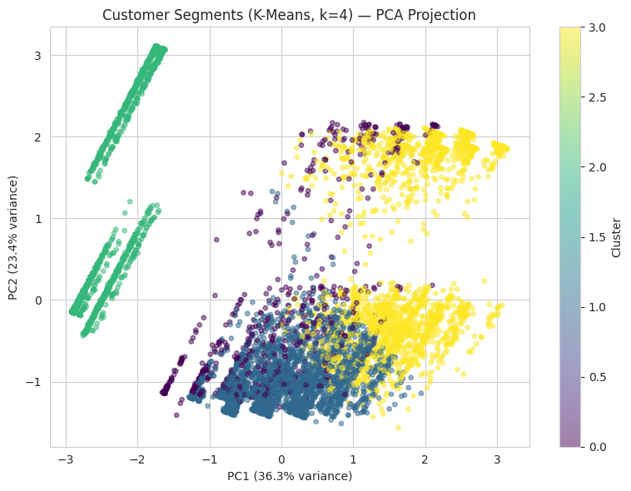
Figure 10. PCA projection of the four K-Means customer segments (silhouette score ≈ 0.41).
Segment | Avg. Tenure | Avg. Monthly Charges | Avg. Add-Ons | Churn Rate | Size
At-risk newer subscribers | 16.1 mo | $75.17 | 1.6 | 47.0% | 2,835
Mid-tenure, moderate bundle | 31.7 mo | $42.03 | 2.6 | 25.0% | 682
Loyal power users | 57.1 mo | $91.09 | 4.0 | 13.0% | 2,000
Low-cost, low-churn | 30.6 mo | $21.08 | 0.0 | 7.0% | 1,526
Entirely unsupervised — without ever seeing the Churn label — K-Means independently surfaced the same underlying signal that classification found: churn risk tracks short tenure combined with a non-trivial bill relative to service value, not the raw count of subscribed services. The lowest-churn segment has zero average add-ons, showing that “few services” alone is not a churn driver; it is short tenure paired with an unbundled, unjustified bill that is.

3.4 Association Rule Mining: Service Bundling Patterns
The Apriori algorithm was applied to a market-basket encoding of each customer's subscribed services, contract type, and churn status, to surface which service combinations co-occur and which are associated with churn. PhoneService was deliberately excluded from the basket: at roughly 90% adoption it is a near-universal item that would dominate the rule set with trivially high confidence but little insight.
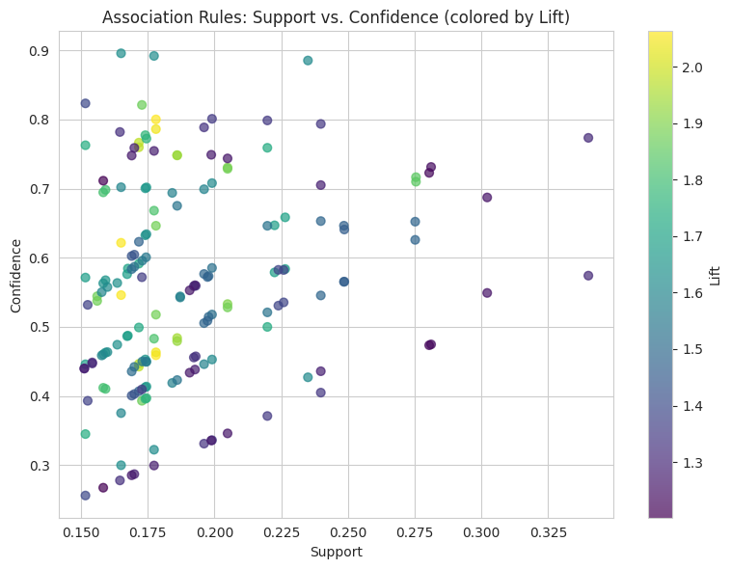
Figure 11. Support vs. confidence for all mined association rules, colored by lift.
The strongest churn-associated rule found was {Month-to-month contract, Fiber optic internet} → Churn = Yes, with support 0.165, confidence 0.546, and lift 2.06 — customers on this combination churn at more than double the base rate. A separate, non-churn pattern emerged among streaming services: StreamingTV, StreamingMovies, and MultipleLines co-occur with lift around 1.98–2.06, reflecting a natural cross-sell bundle among fiber-optic customers.

4. Evaluation and Cross-Technique Insights
Technique | Key Result
Regression | Ridge Regression preferred; R² ≈ 0.999, RMSE ≈ $1 predicting MonthlyCharges
Classification | Baseline Decision Tree best ROC AUC (≈0.83); tuned tree ≈0.79; k-NN ≈0.77
Clustering | K-Means, k = 4; churn ranges from 7% to 47% across segments
Association Rules | Month-to-month + fiber-optic → churn, lift ≈ 2.06
The central finding of this project is that all four techniques — applied independently, using different algorithms and, for clustering, without ever seeing the target label — converge on the same underlying story: churn risk in this dataset tracks short tenure and weak contractual commitment, not the size of the bill itself. Regression shows that price is nearly a deterministic function of subscribed services rather than an independent variable. Classification consistently ranks Contract and InternetService-related features at the top of its importance rankings. Clustering separates a 47%-churn segment from a 7%-churn segment using tenure and bundle depth alone. Association rule mining confirms the same month-to-month/fiber-optic combination as the strongest churn antecedent found by any method.
Agreement across four independently derived techniques is meaningfully stronger evidence than any single method could provide alone, and gives confidence that the drivers identified here — contract commitment, tenure, and bundled service value — are genuine patterns in the data rather than artifacts of any one algorithm's assumptions.

5. Ethical Considerations

5.1 Data Privacy
The dataset is a de-identified, publicly released sample: customerID is a synthetic key not tied to any real individual, and no sensitive personal identifiers beyond coarse demographic categories (gender, senior-citizen status, partner/dependent status) are present. This coursework use required no additional privacy controls. A production deployment on real customer data, however, would need to add access controls, minimize retained demographic fields to only what is strictly necessary for the modeling purpose, and comply with applicable data-protection regulation (e.g., GDPR or CCPA).

5.2 Fairness
Demographic attributes (gender, SeniorCitizen, Partner, Dependents) were included as classification predictors. This carries a real risk: a model trained on these features could learn to differentiate retention offers, pricing, or service recommendations along demographic lines, even unintentionally, if those attributes happen to correlate with churn in the training data. Before any version of this model were used to automate real pricing or retention decisions, it should be audited for disparate impact across these demographic groups (e.g., comparing false-negative churn-prediction rates by group), and the demographic features should be excluded or fairness-constrained if such disparities are found.

5.3 Potential Biases
This dataset reflects one fictional company's pricing structure, service catalog, and customer base at a single point in time. The specific churn drivers identified here — contract type, fiber-optic pricing — are shaped by that company's particular market and should not be generalized as a universal theory of telecom churn; a different provider, region, or time period could show materially different patterns. Any deployment of this analysis outside the scope of this coursework dataset would need re-validation on the target population before being trusted.

5.4 Steps Taken to Address These Concerns
- Classification models were evaluated with F1 score and ROC AUC, not accuracy alone, specifically to avoid rewarding a model that superficially performs well by ignoring the minority churn class the population most relevant to any retention intervention.
- Cluster and association-rule interpretations were cross-checked against the independently derived classification results (Section 4) rather than accepted at face value from any single technique, reducing the risk of over-interpreting a pattern that could be an artifact of one particular algorithm.
- The report explicitly documents the tuned classifier underperforming the baseline on this test split (Section 3.2) rather than selectively reporting only the favorable result, in the interest of transparent and honest evaluation.

6. Practical Recommendations
- Target retention offers at the highest-risk segment: short-tenure (under 24 months), month-to-month, fiber-optic customers with few add-on services should receive proactive contract-upgrade or bundle-discount offers ahead of their renewal decision point, since this segment shows a 47% churn rate versus a 26.5% baseline.
- Use NumAddOnServices and Contract type as compact churn-risk features in any operational scoring model, rather than MonthlyCharges or TotalCharges — the regression results show billing amount is largely redundant with these more interpretable, non-leaky features.
- Proactively bundle streaming services with fiber-optic plans at sign-up: customers who adopt one streaming service are highly likely to want the other, and this bundling pattern co-occurs with the long-tenured, low-churn “loyal power users” segment.
- Re-run this pipeline periodically as new customer cohorts accrue tenure and as pricing or competitive conditions change, since churn drivers in subscription businesses are not static.

6.1 Limitations and Future Improvements
- The dataset is a single static snapshot; a production system would benefit from time-series or survival-analysis approaches to churn rather than a single binary-outcome classifier.
- Only two classification algorithms and one clustering algorithm were evaluated in this project; ensemble methods (Random Forest, Gradient Boosting) and alternative clustering approaches (DBSCAN, hierarchical clustering) could be explored for further performance and robustness gains.
- Association rule mining was deliberately scoped to service, contract, and churn items for interpretability; a broader basket combined with sequence mining could reveal service-adoption order effects not visible in this cross-sectional snapshot.

7. References
IBM. (n.d.). Telco Customer Churn [Data set]. Kaggle. https://www.kaggle.com/datasets/blastchar/telco-customer-churn
Pedregosa, F., et al. (2011). Scikit-learn: Machine learning in Python. Journal of Machine Learning Research, 12, 2825–2830.
Raschka, S. (2018). MLxtend: Providing machine learning and data science utilities and extensions to Python's scientific computing stack. Journal of Open Source Software, 3(24), 638.
McKinney, W. (2010). Data structures for statistical computing in Python. Proceedings of the 9th Python in Science Conference, 56–61.
Agrawal, R., & Srikant, R. (1994). Fast algorithms for mining association rules. Proceedings of the 20th International Conference on Very Large Data Bases, 487–499.

