

##### INDIAN INSTITUTE OF TECHNOLOGY INDORE

FUND MANAGEMENT SYSTEM

DESIGN ARTEFACTS

DATE: 12-02-2016

# TEAM MEMBERS

PRIYANSHU KUMAR

GUDURU SAI TEJA

K. SUDHARSAN

AKSHAY SINGH CHAUHAN

PREPARED FOR

CS-258 SOFTWARE ENGINEERING

SPRING 201

# 1 Interaction Model Diagram

## 

## Use Case Diagram

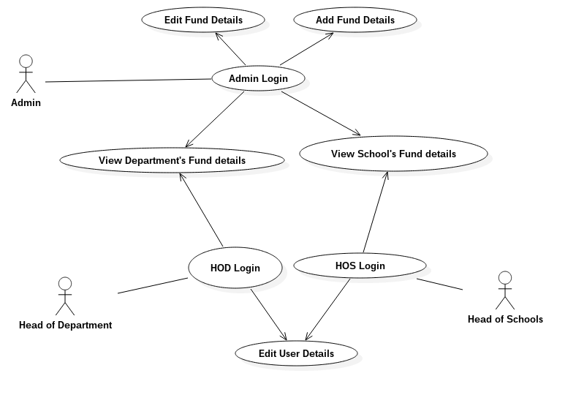

## Sequence Diagram

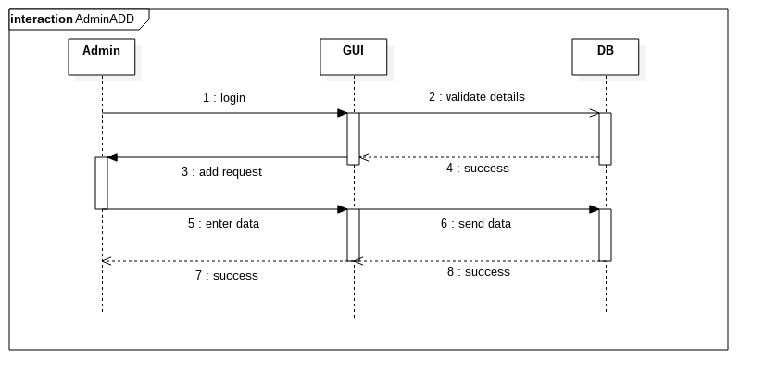

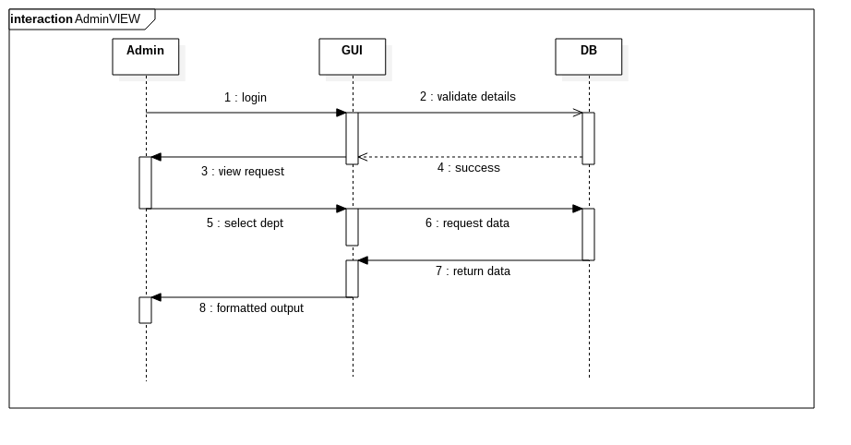

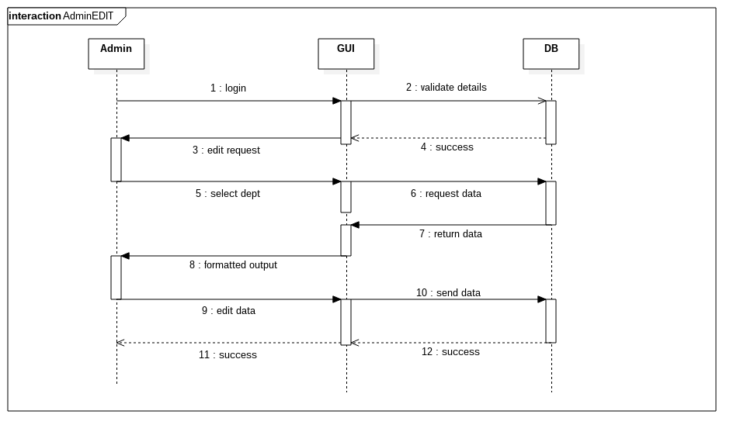

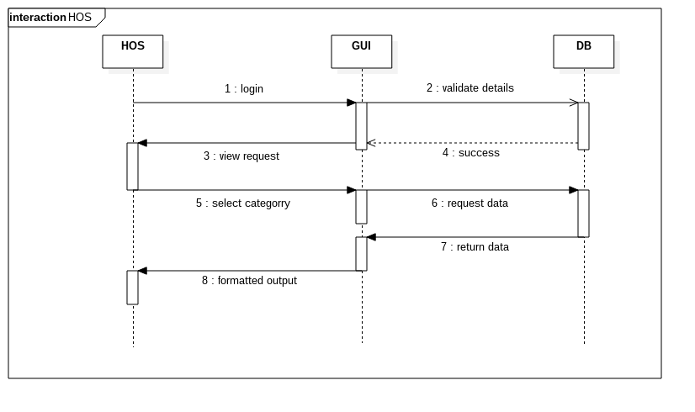

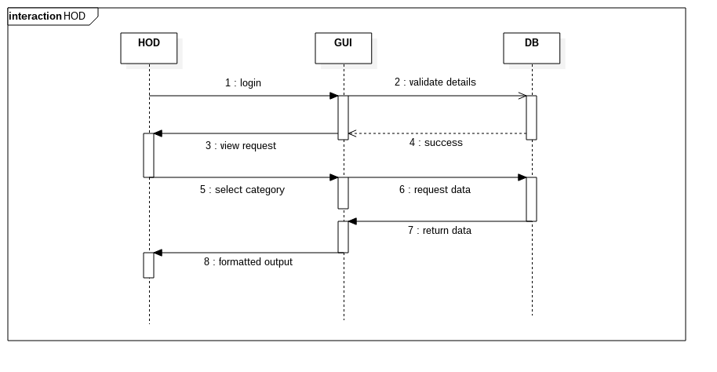

# 2. Behavioral Model

## 2.1 Data Flow Diagram

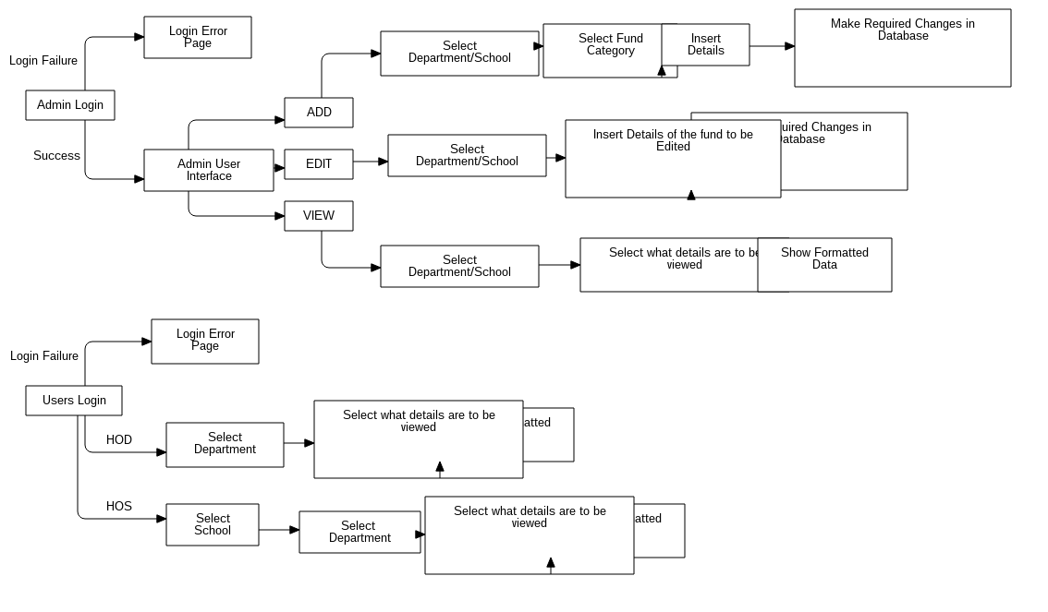

## 

## 3. Class Diagram

# D:\png\Model1__ClassDiagram_8.png

# 4. Context Diagram

