**What does the liver do?**

* [Structure](https://www.medicalnewstoday.com/articles/305075#structure)
* [Functions](https://www.medicalnewstoday.com/articles/305075#functions)
* [Regeneration](https://www.medicalnewstoday.com/articles/305075#regeneration)
* [Diseases](https://www.medicalnewstoday.com/articles/305075#diseases)
* [Health](https://www.medicalnewstoday.com/articles/305075#health)
* [Summary](https://www.medicalnewstoday.com/articles/305075#summary)

The liver is the largest solid organ in the body. It carries out over 500 tasks and plays an essential role in digestion. Its roles include detoxification, protein synthesis, and producing digestive enzymes.

The roles of the liver include detoxification, protein synthesis, and the production of chemicals that help digest food. It is part of the digestive system.

This article will cover the main roles of the liver, how the liver regenerates, what happens when the liver does not function correctly, and how to keep the liver healthy.

**Structure**

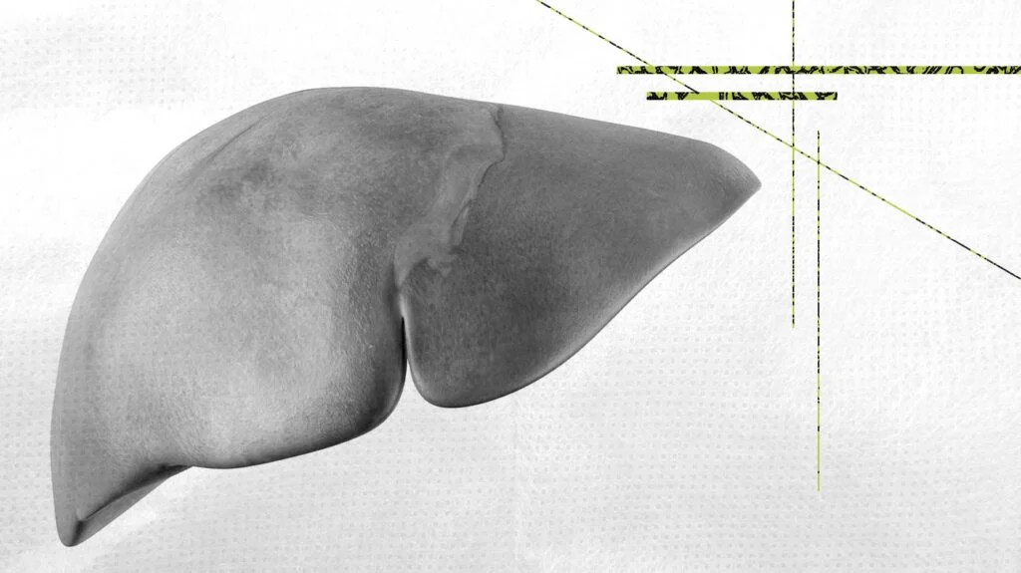Share on PinterestSEBASTIAN KAULITZKI/SCIENCE PHOTO LIBRARY/Getty Images

A person’s liver is in the upper right section of the abdomen and sits below the diaphragm. It typically weighs [around 3 poundsTrusted Source](https://www.cdc.gov/hepatitis/theliver.htm), but this can vary between people. The [skin](https://www.medicalnewstoday.com/articles/320435) is the only organ heavier and larger than the liver.

The liver is roughly triangular and consists of two lobes: a larger right lobe and a smaller left lobe. The falciform ligament separates the lobes. This ligament is a band of tissue that keeps the liver anchored to the diaphragm.

A layer of fibrous tissue called Glisson’s capsule covers the outside of the liver. The peritoneum, a membrane that forms the lining of the abdominal cavity, then covers this.

This helps hold the liver in place and protects it from physical damage.

**Blood vessels**

Unlike most organs, the liver has two major sources of blood. The portal vein brings in nutrient-rich blood from the digestive system, and the hepatic artery carries oxygenated blood from the heart.

The blood vessels divide into small capillaries, with each ending in a lobule. Lobules are the functional units of the liver and consist of millions of cells called hepatocytes.

Three hepatic veins remove blood from the liver.

**Functions**

The liver is a gland that has many functions in the body. It is difficult to give a precise number, but it may have more than [500 distinct roles](https://www.hepatitis.va.gov/basics/liver-as-factory.asp).

The major functions of the liver include:

* **Bile production:** Bile helps the small intestine [break down and absorb fatsTrusted Source](https://www.ncbi.nlm.nih.gov/books/NBK542254/), [cholesterol](https://www.medicalnewstoday.com/articles/9152.php), and some vitamins. Bile consists of bile salts, cholesterol, bilirubin, electrolytes, and water.
* **Absorbing and metabolizing bilirubin:** The breakdown of hemoglobin forms bilirubin. The liver or [bone marrow](https://www.medicalnewstoday.com/articles/285666.php) stores iron released from hemoglobin, which makes the next generation of blood cells.
* **Supporting blood clots:** Vitamin K is necessary to create coagulants that help clot the blood. Bile is [essential for vitamin K absorptionTrusted Source](https://ods.od.nih.gov/factsheets/VitaminK-HealthProfessional/) and forms in the liver. The liver must produce enough bile to make clotting factors.
* **Fat metabolization:** Bile breaks down fats and makes them easier to digest.
* **Metabolizing carbohydrates:** The liver stores carbohydrates. The body can break down stored carbohydrates in the liver, known as glycogen, into glucose. Glucose, or sugar, is released into the bloodstream to regulate blood sugar levels and for a quick burst of energy.
* **Vitamin and mineral storage:** The liver stores [fat-soluble vitamins](https://www.medicalnewstoday.com/articles/195878#the-13-vitamins), known as vitamins A, D, E, K, and B12. It keeps significant amounts of these vitamins stored. The liver stores iron from hemoglobin in the form of ferritin, ready to make new red blood cells. The liver also stores and releases [copper](https://www.medicalnewstoday.com/articles/288165.php).
* **Helps metabolize proteins:** Bile helps break down proteins for digestion.
* **Filters the blood:** The liver filters and removes compounds from the body, including hormones, such as [estrogen](https://www.medicalnewstoday.com/articles/277177.php) and aldosterone, and compounds from outside the body, including alcohol and other drugs.
* **Immunological function:** The liver is part of the mononuclear phagocyte system. Cells involved in immune activity, Kupffer cells, are found in high numbers in the liver. [These cells destroyTrusted Source](https://www.nature.com/articles/cmi2015104) disease-causing viruses, bacteria, or other microorganisms that might enter the liver through the gut.
* **Production of albumin:** [Albumin](https://www.medicalnewstoday.com/articles/322403) is the most common protein in blood serum. It transports fatty acids and steroid hormones to help support the correct pressure and prevent the leaking of blood vessels.
* **Synthesis of angiotensinogen:** This hormone raises [blood pressure](https://www.medicalnewstoday.com/articles/270644.php) by narrowing the blood vessels when alerted by production of an enzyme called renin in the kidneys.

**Regeneration**

Because of the importance of the liver and its functions, evolution has ensured that it can regrow rapidly as long as it is kept healthy. All vertebrates, from fish to humans, have the [ability to regrow the liverTrusted Source](https://www.ncbi.nlm.nih.gov/pmc/articles/PMC7970152/).

The liver is the [only visceral organTrusted Source](https://www.ncbi.nlm.nih.gov/pmc/articles/PMC6457252/) that can regenerate. It can regenerate completely, as long as a minimum of about [25%](https://share.upmc.com/2017/04/can-you-live-without-a-liver/) of the tissue remains. The liver can regrow to its previous size and ability without any loss of function during the growth process.

Removal of two-thirds of the liver in mice causes the remaining liver tissue to regrow to its original size and restore function within [7—10 daysTrusted Source](https://www.ncbi.nlm.nih.gov/pmc/articles/PMC6128415/). In humans, the process takes slightly longer, but regeneration can still occur in [8—15 daysTrusted Source](https://www.ncbi.nlm.nih.gov/pmc/articles/PMC2701258/). Researchers suggest surgical removal of the right or left lobe of the liver results in complete restoration of the liver mass after [3 monthsTrusted Source](https://www.ncbi.nlm.nih.gov/pmc/articles/PMC7665117/), while maximum cellular activity happens 7 to 10 days after the procedure.

Over the following few weeks, the new liver tissue becomes indistinguishable from the original tissue.

A number of compounds are responsible for liver regeneration, including growth factors and cytokines. Some of the most important compounds in the process appear to be but are not limited to:

* hepatocyte growth factor
* [insulin](https://www.medicalnewstoday.com/articles/323760)
* transforming growth factor-alpha
* epidermal growth factor
* interleukin-6
* norepinephrine

Top of Form

[](https://www.medicalnewstoday.com/articles/inline?correlationId=330d4341-0f79-4e7e-939c-52ed1f6a14a5)

MEDICAL NEWS TODAY NEWSLETTER

**Sign up for a weekly diabetes newsletter.**

Get the latest diabetes updates in a weekly newsletter. Whether it’s for you or a loved one, we gather research on risk factors, nutrition, treatment, and more.

Enter your email

SIGN UP

Your [privacy](https://www.medicalnewstoday.com/privacy-policy) is important to us

Bottom of Form

**Diseases**

An organ as complex as the liver can experience a range of problems. A healthy liver functions very efficiently. However, the consequences can be dangerous or even fatal in a diseased or malfunctioning liver.

Examples of liver disease include:

* **Fascioliasis:**The parasitic invasion of a worm, known as a [liver flukeTrusted Source](https://www.cdc.gov/dpdx/fascioliasis/index.html), causes this condition. The liver fluke can lie dormant in the liver for months or even years. Fascioliasis is a tropical disease.
* **Cirrhosis:**This sees scar tissue replace liver cells in a process known as [fibrosis](https://www.medicalnewstoday.com/articles/172295). Toxins, alcohol, and hepatitis are some of the many factors that cause this condition. Eventually, fibrosis can lead to liver failure because the functionality of liver cells becomes destroyed.
* **Hepatitis:**[Hepatitis](https://www.medicalnewstoday.com/articles/hepatitis) is the name given to a general infection of the liver, and viruses, toxins, or an autoimmune response can cause it. An inflamed liver characterizes this condition. In many cases, the liver can heal itself, but liver failure can occur in serious cases.
* **Alcoholic liver disease:**Drinking too much alcohol over long periods can [cause liver damage](https://www.medicalnewstoday.com/articles/305062#long-term-effects-).
* **Primary sclerosing cholangitis (PSC):**[PSC](https://rarediseases.info.nih.gov/diseases/1280/primary-sclerosing-cholangitis) is a serious inflammatory disease of the bile ducts that results in their destruction. There is currently no cure, and the cause is unknown.
* **Fatty liver disease:**This usually occurs alongside [obesity](https://www.medicalnewstoday.com/articles/323551) or the harmful use of alcohol. In fatty liver disease, vacuoles of fat build up in the liver cells. [Nonalcoholic fatty liver disease](https://www.medicalnewstoday.com/articles/312536)occurs when alcohol use is not the cause.
* **Gilbert’s syndrome:**This is a genetic disorder affecting [4—16%Trusted Source](https://www.ncbi.nlm.nih.gov/books/NBK470200/) of the population. In Gilbert’s syndrome, the body does not fully break down bilirubin. Mild [jaundice](https://www.medicalnewstoday.com/articles/165749.php) can occur, but the disorder is harmless.
* **Liver cancer:**The most common types of [liver cancer](https://www.medicalnewstoday.com/articles/172408.php) are hepatocellular [carcinoma](https://www.medicalnewstoday.com/articles/300871.php) and [cholangiocarcinomaTrusted Source](https://www.cancer.gov/types/liver/bile-duct-cancer" \t "_blank). The leading causes are alcohol and hepatitis. It is the [sixth](https://www.wcrf.org/cancer-trends/worldwide-cancer-data/) most common form of cancer globally and the [thirdTrusted Source](https://www.who.int/news-room/fact-sheets/detail/cancer" \t "_blank) most frequent cause of cancer death around the world.

**Health**

Below are some recommendations from the [American Liver Foundation](https://www.liverfoundation.org/13-ways-to-a-healthy-liver/) to help keep the liver working as it should:

* **Diet:**As the liver is responsible for digesting fats, consuming too many can overwork the organ and disturb it from other tasks. This also [has links toTrusted Source](https://dmsjournal.biomedcentral.com/articles/10.1186/s13098-020-00570-y) fatty liver disease.
* **Moderate alcohol ingestion:**Avoid consuming more than two drinks at a time. Drinking too much [alcohol](https://www.medicalnewstoday.com/articles/305062) causes cirrhosis of the liver over time.
* **Avoiding illicit substances:** [Illicit substances](https://www.medicalnewstoday.com/categories/alcohol) can overload the liver with toxins. Avoiding these substances can allow the liver to perform its necessary functions without impediment.
* **Caution when mixing medications:** Some prescription drugs and natural remedies can interact negatively. Mixing drugs with alcohol puts significant pressure on the liver.
* **Protection against airborne chemicals:** Airborne chemicals can cause liver damage. When painting or using strong cleaning or gardening chemicals, the area should be well ventilated, and people should wear a mask.
* **Travel and vaccinations:** Vaccination is essential if a person travels to an area where hepatitis A or B might be a concern. [Malaria](https://www.medicalnewstoday.com/articles/150670.php) grows and multiplies in the liver, and [yellow fever](https://www.medicalnewstoday.com/articles/174372.php) can lead to liver failure.
* **Safe sex:** There is no vaccination for [hepatitis C](https://www.medicalnewstoday.com/articles/294705.php). Safe sex practices can help prevent the disease.
* **Avoid exposure to blood and germs:** Receive medical attention if exposed to the blood of another person.

Despite its ability to regenerate, the liver depends on being healthy to do so. Lifestyle choices and dietary measures, the liver can help protect the liver in most cases.

**Summary**

The liver is the largest solid organ in the human body. It is part of the digestive system and plays an essential role in removing toxins from the blood, metabolizing nutrients, and immune function.