COMP4421 (Fall 2018)

Assignment #3

Name: Kristian Suhartono StudentID : 20313207 E-mail: [ksuhartono@connect.ust.hk](mailto:ksuhartono@connect.ust.hk)

II. Programming Tasks

1. Digit Segmentation

The algorithm:

* Preprocessing the image to remove noise
* Thresholding the input to get binary images
* Horizontal and vertical projection to get the digits (finding the peaks in each projection)
* Clearing of excess empty spaces
* Resizing of image to 20x20
* Padding to 28x28
* Centering of image based on the center of gravity
  1. Image 1:

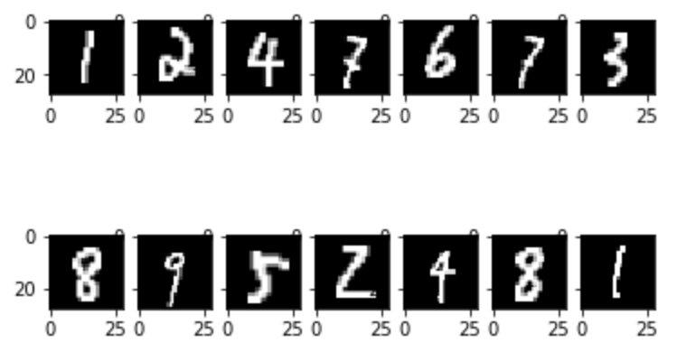

* 1. Image 2:

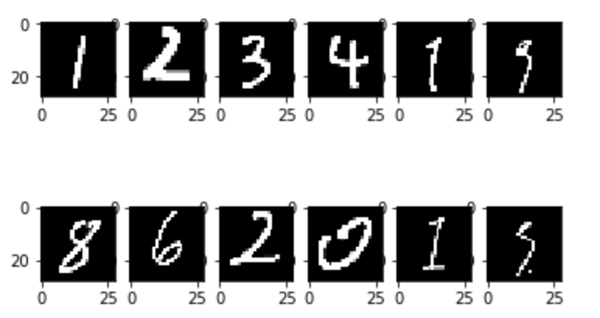

* 1. Image 3:

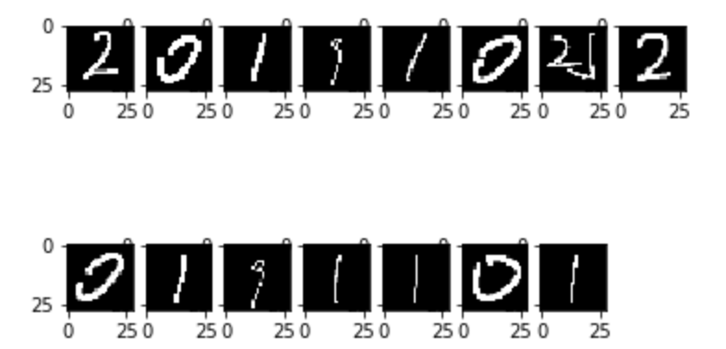

1. Classification via Adaboost

Classifier used: Decision Tree

* 1. Accuracy of Image 1: 15/16 = 93.75%
  2. Accuracy of Image 2: 11/12 = 91.67%
  3. Accuracy of Image 3: 11/16 = 68.75%