***Task-01 Terraform Commands***

***Task-01***

***Find purpose of basic Terraform commands which you'll use often***

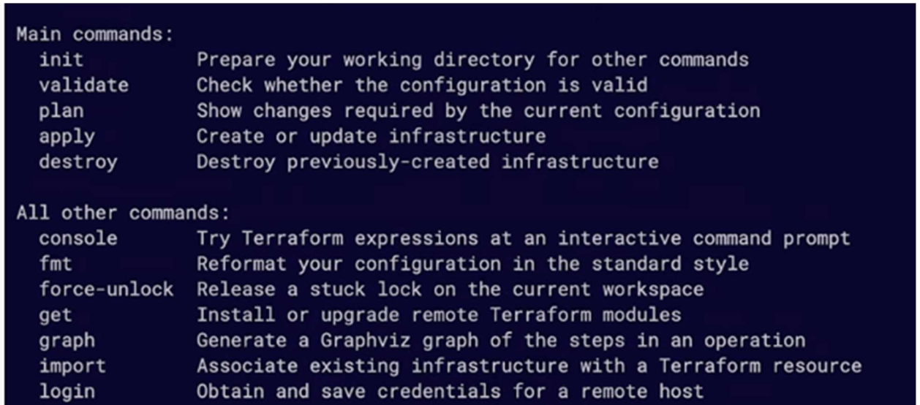

***1 Terraform init:***

***Initializes a new or existing Terraform working directory by downloading the required provider plugins and sets up the backend to store the state. This command must be run before any other Terraform command is executed.***

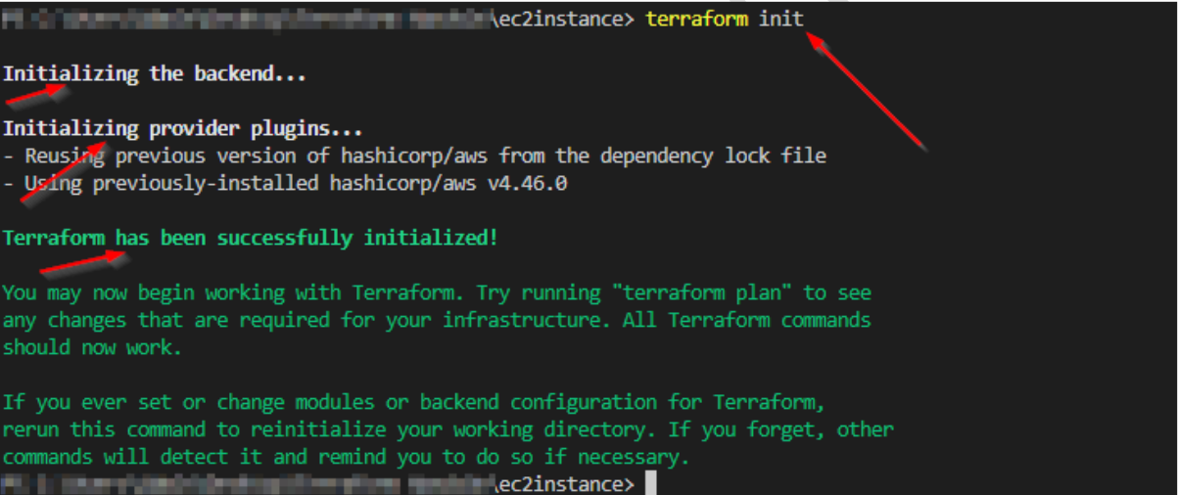

Terraform init Diagram.

***2 Terraform init-upgrade:***

***Upgrades the configuration to the latest version of Terraform. This is useful if you have upgraded your Terraform version and want to ensure that your configuration is compatible with the new version.***

***3 Terraform plan:***

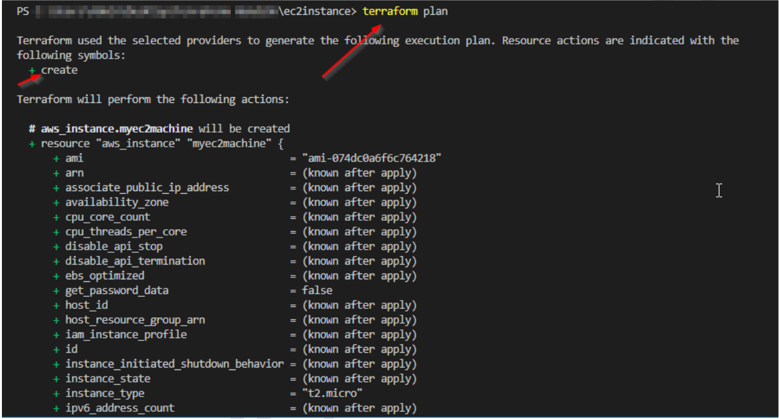

Terraform plan

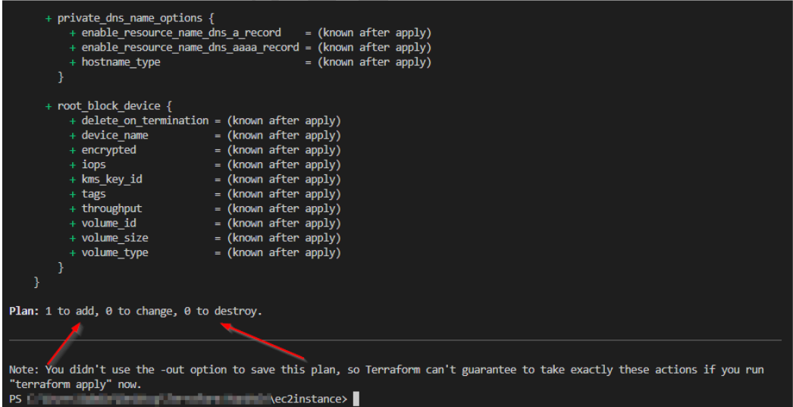

Terraform plan Diagram.

***Shows the changes that Terraform will make to the infrastructure to bring it into the desired state,without actually making the changes. This is useful to see what changes terraform will make before actually applying them.***

***4 Terraform apply:***

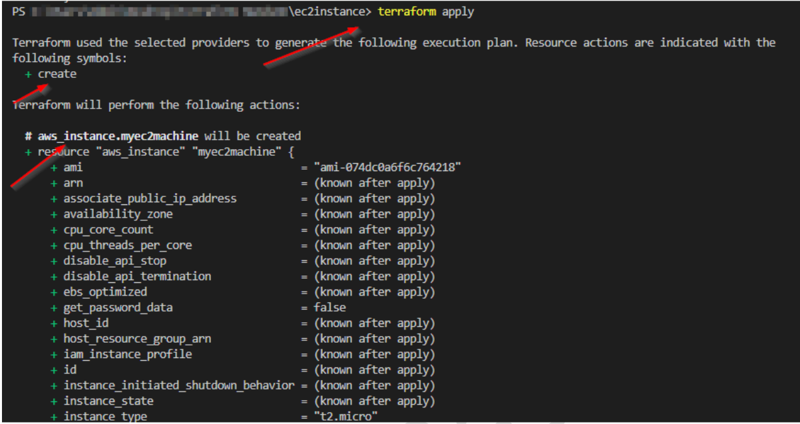

Terraform apply Diagram

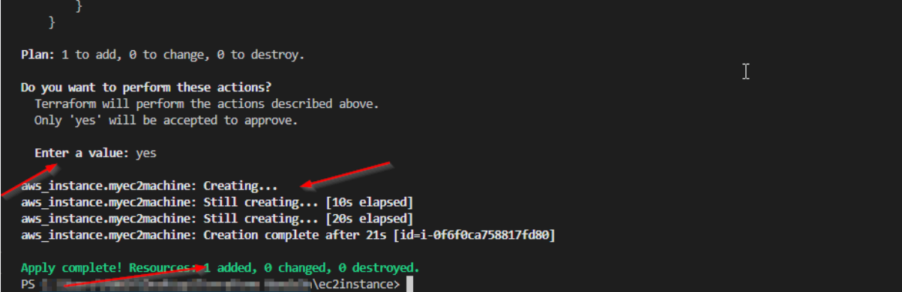

Terraform apply Diagram

***Applies the changes to the infrastructure described in the Terraform configuration files. This command will create,modify,or delete resources as needed to bring the infrastructure into the desired state.***

***5 Terraform Validates:***

***Validates the syntax and structure of the Terraform configuration file. This command checks for errors, missing required arguments and other issues.***

***6 Terraform fmt:***

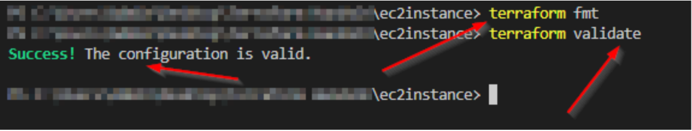

Terraform fmt Diagram.

***Rewrites terraform Configuration files to a canonical format, Which makes it easier to read and manintain.***

***7 Terraform destroy:***

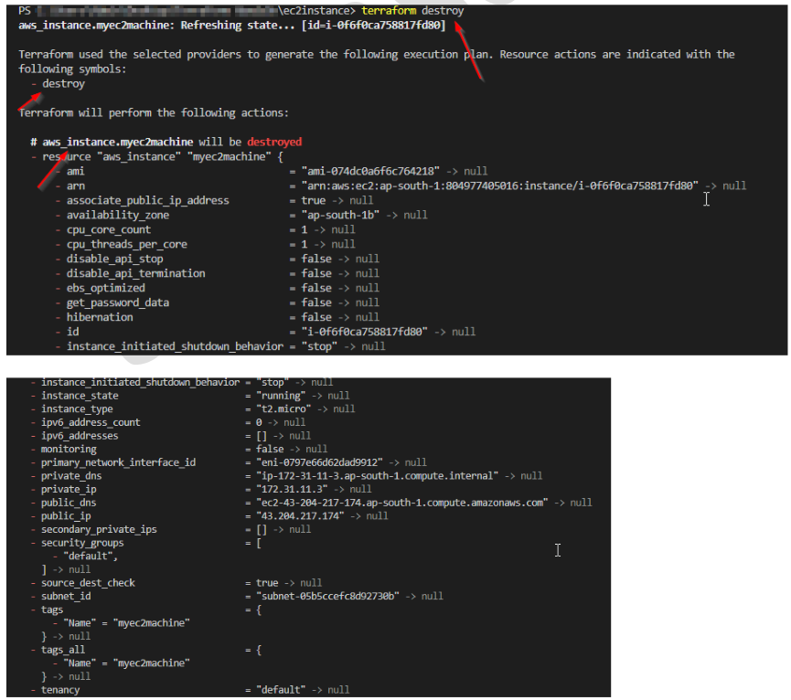

Terraform Destroy Diagram.

***Destroys all the infrastructure created by Terraform, freeing up the resources and ensuring that you are not paying for unused infrastructure. This command should be used with caution as it will delete all the resources described in the configuration file.***