**Activity – Applying Usability**

**In this module we’ve looked at a range of usability tools including Personas,**

**Card Sorting, Task Analysis, Use Cases, and Surveys. Remember the video**

**we watched in module two about a polling booth set up by the Australian**

**Electoral Commission? In small groups, select one of the tools and apply it to**

**developing a new online voting system for the AEC:**

** Personas – use the approach outlined in the module book to develop one**

**persona for a person who would use this technology (voter/AEC employee)**

Australian Voter Persona:-

|  |  |  |  |  |
| --- | --- | --- | --- | --- |
| **Who** | **Demographic Information** | **Goals** | | |
| Sandra Blue | **Age:**37  **Location:**Brisbane, 4000  **Job Title:**Sales Rep | **Life Goals:**  Sandra wants to be a person whois part of a collective voice. | **End Goals:**  Sandra wants her vote to count and wants to do it quickly and efficiently. | **Experience Goals:**  Sandra wants to feel proud of their country and what they do for not only their citizens, but for the world. |

** Card sorting – complete a card sorting exercise using the cards provided by**

**your instructor**

Cannot do this as I have no cards from the instructor to do it.

** Task analysis – complete a task analysis for the voting process**

This is done from the perspective of a voter…

|  |  |  |
| --- | --- | --- |
| **Step No.** | **Task** | **What to do…** |
| **1** | Line up | Arrive at a polling site and line up to vote |
| **2** | Register | Arrive at the registering dress and give your details to be marked off the list and given your ballots. |
| **3** | Vote | Take your ballots to a polling booth and fill them out as you see fit. |
| **4** | Deposit | Take your filled out ballots and deposit then in the appropriate container for that ballot. |
| **5** | Leave | You are now done voting and can leave the premises. |

** Use cases – write a use case for the voting process**

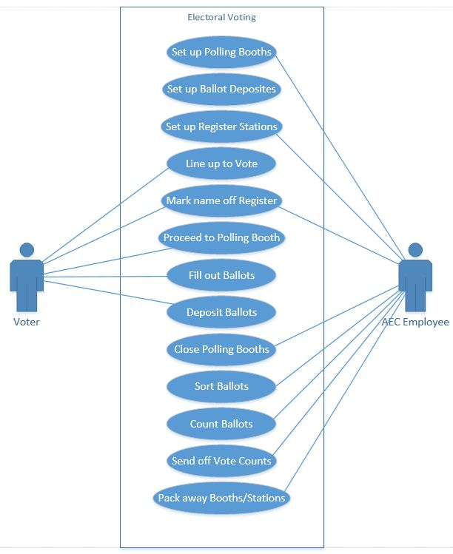

** Surveys – generate a list of survey questions for the voting system: what do**

**you need to know?**

Survey questions:-

* What is your age bracket?
* Do you like the current paper voting system? If yes, why? If no, why not?
* Would you like an electronic voting system? If yes, why? If no, why not?
* Would you prefer one or the other or a choice of either?
* What technological devices do you own/use? (Gives us an idea of their technological capability)

**Advanced Activity – Comparing the tools**

**The tools we’ve covered are related both to each other and to your future**

**design, but what are the connections? Work together to compare the tools and**

**identify the common threads and the differences.**

**How would you then use these tools in your design stage?**

**Similarities:**

* Informal Usability Testing, Usability Testing, Expert Reviews are all evaluations.
* Alls tools are centric on the tools
* User Interviews, Personas, User Research – all regarding users.

**Differences:**

Number of practitioners using each tool varies significantly. The ranges are as follows:

* Above 70%: Informal Usability Testing, Expert Reviews, User Interviews, User Research
* 50-70%: Formal Usability Testing, Personas, Requirements Gathering, Task Analysis, Card Sorting
* 33-50%: Contextual Inquiry, Focus Groups, Competitive Benchmarking, Remote Usability Testing, Surveys,
* Less than 33%: Eye Tracking, Accessibility Reviews and testing, Analyse web metrics, Market Reviews