Ecology Workshop Project Proposal: Seasonal Vertical Distribution of Phytoplankton in a Subtropical Dystrophic Lake

Kristy Sullivan

1/16/2020

### Research Statement

Physical, chemical, and competative processes can influence the vertical and seasonal distribution of phytoplankton in freshwater lakes. In dissolved organic carbon (DOC) rich waters, the photic zone may be limited to just a few meters below the surface. Due to temperate bias, current models of phytoplankton succession are unable to predict the seasonal trends observed in many subtropical and tropical monomictic lakes. In subtropical dystrophic Lake Annie (Highlands County, FL, USA), dissolved organic carbon quality, quantity, and resistance to mixing may be strong drivers of phytoplankton assemblages spatially and temporally.

### Objectives

My goals in this workshop are to develop spatiotemporal species distribution models of dominant phytoplankton species in response to environmental drivers (i.e. DOC, temperature, nutrients). I hope to use the results of this project as a chapter of my masters’ thesis.

### Hypotheses

1. Temporal Patterns: Species diversity and richness will be greatest in dark years due to increased resource availability (high DOC). Mixotrophic to autotrophic phytoplankton ratios will also increase with greater concentrations of DOC.
2. Vertical Patterns: Diversity and richness will be greatest in the epilimnion due to greatest light availability.

### Datasets

The datasets to be used in this project include a personal dataset of phytoplankton absolute abundance, DOC quality and quantity, bacterial abundance, dissolved oxygen, and temperature measured quartly (November 2018 - January 2020) from five depths (surface, 0m; chl-maximum, 2-4m; epilimnion, 6-9m; thermocline, 7-12m; and hypolimnion, 15m) from the central buoy of Lake Annie in Highlands County, FL. A second 14 year dataset of environmental parameters and phytoplankton net tows taken monthly from the center buoy at a depth of 10 meters (2006-2019) will be accessed with permission from Archbold Biological Station. These datasets will be publically available from the Archbold Biological Station data repository: <https://www.archbold-station.org/html/datapub/data/data.html>

### Statistical analyses

A preliminary NMDS analysis will be used to determine the common predictors of the observed phytoplankton distributions across time. From these data, I will be able to identify which species commonly occur together, and what environmental drivers influence their abundances. I will use these data to create a model which will predict the seasonal species distribution of phytoplankton species in Lake Annie given input values of the most influential drivers (i.e. Schmidt stability, DOC concentration/quality, and nutrients). I hope to create a model similar to the well established PEG model of temperate dimictic lakes (Sommer et al., 1986).

### Preliminary Results

Figure 1 (below) shows the relative abundance of the eight phyla of phytoplankton found in Lake Annie from monthly 10 m vertical net tows. There is a high relative abundance of *Bacillariophyta* (yellow) from years 2006-2010, while they are essentially absent years 2010-2013 at which point *Cyanophyta* and *Ochrophyta* become most dominant. This could be due to a decreased bioavailability of silica for the diatoms or perhaps a shift in nutrients. Most likely, there are multiple drivers with additive effects causing the observed abrupt shift in phyla relative abundance.

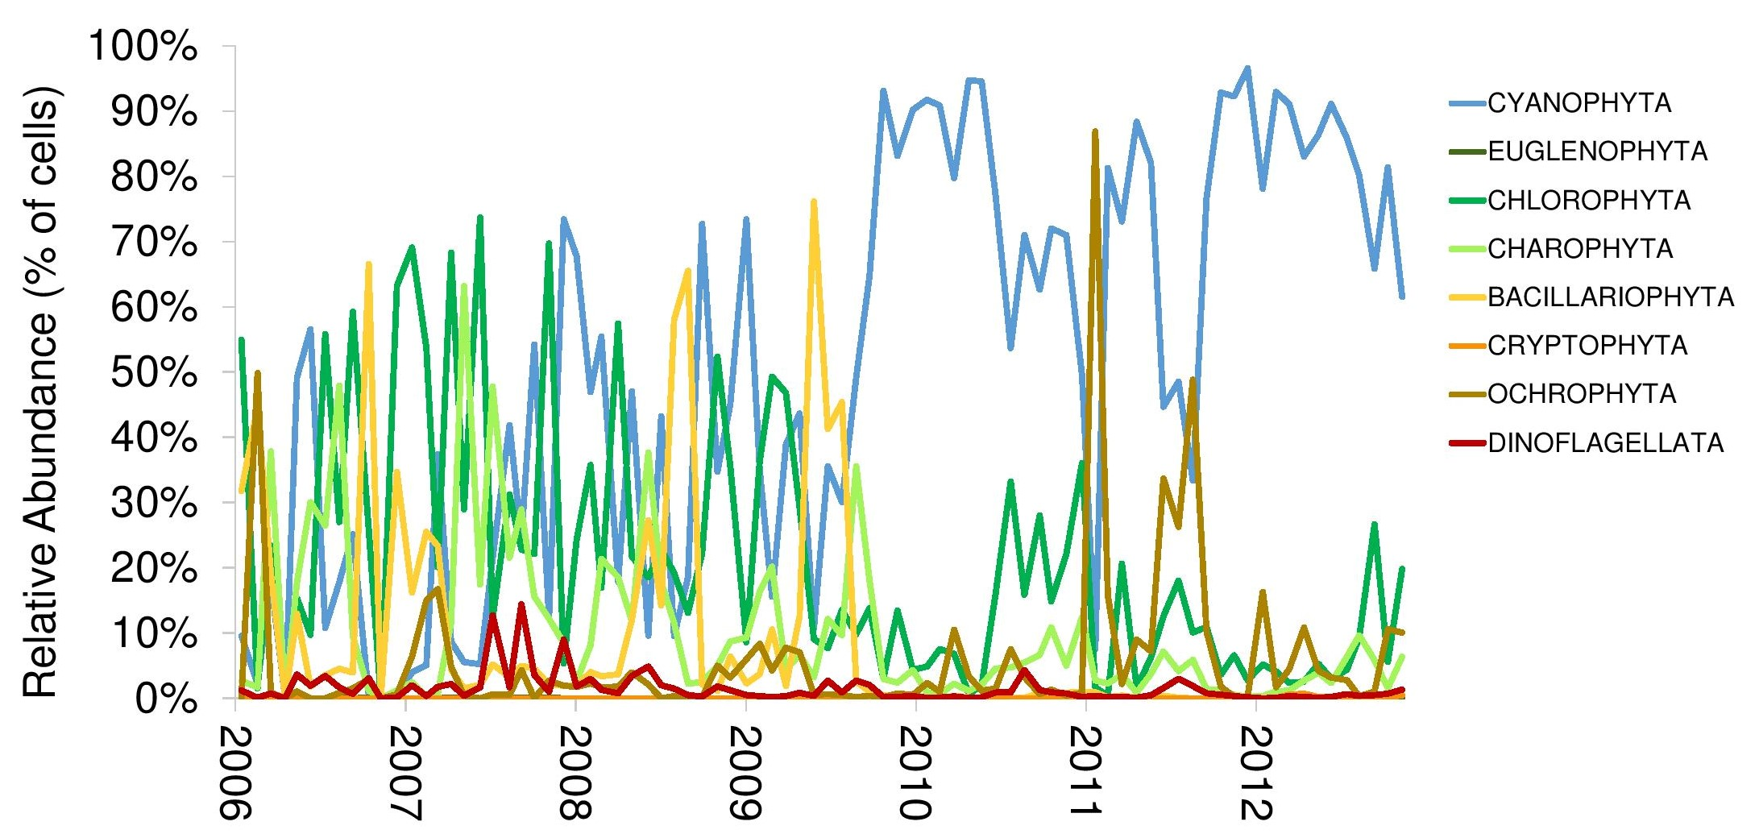

alt text