Mona and Kevin:

I have prepared several sample projects from my career that support my knowledge and expertise in the following areas:

1. Presentations and workshops for tribal land ownership and leases
2. Project management and deployment (using opensource, PostgreSQL, and proprietary data/apps).
3. Budgeting and Grant/Proposal Writing
4. Research and Development
5. Documentation and Training Others
6. **Presentations & Workshops related to land ownership and leases:**
   * This lengthy document describes all my projects completed during my tenure at the Bad River Tribe including the tribal lease map (see pg. ***Memorandum_Of_GIS_Benefits_withImages.pdf***
   * I developed this tool to identify ideal sites for new land purchase and development that avoided both vulnerable sites (wetlands) and historic sites: ***MulitcriteriaAnalysis_for_Development_WaterResAvoidance_v4_shorter.pptx***
   * I coordinated a regional meeting with 30+ attendees to discuss opensource GIS, tribal lease and land ownership (google “ tribal checkboarding” or see <https://iltf.org/land-issues/issues/>)



* Although I no longer have access to the Tribal Leader Web map, I have a screenshot of the application. I held monthly “Maps-on-the-Mind” brown bag lunches; at this topic, I discussed the tribal land ownership and lease web maps available to tribal members: ***TribalLeaseManagement_Webmap_BrownBagLunch.pdf***

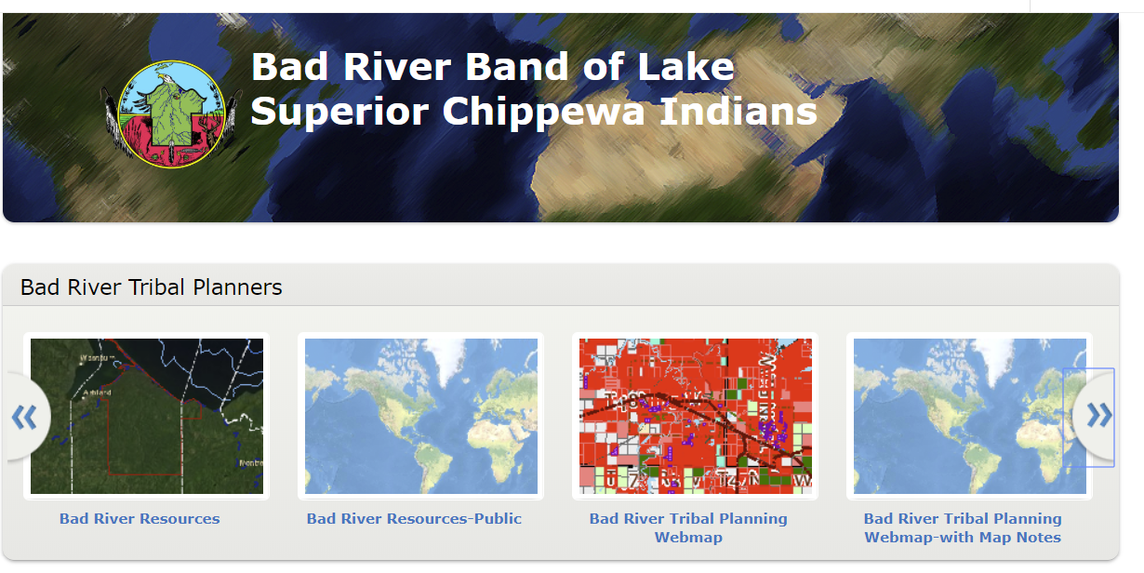

1. **Project Management & Deployment:**
   * I couldn’t find my research on the opensource web feature service and web map service tools to be used through QGIS for the City of Duluth, but I did find some old files in my Google Drive for when I was experimenting with the OpenLayers and Leaflet GIS programming libraries through QGIS called “qgis2web” (<https://plugins.qgis.org/plugins/qgis2web/>:
     + 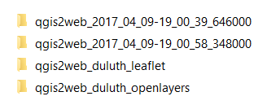
     + QGIS, as the opensource GIS desktop application has a plethora of plugins, on of which is exporting your loaded WMS/WFS/shapefile data to a web map built in the leaflet or OpenLayers JavaScript libraries.
   * This document is my final agreement with ShareGeo for contracting with initial configuration of GeoMoose opensource OpenLayers web GIS system on Linux server: ***Contract_GoodsAndServices_SharedGeo_v3.docx***
     + This tool was still in use as of the end of 2018. They recently have been making updates to their internal mapping systems. However, I found a picture of the initial development of our tool, which we later branded with the Tribe’s logo…etc.
     + 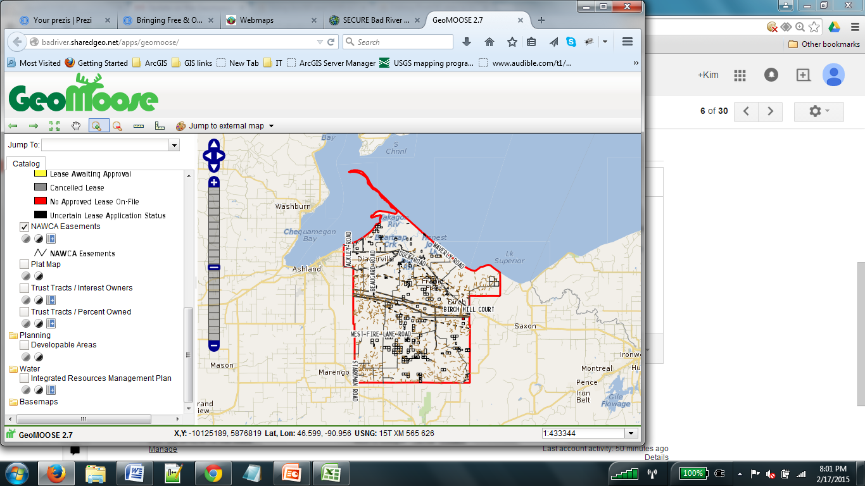
   * I developed a Web map application using the Google Maps API, Java servlet, and PostgreSQL database. See the video: <https://ksundeen.github.io/assets/videos/CycleRoutesIntro_small.mp4> and read the full project description: ***CycleRoutesApp_GoogleMapsJavaPostgreSQLReport.pdf***
   * I designed a workshop 2 times where I deployed ArcGIS Enterprise software using the free/opensource PostgreSQL database on an Azure hosted virtual environment. I used this Azure system for training both for my workshop, and to the MN GIS/LIS Board. They then decided to continue contracting with me to lead and help train others to use this environment. I used the Azure virtual lab environment to configure virtual machines for 10-25 students including the one for my web GIS system that used the Boundless PostgreSQL database.
     + See ***Exploring the Utility Network in ArcGIS Pro 2018 PRINT.pptx***
   * I designed a full process for researching, presenting, and then implementing a new mobile integration using Esri’s Workforce application. This also involved researching Esri’s Workflow Manager suite. This application is in production: ***FieldCollectionLifeCycleWorkflow.pptx***
   * I lead a GIS feasibility study where interviewed 13 users (mostly project managers and engineers) to identify clear project requirements and their perception of our current GIS web map. From the results, I defined a project plan for 2019: ***GISFeasibilityResults_ExecutiveSummary.pdf*** and (longer: ***GISFeasibilityStudy2019_Results.pdf***
   * I added new improvements and documented how Google Analytics tracks user interaction on the internal Lake Superior Consulting GIS applications. This uses a free resource that Google provides: ***Google Analytics Overview.pptx***
2. **Grant Writing and Budgeting:**
   * I researched, wrote, and was awarded a FEMA emergency management grant for the Tribe to help build a new mapping application and document management system to help address emergency response activities and identify vulnerable areas within the Bad River reservation.
     + ***FEMA_$127000 Grant Abstract.docx***
     + ***FEMA_$127000 Grant for Emergency Management LocalMitigationPlan_DRAFT.docx***
3. **Research & Development**
   * GIS Certificate research showing complicated modeling and my approach to solve a problem and present results to a larger audience: ***GIS_project_HgPrediction.pptx***
   * Crane and power line strike research: ***Summary_of_CraneCollisionResearchInWisconsin_DRAFT.pdf***
     + Full master’s thesis: ***ness-sundeen_ms_thesis.pdf***
4. **Documentation and Training Others**
   * City of Duluth Metadata Export tool using Python to Microsoft Word: ***Python-created__FieldListDefinitions_AllUtilities.pdf***
   * I trained other tribal employees on updating content in the Joomla Content Management System: ***Bad River Website Workshop.pptx***
   * Developed process for transferring data via python and uploading to our SQL server databases. ArcGIS for Collected mobile application was used: ***CollectorForArcGISGuide_MNPower.pdf***
   * I developed a process, training, and lead a workshop on using Azure virtual environments for the MN GIS/Land Information (MN GIS/LIS) Consortium: ***MNGISLIS_Azure_TrainingManual.pdf***
   * User guide for the online application for the City of Duluth that handles street closures: ***ViewerUserGuide_PublicStreetClosuresDetourMapper_Webmap.pdf***
   * User guide for the online web application that consumed a geoprocessing service that used python to write data back to the SQL database depending on user selections. ***ViewerUserGuide_StreetObstructionsDetourMapper_ArcGISOnline.pdf***