Project Design Phase
Solution Architecture

Date | 30-09-2026
Team ID | SWTID-2026-5703
Project Name | AI-Augmented Backend Development AI FitTrack API
Maximum Marks | 4 Marks

Solution Architecture:
Solution architecture is a complex process – with many sub-processes – that bridges the gap between business problems and technology solutions. Its goals are to:
- Find the best tech solution to solve existing business problems.
- Describe the structure, characteristics, behavior, and other aspects of the software to project stakeholders.
- Define features, development phases, and solution requirements.
- Provide specifications according to which the solution is defined, managed, and delivered.

Solution Architecture Diagram - AI FitTrack:

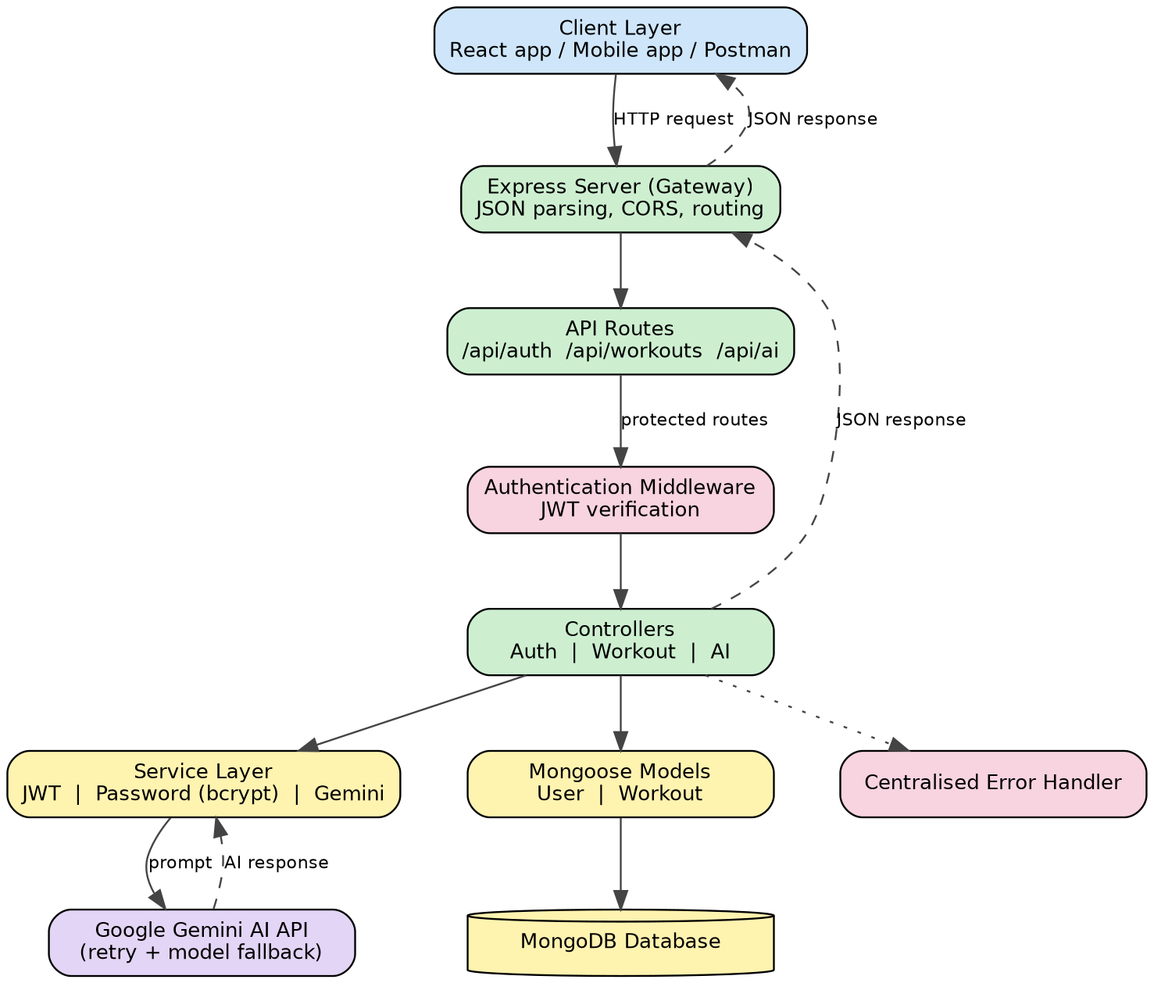
Figure 1: Architecture and data flow of the AI FitTrack backend API
Architecture flow:
- The client (React app, mobile app, Postman or Thunder Client) sends an HTTP request to the Express server.
- The server parses JSON, applies CORS and forwards the request to the matching route (/api/auth, /api/workouts or /api/ai).
- Protected routes pass through the authentication middleware, which verifies the JWT before the controller runs.
- Controllers run the business logic: they use Mongoose models to read and write MongoDB, and call the Gemini service for AI features.
- The Gemini service builds the prompt, calls Google Gemini (retrying and falling back to a secondary model if needed) and returns the response.
- The controller returns a structured JSON response; errors are handled centrally by the error handler middleware.

