PHASE 3 — PROJECT DESIGN
INTRODUCTION :
Team ID : SWTID-2026-5703
Project : AI FitTrack — AI-Powered Fitness Tracking Backend API
Team members :
NAME | MAIL ID
Suriya K | Ksuriyamsdgk@Gmail.Com
Subash I | Phycoodove@Gmail.Com
Sivanesh S | sivaneshselvaraj.2007@gmail.com
Selvaganapathi M | Selvaganapathicaptan@Gmail.Com
3.1 Purpose of Project Design
This phase defines how FitTrack AI is structured and how its components communicate, covering architecture, modules, database design, API flow and security.
3.2 System Architecture
FitTrack AI follows a layered MVC-oriented backend. The Express server routes each request, protected routes pass through JWT authentication middleware, controllers invoke business logic or the Gemini AI service, and Mongoose models connect to MongoDB. A structured JSON response is returned to the client.
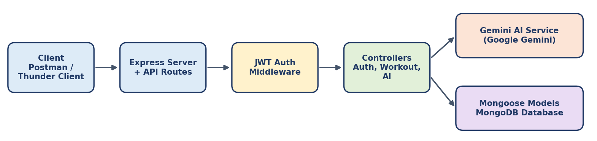
Figure 3.1 — FitTrack AI system architecture and request flow
3.3 MVC Architecture Pattern
Layer | Responsibility
Model | Mongoose schemas (User, Workout); data validation and database interaction.
View / Client | Postman, Thunder Client, React or mobile app that sends requests and receives JSON responses.
Controller | Receives requests, validates input and coordinates authentication, workout and AI operations.
Service | Reusable logic: Gemini AI service (prompts, retry / fallback), JWT and password handling.
Database | MongoDB stores the Users and Workouts collections.
3.4 Module Design
Module | Main Function
Authentication | Register, login and profile retrieval with JWT tokens; bcrypt password hashing.
Workout Management | Add, get all, get by ID, update, delete and search workouts (owned by the user).
AI Module | Workout recommendation and fitness insights through Google Gemini.
Middleware | JWT verification (auth.js) and centralized error handling (errorHandler.js).
3.5 Database Design
Collection | Fields
User | _id, name, email (unique), password (hashed), createdAt, updatedAt
Workout | _id, user (ref User), workoutName, category, duration, caloriesBurned, workoutDate, createdAt, updatedAt
Relationship: one User has many Workouts; every workout belongs to exactly one authenticated user.

