PHASE 5 — PROJECT DEVELOPMENT
INTRODUCTION :
Team ID : SWTID-2026-5703
Project : AI FitTrack — AI-Powered Fitness Tracking Backend API
Team members :
NAME | MAIL ID
Suriya K | Ksuriyamsdgk@Gmail.Com
Subash I | Phycoodove@Gmail.Com
Sivanesh S | sivaneshselvaraj.2007@gmail.com
Selvaganapathi M | Selvaganapathicaptan@Gmail.Com
Development Procedure
- Create the AI-FitTrack-API project folder and the src folder; initialize with npm init -y.
- Install express, mongoose, dotenv, bcryptjs, jsonwebtoken, cors and @google/genai; install nodemon as a dev dependency.
- Configure environment variables (PORT, MONGO_URI, JWT_SECRET, GEMINI_API_KEY) and the MongoDB connection in config/db.js.
- Implement server.js, app.js, authentication middleware and error-handling middleware.
- Implement the User and Workout Mongoose schemas, controllers, the Gemini service and the routes.
- Run the server with npm start and verify every API endpoint.
Implemented API Functions
Method | Endpoint | Function
POST | /api/auth/register | Register a new user
POST | /api/auth/login | Authenticate a user and return a JWT token
GET | /api/auth/profile | Get the logged-in user’s profile (protected)
POST | /api/workouts | Add a workout (protected)
GET | /api/workouts | Get all workouts; GET /api/workouts/:id gets one workout
PUT / DELETE | /api/workouts/:id | Update or delete a workout
POST | /api/ai/workout-recommendation | AI-generated personalized workout plan
POST | /api/ai/fitness-insights | AI-generated fitness insights from statistics
Development Evidence
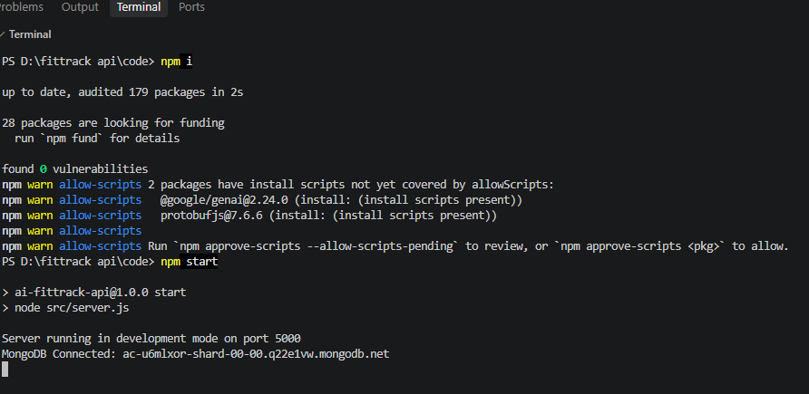
Server start-up — npm i, npm start: server running on port 5000 and MongoDB Connected

