PHASE 6 — PROJECT TESTING
INTRODUCTION :
Team ID : SWTID-2026-5703
Project : AI FitTrack — AI-Powered Fitness Tracking Backend API
Team members :
NAME | MAIL ID
Suriya K | Ksuriyamsdgk@Gmail.Com
Subash I | Phycoodove@Gmail.Com
Sivanesh S | sivaneshselvaraj.2007@gmail.com
Selvaganapathi M | Selvaganapathicaptan@Gmail.Com
API Test Cases
Test | Endpoint | Observed Result | Status
Registration | POST /api/auth/register | 201 Created — user registered, token returned | PASS
Login | POST /api/auth/login | 200 OK — login successful; JWT token returned | PASS
Get Profile | GET /api/auth/profile | 200 OK — returns id, name, email | PASS
Invalid Token | GET /api/auth/profile (no token) | 401 Unauthorized — request rejected by middleware | PASS
Add Workout | POST /api/workouts | 201 Created — saved workout returned | PASS
Get All Workouts | GET /api/workouts | 200 OK — count and data array returned | PASS
Get Workout by ID | GET /api/workouts/:id | 200 OK — single workout returned | PASS
Update Workout | PUT /api/workouts/:id | 200 OK — updated workout returned | PASS
Delete Workout | DELETE /api/workouts/:id | 200 OK — workout removed successfully | PASS
AI Recommendation | POST /api/ai/workout-recommendation | 200 OK — personalized workout plan returned | PASS
AI Fitness Insights | POST /api/ai/fitness-insights | 200 OK — personalized fitness insight returned | PASS
Note: during AI testing the primary Gemini model returned a temporary 503 high-demand response; the service retried and automatically fell back to a secondary model, and both AI requests completed successfully.
Testing Screenshots
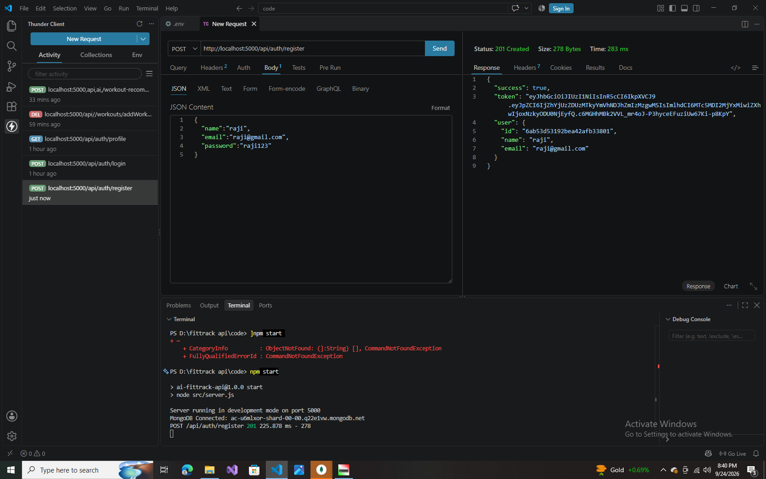
Fig 6.1 — Register: POST /api/auth/register (201 Created)
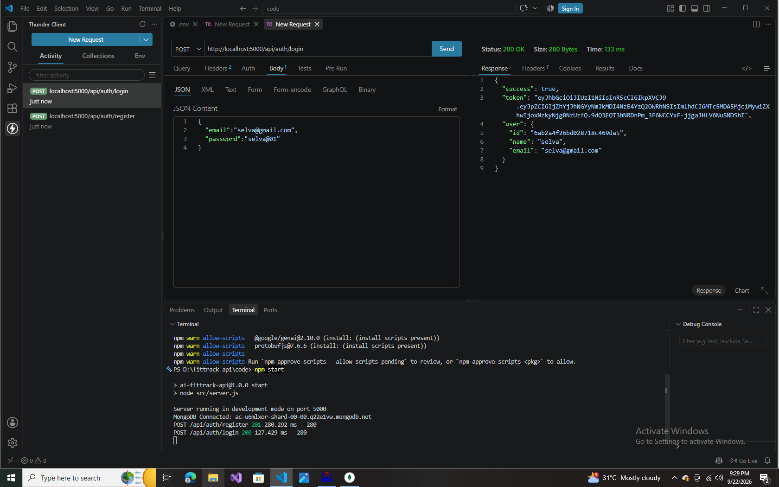
Fig 6.2 — Login: POST /api/auth/login (200 OK)
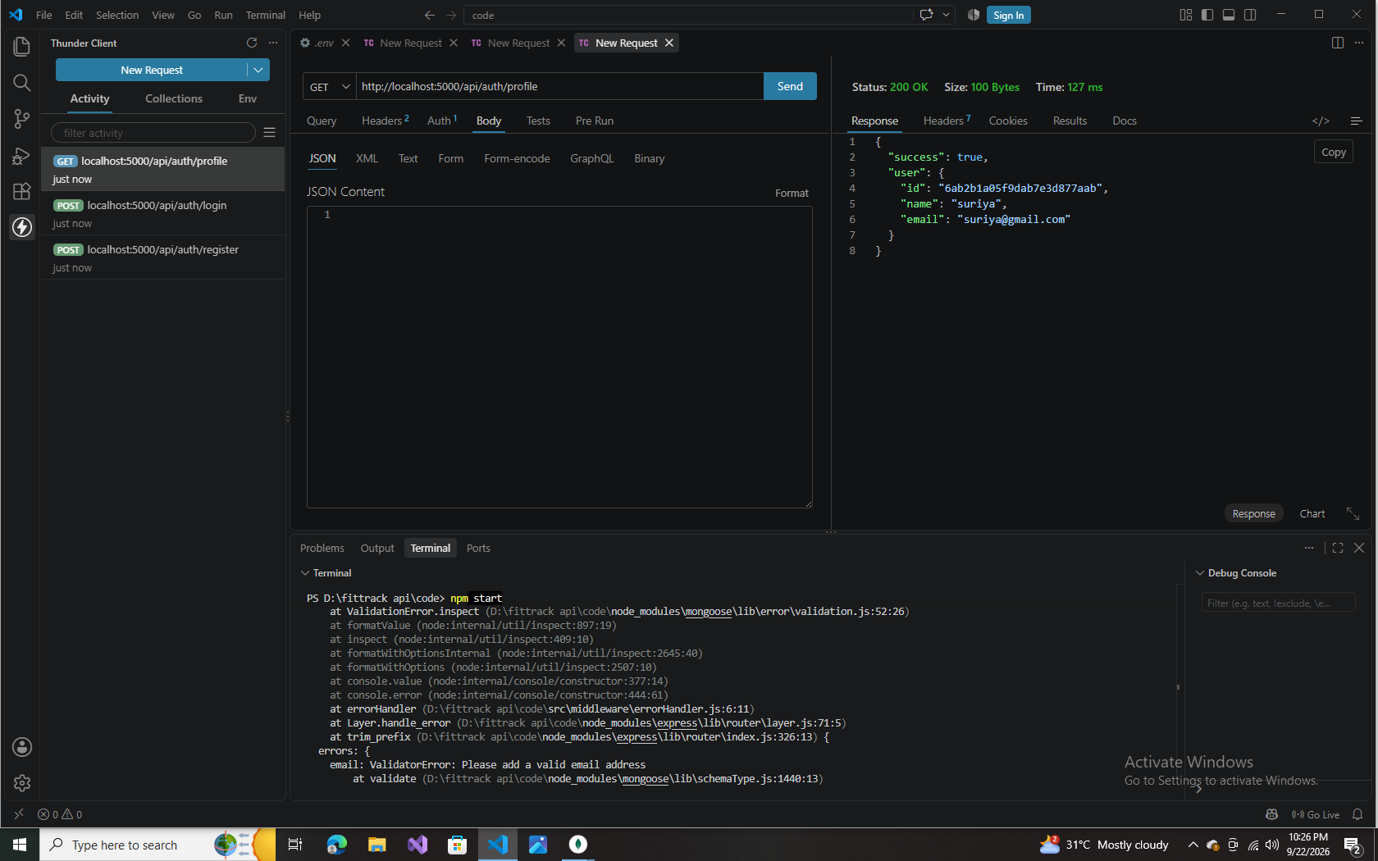
Fig 6.3 — Profile: GET /api/auth/profile (200 OK)
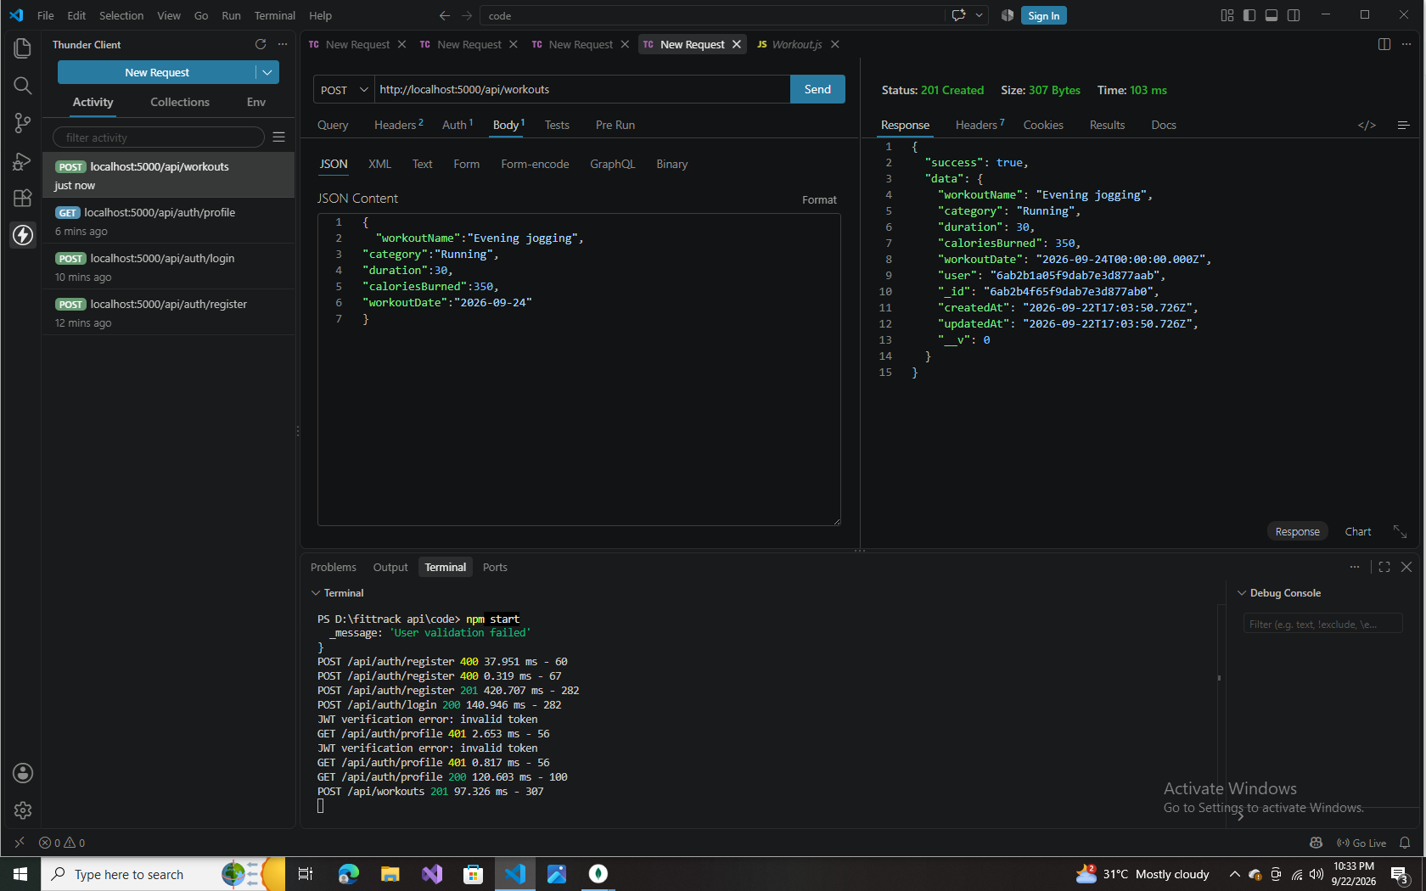
Fig 6.4 — Add Workout: POST /api/workouts (201 Created)
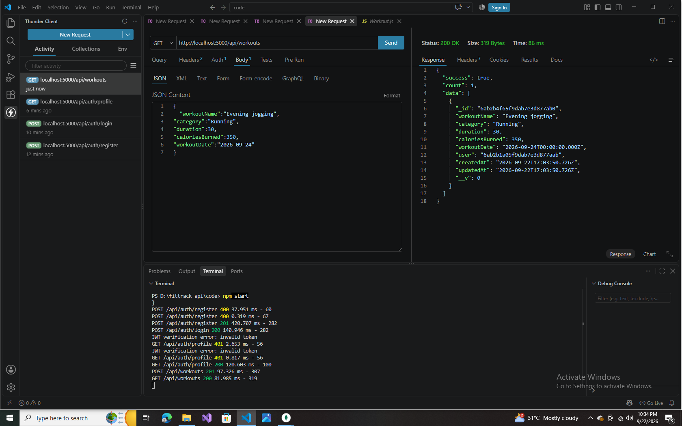
Fig 6.5 — Get All Workouts: GET /api/workouts (200 OK)
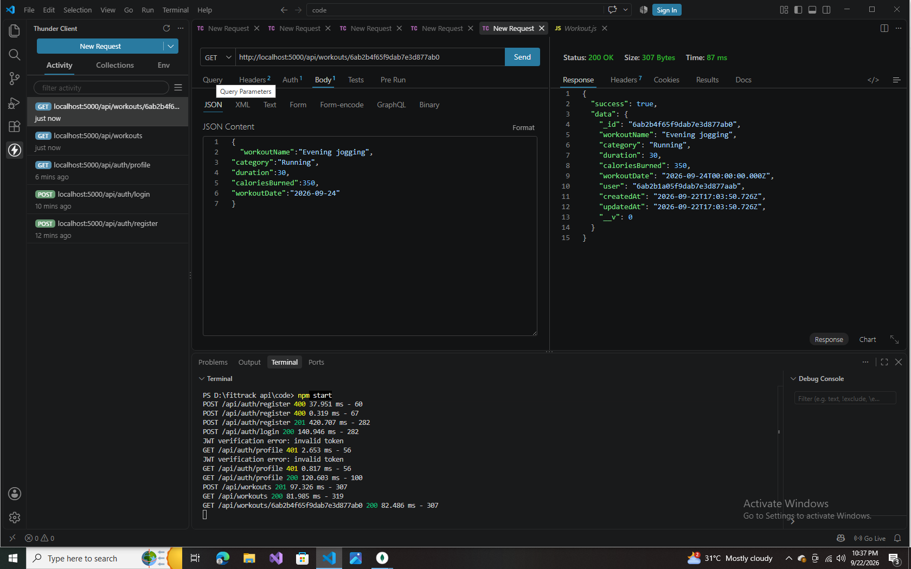
Fig 6.6 — Get Workout by ID: GET /api/workouts/:id (200 OK)
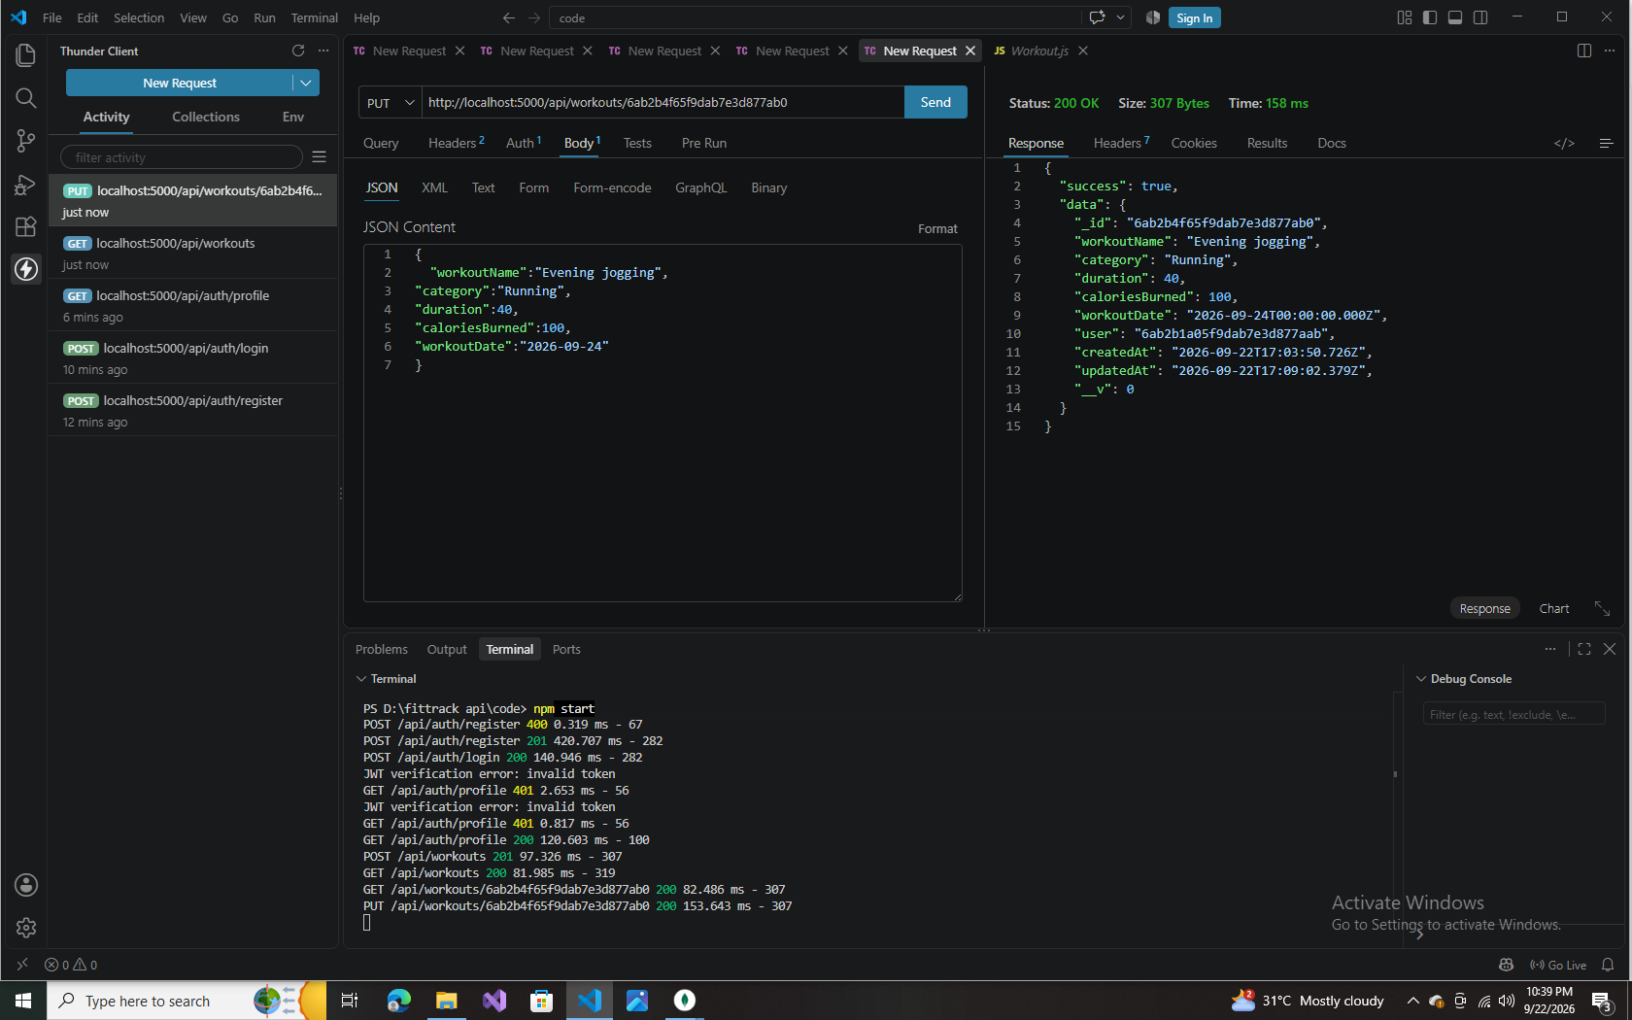
Fig 6.7 — Update Workout: PUT /api/workouts/:id (200 OK)
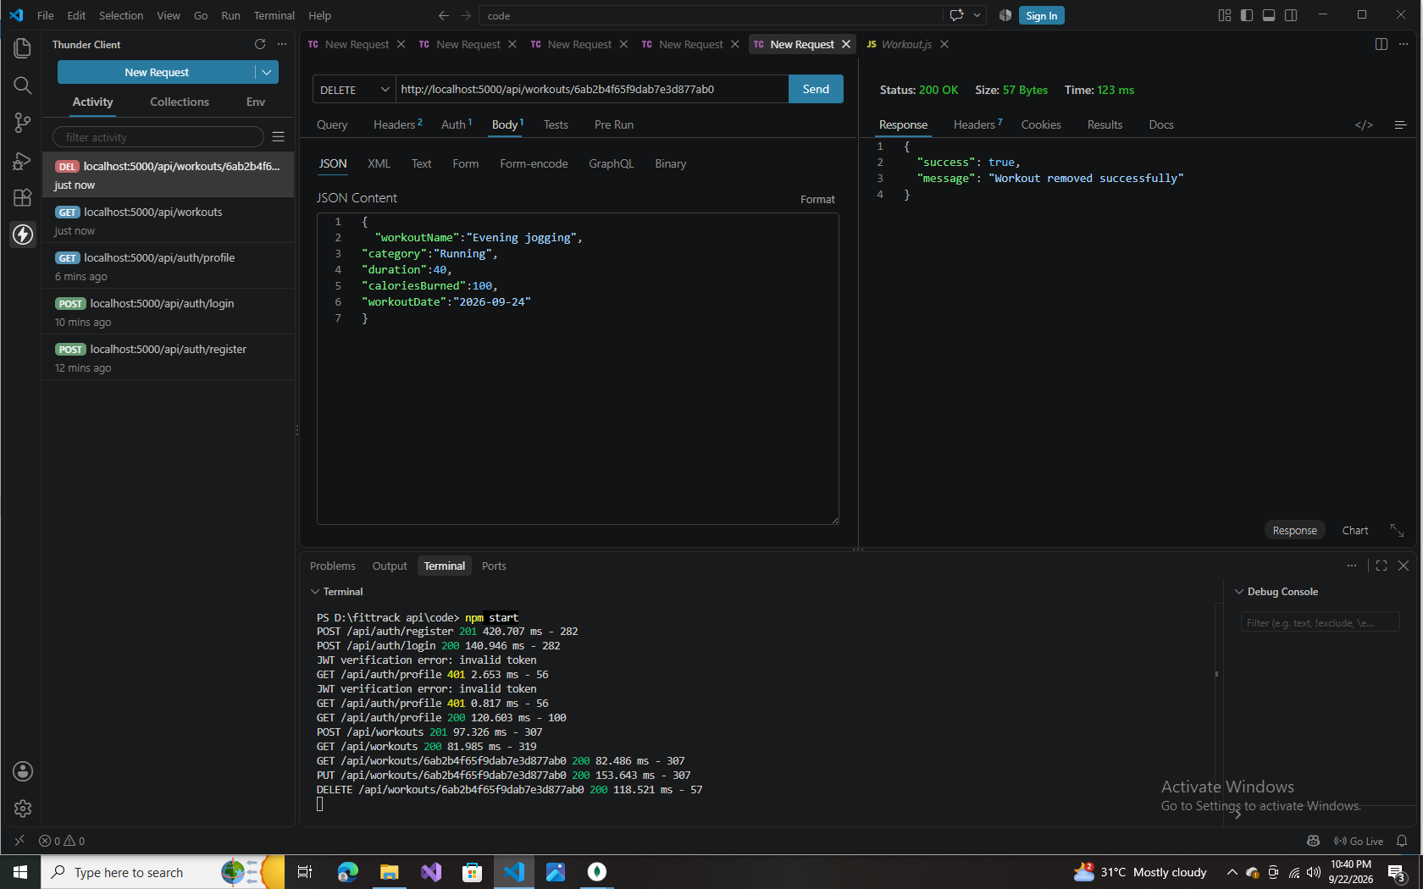
Fig 6.8 — Delete Workout: DELETE /api/workouts/:id (200 OK)
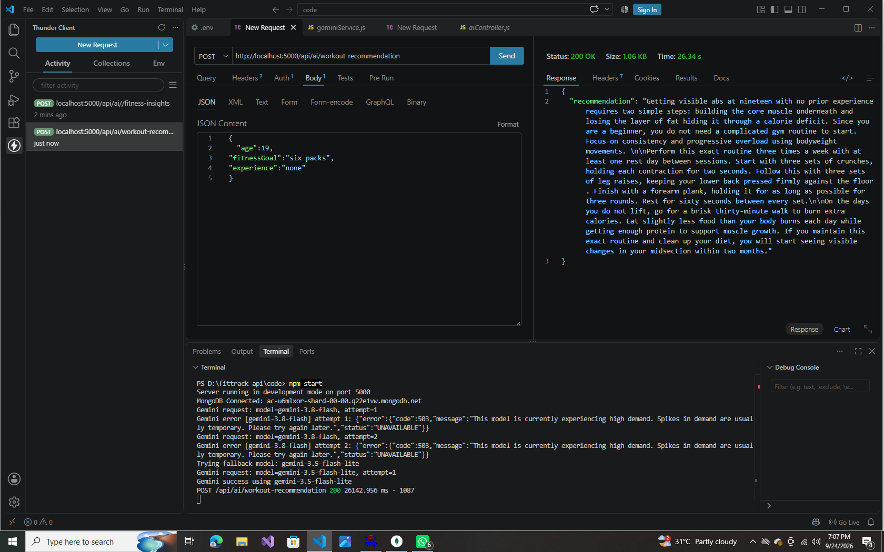
Fig 6.9 — AI Recommendation: POST /api/ai/workout-recommendation (200 OK)
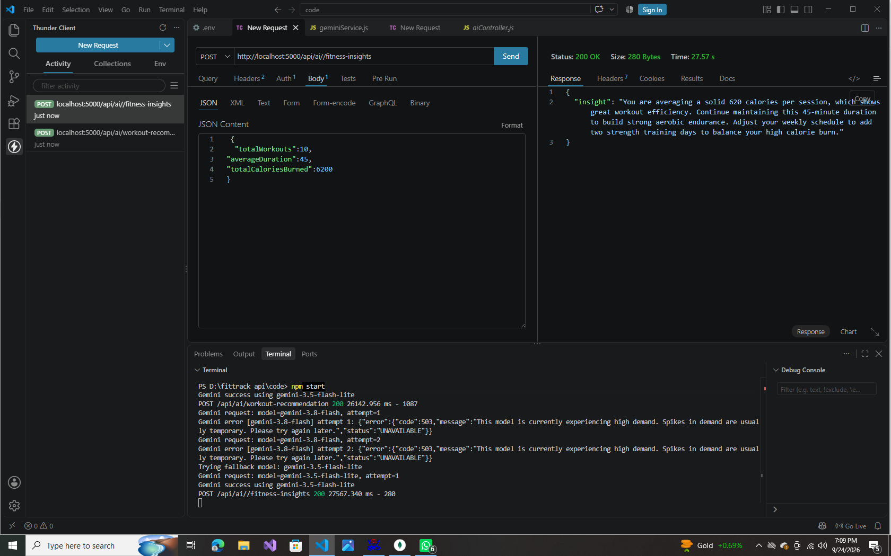
Fig 6.10 — AI Fitness Insights: POST /api/ai/fitness-insights (200 OK)
Testing order: Authentication APIs → Workout APIs → AI APIs.

