How to run cucumber test cases on Jenkins – as follows

1st . Download Maven (Binary) and add the path to the “Global tool config” on jenkins

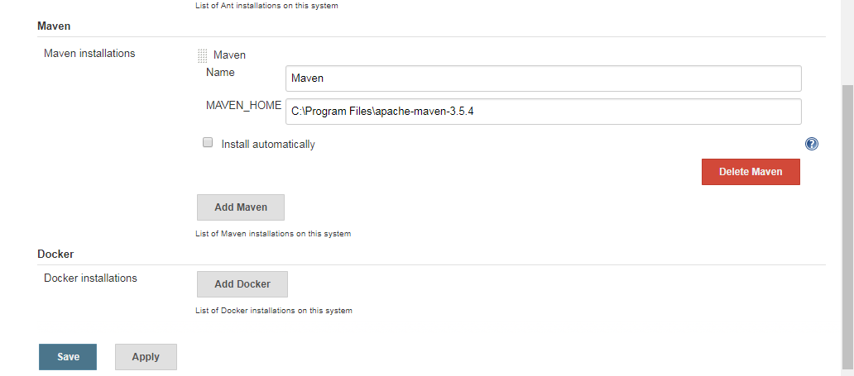

2nd . Import the maven cucumber project.

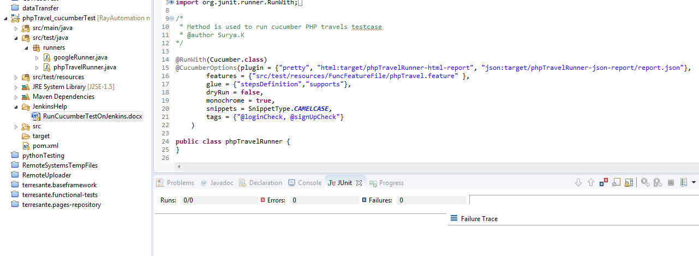

3rd. Jenkins configuration for cucumber:

* Install plugin “Cucumber reports” for report generation on Jenkins.

4th. For Successful report generation, Absolute path has to be fine.

Here, C:\Eclipse_Files\Jenkins\phpTravel_cucumberTest\target\phpTravelRunner-json-report

Custom workspace/Json reports path

5th. For Custom workspace:

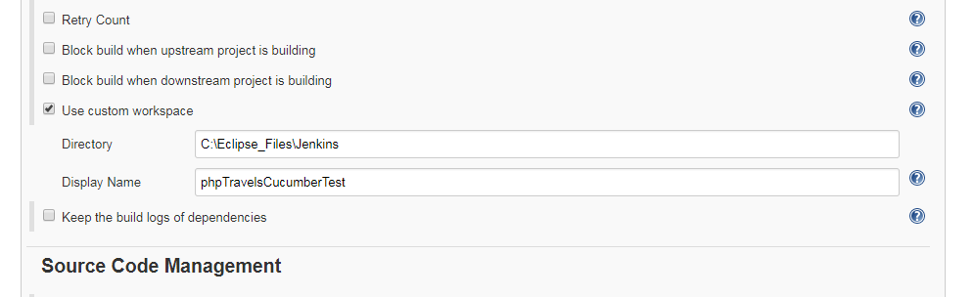

6th. If git used, install “git bash”

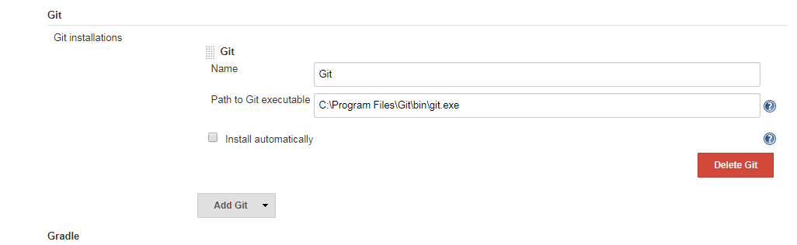

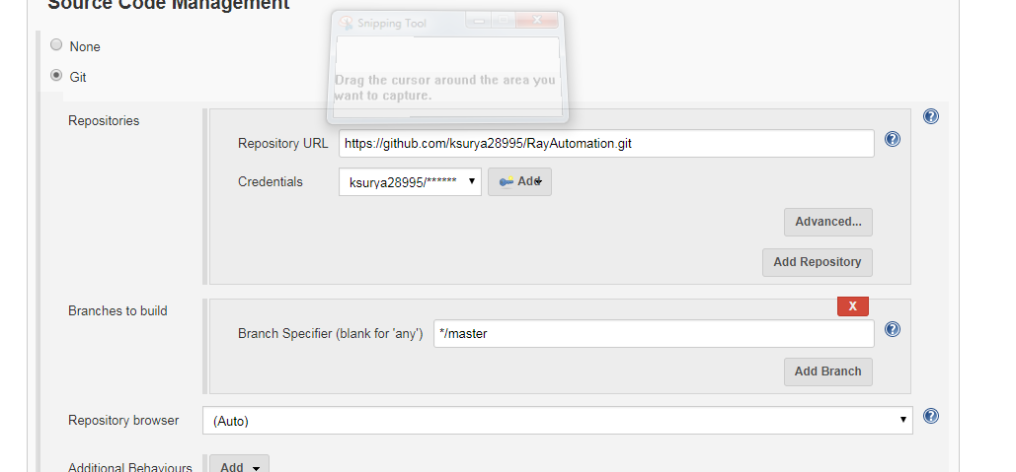

7th. **Build config:**

**“Clean install”** will get the test case list from pom file and runs.

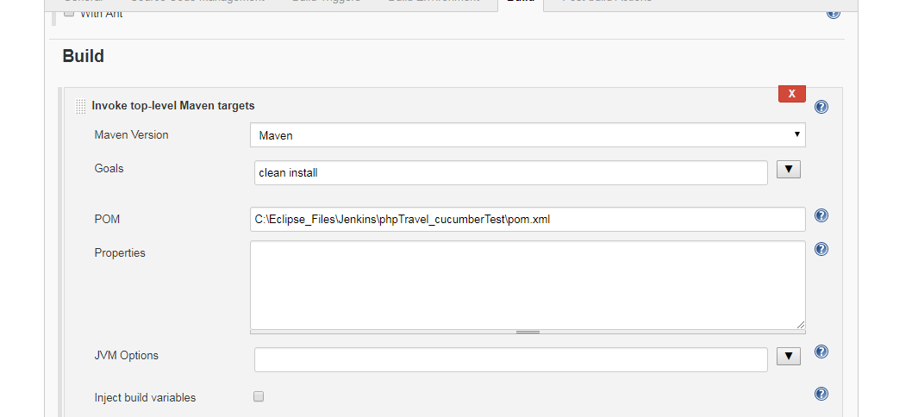

**8th. ucumber report generation config:**

**“**target**”** folder similar to build. This creates report.json file from which Cucumber report file is generated.

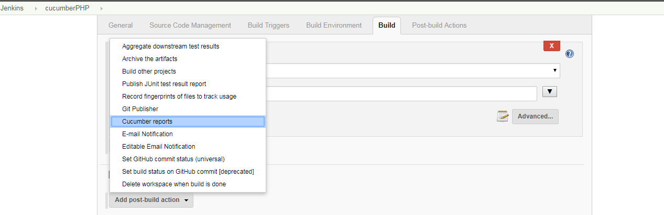

----------------------------------------------------------------------------------------------------------------------------------------

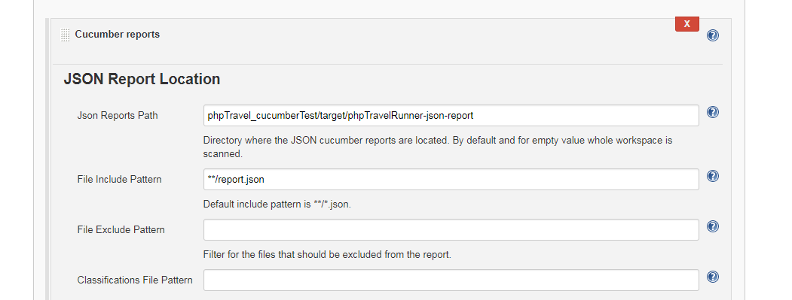

Some samples pics:





