**CMSC 204**

**Assignment 1 Document**

Submitted by: Kabindra Raj Suwal

**Pseudocode:**

* Method isValidPassword
  1. Check if there are minimum 6 characters in the password. Throw LengthException if the condition is not satisfied.
  2. Check if the password contains any uppercase alphabets using a Boolean method named hasUppercase. Throw NoUpperAlphaException if the condition is not satisfied.
  3. Check if the password contains any lowercase alphabets using a Boolean method named hasLowercase. Throw NoLowerAlphaException if the condition is not satisfied.
  4. Check if the password contains any numbers by using regular expression. Throw NoDigitException if the condition is not satisfied.
  5. Check if the password contains any special character by using regular expression. Throw NoSpecialCharacterException if the condition is not satisfied.
  6. Check if there is any character repeated more than twice in a sequence. Use for loop to compare adjacent characters and determine if they are the same. Throw InvalidSequenceException if the condition is satisfied.
  7. If no exceptions are thrown, return true to determine the password is valid.
* Method isWeakPassword
  1. Check if there are less than 10 characters in the password.
  2. Return true if the condition is satisfied.
* Method getInvalidPassword
  1. Check all passwords inputted from the array.
  2. Return the array of passwords that threw an exception.

**Learning Experience:**

This assignment was very fun to do. This assignment refreshed the topic I learned in CMSC 203 like inheritance, junit tests and exceptions. In my previous CMSC classes we were not required to submit the Javadoc but since this assignment required us to submit the Javadoc as well, I learned how to make Javadoc too.

The main problem I faced was the junit tests. My tests were failing again and again. I learned how to analyze the mistakes from junit tests and correct it. My mistake was the exception messages that I had typed did not match which was resulting my junit to fail. I also learned to make exceptions as per the need.

All in all, this assignment helped me refresh the previous concepts and also allowed me to learn various new things.

**Test Table:**

|  |  |  |  |  |  |
| --- | --- | --- | --- | --- | --- |
| **#** | **Input** | **Actual Input** | **Expected Output** | **Actual Output** | **Result** |
| 1 | Password | Password | NoDigitException  NoSpecialCharacterException | NoDigitException | pass |
| 2 | open | open | LengthException  NoUpperAlphaException  NoDigitException  NoSpecialCharacterException | LengthException | pass |
| 3 | P@ssw0rd | P@ssw0rd | Valid but weak | Valid but weak | pass |

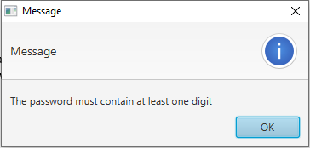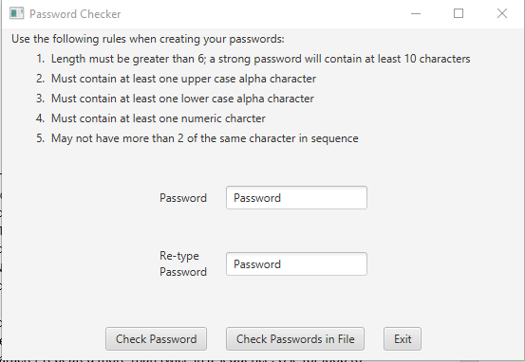**Test Case 1 Screenshot:**

**Test Case 2 Screenshot:**

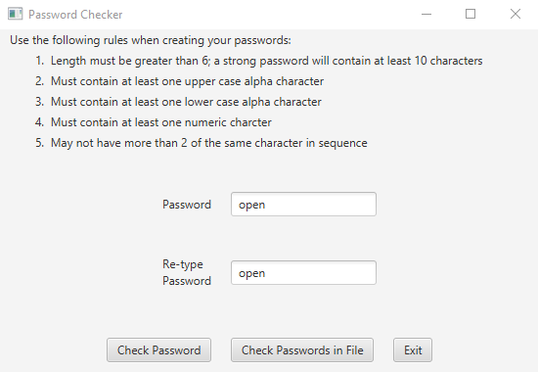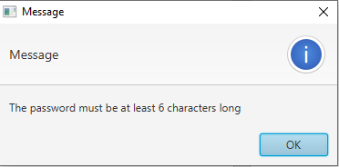

**Test Case 3 Screenshot:**

