ISAD251 Application Factsheet

* **The** **Application**

This application is a minimum function application to allow users to order Tea shop product from website. Customer can View and cancel their orders and view all order histories. As an admin user, to view all order history and all products, also can add new products and Edit, Delete the Products that sold in the Tea shop.

* **The features of the applications**
  + Customer could see order history and cancel order when Customer think they want to cancel the order before the order is delivered.
  + After customer make an order, they can see the order ID, for searching the ID when they want to cancel order. It uses Redirect action to the Detail page of new order.
  + Admin can add the new products they sell
  + Simple View, easy to start using the web page.
  + Admin can modify or delete the products.
* **How It Works**

To Access as an admin, type ~ **/AdminHome** in address bar, then you can enter to the adminhome. All Admin control staff is in Adminhome.

* **BrowserTest**

My default Browser is Google Chrome The Screenshot folder has all screenshots by Google chrome, so I will put the screenshot by using Microsoft Edge.

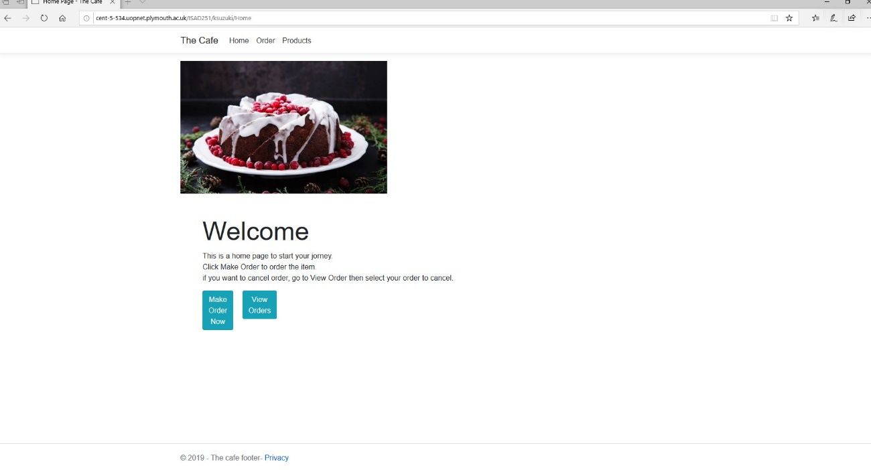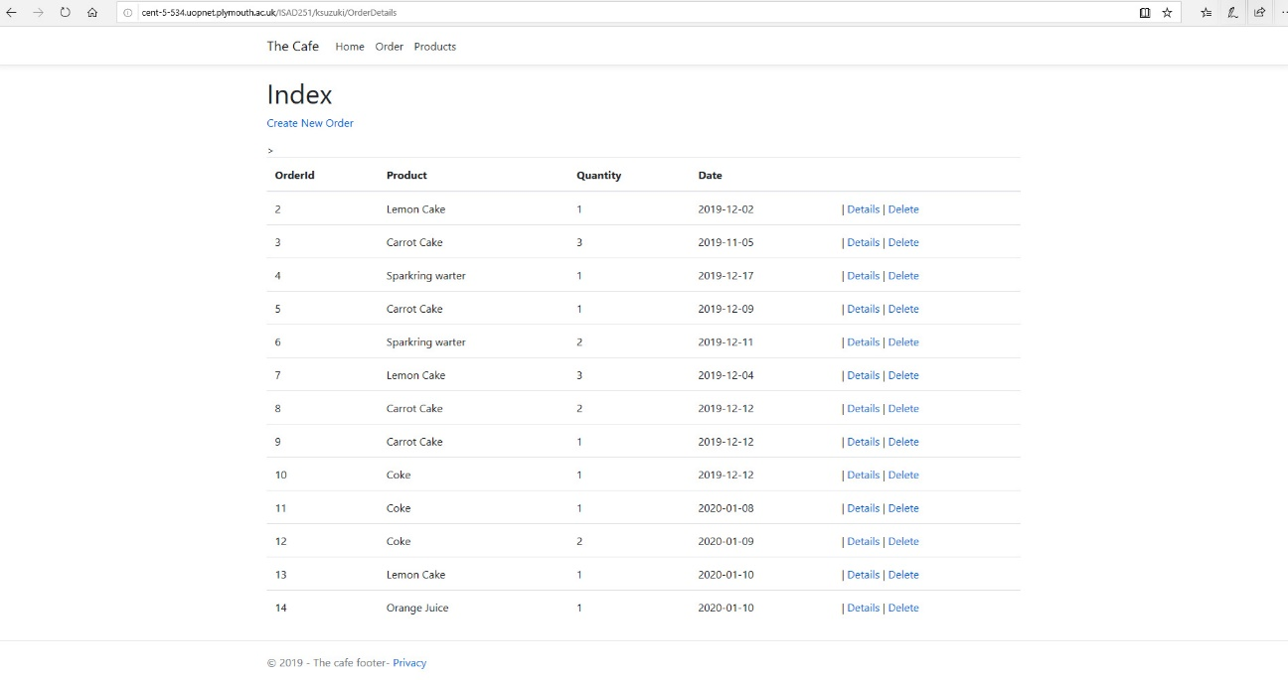

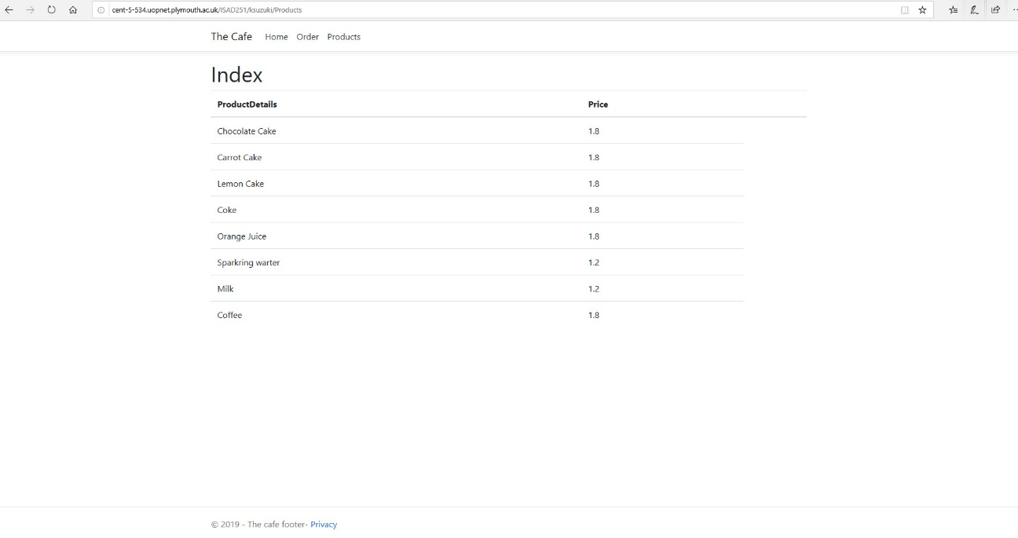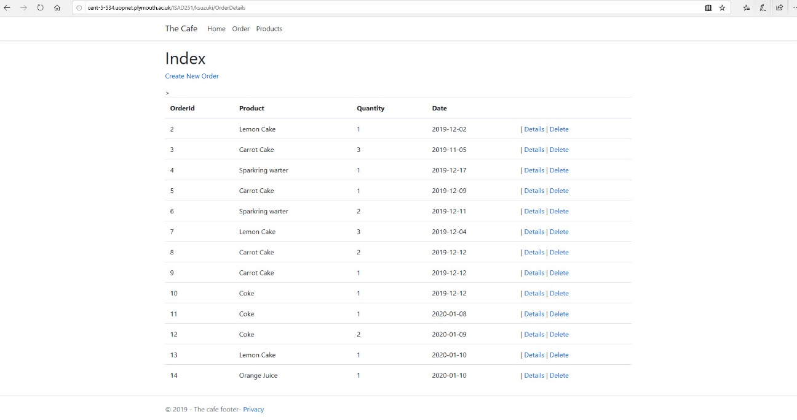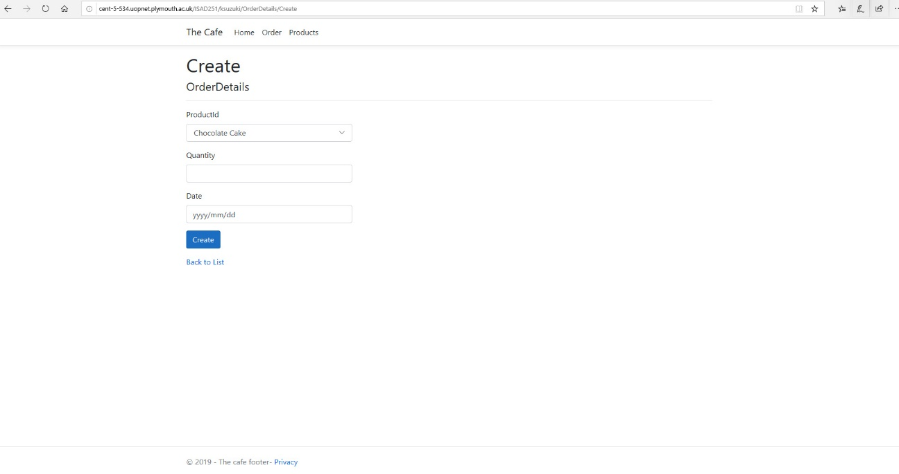^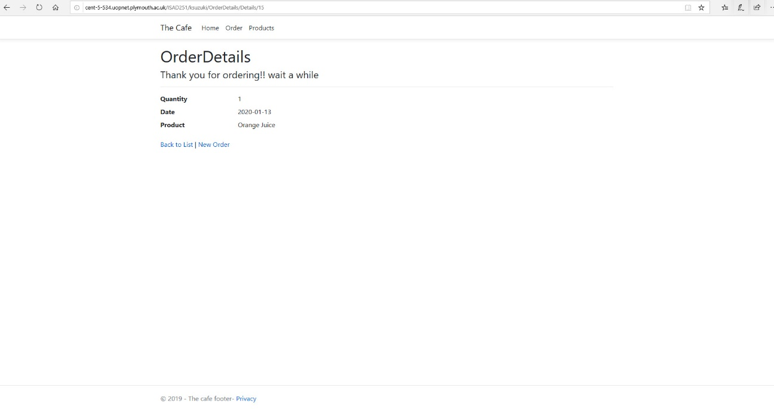Seems all the function and pages work in microsoft Edge aswell.