“Pipeexec: Running Multiple Linux Commands Concurrently Using Pipes”
A Project Report Submitted in the partial fulfillment of the requirements for the award of the degree of

BACHELOR OF TECHNOLOGY
In

DEPARTMENT OF COMPUTER SCIENCE ENGINEERING

By

M. NIHARIKA 2520090021

K. VANSIKA 2520090239

K. NEHA 2520090240

Under the Esteemed Guidance of

Dr. K. Anusha
Assistant Professor
Department of Computer Science and Engineering




K L (Deemed to be) University DEPARTMENT OF COMPUTER SCIENCE ENGINEERING
&

DEPARTMENT OF COMPUTER SCIENCE AND INFORMATION TECHNOLOGY

Declaration

The Project Report entitled “Pipeexec: Running Multiple Linux Commands Concurrently Using Pipes” is a record of Bonafide work of M. NIHARIKA - 2520090021, K. VANSIKA - 2520090239, K. NEHA - 2520090240 submitted in
partial fulfillment for the award of B. Tech in Computer Science and Engineering (or) Computer Science and Information Technology to the K L University. The results embodied in this report have not been copied from any other departments/University/Institute.

M. NIHARIKA 2520090021

K. VANSIKA 2520090239

K. NEHA 2520090240

K L (Deemed to be) University

DEPARTMENT OF COMPUTER SCIENCE ENGINEERING

CERTIFICATE

This is to certify that the mini project based report entitled “Pipeexec: Running Multiple Linux Commands Concurrently Using Pipes” is a bonafide work done and submitted by M. NIHARIKA (2520090021), K. VANSIKA (2520090239) and K. NEHA (2520090240),
in partial fulfillment of the requirements for the award of the degree of BACHELOR OF TECHNOLOGY in Department of Computer Science Engineering, K L (Deemed to be University), during the academic year 2025-2026.

Signature of the Guide

Signature of the Course Coordinator Signature of the HOD

ACKNOWLEDGEMENT
The success in this project would not have been possible but for the timely help and guidance rendered by many people. Our wish to express my sincere thanks to all those who has assisted us in one way or the other for the completion of my project.

Our greatest appreciation to my Course Coordinator Dr. K. Anusha, and my guide Dr. K. Anusha, Department of Computer Science which cannot be expressed in words for his/her tremendous support, encouragement and guidance for this project.

We express our gratitude to Dr. P Venkateshwara Roa (CSE), Head of the Department for Computer Science Engineering for providing us with adequate facilities, ways and means by which we are able to complete this project-based Lab.

We thank all the members of teaching and non-teaching staff members, and also who have assisted me directly or indirectly for successful completion of this project. Finally, I sincerely thank my parents, friends and classmates for their kind help and cooperation during my work.

M. NIHARIKA 2520090021

K. VANSIKA 2520090239

K. NEHA 2520090240
Abstract

Modern operating systems run many programs at the same time, and the Unix tradition builds complex tasks by connecting small programs through pipes. Beginners, however, usually meet this idea only through the shell’s “|” symbol and never see the machinery behind it. Running commands one after another also wastes time, because the processor idles while commands wait for input/output or timers. This project, pipeexec, addresses both issues with a C program for Ubuntu that runs multiple Linux commands concurrently and moves data between them using pipes.

pipeexec offers two modes. In pipeline mode (cmd1 | cmd2 | cmd3 …) every stage is started at the same time and the standard output of stage i is connected to the standard input of stage i+1 using pipe(), fork(), dup2() and execvp(). In parallel mode independent commands run simultaneously; each child writes to its own pipe, and the parent process multiplexes all pipes with poll(), assembles complete lines and prints them with a [n] prefix so that outputs never mix. In both modes the parent collects every child with waitpid() and reports its exit status or terminating signal. A built-in demo mode runs ready-made examples.

The program compiles with gcc -Wall -Wextra without warnings and was tested on Ubuntu with eight test cases, including a SIGPIPE case, a missing-command case and a stress test that moved 200,000 lines through pipes without loss. Four commands that each sleep for one second completed in about 1.0 second instead of 4.0 seconds, and a three-stage pipeline over one million numbers produced the same result as the native shell pipeline. The project gives a compact, working demonstration of process creation, inter-process communication, I/O multiplexing and process synchronisation in Linux.

Index

S. No. | Chapter | Topics / Subtopics | Page No.
 | Acknowledgement |  | i
 | Abstract |  | ii
1 | Introduction |  | 8–10
 |  | 1.1 Background of the Project
 |  | 1.2 Problem Statement
 |  | 1.3 Scope of the Project
 |  | 1.4 Objectives of the Project
 |  | 1.5 Importance of the Application
 |  | 1.6 Target Users / Audience
2 | OS Concepts and Background Study |  | 11–14
 |  | 2.1 Operating System Concepts Related to the Project
 |  | 2.2 Existing Methods / Algorithms
 |  | 2.3 Proposed Approach
 |  | 2.4 Advantages of the Proposed Approach
3 | System Requirements |  | 15–16
 |  | 3.1 Hardware Requirements
 |  | 3.2 Software Requirements
 |  | 3.3 Operating System Environment – Ubuntu / WSL
 |  | 3.4 Development Tools and Compilers
4 | Technology and Tools Used |  | 17–19
 |  | 4.1 C / C++ Programming
 |  | 4.2 GCC Compiler
 |  | 4.3 Linux System Calls
 |  | 4.4 POSIX Threads / Synchronization
 |  | 4.5 Linux Commands and Utilities
 |  | 4.6 Other Tools / Libraries Used
5 | System Architecture and Design |  | 20–24
 |  | 5.1 Overall System Architecture
 |  | 5.2 System Workflow
 |  | 5.3 Flowchart / Data Flow
 |  | 5.4 Module Description
 |  | 5.5 Input and Output Design
6 | Implementation |  | 25–34
 |  | 6.1 Module-wise Implementation
 |  | 6.2 Algorithm / Pseudocode
 |  | 6.3 Core C / C++ Implementation
 |  | 6.4 Linux System Calls / APIs Used
 |  | 6.5 Process / Thread Implementation
 |  | 6.6 IPC / Synchronization Implementation
 |  | 6.7 Memory Management Implementation
 |  | 6.8 Optional User Interface Implementation
7 | Execution and Demonstration |  | 35–38
 |  | 7.1 Compilation in Ubuntu
 |  | 7.2 Execution Commands
 |  | 7.3 Sample Inputs and Outputs
 |  | 7.4 Screenshots of Execution
 |  | 7.5 Demonstration of OS Concepts
8 | Conclusion |  | 39–41
 |  | 8.1 Summary of the Project
 |  | 8.2 Objectives Achieved
 |  | 8.3 Results Achieved
 |  | 8.4 Skills and Learning Outcomes
9 | References |  | 42
 |  | 9.1 Books
 |  | 9.2 Research Papers
 |  | 9.3 Linux / GNU Documentation
 |  | 9.4 Online Resources

CHAPTER 1
INTRODUCTION

1.1 Background of the Project
A modern operating system is expected to run many activities at the same time. Each running program is a process, and the kernel shares the processor between processes so quickly that they appear to run together. Unix and Linux were designed around the idea that a large task should be solved by combining many small programs, each doing one job well, and that the output of one program should be able to flow directly into the input of the next. The mechanism that makes this possible is the pipe.
When a user types a command such as ls -l /etc | grep conf | wc -l in a shell, the shell creates three processes at once, connects them with two pipes and waits for them to finish. All three programs run concurrently: grep starts filtering as soon as ls produces its first line, and the kernel blocks or wakes each process depending on whether its pipe is empty or full. Most users never see how this works because the shell hides the details.
This project, pipeexec, re-creates that machinery in a small C program for Ubuntu. It launches several Linux commands at the same time and moves data between them using pipes. It supports two modes: a pipeline mode, in which the standard output of every stage is connected to the standard input of the next stage, and a parallel mode, in which independent commands run together while the parent process collects their output through one pipe per child and prints it line by line with a [n] prefix. The program uses the core Linux system calls pipe(), fork(), dup2(), execvp(), poll() and waitpid(), which makes it a compact and practical demonstration of process creation, inter-process communication (IPC) and synchronisation.

1.2 Problem Statement
Running several commands one after another wastes time, because the processor sits idle while a command waits for disk, network or a timer. Connecting commands by writing the output of one into a temporary file and reading it back in the next is slow and clutters the disk. Using the shell’s | operator solves both problems but treats the mechanism as a black box. Students of Operating Systems therefore need a transparent, working program that shows how concurrent processes are created, wired together and supervised.
The problem addressed by this project is: to design and implement a C program for Linux that runs multiple commands concurrently, transfers data between them through pipes without temporary files, collects the output of independent commands safely, and reports how every process terminated.

1.3 Scope of the Project
The scope of pipeexec is deliberately limited to the operating-system concepts it demonstrates.
In scope | Out of scope
Linux / POSIX user-space program written in C | Native Windows support (WSL is supported)
Pipeline mode: cmd1 | cmd2 | … | cmdN, all stages concurrent | Full shell syntax: quotes, redirection (>, <), globbing (*), variables, &&, ;
Parallel mode: independent commands with merged, prefixed output | Job control, background jobs, signal forwarding to children
Up to 32 commands per run and 63 arguments per command | Network communication, sockets or shared memory
Built-in demo mode with sample pipelines | Graphical user interface
Exit-status and signal reporting for every child process | “pipefail” style exit-code semantics
Table 1.1: Scope of the project

1.4 Objectives of the Project
- To understand and demonstrate process creation with fork() and program loading with execvp().
- To implement a multi-stage pipeline in which the standard output of stage i feeds the standard input of stage i+1 through kernel pipes.
- To run independent commands truly concurrently and gather their output without mixing lines from different commands.
- To use dup2() for redirecting standard streams, and to close every unused file descriptor so that end-of-file is delivered correctly.
- To multiplex several pipes in a single process using poll() instead of blocking on one child at a time.
- To collect every child with waitpid(), avoid zombie processes and report exit status or terminating signal.
- To compile and run the program on Ubuntu, verify its behaviour with real commands and measure the benefit of concurrency.

1.5 Importance of the Application
The fork–pipe–dup2–exec sequence implemented here is the heart of every Unix shell, build tool and process supervisor. Understanding it removes much of the mystery from topics such as file-descriptor inheritance, blocking I/O, EOF detection and zombie processes. The program also has a direct practical value: when independent commands are launched together, the total running time approaches that of the slowest command rather than the sum of all commands. In the tests reported in Chapter 7, four commands that each sleep for one second finished in about 1.0 second instead of 4.0 seconds.

1.6 Target Users / Audience
- Operating Systems students who need a worked example of processes, pipes and I/O multiplexing.
- Instructors and lab evaluators looking for a small, readable program that exercises the most important POSIX process APIs.
- Developers and system administrators who want a lightweight tool to run several commands at once and see their output labelled by command.
- Beginners in Linux system programming who want a stepping stone towards writing their own shell.

CHAPTER 2
OS CONCEPTS AND BACKGROUND STUDY

2.1 Operating System Concepts Related to the Project

Processes and process creation
A process is a running instance of a program together with its address space, open files and kernel bookkeeping (the process control block). Linux creates a new process with fork(), which duplicates the calling process. The kernel uses copy-on-write, so the copy is cheap: memory pages are shared until one of the processes modifies them. fork() returns the child’s process ID (PID) in the parent and 0 in the child, which lets one program body behave differently in each. pipeexec creates one child per command.

Loading a new program: the exec family
A freshly forked child is still a copy of the parent. The exec family replaces the child’s address space with a new program. execvp() searches the directories listed in PATH, so the user may write ls instead of /usr/bin/ls. If execvp() succeeds it never returns; if it fails (for example the command does not exist) the child reports the error and terminates with status 127, the conventional “command not found” code.

File descriptors and redirection
Every process owns a table of small integers, the file descriptors. By convention descriptor 0 is standard input, 1 is standard output and 2 is standard error. Descriptors are inherited across fork() and survive exec. The call dup2(old, new) makes descriptor new refer to the same open file description as old. Redirection in a shell is nothing more than a dup2() performed between fork() and exec, and this is exactly how pipeexec connects each command to its pipes.

Pipes and inter-process communication
pipe() creates a unidirectional byte channel inside the kernel and returns two descriptors: fd[0] for reading and fd[1] for writing. On Linux the pipe holds up to 64 KiB by default. If the buffer is full, a writer blocks until a reader drains it; if the buffer is empty, a reader blocks until data arrives. This blocking behaviour provides automatic flow control and synchronisation between producer and consumer without any extra locking in user code.
A reader sees end-of-file (a read() returning 0) only when every descriptor referring to the write end has been closed. This rule explains why each process must close the pipe ends it does not use. Likewise, writing to a pipe whose read end has been closed raises the signal SIGPIPE, which by default terminates the writer. For example, in yes | head -3 the process yes is killed by SIGPIPE once head has exited.

I/O multiplexing with poll()
In parallel mode the parent must read from many children whose output arrives at unpredictable moments. Blocking on one child would delay all the others. poll() takes an array of descriptors, sleeps until at least one is ready (data available, or hang-up) and reports which. The parent therefore needs only one thread of control to serve all children fairly.

Process synchronisation and termination
When a child terminates, the kernel keeps its exit information until the parent collects it with wait() or waitpid(). A terminated child that has not yet been collected is a zombie. waitpid() also tells the parent whether the child exited normally (WIFEXITED, WEXITSTATUS) or was killed by a signal (WIFSIGNALED, WTERMSIG), which pipeexec reports for every command.

Concurrency and parallelism
Processes that exist at the same time and make progress during overlapping periods are concurrent; on a multi-core machine they may also run in parallel on different cores. pipeexec starts all of its children before it waits for any of them, so the scheduler is free to overlap them. Table 2.1 summarises where each concept appears in the project.
OS concept | Kernel facility | Use in pipeexec
Process creation | fork() | One child per command / pipeline stage
Program loading | execvp() | Child becomes the requested command
Redirection | dup2() | Connect child stdin/stdout/stderr to pipes
IPC | pipe() | Move data between stages; return output to parent
I/O multiplexing | poll() | Parent watches all child pipes at once
Synchronisation | waitpid(), pipe blocking | Wait for children; flow control between stages
Signals | SIGPIPE, SIGCHLD | Early-exit consumers; child termination
Memory management | COW, stack, heap | fork() sharing; Child buffers; strdup()/free()
Table 2.1: OS concepts and their role in the project

2.2 Existing Methods / Algorithms
Several established techniques already combine or parallelise commands. Each has strengths, but each hides or sidesteps the mechanisms this project wants to expose.
Method | How it works | Limitation for this study
Shell pipeline (a | b | c) | Shell forks all stages, wires pipes with dup2() | Implementation hidden inside the shell
Sequential execution with temp files | a > t1; b < t1 > t2; c < t2 | Stages run one after another; disk I/O; no concurrency
system() / popen() | Library call starts /bin/sh -c cmd | Extra shell process; limited control over fds and status
Background jobs (a & b & wait) | Shell runs jobs asynchronously | Output of jobs is interleaved and unlabelled
xargs -P / GNU parallel | External tools run many jobs at once | Black-box tools; not a learning exercise
Threads (pthreads) | Several threads inside one process | Shared memory, locks needed; not process/IPC oriented
Table 2.2: Existing methods compared
The classic algorithm used by shells to build a pipeline is: for each stage create a pipe, fork, in the child duplicate the pipe ends onto descriptors 0 and 1, close the originals and exec; in the parent close the ends it no longer needs and remember the read end for the next stage. pipeexec follows this algorithm and extends the same idea to a second, parallel mode.

2.3 Proposed Approach
pipeexec is a single C source file that offers three sub-commands: pipeline, parallel and demo. The proposed approach is:
- Parse each command string into an argument vector by splitting on spaces and tabs (strtok_r).
- Pipeline mode: create one pipe between each pair of neighbouring stages, fork all stages before waiting for any, redirect each stage’s stdin and stdout with dup2(), exec the command, and let the parent close unused descriptors and waitpid() for every stage.
- Parallel mode: give each child its own pipe, redirect both its stdout and stderr into it, then let the parent poll() every pipe, split the incoming bytes into lines and print each as [n] line.
- Report how each process ended: exit status or terminating signal, written to standard error so it can be separated from the data.
- Demo mode: run a built-in four-stage pipeline and a five-command parallel batch so the program can be demonstrated without typing any arguments.

2.4 Advantages of the Proposed Approach
- True concurrency: all children are started before the parent waits, so the total time is close to that of the slowest command.
- No temporary files: data travels through kernel memory, never touching the disk.
- Clean, labelled output: the parent assembles complete lines per child, so lines from different commands never mix inside a line.
- Single-threaded parent: poll() removes the need for threads, locks or busy waiting.
- Complete supervision: every child is reaped, so there are no zombies, and its exit status or killing signal is reported.
- Small and portable: about 260 lines of standard C and POSIX calls, compiled with one gcc command and free of external libraries.

CHAPTER 3
SYSTEM REQUIREMENTS

3.1 Hardware Requirements
pipeexec is a very small program: the executable is about 21 KB, and in parallel mode the parent needs roughly 257 KiB of stack for its child table. The hardware requirements are therefore set by the operating system and development tools rather than by the program itself.
Component | Minimum | Recommended
Processor | 64-bit, dual-core, 1.5 GHz | Multi-core (4+ cores) so that children really run in parallel
Memory (RAM) | 2 GB | 4 GB or more (needed for Ubuntu desktop or WSL2)
Storage | 5 GB free disk space | 10 GB free (OS, tools, source, logs)
Display / input | Standard monitor, keyboard | Terminal window of 100×30 characters or larger
Network | Not required to run | Needed once to install packages with apt
Table 3.1: Hardware requirements

3.2 Software Requirements
Software | Version used / required | Purpose
Operating system | Ubuntu 22.04 LTS or later (verified on Ubuntu 24.04) | Provides Linux kernel and POSIX interfaces
Compiler | GCC 9 or later (verified with GCC 13.3.0) | Compiles pipeexec.c
C library | glibc (bundled with Ubuntu) | fork, pipe, poll, waitpid wrappers
Shell | bash | Launching the program and comparing with native pipelines
Core utilities | GNU coreutils, grep, procps | Commands run by the demo: ls, sort, head, wc, date, uname, ps
Text editor / IDE | VS Code, gedit, vim or nano | Editing the source
Debugging aids (optional) | gdb, strace, valgrind | Tracing system calls and checking memory
Table 3.2: Software requirements

3.3 Operating System Environment – Ubuntu / WSL
The project targets Ubuntu Linux, either installed natively, in a virtual machine, or through the Windows Subsystem for Linux (WSL2). WSL2 runs a real Linux kernel, so fork(), pipe() and poll() behave exactly as on native Ubuntu. The program depends on POSIX headers (<poll.h>, <sys/wait.h>, <unistd.h>) and therefore cannot be compiled with a native Windows compiler. The source defines _GNU_SOURCE to expose the full set of GNU/POSIX declarations.
Preparing the environment takes three commands:
# On Windows 10/11 (PowerShell, administrator) - only if Ubuntu is not installed
wsl --install -d Ubuntu

# Inside Ubuntu / WSL
sudo apt update
sudo apt install -y build-essential

# Verify the toolchain
gcc --version
uname -sr
Listing 3.1: Preparing an Ubuntu / WSL environment

3.4 Development Tools and Compilers
Tool | Role in the project
gcc | Compiles pipeexec.c into the executable with warnings enabled (-Wall -Wextra)
make (optional) | Automates the one-line build for larger experiments
gdb | Source-level debugging, e.g. set follow-fork-mode child to step into a stage
strace | Shows pipe2, clone, dup2, execve and wait4 calls actually issued (Section 7.5)
ps / pstree | Displays the parent–child process tree while the commands run
valgrind (optional) | Checks for memory leaks and invalid accesses
time | Measures elapsed time to compare concurrent and sequential execution
Table 3.3: Development tools

CHAPTER 4
TECHNOLOGY AND TOOLS USED

4.1 C / C++ Programming
pipeexec is written in C (the GNU C dialect selected by _GNU_SOURCE, compiled by default as GNU11 or later). C was chosen because the Linux system-call interface is defined in terms of C functions and types, and because C exposes memory and descriptors directly. The program uses the following language features:
- Preprocessor constants MAX_CMDS (32), MAX_ARGS (64) and BUF_SZ (4096) to bound arrays.
- Static functions (parse, die, report_status, run_pipeline, flush_lines, run_parallel, usage) to keep each responsibility separate and local to the file.
- A struct (Child) that groups a child’s PID, pipe descriptor, line buffer and fill count.
- Pointer arithmetic and string functions such as strtok_r, strdup, memchr and memmove for command parsing and line splitting.
- Format strings with the %.*s conversion to print a line of known length without copying it.
C++ was not required: the program needs no classes, templates or standard containers.

4.2 GCC Compiler
The GNU Compiler Collection (gcc) translates the source into a native executable. The build command is:
gcc -Wall -Wextra -o pipeexec pipeexec.c

Option | Meaning
-Wall | Enable the common warnings (unused variables, missing returns, format mismatches)
-Wextra | Enable additional warnings (signed/unsigned comparisons, unused parameters)
-o pipeexec | Name the output executable pipeexec
pipeexec.c | The single translation unit; no extra libraries need to be linked
Table 4.1: GCC options used
The program compiles with zero warnings under GCC 13.3.0 with these flags.

4.3 Linux System Calls
System calls are the controlled entry points into the kernel. pipeexec relies on the six calls below (plus read(), close() and _exit()). Their detailed use is explained in Chapter 6.
System call | Header | Purpose
pipe(int fd[2]) | unistd.h | Create a one-way kernel data channel; fd[0] reads, fd[1] writes
fork() | unistd.h | Create a child process as a copy of the caller
dup2(old, new) | unistd.h | Make descriptor new refer to the same file as old (redirection)
execvp(file, argv) | unistd.h | Replace the process image with a command found via PATH
poll(fds, n, timeout) | poll.h | Wait until one of several descriptors is ready
waitpid(pid, &st, 0) | sys/wait.h | Collect a child’s termination status
read(fd, buf, n) | unistd.h | Receive bytes from a pipe
close(fd) | unistd.h | Release a descriptor so EOF can be detected
_exit(status) | unistd.h | Terminate a child immediately without flushing parent’s stdio buffers
Table 4.2: System calls used

4.4 POSIX Threads / Synchronization
pipeexec deliberately does not use POSIX threads. Concurrency is achieved with separate processes created by fork(), and the parent serves all children from a single thread using poll(). This design was chosen for three reasons:
- The aim of the project is to demonstrate process-based concurrency and IPC, which is how shells implement pipelines.
- Each command is an independent external program; it must run in its own address space regardless, so a thread per command would only add a layer.
- A single-threaded parent has no shared mutable data, so mutexes, condition variables and the associated race conditions are unnecessary.
Synchronisation in the project is nevertheless real and is provided by the kernel: the blocking semantics of pipes synchronise producers and consumers, and waitpid() synchronises the parent with the termination of every child. A thread-based variant (one reader thread per child writing into a shared output queue protected by a mutex) is discussed as future work in Chapter 8.

4.5 Linux Commands and Utilities
Command | Role
ls -l /etc | Produces a long directory listing; first stage of the demo pipeline
grep conf | Filters lines containing “conf”
sort -k9 | Sorts by the ninth field (the file name in ls -l output)
head -N | Prints only the first N lines; exits early, which can trigger SIGPIPE upstream
wc -l | Counts lines; used to verify pipeline output
echo, uname -a, whoami, date | Short independent commands for parallel mode
sleep N | Simulates a long-running job to show concurrency
seq, yes | Generate large or endless output for stress and SIGPIPE tests
ps --forest, strace, time | Observation tools used in Chapter 7
Table 4.3: Linux commands used in demonstrations

4.6 Other Tools / Libraries Used
Only the C standard library and the POSIX headers supplied with Ubuntu are used; no third-party library is linked.
Header | Used for
stdio.h | printf, fprintf, snprintf, puts, perror, fflush
stdlib.h | exit, EXIT_FAILURE, free
string.h | strtok_r, strdup, memchr, memmove, memset, strcmp, strerror
errno.h | errno and EINTR handling in the poll loop
unistd.h | fork, pipe, dup2, execvp, read, close, _exit
poll.h | struct pollfd, poll, POLLIN, POLLHUP
sys/wait.h | waitpid and the WIFEXITED / WEXITSTATUS / WIFSIGNALED / WTERMSIG macros
Table 4.4: Headers and their use

CHAPTER 5
SYSTEM ARCHITECTURE AND DESIGN

5.1 Overall System Architecture
pipeexec has a layered architecture. The user runs the executable from a terminal; the parent process parses the command line and dispatches to one of two execution engines (run_pipeline() or run_parallel()). Each engine creates one child process per command with fork(), wires its file descriptors with dup2() and turns it into the requested program with execvp(). All data movement and scheduling is performed by the Linux kernel.
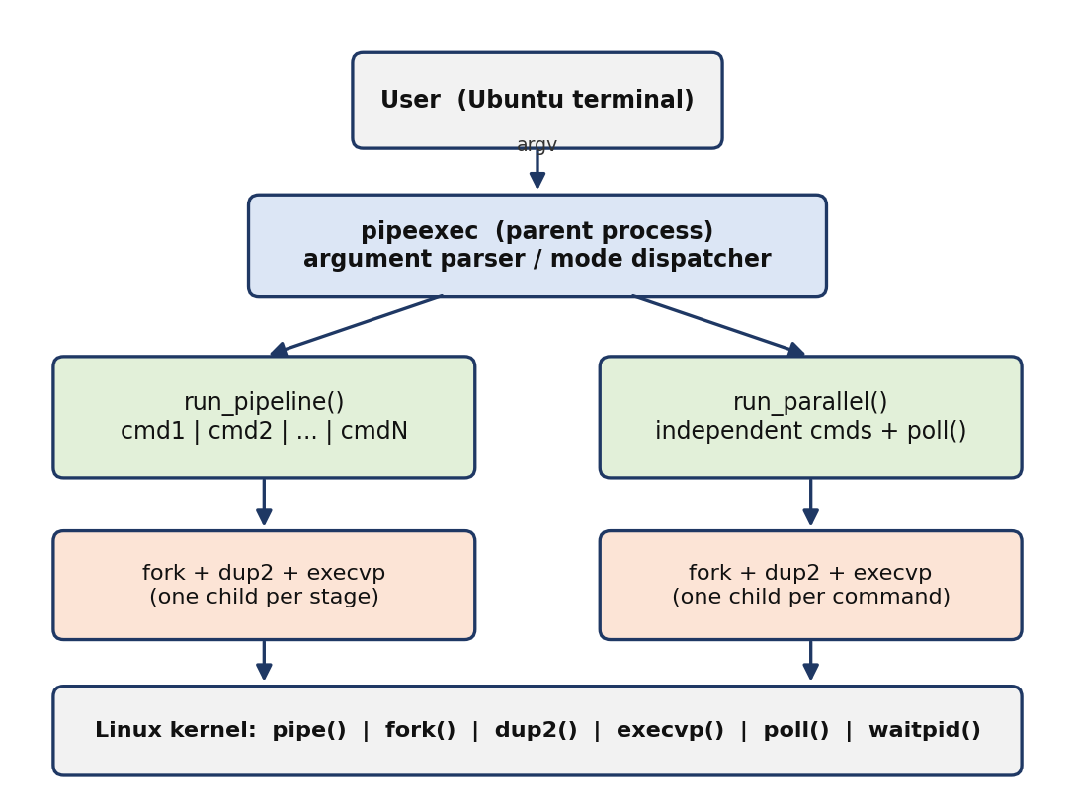
Figure 5.1: Overall system architecture of pipeexec

5.2 System Workflow
Step | Action | Component
1 | User starts ./pipeexec <mode> "cmd1" "cmd2" … | Terminal / shell
2 | main() validates argc, selects the mode (demo, pipeline, parallel) and checks 1 ≤ n ≤ 32 | main()
3 | For each command: strdup() a private copy and split it into argv with parse() | parse()
4 | Create the pipe(s) for this stage (pipeline: between stages; parallel: one per child) | pipe()
5 | fork(); child redirects its descriptors with dup2(), closes spare ends, calls execvp() | fork(), dup2(), execvp()
6 | Parent closes the ends it does not need and continues to the next command | close()
7 | Pipeline: parent waits. Parallel: parent poll()s, reads, splits into lines, prints [n] line | poll(), read(), flush_lines()
8 | waitpid() for every child; print [label] exited with status N or killed by signal N | waitpid(), report_status()
9 | Return exit code (pipeline: last stage; parallel: 1 if any command failed) | main()
Table 5.1: Step-by-step system workflow

5.3 Flowchart / Data Flow
Figure 5.2 shows the control flow of the whole program. Figures 5.3 and 5.4 show how data flows through the two modes.
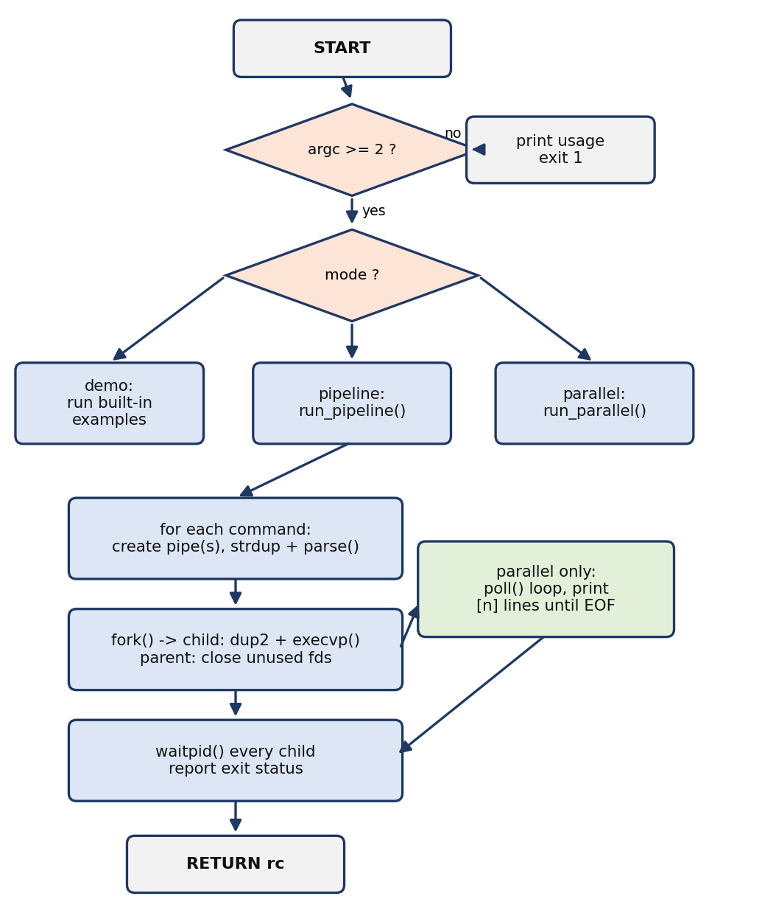
Figure 5.2: Flowchart of pipeexec
Pipeline data flow. Stage 1 inherits the terminal’s standard input. The standard output of each stage is the write end of a pipe and the standard input of the next stage is the read end of the same pipe. The last stage writes to the terminal.
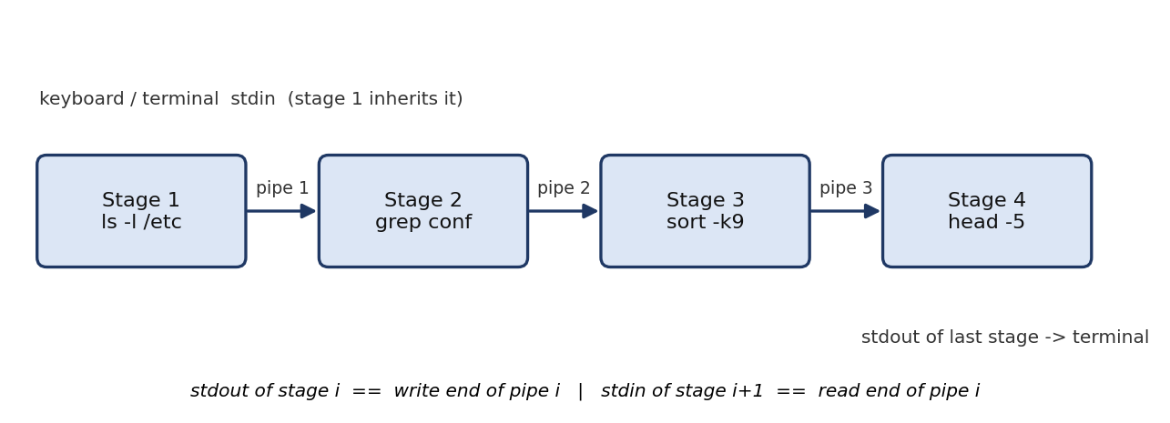
Figure 5.3: Data flow in pipeline mode (four stages, three pipes)
Parallel data flow. Every child has its own pipe. Both its standard output and its standard error are redirected into the write end. The parent holds all the read ends, waits in poll(), assembles complete lines and prints them with the child’s number.
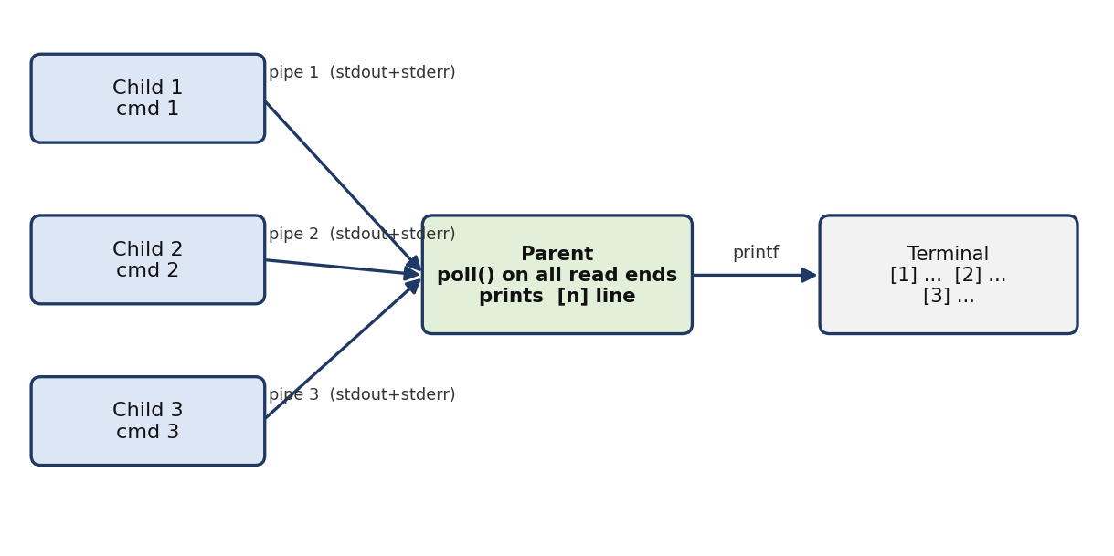
Figure 5.4: Data flow in parallel mode (one pipe per child)

5.4 Module Description
Although the program is a single file, it is organised into clear modules.
Module | Responsibility | Key interactions
main() | Parse argv, choose mode, validate command count, run the built-in demo | Calls run_pipeline(), run_parallel(), usage()
parse() | Split a command string on spaces/tabs into a NULL-terminated argv (max 63 args) | Uses strtok_r(); modifies its input copy
die() | Print a system error with perror() and exit | Used when pipe(), fork() or poll() fail
report_status() | Print whether a child exited normally or by signal | Uses WIFEXITED / WIFSIGNALED macros
run_pipeline() | Create pipes, fork and wire N stages, wait for all, return last stage’s status | pipe, fork, dup2, execvp, waitpid
Child (struct) | Per-child record: pid, read descriptor, 8 KB line buffer, length | Used only by parallel mode
flush_lines() | Print every complete line in a child’s buffer; keep the incomplete tail | memchr, memmove, printf
run_parallel() | Start N children with private pipes, poll() them, print prefixed lines, collect status | pipe, fork, dup2, poll, read, waitpid
usage() | Print command-line help to standard error | Called on invalid input
Table 5.2: Module description

5.5 Input and Output Design

Input design
./pipeexec pipeline "cmd1" "cmd2" ... # 1 to 32 commands
./pipeexec parallel "cmd1" "cmd2" ... # 1 to 32 commands
./pipeexec demo # no further arguments
Listing 5.1: Command-line grammar
Each command is one quoted argument, so the shell passes the whole command (with its own options) to pipeexec as a single string. pipeexec splits it on spaces and tabs. Because there is no inner shell, quotes, redirections, wildcards and environment variables inside a command string are not interpreted (for example echo *.c prints the text *.c).

Output design
Output | Stream | Format
Pipeline data | stdout | Whatever the last stage prints, unchanged
Parallel data | stdout | [n] <line> where n is the command number (1-based); stderr of children is merged in
Process status | stderr | [stage i: cmd] / [cmd i: cmd] exited with status N, or killed by signal N
Exec failure | stderr | exec 'name' failed: <reason>; child exits with status 127
Usage / errors | stderr | Usage text, “empty command at stage i”, or perror() messages
Table 5.3: Output design
Situation | Process exit code of pipeexec
Pipeline, last stage exits normally | Exit status of the last stage
Pipeline, last stage killed by a signal | 0 (status is reported on stderr)
Parallel, every command exits with 0 | 0
Parallel, any command fails or is killed | 1
Missing / invalid arguments, or system call failure | 1 (EXIT_FAILURE)
Table 5.4: Exit codes of pipeexec

CHAPTER 6
IMPLEMENTATION

6.1 Module-wise Implementation

Constants and the command parser
Three constants bound the program’s data structures. parse() tokenises a writable copy of the command string; it uses the re-entrant strtok_r() and stops one slot early to leave room for the NULL that execvp() requires at the end of argv.
#define MAX_CMDS 32
#define MAX_ARGS 64
#define BUF_SZ 4096

static int parse(char *s, char **argv)
{
int n = 0;
char *save = NULL;
for (char *t = strtok_r(s, " \t", &save); t && n < MAX_ARGS - 1;
t = strtok_r(NULL, " \t", &save))
argv[n++] = t;
argv[n] = NULL;
return n;
}

Error and status helpers
die() prints the system error text for the current errno and terminates the program. report_status() decodes the status word returned by waitpid() with the standard macros and prints a one-line report on standard error.

Pipeline module
run_pipeline() loops over the commands. For every stage except the last it creates a pipe. After fork() the child redirects its input from the previous pipe (prev_read) and its output into the new pipe, closes the descriptors it no longer needs and calls execvp(). The parent closes what it no longer needs and keeps the new read end as prev_read for the next iteration. Only after all stages have been started does the parent call waitpid() on each of them.

Parallel module
run_parallel() gives every child its own pipe, with stdout and stderr both redirected into it. Each child also closes the read ends of earlier siblings that it inherited, so that no process holds a write end or read end it does not need. The parent then enters a poll() loop. Whenever a pipe is readable the parent appends the bytes to that child’s buffer and calls flush_lines(), which prints complete lines as [n] line and keeps any partial line for the next read. At end-of-file the remaining partial line is flushed, the pipe is closed and its slot in the pollfd array is set to -1 so that poll() ignores it.

main() and demo mode
main() selects the mode. demo runs the four-stage pipeline ls -l /etc | grep conf | sort -k9 | head -5 and a five-command parallel batch (echo, uname -a, sleep 1, whoami, date). For pipeline and parallel the number of command arguments n = argc - 2 must lie between 1 and MAX_CMDS; otherwise usage() is printed.

6.2 Algorithm / Pseudocode

Algorithm 1: Pipeline execution
PIPELINE(n, cmds[0..n-1]):
prev_read <- -1
for i <- 0 to n-1:
if i < n-1: create pipe fd[0], fd[1] else fd <- (-1, -1)
copy <- strdup(cmds[i]); argv <- parse(copy)
pid <- fork()
if pid = 0: // child
if prev_read != -1: dup2(prev_read, 0); close(prev_read)
if fd[1] != -1: dup2(fd[1], 1); close(fd[0]); close(fd[1])
execvp(argv[0], argv)
print error; _exit(127)
pids[i] <- pid; free(copy) // parent
if prev_read != -1: close(prev_read)
if fd[1] != -1: close(fd[1])
prev_read <- fd[0]
for i <- 0 to n-1:
waitpid(pids[i], &status); report(status)
if i = n-1 and exited normally: rc <- exit status
return rc

Algorithm 2: Parallel execution with poll()
PARALLEL(n, cmds[0..n-1]):
for i <- 0 to n-1:
create pipe fd; argv <- parse(strdup(cmds[i]))
pid <- fork()
if pid = 0: // child
close(fd[0]); dup2(fd[1], 1); dup2(fd[1], 2); close(fd[1])
close read ends of children 0..i-1
execvp(argv[0], argv); _exit(127)
close(fd[1]); child[i] <- (pid, fd[0], empty buffer) // parent
open <- n
while open > 0:
poll(all read ends, wait forever)
for each ready child i:
r <- read(child[i].fd, buffer tail)
if r > 0: append; FLUSH(i, final=false)
if buffer full: FLUSH(i, final=true)
else: FLUSH(i, final=true); close fd; mark slot -1; open <- open-1
for i <- 0 to n-1: waitpid(child[i].pid); report; if failed: rc <- 1
return rc

Algorithm 3: Line assembly (flush_lines)
FLUSH(child, final):
start <- beginning of buffer
while a newline exists between start and end of data:
print "[idx] " + text up to the newline; start <- after the newline
left <- bytes remaining after start
if final and left > 0: print "[idx] " + remaining text; left <- 0
move the remaining bytes to the front of the buffer; length <- left

6.3 Core C / C++ Implementation
The complete source code of pipeexec.c is given below. It compiles without warnings using the command in Chapter 4.
/*
* pipeexec.c - Run multiple Linux commands concurrently and move output
* between processes using pipes.
*
* Modes
* 1) pipeline : cmd1 | cmd2 | cmd3 ... (all stages run at the same time,
* stdout of stage i is piped into stdin of stage i+1)
* 2) parallel : independent commands run at the same time; the parent
* collects each child's output through its own pipe and
* prints it line by line with a [n] prefix.
*
* Build : gcc -Wall -Wextra -o pipeexec pipeexec.c
* Usage : ./pipeexec pipeline "ls -l /etc" "grep conf" "wc -l"
* ./pipeexec parallel "ls /etc" "date" "uname -a" "sleep 1"
* ./pipeexec demo
*/
#define _GNU_SOURCE
#include <errno.h>
#include <poll.h>
#include <stdio.h>
#include <stdlib.h>
#include <string.h>
#include <sys/wait.h>
#include <unistd.h>

#define MAX_CMDS 32
#define MAX_ARGS 64
#define BUF_SZ 4096

/* Split a command string on spaces/tabs into an argv array (modifies s). */
static int parse(char *s, char **argv)
{
int n = 0;
char *save = NULL;
for (char *t = strtok_r(s, " \t", &save); t && n < MAX_ARGS - 1;
t = strtok_r(NULL, " \t", &save))
argv[n++] = t;
argv[n] = NULL;
return n;
}

static void die(const char *msg)
{
perror(msg);
exit(EXIT_FAILURE);
}

static void report_status(const char *label, int status)
{
if (WIFEXITED(status))
fprintf(stderr, "[%s] exited with status %d\n", label, WEXITSTATUS(status));
else if (WIFSIGNALED(status))
fprintf(stderr, "[%s] killed by signal %d\n", label, WTERMSIG(status));
}

/* ---------------------------------------------------------------- */
/* Mode 1: pipeline cmd1 | cmd2 | ... | cmdN */
/* ---------------------------------------------------------------- */
static int run_pipeline(int n, char **cmds)
{
pid_t pids[MAX_CMDS];
int prev_read = -1; /* read end of previous pipe */

for (int i = 0; i < n; i++) {
int fd[2] = {-1, -1};
if (i < n - 1 && pipe(fd) < 0)
die("pipe");

char *copy = strdup(cmds[i]);
char *argv[MAX_ARGS];
if (!copy || parse(copy, argv) == 0) {
fprintf(stderr, "empty command at stage %d\n", i + 1);
return 1;
}

pid_t pid = fork();
if (pid < 0)
die("fork");

if (pid == 0) { /* ---- child ---- */
if (prev_read != -1) { /* stdin <- previous stage */
dup2(prev_read, STDIN_FILENO);
close(prev_read);
}
if (fd[1] != -1) { /* stdout -> next stage */
dup2(fd[1], STDOUT_FILENO);
close(fd[0]);
close(fd[1]);
}
execvp(argv[0], argv);
fprintf(stderr, "exec '%s' failed: %s\n", argv[0], strerror(errno));
_exit(127);
}

/* ---- parent: close fds it no longer needs ---- */
pids[i] = pid;
free(copy);
if (prev_read != -1)
close(prev_read);
if (fd[1] != -1)
close(fd[1]);
prev_read = fd[0];
}

int rc = 0;
for (int i = 0; i < n; i++) {
int status;
waitpid(pids[i], &status, 0);
char label[64];
snprintf(label, sizeof label, "stage %d: %s", i + 1, cmds[i]);
report_status(label, status);
if (i == n - 1 && WIFEXITED(status))
rc = WEXITSTATUS(status);
}
return rc;
}

/* ---------------------------------------------------------------- */
/* Mode 2: parallel - run all at once, collect output through pipes */
/* ---------------------------------------------------------------- */
typedef struct {
pid_t pid;
int fd; /* read end of child's output pipe */
char buf[BUF_SZ * 2];
size_t len;
} Child;

static void flush_lines(Child *c, int idx, int final)
{
char *start = c->buf, *nl;
while ((nl = memchr(start, '\n', c->len - (start - c->buf)))) {
printf("[%d] %.*s\n", idx + 1, (int)(nl - start), start);
start = nl + 1;
}
size_t left = c->len - (start - c->buf);
if (final && left > 0) {
printf("[%d] %.*s\n", idx + 1, (int)left, start);
left = 0;
}
memmove(c->buf, start, left);
c->len = left;
fflush(stdout);
}

static int run_parallel(int n, char **cmds)
{
Child ch[MAX_CMDS];
memset(ch, 0, sizeof ch);

for (int i = 0; i < n; i++) {
int fd[2];
if (pipe(fd) < 0)
die("pipe");

char *copy = strdup(cmds[i]);
char *argv[MAX_ARGS];
if (!copy || parse(copy, argv) == 0) {
fprintf(stderr, "empty command %d\n", i + 1);
return 1;
}

pid_t pid = fork();
if (pid < 0)
die("fork");

if (pid == 0) { /* ---- child ---- */
close(fd[0]);
dup2(fd[1], STDOUT_FILENO);
dup2(fd[1], STDERR_FILENO);
close(fd[1]);
for (int j = 0; j < i; j++) /* drop earlier siblings' pipes */
close(ch[j].fd);
execvp(argv[0], argv);
fprintf(stderr, "exec '%s' failed: %s\n", argv[0], strerror(errno));
_exit(127);
}

close(fd[1]); /* parent keeps only the read end */
free(copy);
ch[i].pid = pid;
ch[i].fd = fd[0];
}

/* Multiplex all pipes with poll() until every child closes its end. */
struct pollfd pfds[MAX_CMDS];
int open_fds = n;
for (int i = 0; i < n; i++) {
pfds[i].fd = ch[i].fd;
pfds[i].events = POLLIN;
}

while (open_fds > 0) {
if (poll(pfds, n, -1) < 0) {
if (errno == EINTR) continue;
die("poll");
}
for (int i = 0; i < n; i++) {
if (pfds[i].fd < 0 || !(pfds[i].revents & (POLLIN | POLLHUP)))
continue;
ssize_t r = read(ch[i].fd, ch[i].buf + ch[i].len,
sizeof ch[i].buf - ch[i].len);
if (r > 0) {
ch[i].len += (size_t)r;
flush_lines(&ch[i], i, 0);
if (ch[i].len == sizeof ch[i].buf) /* very long line */
flush_lines(&ch[i], i, 1);
} else { /* EOF or error */
flush_lines(&ch[i], i, 1);
close(ch[i].fd);
pfds[i].fd = -1; /* poll ignores it */
open_fds--;
}
}
}

int rc = 0;
for (int i = 0; i < n; i++) {
int status;
waitpid(ch[i].pid, &status, 0);
char label[64];
snprintf(label, sizeof label, "cmd %d: %s", i + 1, cmds[i]);
report_status(label, status);
if (!WIFEXITED(status) || WEXITSTATUS(status) != 0)
rc = 1;
}
return rc;
}

/* ---------------------------------------------------------------- */
static void usage(const char *p)
{
fprintf(stderr,
"Usage:\n"
" %s pipeline \"cmd1\" \"cmd2\" ... run cmd1 | cmd2 | ... concurrently\n"
" %s parallel \"cmd1\" \"cmd2\" ... run independent commands concurrently\n"
" %s demo run built-in examples\n", p, p, p);
}

int main(int argc, char **argv)
{
if (argc < 2) { usage(argv[0]); return 1; }

if (!strcmp(argv[1], "demo")) {
char *p1[] = {"ls -l /etc", "grep conf", "sort -k9", "head -5"};
char *p2[] = {"echo hello from A", "uname -a", "sleep 1", "whoami", "date"};
puts("=== Pipeline: ls -l /etc | grep conf | sort -k9 | head -5 ===");
run_pipeline(4, p1);
puts("\n=== Parallel commands ===");
run_parallel(5, p2);
return 0;
}

int n = argc - 2;
if (n < 1 || n > MAX_CMDS) { usage(argv[0]); return 1; }

if (!strcmp(argv[1], "pipeline")) return run_pipeline(n, argv + 2);
if (!strcmp(argv[1], "parallel")) return run_parallel(n, argv + 2);

usage(argv[0]);
return 1;
}
Listing 6.1: Complete source code – pipeexec.c

6.4 Linux System Calls / APIs Used
Call | Where used | How it is used | Failure handling
pipe() | run_pipeline, run_parallel | Creates fd[0]/fd[1]; pipeline: n-1 pipes; parallel: n pipes | die("pipe")
fork() | run_pipeline, run_parallel | One child per command, all before any wait | die("fork")
dup2() | child after fork | stdin ← previous pipe; stdout (and stderr in parallel) → next pipe | Not checked in source
close() | parent and child | Drop every unused pipe end so EOF is delivered | Not checked
execvp() | child | Replace child with the command, search PATH | Print message, _exit(127)
_exit() | child on exec failure | Terminate without flushing duplicated stdio buffers | —
poll() | run_parallel | Wait for POLLIN / POLLHUP on all pipes, timeout -1 | Retry on EINTR, else die("poll")
read() | run_parallel | Read into the tail of the child’s buffer | r ≤ 0 treated as EOF/error
waitpid() | both modes | Collect each child; fills status | Status decoded by report_status()
strtok_r(), strdup() | parse, both modes | Tokenise a private copy of each command | NULL copy → error message
memchr(), memmove() | flush_lines | Find line ends; compact leftover bytes | —
Table 6.1: System calls and APIs in the implementation

6.5 Process / Thread Implementation
Every command runs in its own process. The parent never executes a command itself; it only creates, supervises and collects children. In pipeline mode all stage processes are siblings (children of the same parent), not a nested chain. This is exactly how a shell arranges a | b | c. The process tree captured with ps while ./pipeexec pipeline "sleep 3" "sleep 3" "sleep 3" was running is shown below.
PID PPID STAT CMD
332 1 S ./pipeexec pipeline sleep 3 sleep 3 sleep 3
334 332 S \_ sleep 3
335 332 S \_ sleep 3
336 332 S \_ sleep 3
Listing 6.2: Process tree during a three-stage pipeline (captured with ps --forest)
The life cycle of each child is summarised in Table 6.2.
Phase | What happens | Code location
Created | fork() returns 0 in the child; address space is a copy-on-write clone of the parent | after fork()
Wiring | Child duplicates pipe ends onto fd 0/1/2 and closes the rest | dup2(), close()
Running | execvp() replaces the image; the command runs concurrently with its siblings | execvp()
Terminated | Command exits or is killed; the kernel keeps its status (zombie state) | —
Reaped | Parent calls waitpid(); status is decoded and the process table entry is freed | waitpid(), report_status()
Table 6.2: Life cycle of a child process
A child that fails to execvp() calls _exit(127) rather than exit(). After fork() the child holds a copy of the parent’s buffered standard-I/O data; exit() would flush that copy a second time and duplicate output, whereas _exit() terminates immediately.
As explained in Section 4.4, no threads are used. The parent is single-threaded and serves all children through poll(), so there are no data races and no locks.

6.6 IPC / Synchronization Implementation

Pipes as the IPC mechanism
All data exchange between processes uses anonymous pipes. In pipeline mode the descriptor tables of the children after wiring are as shown in Table 6.3 (an example with three stages and two pipes P1 and P2).
Process | fd 0 (stdin) | fd 1 (stdout) | fd 2 (stderr)
Stage 1 | Terminal (inherited) | P1 write end | Terminal
Stage 2 | P1 read end | P2 write end | Terminal
Stage 3 (last) | P2 read end | Terminal | Terminal
Parent | Terminal | Terminal | Terminal (all pipe ends closed)
Table 6.3: Descriptor tables in pipeline mode
In parallel mode each child’s stdout and stderr refer to the write end of its private pipe, and the parent holds the corresponding read end.

Why closing descriptors is essential
A pipe delivers end-of-file only after every descriptor for its write end has been closed. If the parent kept fd[1] open after forking a stage, the next stage (for example wc -l) would never see EOF and would wait forever. For this reason the parent closes fd[1] and the old prev_read immediately after each fork(), each child closes the originals after dup2(), and in parallel mode each child also closes the read ends of earlier siblings.

Blocking, back-pressure and flow control
Because pipes have a finite buffer (64 KiB on Linux), a fast producer cannot overrun a slow consumer: it blocks in write() until the consumer reads. No user-level semaphores are needed. In the stress test of Section 7.5, two seq 1 100000 commands (about 1.2 MB of output in total) passed through the parallel mode and exactly 200,000 prefixed lines were received.

Multiplexing with poll()
If the parent simply read child 1 until EOF, then child 2, and so on, any child other than the one currently being read would eventually fill its pipe and block, destroying concurrency and delaying its output. With poll() the parent reads whichever pipe has data. A finished pipe’s entry is set to -1, which poll() ignores, and the loop ends when all pipes have reached EOF. EINTR is handled by retrying.

Parent–child synchronisation
waitpid() blocks the parent until a particular child terminates and provides its status. All children are started before the first waitpid(), so waiting does not serialise execution. Reaping the children prevents zombies.

6.7 Memory Management Implementation
pipeexec uses automatic (stack) storage for almost all data and heap storage only for the command copy.
Object | Storage | Size | Lifetime
argv[MAX_ARGS] | Stack | 64 pointers = 512 B | Per loop iteration
copy = strdup(cmd) | Heap | strlen(cmd)+1 bytes | Freed in parent after fork()
pids[MAX_CMDS] | Stack | 32 × 4 B = 128 B | Duration of run_pipeline()
Child ch[MAX_CMDS] | Stack | 32 × 8,208 B = 262,656 B (≈ 257 KiB) | Duration of run_parallel()
Child.buf | Stack (inside struct) | 2 × BUF_SZ = 8,192 B per child | Duration of run_parallel()
pollfd pfds[MAX_CMDS] | Stack | 32 × 8 B = 256 B | Duration of the poll loop
Pipe buffers | Kernel memory | 64 KiB per pipe (default) | Until both ends are closed
Table 6.4: Memory used by the program
The Child array is cleared with memset() so that every field starts at zero. At 257 KiB it fits comfortably within the default 8 MiB stack limit. fork() is cheap because pages are shared copy-on-write, and execvp() then discards the cloned image entirely.
flush_lines() manages the per-child buffer without dynamic allocation. Complete lines are printed using the %.*s format with the exact length found by memchr(). The unfinished tail is moved to the start of the buffer with memmove() (which is safe for overlapping regions) so the next read() can append to it. If a line is longer than the buffer, the buffer is flushed as a partial line instead of overflowing.
Known limitation. In the two error paths where a command string is empty, the function returns immediately without freeing the copy made by strdup() and, if earlier stages were already forked, without waiting for them. This occurs only for invalid input and is noted as an improvement for a future version.

6.8 Optional User Interface Implementation
pipeexec has a text-mode, command-line interface; no graphical interface was implemented because the focus is on operating-system mechanisms. The interface nevertheless includes several usability features:
- A usage message listing the three sub-commands is printed when the arguments are missing or invalid.
- In parallel mode every output line carries a `[n]` prefix identifying its command.
- Status messages go to standard error, so a user can separate data from diagnostics, for example ./pipeexec parallel … 2>/dev/null.
- The demo sub-command lets an examiner see both modes work with a single command and no typing.

CHAPTER 7
EXECUTION AND DEMONSTRATION

7.1 Compilation in Ubuntu
Save the source as pipeexec.c, open a terminal in the same directory and compile:
gcc -Wall -Wextra -o pipeexec pipeexec.c
ls -l pipeexec

The compiler prints no warnings and produces an executable of about 21 KB. The verification runs in this chapter were made on Ubuntu 24.04 with GCC 13.3.0 (Linux kernel 6.x).

7.2 Execution Commands
Purpose | Command
Build | gcc -Wall -Wextra -o pipeexec pipeexec.c
Pipeline of three stages | ./pipeexec pipeline "ls -l /etc" "grep conf" "wc -l"
Four independent commands | ./pipeexec parallel "ls /etc" "date" "uname -a" "sleep 1"
Built-in demonstration | ./pipeexec demo
Hide status messages | ./pipeexec parallel "date" "whoami" 2>/dev/null
Show usage | ./pipeexec
Table 7.1: Execution commands

7.3 Sample Inputs and Outputs
# | Input | Observed output (abridged) | Result
1 | pipeline "ls -l /etc" "grep conf" "wc -l" | 23 and three “exited with status 0” lines | Pass
2 | parallel "echo a" "echo b" "echo c" | [1] a [2] b [3] c | Pass
3 | pipeline "yes" "head -3" | y y y; “[stage 1: yes] killed by signal 13” | Pass (SIGPIPE)
4 | pipeline "foobar" "wc -l" | exec 'foobar' failed: No such file or directory; status 127; wc prints 0 | Pass
5 | parallel "echo hi" "false" | [1] hi; “[cmd 2: false] exited with status 1”; exit code 1 | Pass
6 | parallel "seq 1 100000" "seq 1 100000" | Exactly 200,000 lines with prefix [1] or [2] | Pass
7 | pipeline "seq 1 1000000" "grep 99" "wc -l" | 45739, identical to the shell’s seq … | grep 99 | wc -l | Pass
8 | (no arguments) | Usage text | Pass
Table 7.2: Test cases, inputs and observed results

7.4 Screenshots of Execution
The following terminal captures were produced by compiling and running the program as described above.
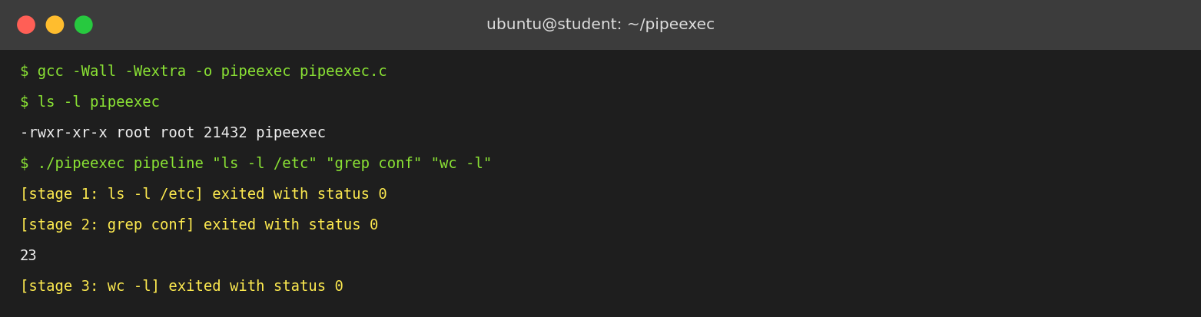
Figure 7.1: Compilation and a three-stage pipeline
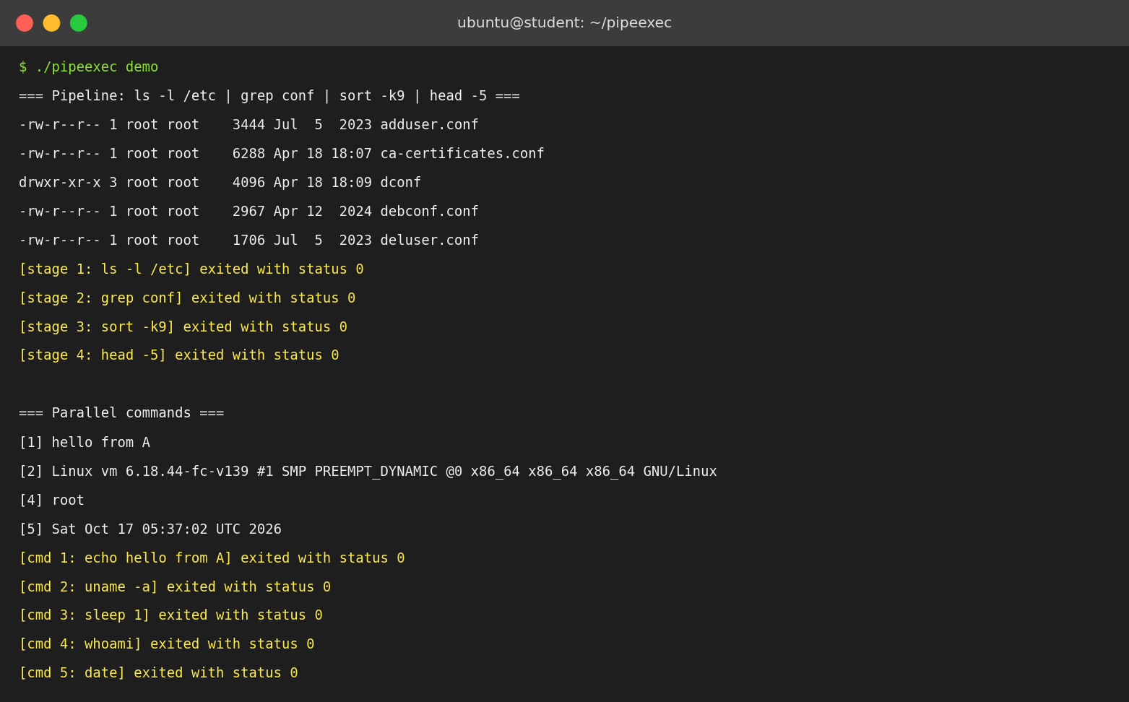
Figure 7.2: Built-in demo (pipeline followed by parallel commands)
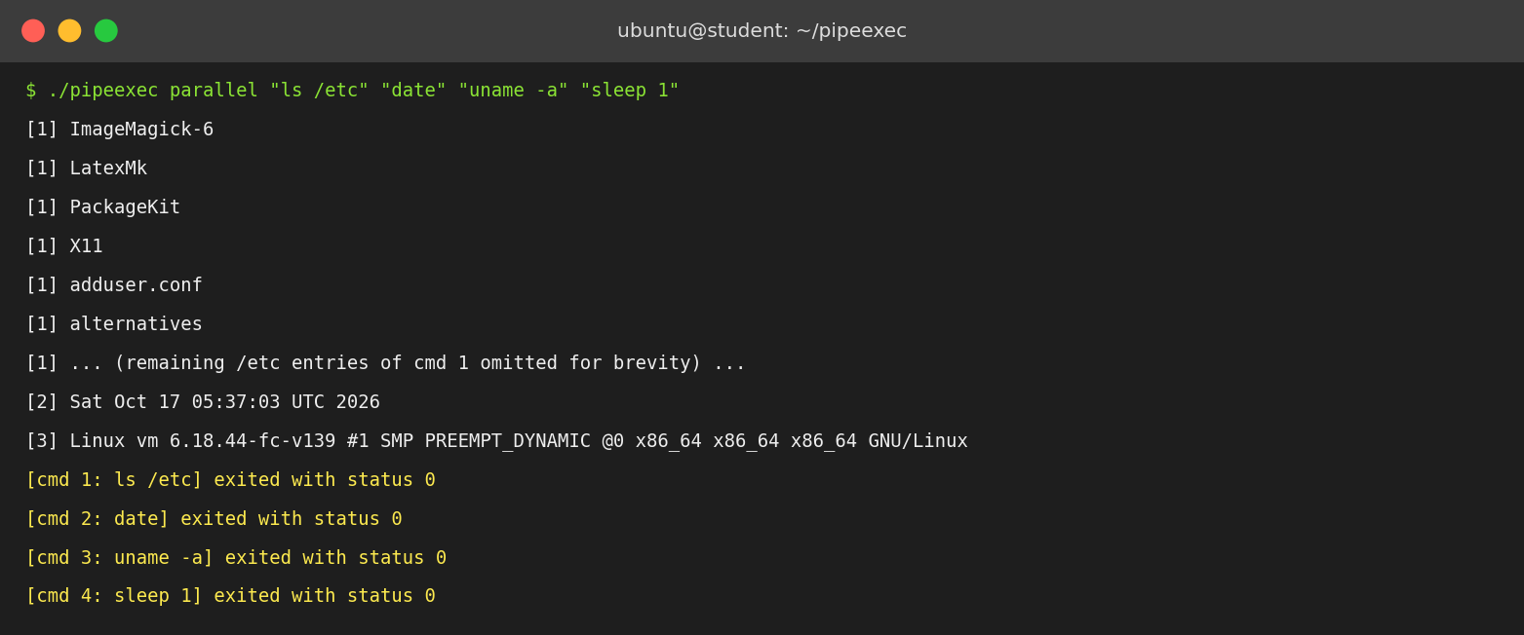
Figure 7.3: Parallel mode – output lines labelled [1], [2], [3] (long listing abridged)
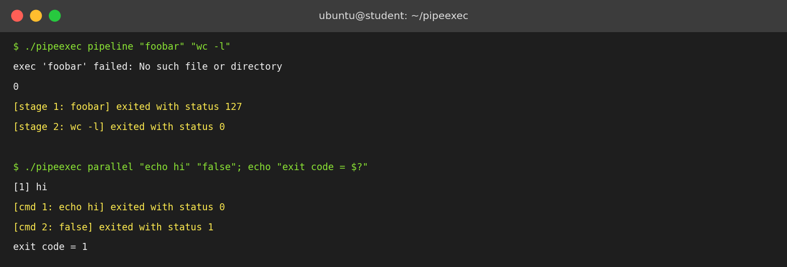
Figure 7.4: Error handling – exec failure (status 127) and non-zero exit status
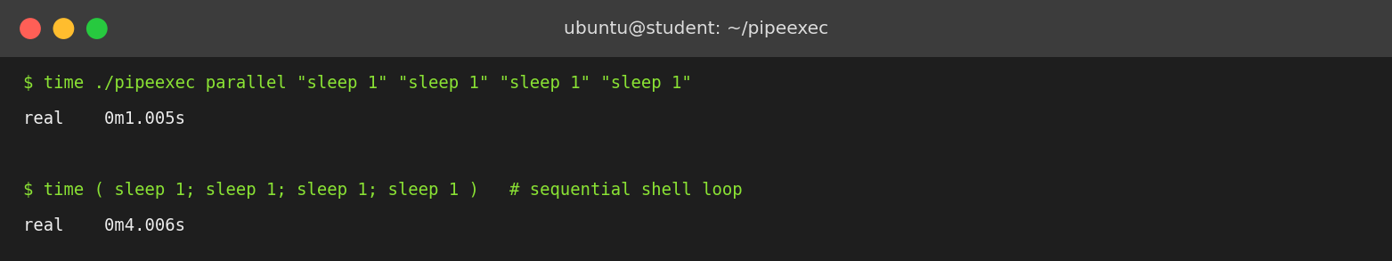
Figure 7.5: Elapsed time, concurrent versus sequential execution

7.5 Demonstration of OS Concepts

(a) Concurrency – processes overlap in time
Four one-second sleep commands finished in about one second in both modes, whereas the same commands executed one after another need four seconds (Figure 7.5).
Run | Elapsed time (real)
pipeexec parallel with 4 × sleep 1 | 1.005 s
pipeexec pipeline with 4 × sleep 1 | 1.006 s
Sequential shell: sleep 1; sleep 1; sleep 1; sleep 1 | 4.006 s
Table 7.3: Measured elapsed time (single run)

(b) Process creation, redirection and exec – system call trace
Tracing ./pipeexec pipeline "echo hello" "wc -c" with strace -ff shows the exact sequence of kernel calls. The parent creates a pipe (descriptors 3 and 4) and forks two children (glibc implements fork() with the clone system call). Child 392 redirects its standard output into the pipe’s write end and becomes echo; child 393 redirects its standard input from the read end and becomes wc. Finally, the parent collects both children with wait4.
--- parent (pid 391) ---
execve("./pipeexec", ["./pipeexec", "pipeline", "echo hello", "wc -c"], ...) = 0
pipe2([3, 4], 0) = 0
clone(flags=SIGCHLD) = 392
clone(flags=SIGCHLD) = 393
wait4(392, [{WIFEXITED(s) && WEXITSTATUS(s) == 0}], 0, NULL) = 392
wait4(393, [{WIFEXITED(s) && WEXITSTATUS(s) == 0}], 0, NULL) = 393

--- child 392 (stage 1) --- --- child 393 (stage 2) ---
dup2(4, 1) = 1 dup2(3, 0) = 0
execve("/usr/bin/echo", ...) = 0 execve("/usr/bin/wc", ...) = 0
Listing 7.1: strace output (failed PATH-search attempts removed)

(c) IPC and EOF detection
In test 7 the three stages seq, grep and wc pushed about 6.9 MB through the first pipe and produced the same result (45739) as the shell’s own pipeline. That wc terminated at all proves that end-of-file was delivered, which in turn proves that all unused write ends were closed correctly.

(d) Signals – SIGPIPE
In pipeexec pipeline "yes" "head -3" the consumer head exits after three lines. The next write() by yes to the now reader-less pipe raises SIGPIPE (signal 13) and the parent reports [stage 1: yes] killed by signal 13. Without this behaviour yes would run forever.

(e) Multiplexing, buffering and line integrity
In test 6 two commands wrote 100,000 lines each at full speed. Even though their output arrived in arbitrary-sized chunks from two pipes, the parent printed exactly 200,000 complete lines, none merged or split, because each child has a private buffer and only complete lines are emitted. Relative order between commands depends on scheduling, as expected for concurrent processes.

(f) Exit-status handling
report_status() separates a normal exit from death by signal. A command that cannot be executed gives status 127, and parallel mode returns exit code 1 if any command fails (Figure 7.4).

CHAPTER 8
CONCLUSION

8.1 Summary of the Project
This project designed, implemented and tested pipeexec, a C program that runs multiple Linux commands concurrently and moves data between them using pipes. In pipeline mode the program builds the same kind of process chain that a shell creates for cmd1 | cmd2 | …: one pipe between every pair of stages, every stage started before any is awaited, and standard streams rewired with dup2(). In parallel mode independent commands are started together, each with a private pipe, and the parent multiplexes the pipes with poll() and prints each command’s output line by line with a [n] prefix. In both modes every child is reaped with waitpid() and its exit status or terminating signal is reported.
The program is about 260 lines of standard C, uses only POSIX interfaces, compiles without warnings on Ubuntu and passed all eight functional tests described in Chapter 7.

8.2 Objectives Achieved
Objective (Section 1.4) | Status | Evidence
Process creation with fork() and exec | Achieved | strace shows clone + execve per command
Multi-stage pipeline via kernel pipes | Achieved | Test 1 and test 7 (output identical to the shell)
Concurrent independent commands, clean output | Achieved | Tests 2 and 6; 200,000 intact lines
dup2() redirection and descriptor hygiene | Achieved | EOF delivered; wc terminates
poll() multiplexing in a single process | Achieved | Parallel mode with up to 32 children
waitpid() and status reporting | Achieved | Tests 3, 4, 5: status 127, status 1, signal 13
Run and measure on Ubuntu | Achieved | 4.0 s sequential vs 1.0 s concurrent
Table 8.1: Objectives versus outcomes

8.3 Results Achieved
- Speed-up: four commands of one second each completed in 1.005 s concurrently versus 4.006 s sequentially, a speed-up of about 4×, as expected when the work is independent and non-CPU-bound.
- Correctness: a three-stage pipeline over 1,000,000 numbers returned 45739, identical to the shell’s result.
- Robustness: an endless producer (yes) was terminated by SIGPIPE as soon as its consumer finished; a missing command was reported with status 127 without hanging the pipeline.
- Scalability of buffers: about 1.2 MB of output from two commands passed through pipes of 64 KiB without loss or corruption.
- Resource use: the 21 KB executable needs at most about 257 KiB of stack in parallel mode.

Limitations
- Command strings are split only on spaces and tabs; quotes, redirection operators, wildcards and variables are not interpreted.
- In pipeline mode the exit code is that of the last stage (like a shell without pipefail); failures in earlier stages are visible only in the status messages.
- Children’s standard error is merged into standard output in parallel mode but is left on the terminal in pipeline mode.
- The maximum is 32 commands and 63 arguments per command; the exit codes of dup2() and close() are not checked.
- Error paths for empty commands return without freeing memory or reaping children already started (Section 6.7).

Future scope
- Add a mini-shell parser that understands quotes, >, < and 2>, and wildcard expansion.
- Add a --pipefail option and a per-command timeout using alarm() or SIGALRM.
- Replace the fixed-size array with dynamic allocation and use pipe2(O_CLOEXEC) to avoid descriptor leaks.
- Provide a threaded alternative (one reader thread per child with a mutex-protected output queue) and compare it with the poll() design.
- Build a graphical front-end that shows the process tree and the live data flow.

8.4 Skills and Learning Outcomes
- Practical understanding of process management: fork, exec, wait, zombies and exit status.
- Ability to use inter-process communication through pipes and to reason about blocking, back-pressure and end-of-file.
- Skill in file-descriptor manipulation with dup2() and in avoiding descriptor leaks.
- Experience with I/O multiplexing using poll() and with buffering partial lines.
- Competence in systems programming in C under Ubuntu, including compiling with warnings, tracing with strace and measuring with time.
- Insight into how Unix shells implement pipelines, and why the design of small cooperating programs is powerful.
- Teamwork, documentation and testing skills gained while preparing the demonstration, slides and this report.

CHAPTER 9
REFERENCES

9.1 Books
[1] A. Silberschatz, P. B. Galvin and G. Gagne, Operating System Concepts, 10th ed. Hoboken, NJ: Wiley, 2018.
[2] M. Kerrisk, The Linux Programming Interface: A Linux and UNIX System Programming Handbook. San Francisco, CA: No Starch Press, 2010.
[3] W. R. Stevens and S. A. Rago, Advanced Programming in the UNIX Environment, 3rd ed. Upper Saddle River, NJ: Addison-Wesley, 2013.
[4] A. S. Tanenbaum and H. Bos, Modern Operating Systems, 4th ed. Boston, MA: Pearson, 2014.
[5] R. Love, Linux System Programming, 2nd ed. Sebastopol, CA: O’Reilly Media, 2013.

9.2 Research Papers
[6] D. M. Ritchie and K. Thompson, “The UNIX Time-Sharing System,” Communications of the ACM, vol. 17, no. 7, pp. 365–375, July 1974.
[7] M. D. McIlroy, E. N. Pinson and B. A. Tague, “UNIX Time-Sharing System: Foreword,” The Bell System Technical Journal, vol. 57, no. 6, pp. 1899–1904, 1978.
[8] A. Baumann, J. Appavoo, O. Krieger and T. Roscoe, “A fork() in the road,” in Proc. 17th Workshop on Hot Topics in Operating Systems (HotOS ’19), Bertinoro, Italy, 2019.

9.3 Linux / GNU Documentation
[9] Linux man-pages: pipe(2), fork(2), dup2(2), execvp(3), poll(2), waitpid(2), pipe(7), signal(7). https://man7.org/linux/man-pages/
[10] The GNU C Library Reference Manual, Free Software Foundation. https://www.gnu.org/software/libc/manual/
[11] GCC, the GNU Compiler Collection – Online Documentation. https://gcc.gnu.org/onlinedocs/
[12] Ubuntu Documentation. https://documentation.ubuntu.com/

9.4 Online Resources
[13] Microsoft, “Install WSL.” https://learn.microsoft.com/windows/wsl/install
[14] B. Hall, Beej’s Guide to Unix IPC. https://beej.us/guide/bgipc/
[15] strace project, “strace – trace system calls and signals.” https://strace.io/

