TASKPILOT – AGENTIC AI TASK PLANNER
Capstone Deliverables
Five artifacts that demonstrate enterprise architecture completeness
Student | Roll Number
DIVYAPRIYA B | 2023103572
Course: Scalable Enterprise Architectural Deployments of Agentic AI Solutions
Live Application: https://easy-push.lovable.app/

Overview
This document presents the five capstone deliverables for TaskPilot – Agentic AI Task Planner, a lightweight web application that converts a user's high-level goal into structured, prioritized, scheduled and trackable action plans.

Deliverable Scope
# | Deliverable | Coverage
1 | Architecture Diagram | Layers, components, trust boundaries and integrations
2 | Agent Workflow Design | Roles, states, tools, handoffs, approvals and failure paths
3 | Deployment Strategy | Runtime, scaling, resilience, environments and release
4 | Security Model | Identity, authorization, secrets, privacy, guardrails and audit
5 | Monitoring Dashboard Design | Health, trace, quality, safety, cost and business outcomes

1. Architecture Diagram
TaskPilot is organized into presentation, application/agent, data/state and deployment layers. The design keeps the current prototype lightweight while defining clear boundaries for future AI and cloud integrations.
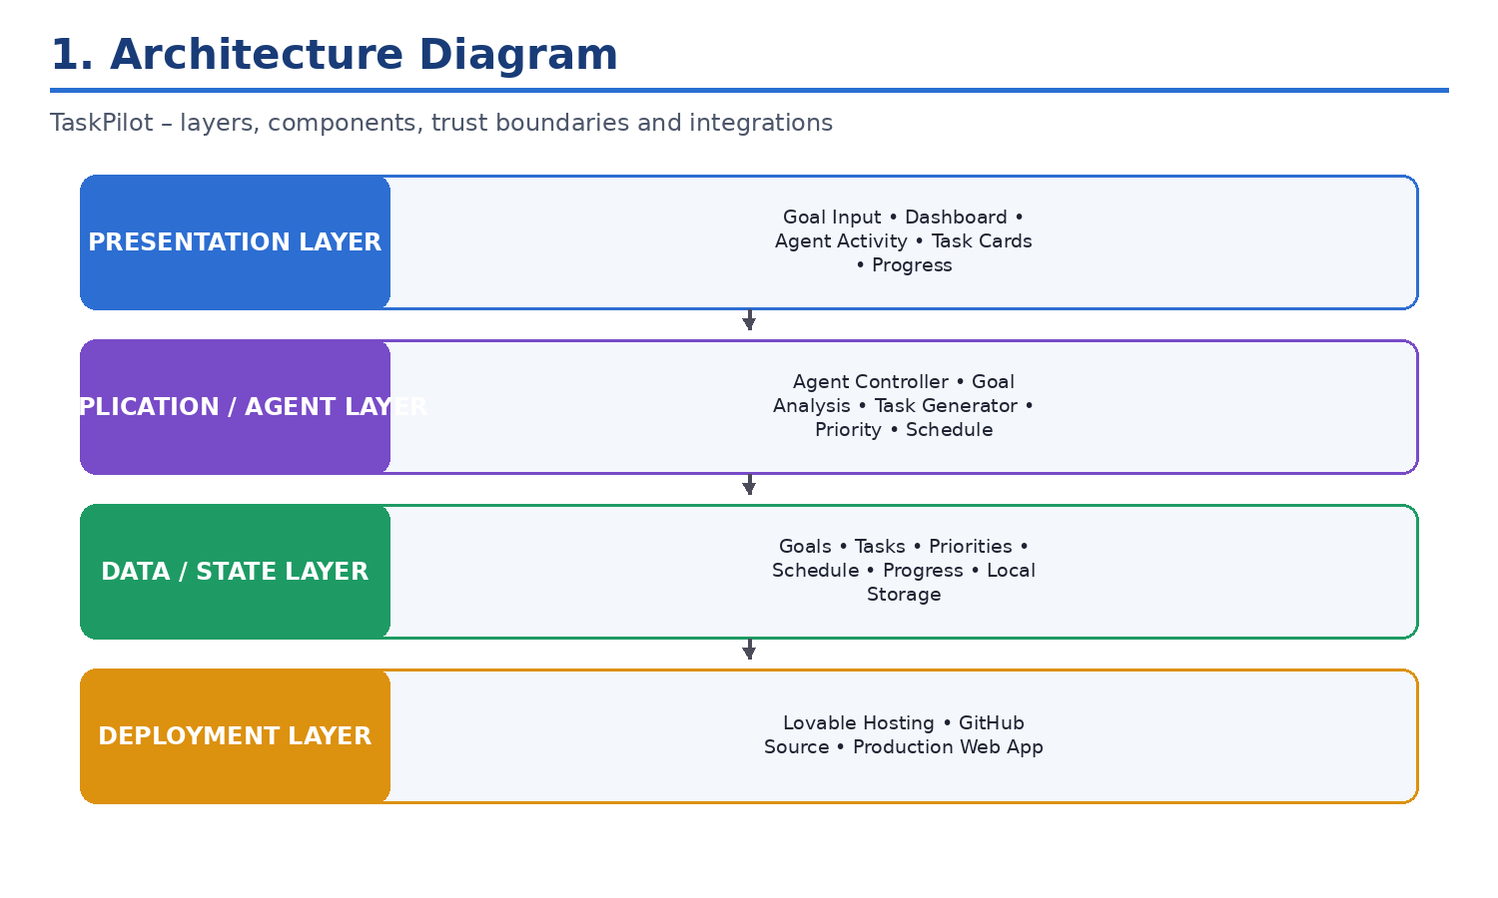
Figure 1: TaskPilot main architectural layers

Presentation Layer
- React-based web interface
- Goal input and example goals
- Dashboard and action-plan views
- Agent activity/status panel
- Task cards and progress visualization

Application / Agent Layer
- Agent Controller
- Goal analysis and task decomposition
- Task generation
- Priority management
- Day-wise schedule generation
- Progress calculation

Data / State Layer
- User goal
- Generated tasks
- Priority and schedule information
- Completion state and progress
- Browser Local Storage

Deployment Layer
- Lovable development/hosting environment
- GitHub source control
- Production web application
- Browser-based runtime

Trust Boundaries and Integrations
The current prototype keeps primary application state in the user's browser and does not require a separate database or external AI API key for the basic planning workflow. Future versions can introduce a backend, cloud database and LLM services behind controlled API boundaries.

2. Agent Workflow Design
The workflow begins when a user enters a high-level goal and ends when a structured plan is generated, stored and displayed for user execution and progress tracking.
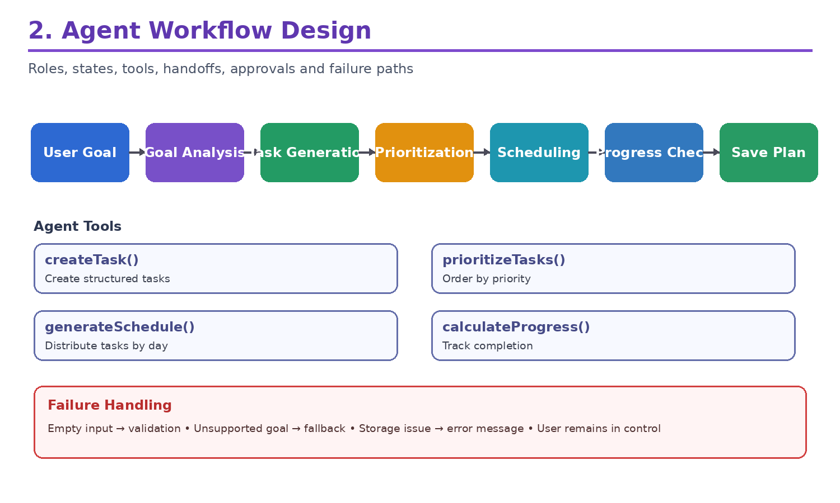
Figure 2: TaskPilot agent workflow

Agent Responsibilities
- Understand the user's high-level goal.
- Break the goal into actionable tasks.
- Assign task priorities.
- Generate a day-wise schedule.
- Calculate and display progress.
- Maintain plan state using browser storage.
- Provide concise agent activity/status updates.
- Keep the user in control of task execution.

Agent States
State | Description
Input | User provides a planning goal
Analysis | Goal and context are interpreted
Task Generation | Actionable tasks are prepared
Prioritization | Tasks receive High, Medium or Low priority
Scheduling | Tasks are distributed across days
Observation | Progress and task state are checked
Completed | Final plan is saved and shown

Agent Tools and Handoffs
- createTask() – creates structured tasks.
- prioritizeTasks() – orders tasks by priority.
- generateSchedule() – distributes tasks across available days.
- calculateProgress() – computes completion metrics.

Approvals and Human Control
TaskPilot follows a human-in-the-loop model. The user defines the goal, reviews the generated plan and decides which tasks to execute. The agent does not autonomously perform irreversible external actions.

Failure Handling
- Empty goal → validate input and request a goal.
- Unsupported goal → use a generic fallback planning template.
- Storage failure → display an understandable error and preserve active state where possible.
- Unexpected error → provide a graceful error state and allow retry.

3. Deployment Strategy
TaskPilot is a browser-based React application. The current live application is hosted through Lovable, while GitHub is used for source control and academic submission.
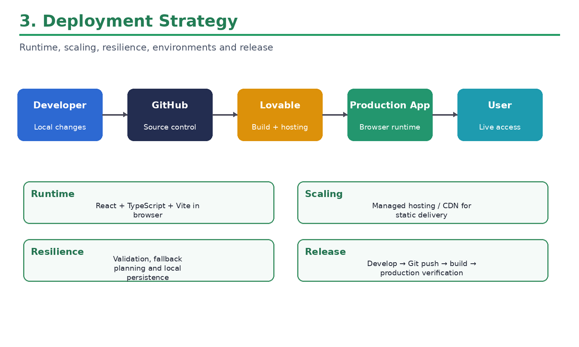
Figure 3: TaskPilot deployment pipeline

Source Repository
https://github.com/divya43-76/TaskPilot-Agentic_AI

Technology Stack
- React
- TypeScript
- Vite
- Tailwind CSS
- JavaScript
- GitHub
- Lovable

Production Deployment
Live Application: https://easy-push.lovable.app/

Runtime
The application executes primarily in the browser. Client-side planning logic generates tasks, priorities and schedules, while browser Local Storage retains task and progress state.

Scaling and Resilience
- Managed hosting/CDN can efficiently serve static assets.
- Future versions can introduce API services and cloud storage for multi-user scaling.
- LLM workloads can be separated into an agent service when external AI is introduced.
- Input validation, fallback planning, graceful errors and local persistence provide basic resilience.

Environment and Release
Recommended flow: Development → local testing → Git commit → GitHub push → deployment build → production verification → live demonstration.

4. Security Model
TaskPilot is currently a lightweight client-side academic prototype. Its security model focuses on input validation, privacy-conscious local storage, avoidance of embedded secrets, guardrails and user control.
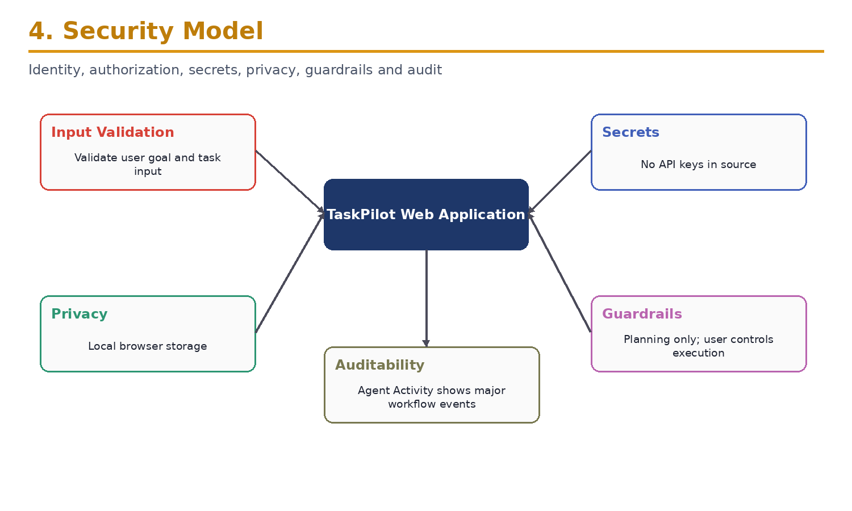
Figure 4: TaskPilot security architecture

Security Controls

Identity and Authentication
The current prototype does not require user authentication. A future multi-user version can add secure authentication or OAuth.

Authorization
The client-side prototype has no administrative server-side functions. Future backend services should enforce authorization for user data, plans and agent tools.

Input Validation
User goals and task inputs should be validated before processing to prevent invalid or unexpected application state.

Data Protection and Privacy
Planning information is stored in browser Local Storage. Users should avoid entering highly sensitive or confidential information into the demonstration application.

Secret Management
The current implementation does not require an external AI API key. If future AI APIs are introduced, credentials should be stored in environment variables or a secure secret manager and never committed to GitHub.
- Do not commit .env or .env.local files containing secrets.
- Do not commit node_modules or generated build artifacts.
- Review dependencies through package.json and package-lock.json.

Guardrails and Auditability
- The agent is limited to planning and productivity assistance.
- The user remains in control of task execution.
- No irreversible external action is automatically performed.
- Agent Activity exposes concise workflow status without hidden reasoning.

5. Monitoring Dashboard Design
The monitoring design covers application health, agent traceability, plan quality, safety, cost and user/business outcomes.
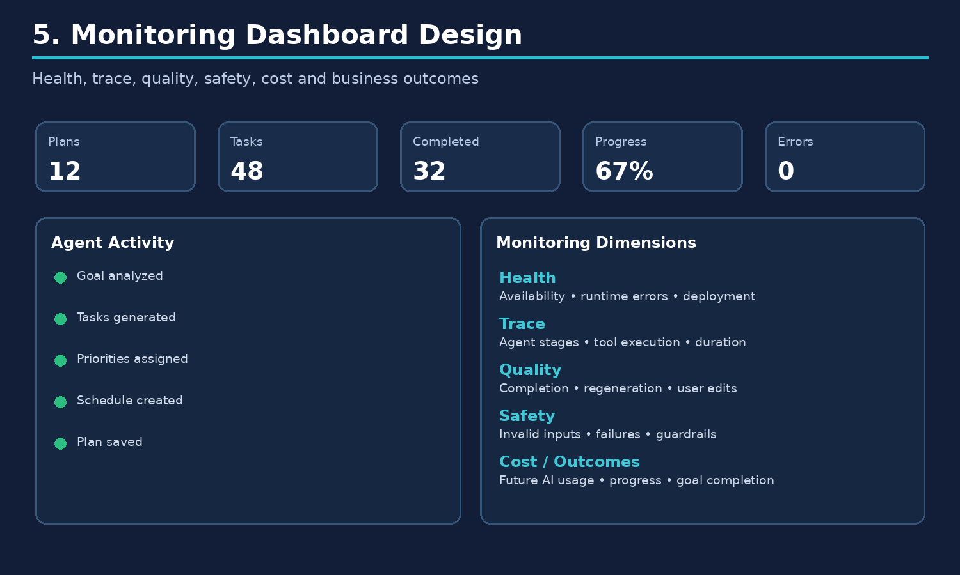
Figure 5: TaskPilot monitoring dashboard design

Key Monitoring Metrics
Dimension | Metrics | Purpose
Application Health | Availability, runtime errors, deployment status | Detect application failures
Agent Trace | Agent stages, tool execution, planning duration | Understand workflow execution
Plan Quality | Task completion, regeneration rate, user edits | Measure usefulness
Safety | Invalid inputs, failures, guardrail events | Detect unexpected behavior
Usage | Plans created, tasks generated, sessions | Understand adoption
Cost | Future API calls, token usage, model requests | Control future AI cost
Outcomes | Progress %, completed tasks, goal completion | Measure user value

Dashboard Components
- Progress view – completion percentage and completed/pending tasks.
- Agent Activity – recent planning workflow events.
- Task and priority summary – workload and priority distribution.
- Health view – future runtime and deployment indicators.
- Outcome view – future goal completion and user activity trends.

Safety and Reliability
- Invalid input attempts
- Failed planning operations
- Unexpected application errors
- Storage failures
- Fallback planning usage

User / Business Outcomes
- Number of plans created
- Task completion percentage
- Plan regeneration rate
- User task modifications
- Goal completion rate
- Returning usage

Capstone Deliverables Summary
# | Artifact | Coverage
1 | Architecture Diagram | Layers, components, trust boundaries and integrations
2 | Agent Workflow Design | Roles, states, tools, handoffs, approvals and failure paths
3 | Deployment Strategy | Runtime, scaling, resilience, environments and release
4 | Security Model | Identity, authorization, secrets, privacy, guardrails and audit
5 | Monitoring Dashboard Design | Health, trace, quality, safety, cost and business outcomes

Project Deliverables
- README.md – project overview, architecture, setup and usage.
- GENERATION_PROMPT.md – prompt used to generate the application.
- TaskPilot_Deliverables.md – Markdown capstone documentation.
- Deployment_Link.md – live application URL.
- screenshots/ – architecture, workflow, deployment, security and monitoring diagrams.

Live Application
TaskPilot – Agentic AI Task Planner: https://easy-push.lovable.app/

Conclusion
TaskPilot demonstrates a compact enterprise-architecture approach to an Agentic AI productivity application. The five deliverables document the system architecture, agent workflow, deployment strategy, security model and monitoring approach. The current prototype is intentionally lightweight and browser-based, while the architecture provides a clear path toward future LLM integration, cloud persistence, authentication, multi-agent collaboration and production-grade observability.

