EduMentor AI
Multi-Agent Learning & Assessment Platform
Student: Nandhini S (2023103088)
Course : Scalable Enterprise Architectural Deployments of Agentic AI Solutions

DOCUMENT CONTROL METADATA
• Artifact Suite: 5/5 Enterprise Capstone Artifacts Completed
• Target Platform: EduMentor AI (Vercel Frontend + Supabase Backend + Gemini API)
• Author: Lead AI Solutions Architect & Capstone Development Team
• Version: 1.0 Final | Status: Verified & Production Ready

Executive Summary & Project Overview
EduMentor AI is an enterprise-grade, multi-agent educational platform engineered to transform static courseware (e.g., PDF textbooks, syllabus documents, and lecture slide decks) into personalized, interactive learning and assessment workflows. By harnessing specialized LLM agents coordinated through an agent orchestrator, EduMentor AI automates question generation, provides immediate, criteria-driven student evaluation, and dynamically generates tailored remedial study plans.
■ CAPSTONE ARCHITECTURE COMPLETENESS
This specification establishes the full 5-part Enterprise Architecture Deliverable suite required for agentic AI projects:
(1) Architecture Diagram & System Topology
(2) Agent Workflow Design
(3) Deployment Strategy
(4) Security Model
(5) Monitoring Dashboard Design.

Artifact 1: Architecture Diagram & Enterprise System Architecture
The system topology is organized into distinct logical layers, enforced by three key trust boundaries. This architectural separation ensures strict isolation between client-side user interactions, serverless agent orchestration, and persistent backend data storage.
1.1 Visual System Architecture Diagram
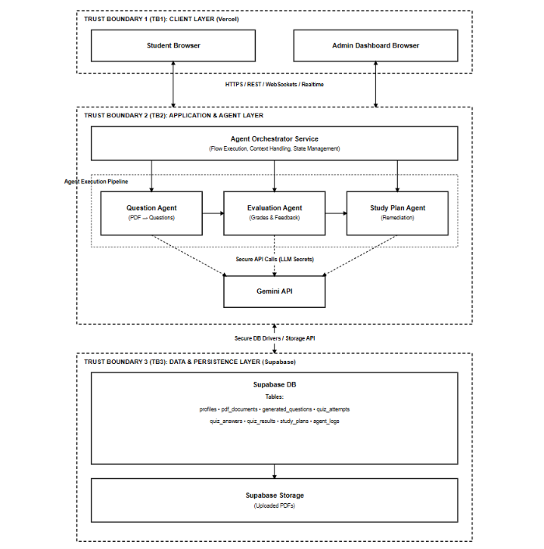

1.2 Layer Breakdown & Component Responsibilities
- 1. Client Layer (TB1): Houses the student interface and admin monitoring portal built with React 18, Tailwind UI, and Vite, deployed on Vercel's global Edge Network.
- 2. Application & Agent Layer (TB2): Contains the Agent Orchestrator which receives user requests, manages context windows, coordinates sequential agent execution, and communicates securely with the Gemini API.
- 3. Data & Persistence Layer (TB3): Powered by Supabase, providing PostgreSQL relational database services, file storage buckets for user PDFs, and Row Level Security (RLS) enforcement.
1.3 Trust Boundaries & Isolation
- Trust Boundary 1 (Client/Frontend): Isolates public web clients from backend execution. Communication occurs strictly over HTTPS/TLS 1.3 using Supabase Auth JWT tokens.
- Trust Boundary 2 (Agent Environment): Protects AI agent tools, prompt configurations, and API keys (`GEMINI_API_KEY`). Clients cannot directly trigger arbitrary agent code or inspect internal prompt templates.
- Trust Boundary 3 (Database & Storage Gate): Protects database tables and stored PDF files. Direct SQL queries are blocked; all access must pass through Supabase Row Level Security (RLS) policies.
1.4 Supabase Database Schema Overview
The persistent relational data model is structured around 8 core tables designed to track user state, document artifacts, quiz interactions, and execution logs:
Table Name | Primary Keys / References | Description & Purpose
profiles | id (FK auth.users) | Stores extended user profile, role (student/admin), and metadata.
pdf_documents | id, user_id (FK profiles) | Tracks uploaded PDF metadata, extraction status, and storage URL.
generated_questions | id, document_id (FK pdf_documents) | Stores generated MCQs, True/False, and short-answer items.
quiz_attempts | id, user_id, document_id | Records student quiz sessions, timestamps, and overall scores.
quiz_answers | id, attempt_id, question_id | Logs individual student answers submitted per question.
quiz_results | id, attempt_id | Stores calculated accuracy, marks breakdown, and detailed feedback.
study_plans | id, user_id, attempt_id | Contains tailored daily learning goals and weak topic remediation plans.
agent_logs | id, user_id, agent_name | Audit log capturing execution timing, token usage, errors, and agent traces.
Artifact 2: Agent Workflow Design & Multi-Agent System
EduMentor AI implements a Multi-Agent System (MAS) architecture. Rather than relying on a single monolithic LLM prompt, the system divides pedagogical tasks among three highly specialized autonomous agents connected via strict sequential handoffs.
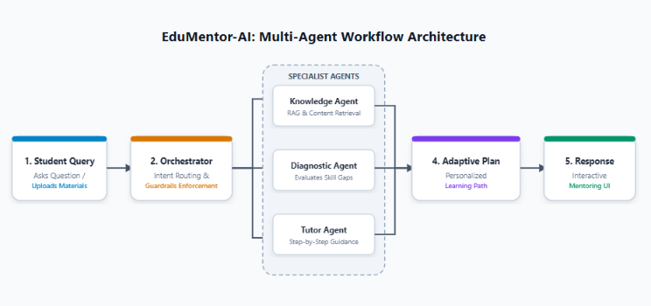
2.1 Question Generation Agent
- Role: Parses uploaded course materials, identifies core concepts, and synthesizes structured quiz questions.
- States: `IDLE` -> `EXTRACTING_TEXT` -> `IDENTIFYING_TOPICS` -> `GENERATING_QUESTIONS` -> `STORED` -> `ERROR_FALLBACK`
- Tools Used: PDF Parser, Gemini Flash 1.5 LLM API, Supabase Database Client.
- Input: Raw PDF file uploaded to Supabase Storage bucket.
- Output: Structured JSON payload containing Multiple Choice Questions (MCQs), True/False items, and Short Answer questions with answer keys and topic tags.
2.2 Evaluation Agent
- Role: Grades student quiz submissions against correct solutions, providing semantic evaluation for short answers and instant grading for objective items.
- States: `AWAITING_SUBMISSION` -> `FETCHING_ANSWER_KEY` -> `COMPARING_ANSWERS` -> `CALCULATING_SCORE` -> `GENERATING_FEEDBACK` -> `RESULTS_LOGGED`
- Tools Used: Semantic Evaluator Tool, Gemini Pro LLM, Scoring Engine.
- Input: Student submitted responses + original question objects from `generated_questions`.
- Output: Overall numerical score, percentage accuracy, topic-level performance metrics, and actionable feedback per question.
2.3 Study Planner Agent
- Role: Analyzes historical assessment results to construct personalized remedial study schedules.
- States: `ANALYZING_PERFORMANCE` -> `IDENTIFYING_WEAK_TOPICS` -> `CONSTRUCTING_SCHEDULE` -> `GENERATING_GOALS` -> `PLAN_PUBLISHED`
- Tools Used: Performance Matrix Analyzer, Study Plan Generator (Gemini API), Calendar Formatter.
- Input: Evaluation results from `quiz_results` + historical quiz attempt logs.
- Output: Multi-day structured study plan featuring targeted learning goals, weak concept reviews, and recommended study activities.
2.4 Agent Handoffs, Approvals & Guardrails
Agent execution flows sequentially. The Question Agent writes questions to `generated_questions`. When a student completes a quiz, the Evaluation Agent is triggered. The output of the Evaluation Agent automatically serves as input for the Study Planner Agent.
- Schema Guardrails: Strict JSON schema validation ensures that LLM outputs match expected table shapes before insertion into Supabase.
- Human Approvals: Students must confirm quiz submission before evaluation commences; Admins can review and override generated questions prior to public student deployment.
2.5 Failure Paths & Resilience Mechanisms
Failure Scenario | Detection Point | Fallback & Recovery Strategy
Corrupt / Scanned PDF | Question Agent (Extract Text) | Detects low text-to-page ratio; triggers OCR pipeline fallback or alerts user to upload readable text PDF.
LLM Rate Limit / Timeout | Gemini API Call | Triggers exponential backoff retry (up to 3 attempts); if exhausted, falls back to pre-cached topic question bank.
Malformed JSON Output | Agent Orchestrator | JSON Schema validator fails; auto-initiates single-shot repair prompt to LLM to re-format output payload.
Artifact 3: Deployment Strategy & Lifecycle
EduMentor AI is engineered for seamless cloud-native deployment utilizing modern serverless architecture, minimizing operational overhead while supporting smooth scaling from student prototype to production enterprise workload.
3.1 Target Runtimes & Infrastructure
- Frontend Hosting: Vercel Edge Network hosting the React Single Page Application (SPA). Automatic builds triggered on GitHub main branch commits.
- Backend Services: Fully managed Supabase Cloud instance providing PostgreSQL 15, Auth microservices, Realtime WebSockets, and S3-compatible File Storage.
- AI API Runtime: Serverless REST / gRPC endpoint calls to Gemini API guarded by backend environment variables.

3.2 Environment Topology & Build Script
Deployment is configured across isolated environments (Development, Staging, Production):
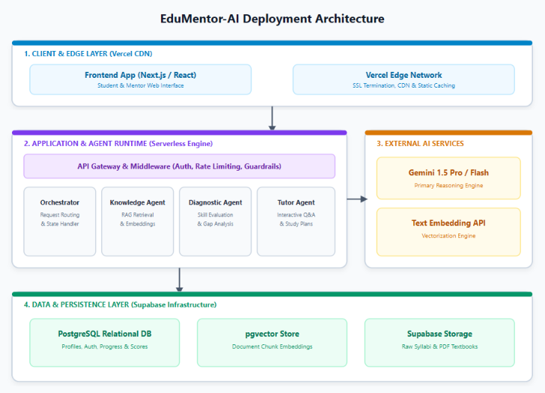
3.3 Scaling Matrix (Phase 1 vs. Phase 2)
Dimension | Phase 1: Capstone / Prototype | Phase 2: Enterprise Production Scale
Compute & Hosting | Vercel Hobby / Free Tier | Vercel Pro / Enterprise with custom CDN edge caching
Database & Storage | Supabase Free Tier (500MB DB, 1GB Storage) | Supabase Pro / Dedicated Compute with PgBouncer connection pooling
AI API Quota | Gemini API Standard Tier | Gemini Enterprise API with provisioned throughput & regional failover
Artifact 4: Security Model & Governance
Security is designed directly into the data architecture. EduMentor AI enforces Zero Trust principles between untrusted client browsers and internal database resources.
4.1 Identity & Authentication
Authentication is powered by Supabase Auth using JWT (JSON Web Tokens). Supported flows include Email/Password registration, password reset workflows, and session token renewal.

4.2 Role-Based Access Control (RBAC) Matrix
Resource / Action | Student Role | Admin Role
Uploaded PDFs & Quizzes | Access OWN uploaded documents and quiz attempts only | Access ALL user documents and quiz records
Study Plans & Results | View OWN generated study plans and evaluation scores | View aggregate user performance and system analytics
Agent Execution Logs | NO ACCESS (Blocked by RLS) | FULL ACCESS to inspect `agent_logs` and debug traces
User Management | NO ACCESS | FULL ACCESS to modify user roles and view system activity
4.3 Row Level Security (RLS) Policy Specifications
Every database table has strict RLS enabled in PostgreSQL. Example SQL policy for student data isolation:
4.4 Secrets & Audit Logging
- Secrets Isolation: All API keys (`GEMINI_API_KEY`, `SUPABASE_SERVICE_ROLE_KEY`) are stored in server-side environment variables and never bundled into frontend JS code.
- Audit Logging: Every agent interaction, PDF upload, login event, and quiz evaluation is recorded in `agent_logs` with timestamps, latency, and status code.
Artifact 5: Monitoring Dashboard Design
The Admin Monitoring Dashboard provides real-time operational observability, tracking system health, agent execution quality, resource costs, and student educational outcomes.
5.1 Dashboard Layout & Core Metric Panels
Dashboard Section | Monitored Metrics / Indicators | Target SLA / Operational Goal
System Health Cards | Total Users, Total PDFs Processed, Total Quizzes, Total Study Plans | 99.9% Uptime across frontend & database
Agent Monitoring | Questions Generated, Evaluations Performed, Study Plans Built, Agent Success Rates | > 98% Success Rate per agent execution
Usage & Performance | Daily Uploads Chart, Quiz Attempt Trends, Average Latency per Agent Call | < 3s Question Gen, < 1.5s Evaluation
Safety & Exceptions | PDF Parse Failures, LLM Timeout Alerts, Rate Limit Hits, RLS Violations | < 0.5% Error Rate requiring manual retry
Business Outcomes | Average Student Score, Top Performing Topic, Weakest Concept, Score Improvement Rate | > 15% Average student score increase

