/***************************

4107056019 廖柏丞 第7次作業 12/9

4107056019 Bocheng Liao The 7th Homework 12/9

***************************/

1. SELECT *, FLOOR(DATEDIFF(CURRENT_DATE, birthdate) / 365.25) AS age FROM `health`  
   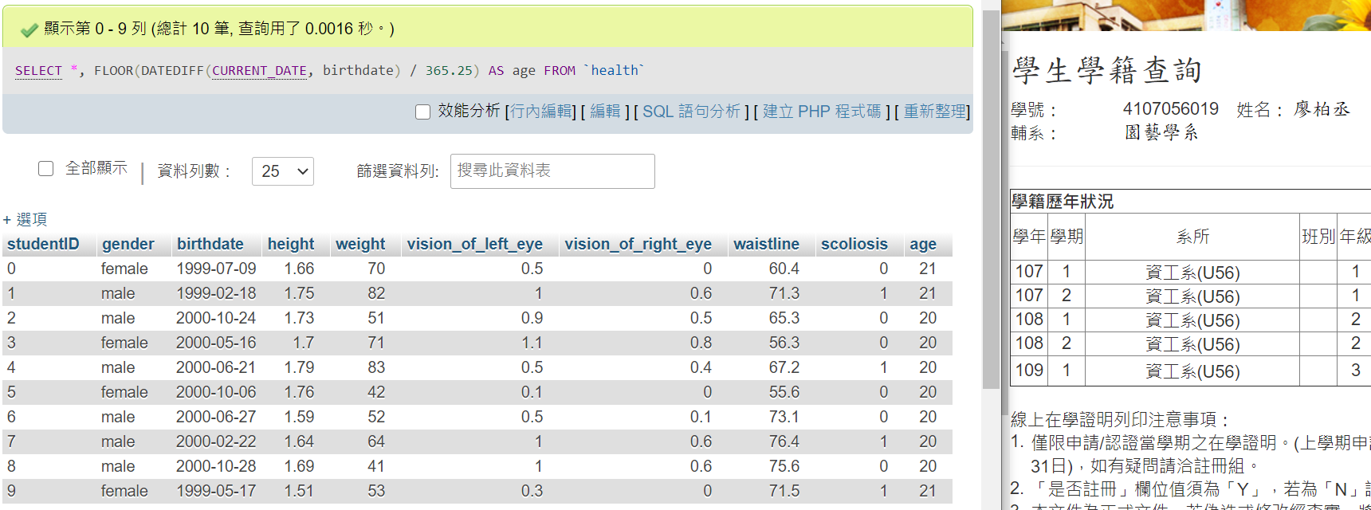  
   SELECT AVG(h.age) FROM (  
    SELECT *, FLOOR(DATEDIFF(CURRENT_DATE, birthdate) / 365.25) AS age FROM `health`  
   ) AS h;  
   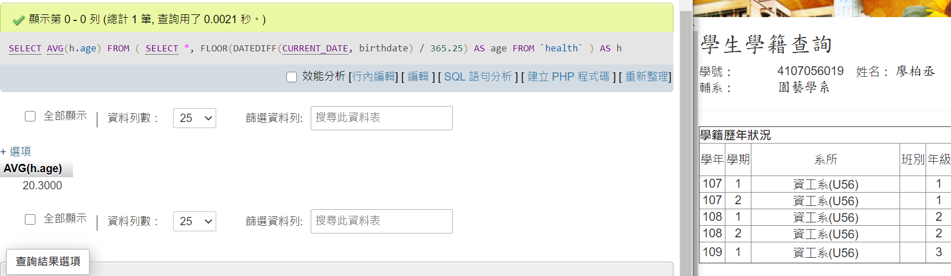
2. SELECT * FROM `health`   
   WHERE `vision_of_left_eye` < 0.8 and `vision_of_right_eye` < 0.8  
   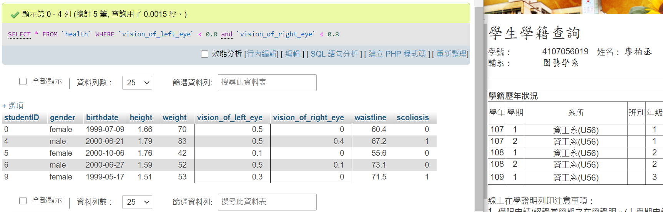
3. SELECT *, (`weight`/`height`/`height`) as BMI FROM `health`  
   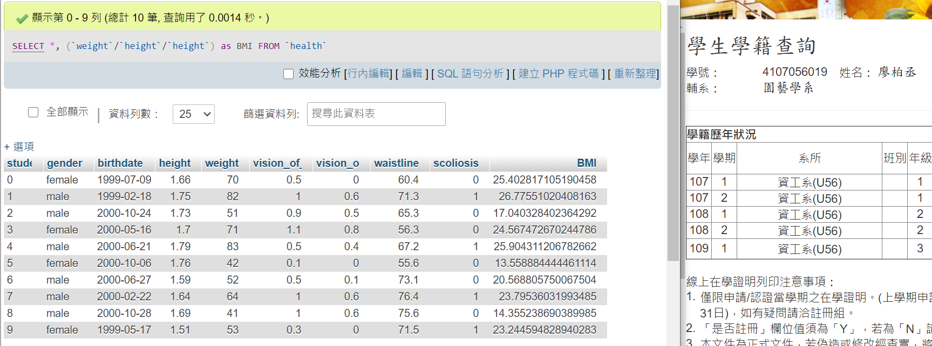  
   SELECT * FROM( SELECT *, (`weight`/`height`/`height`) as BMI FROM `health`) AS h WHERE h.BMI NOT BETWEEN 18.5 AND 24  
   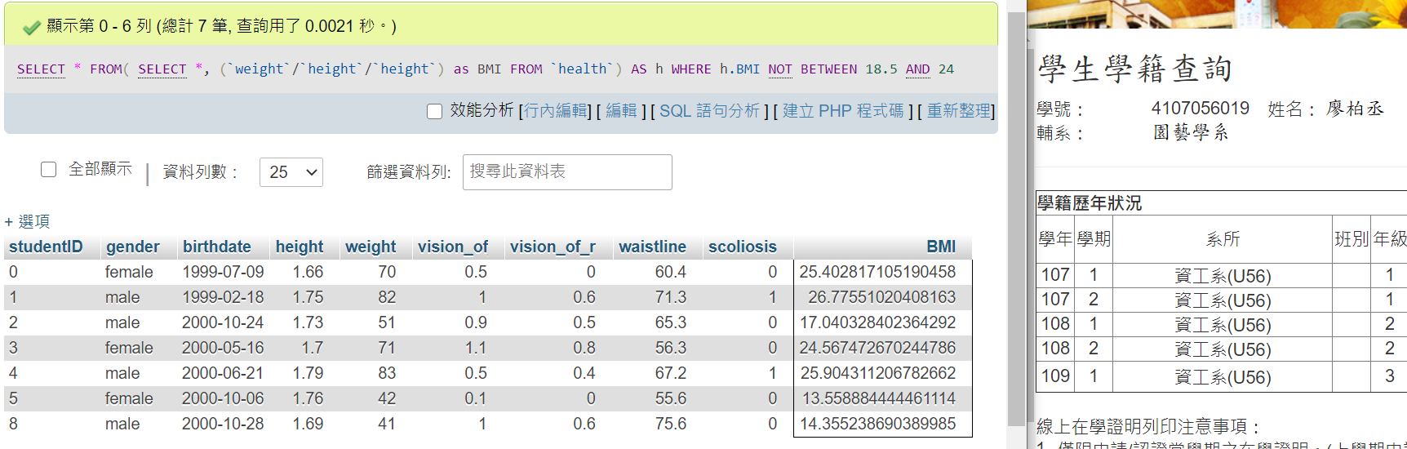
4. SELECT * FROM `health`  
   WHERE (`gender`='male' AND `waistline` >= 90)  
   OR (`gender`='female' AND `waistline` >= 80)  
   