**InQuire®**

**User Guide**

**Rev. <0.6> Approved**

**Prepared by David Yu**

**<03/30/2017>**

**Insyde Software Corp.**

Copyright (c) 1998-2017, All Rights Reserved.

Insyde Software Corp.

No part of this publication may be reproduced, transmitted, transcribed, stored in a retrieval system, or translated into any language or computer language, in any form, or by any means, electronic, mechanical, magnetic, optical, chemical, manual or otherwise, without the prior written permission of Insyde Software Corp.

**Disclaimer**

Insyde Software Corp. provides this document and the programs "as is" without warranty of any kind, either expressed or implied, including, but not limited to, the implied warranties of merchantability or fitness for a particular purpose.

This document could contain technical inaccuracies or typographical errors. Changes are periodically made to the information herein; these changes will be incorporated in future revisions of this document. Insyde Software Corp. is under no obligation to notify any person of the changes.

The following trademarks are used in this document:

 is a registered trademark of Insyde Software Corp.

All other trademarks or trade names are property of their respective holders.

**Revision History**

|  |  |  |  |  |
| --- | --- | --- | --- | --- |
| **Rev.** | **Date** | **Author** | **Approver** | **Summary** |
| 0.1 | <03/22/2016> | David Yu |  | Initial Version |
| 0.2 | <06/17/2016> | David Yu |  | Add more information for new function support. |
| 0.3 | <07/06/2016> | David Yu |  | Revise and add information |
| 0.4 | <08/30/2016> | David Yu |  | Revise and add information |
| 0.5 | <11/24/2016> | David Yu |  | Revise and add information  1.File center 2. Super search 3. Message center |
| 0.6 | <03/30/2017> | David Yu |  | Revise and change function name |
|  |  |  |  |  |
|  |  |  |  |  |
|  |  |  |  |  |
|  |  |  |  |  |
|  |  |  |  |  |
|  |  |  |  |  |

**Table of Contents**

1. Introduction 1

1.1 Overview 1

1.2 Reference 2

1.2.1 Definitions, Glossaries, Acronyms, Abbreviations 2

2. Getting Started with InQuire 3

2.1 Requirements for the InQuire Utility 4

2.2 Account information for InQuire 4

2.3 Home page 5

2.4 Subscription 6

2.5 CODE 7

2.6 Issue Tracking 8

2.7 Training 9

2.8 Download 10

2.9 Super Search 11

2.10 Notification 12

3. Live update 13

4. Trouble shooting 14

# Introduction

The InQuire utility provides easy, centralized access to all of Insyde Software's online cloud services.

## Overview

This document provides an overview for using InQuire and the services you can access from it.

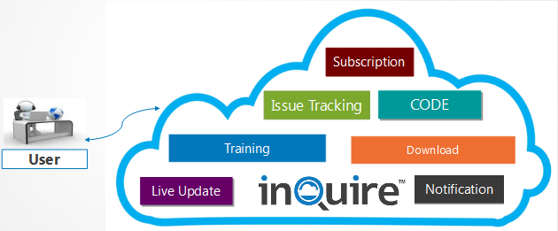

**InQuire benefits:**

* Convenience – integrate all Insyde software services into one utility.
* Faster logins – use a single login for all service functions.
* Enhancing service efficiency can help improve the overall development experience.

## 1.2 Reference

The following publications and sources of information may be useful to you.

### Definitions, Glossaries, Acronyms, Abbreviations

|  |  |
| --- | --- |
| **Term** | **Description** |
| **ITS** | **I**ssue **T**racking **S**ystem |
| **SVN** | Subversion for source version control system |
| **TOD** | Training on Demand |

# Getting Started with InQuire

When you have completed the InQuire installation process from the InQuire installer package, the program should successfully launch for the first time. You will be greeted by InQuire's home page, which will display a line of tabs at the top of the utility window. Each tab provides quick access to our services.

* **Subscription**: Retrieve information from subscribed publications through this service.
* **CODE**: Review the authorized source code repository.
* **Issue Tracking:** Report issues to Insyde and track it via the ITS (Issue Tracking System).
* **Training:** Training On Demand consists of training videos provided by Insyde Software.
* **Download:** Download available tool packages and documents.
* **Super Search:** Search for information from Insyde’s Subscription, Issue Tracking, CODE and WIKI services .
* **Notification:** See the latest publication messages from Insyde.

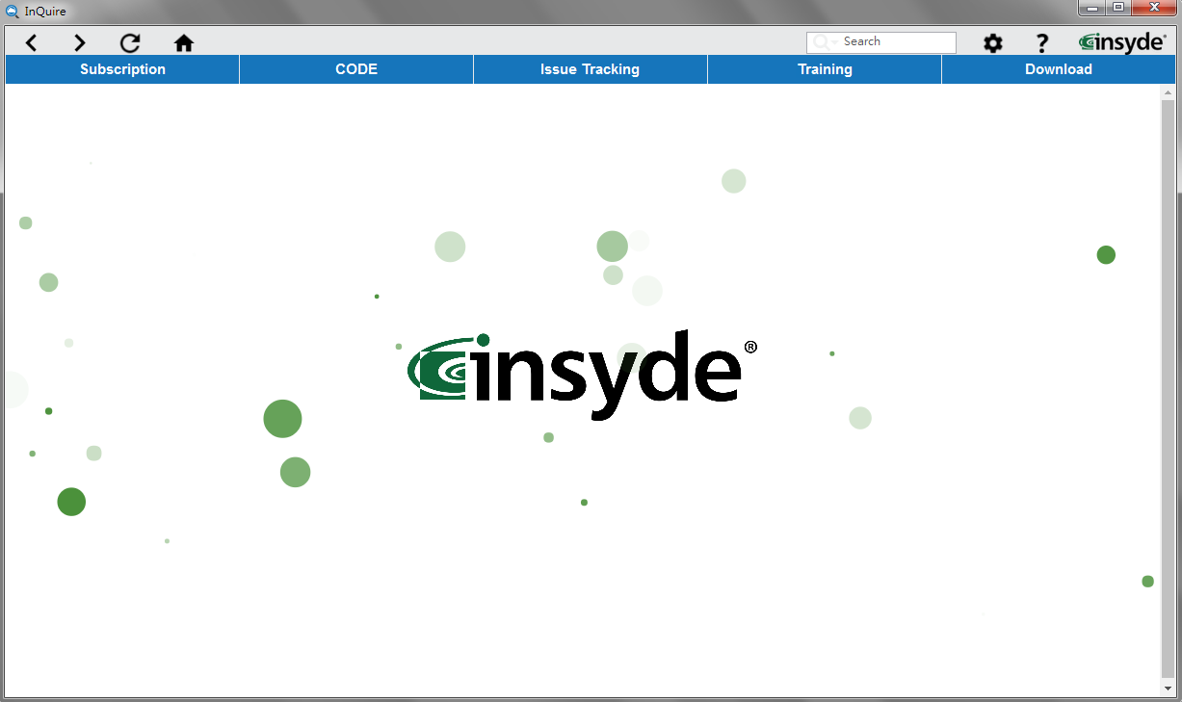

## 2.1 Requirements for the InQuire Utility

* Have a current account and password for Insyde’s Subscription, Issue Tracking system, Code/SVN and VPN services.
* PC Environment: Microsoft Windows 7 and later are supported.

## 2.2 Account information for InQuire

After setup has finished, InQuire will request the account information for all supported Insyde services. To continue, you must first set a master password for InQuire (which is required to open and use InQuire securely) and then fill in all account information for the Insyde services you wish to access via InQuire.

Your account settings must be provided to access each of the following services:

* **Master password**:
* Please input your e-mail address.
* The master password is requested when entering InQuire. Please input your master password.
* **Subscription**: Used when logging into the Subscription service.
* **Issue Tracking**: Used when logging into the Issue Tracking service.
* **CODE/SVN**: Used when logging into the CODE/SVN service.
* **VPN**: Used when logging into VPN to connect to Insyde services from an external location.

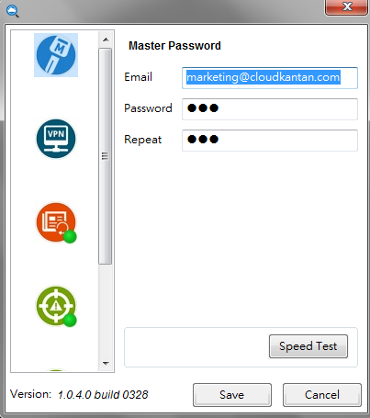

## 2.3 Home page

When InQuire is opened, it defaults to the home page, which displays Insyde Software’s website. Pressing the home icon will also load the home page.

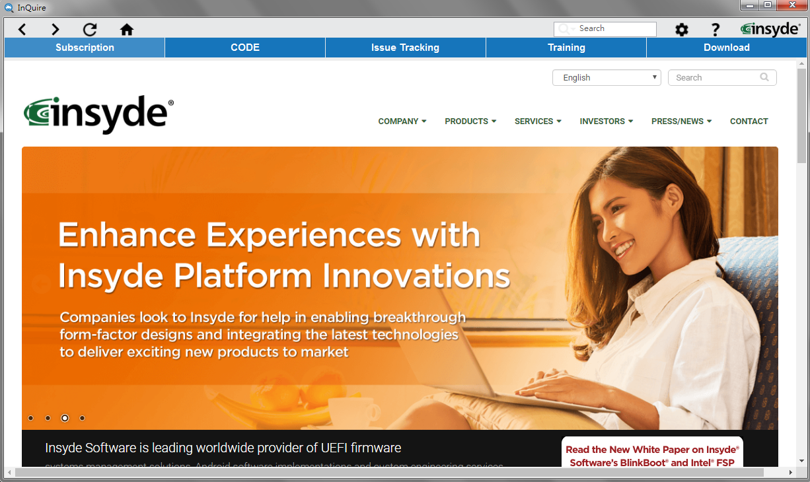

## 2.4 Subscription

Subscription is publication service page that retrieves information from subscribed publications through this service. In order to easily query information, there are related nodes information in tree view on the left side. When you click one of nodes in the tree view that you would like to query, it will present the related information on a publication list.

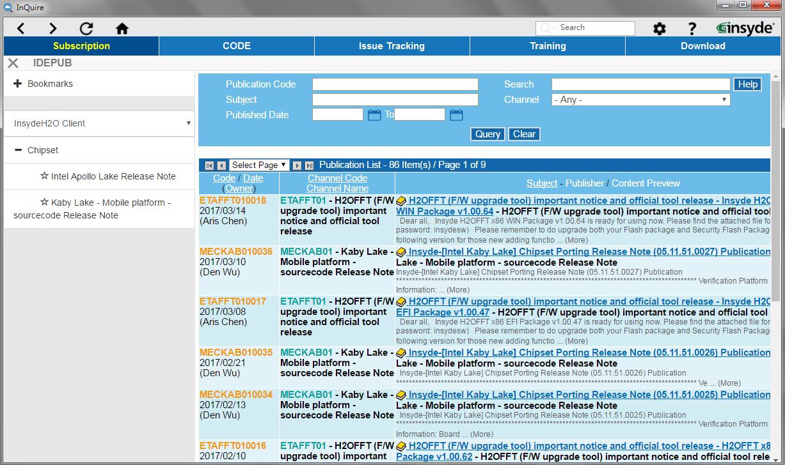

## 2.5 CODE

CODE is a source code repository list page that allows authorized review of each source code repository.

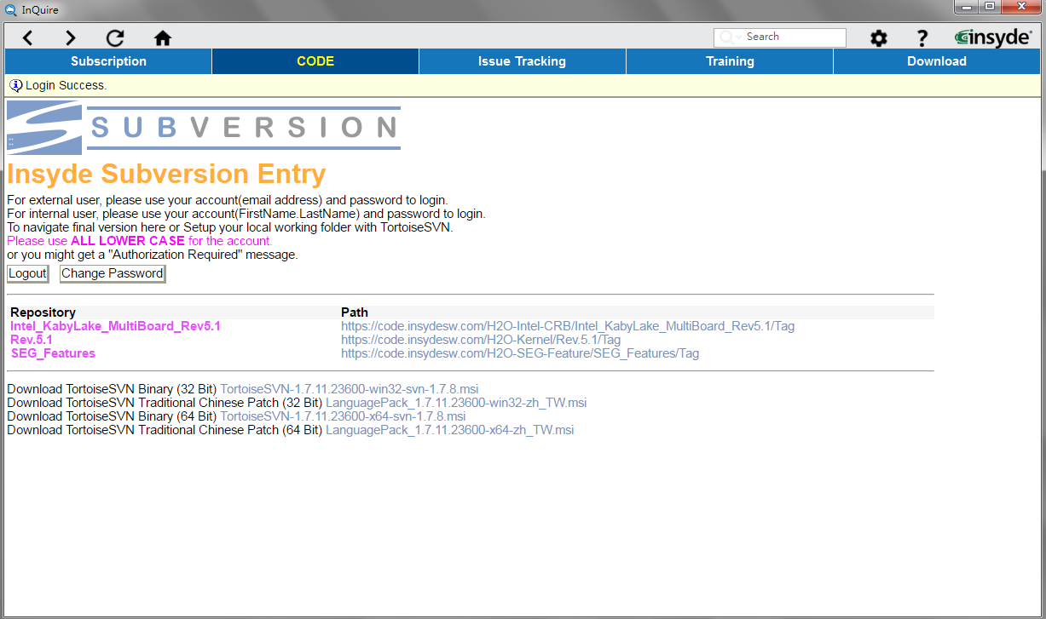

## 2.6 Issue Tracking

The Issue Tracking Service page can report issues to Insyde Software and help track it.

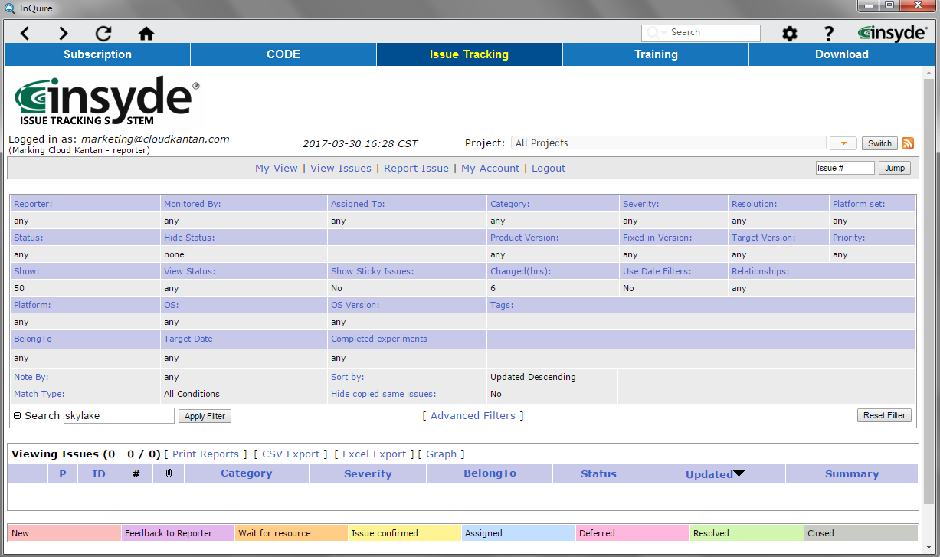

## 2.7 Training

Training represents the Training-on-Demand service that provides online developer training courses from Insyde Software. You can select from available training subjects via the provided playlists and play them from within InQuire.

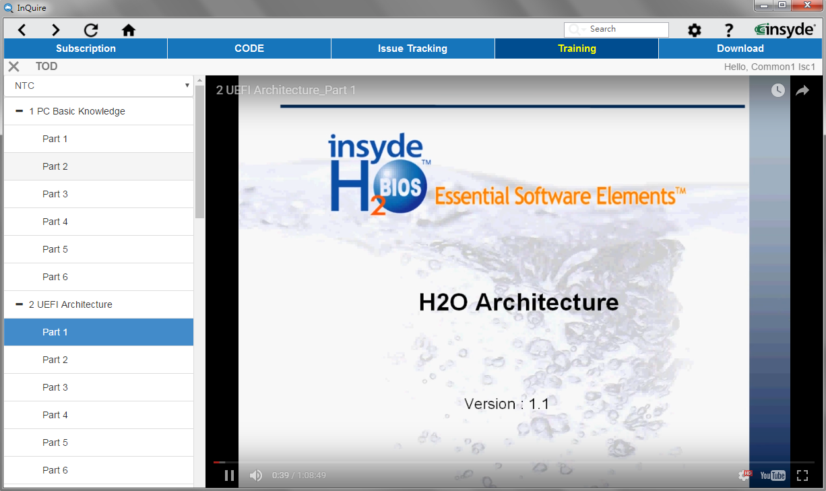

## 2.8 Download

The Download service provides the capability to download related tool packages or documents directly from Insyde Software. Select from available packages or documents via the class lists and download from the service to your local disk.

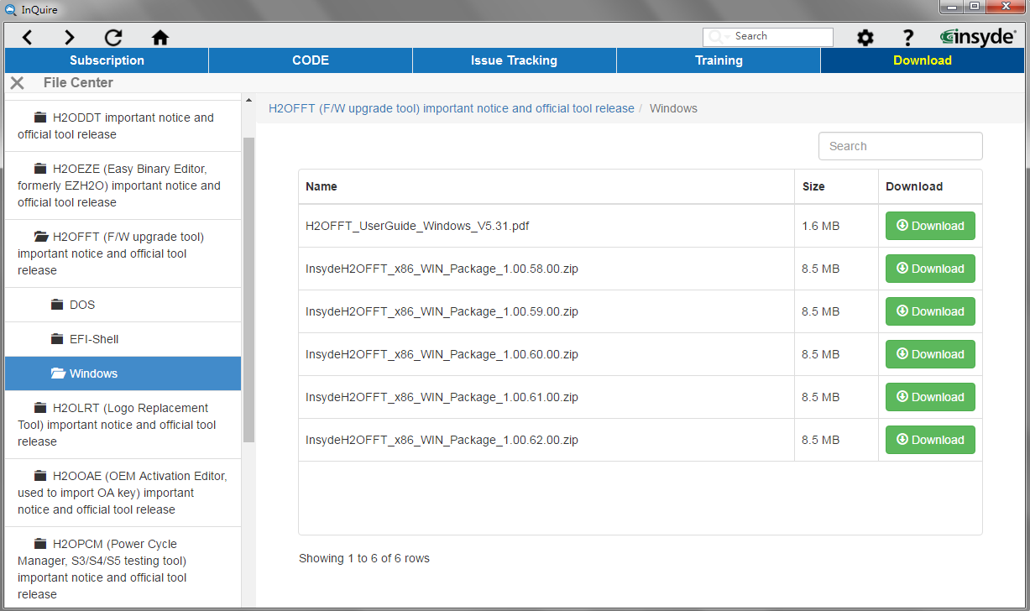

## 2.9 Super Search

Super search can assist users to query information from Insyde’s Subscription, Issue Tracking, CODE and WIKI services via key word.

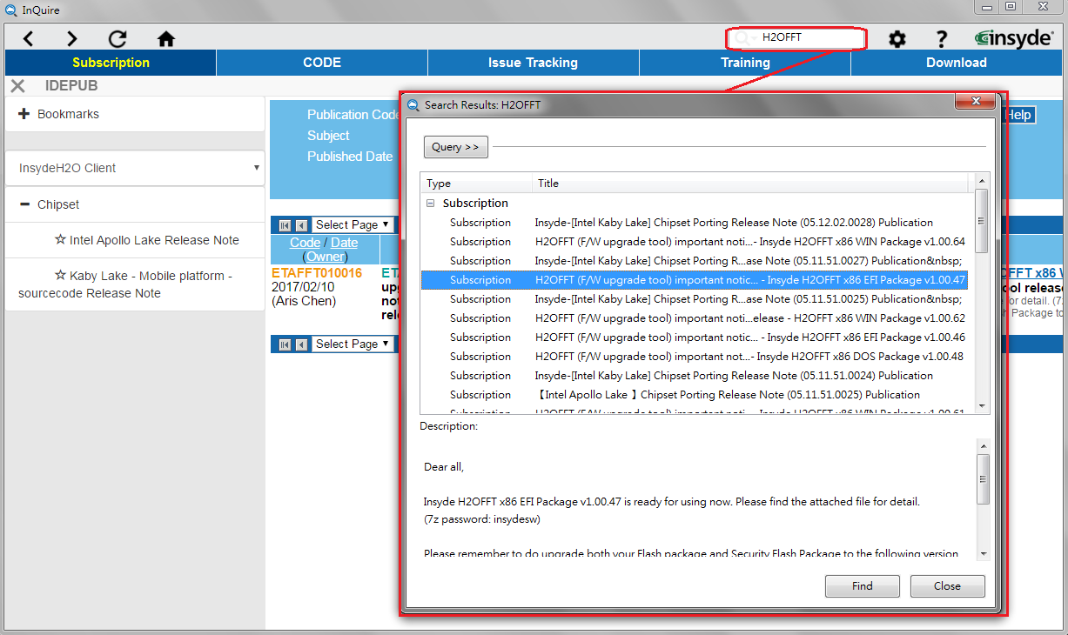

## 2.10 Notification

Notifications will automatically display in the right bottom corner and provide updates for the latest available publications. Clicking on the detail button within the notification window will redirect to the Subscription service page for a detailed description.

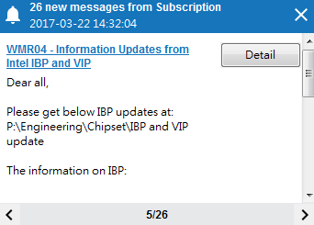

# 3. Live update

Insyde Live Update helps automatically ensure that all InQuire utilities are up-to-date via the

internet. When a new version of an Insyde Software utility is available, the Insyde Live Update icon will be visible from the Windows task bar.

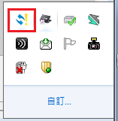

You can also manually use the right mouse button on the Insyde Live Update icon to select “Immediately Update” to perform the update process.

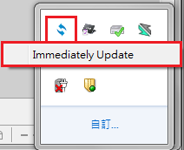

When there are available updates, the latest version of InQuire and other related Insyde tools will be

listed within the Insyde Live Update Window. Select the tools you would like to update, then start the update process by pressing the "Update" button.

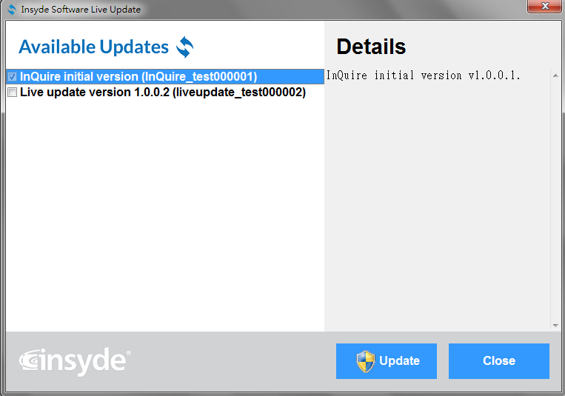

# 4. Trouble shooting

1. How to verify if InQuire’s Training function is available:
2. If Training is available, you will see a welcome screen when you access the Training function.

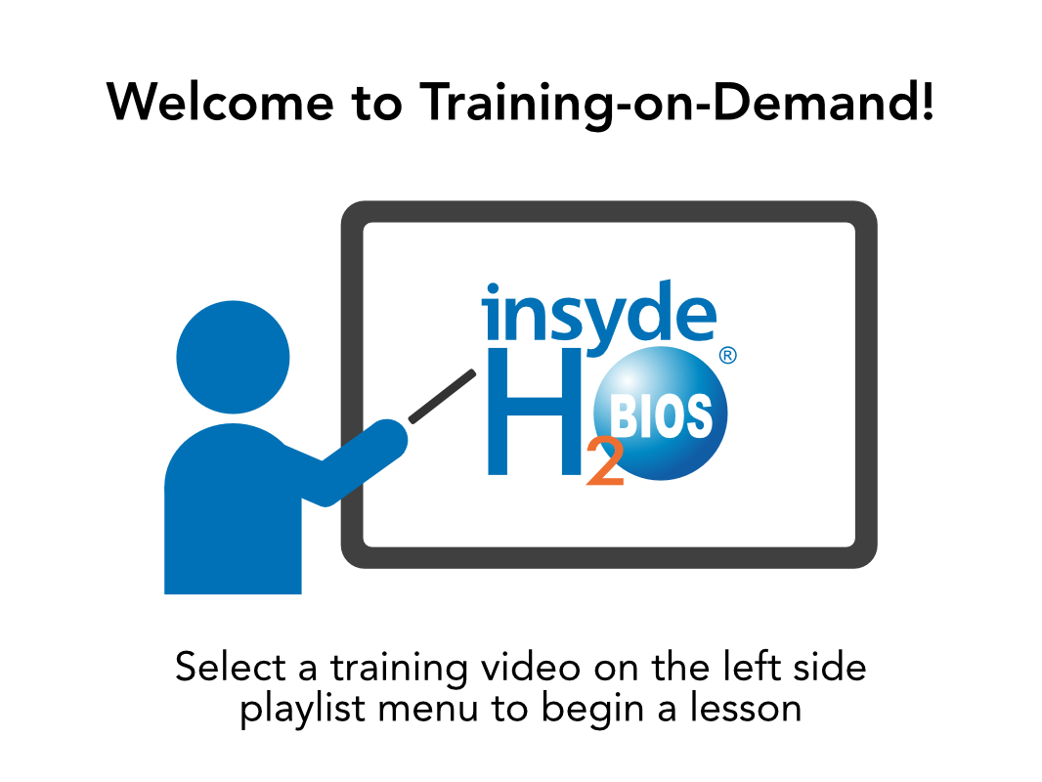

1. If Training is **not** available, you will see the screen below.

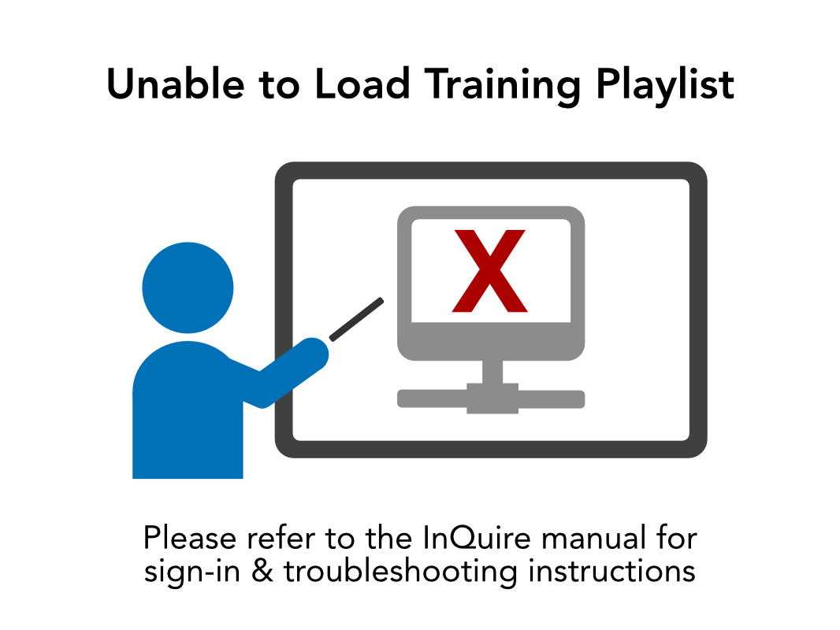

If you see this page, it means that InQuire is not able to connect to the Training service. Please check that you have completed the following steps.

**Step 1.** Ensure that the VPN is connected to Insyde.

**Step 2.** Contact an Insyde Software sales representative and provide your Google account (Gmail address) to apply for authorization. Our training videos utilize the YouTube platform for streaming, so you must provide this information to access these private videos.

**Step 3.** Once your account is authorized, you will receive notification for access to the training course from YouTube.

**Step 4.** Click "Sign in with Google" as shown below.

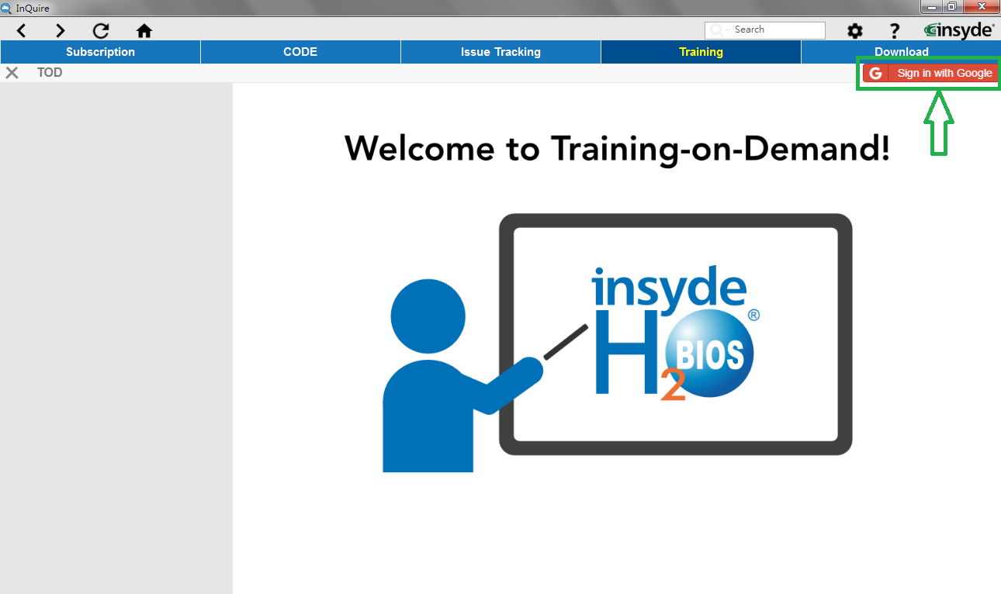

**Step 5.** Enter your Gmail address and password for Google to complete the registration process for access to the training playlists.

All available training courses should be listed on the left side of the utility and be ready for viewing. If you still cannot access the training course from within InQuire, please contact Insyde Sales for troubleshooting.