Part 1

For processes class which used system calls in C++ as command “ps –A | grep argv | wc -l”, it replicate the functioning of a Linux shell running the command line. Because they are parents, the fork must wait for the child to complete. Between each fork, the pipe is used to take in child output and passes it to the parent to connect them. When each child fork is complete task, return to bash and exit.

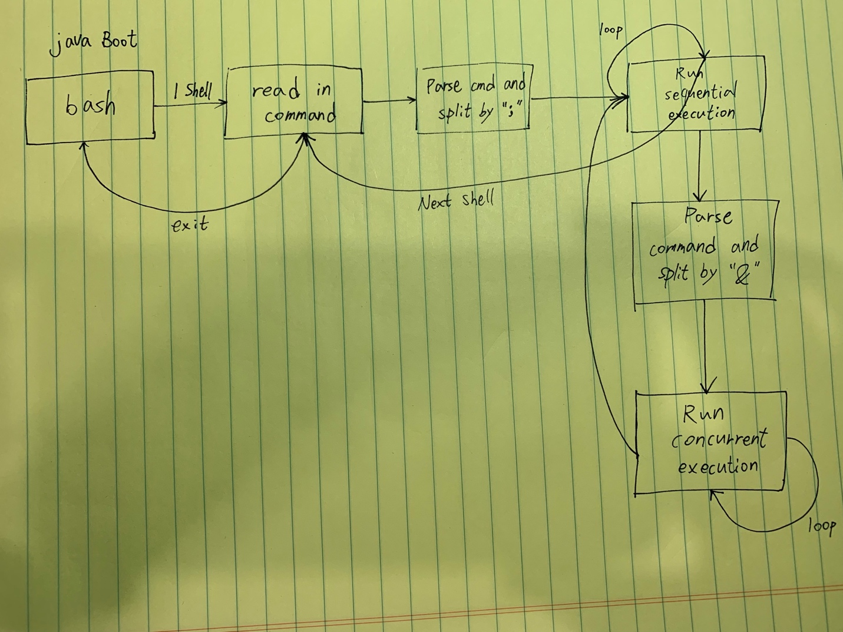

Part 2

Shell.java accepts commands and implements concurrent and / or sequential execution by implementing a minimum of command execution shell within ThreadOS. The main while loop is executed consecutively by accepting user input and parsing each line of user input with a command to execute. Repeat the same process until the last command is reached.

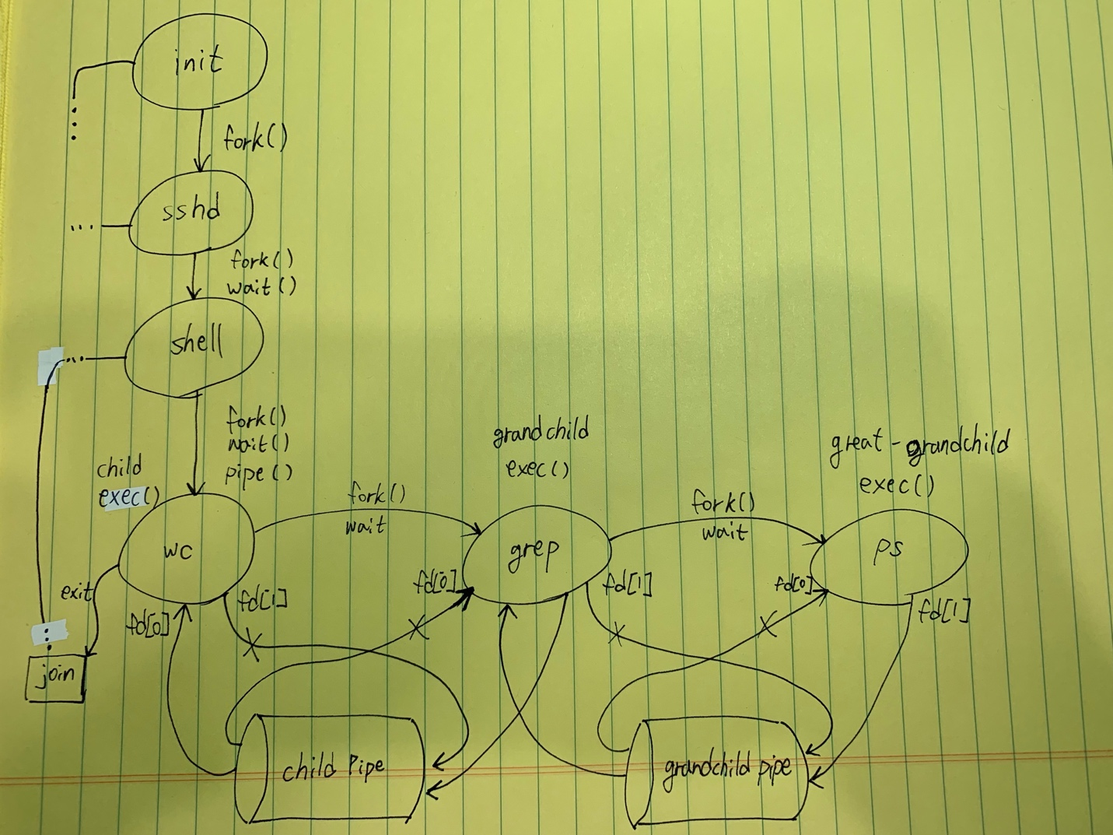

Output:

Part 1

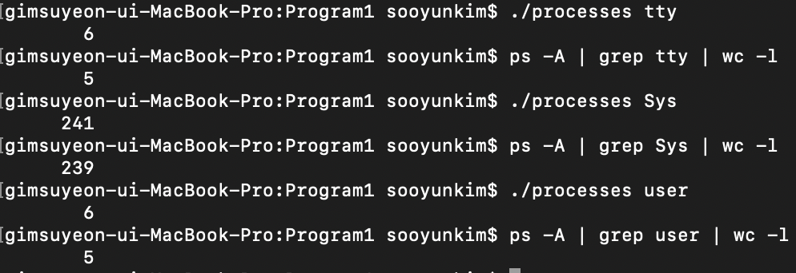

Part 2

