## Lecture 10 group practice

1. **FD**
2. For Staff relation below, check whether the follow FDs are Correct or not

staffNo -> salary

salary -> staffNo

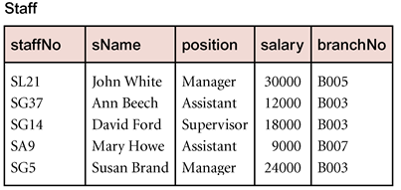

1. Find FDs in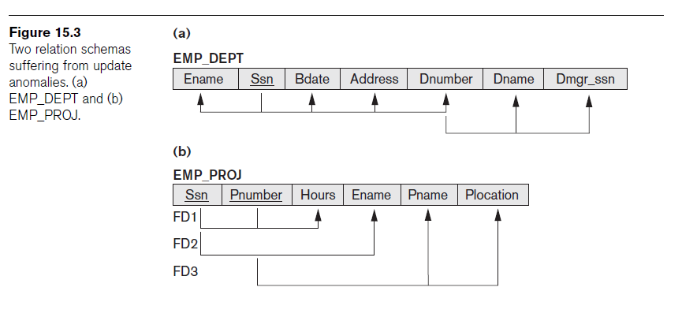
2. **Nested table to 1NF**

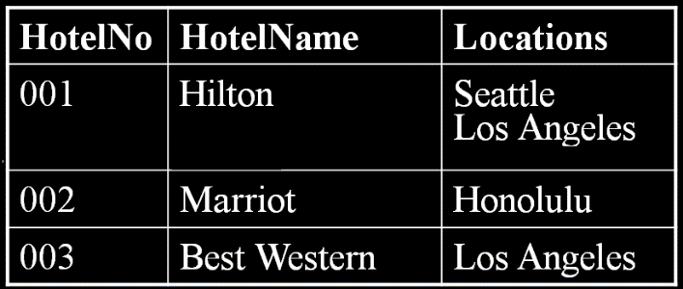

1. **in 2NF? Why? If not, how to get to 2NF?**

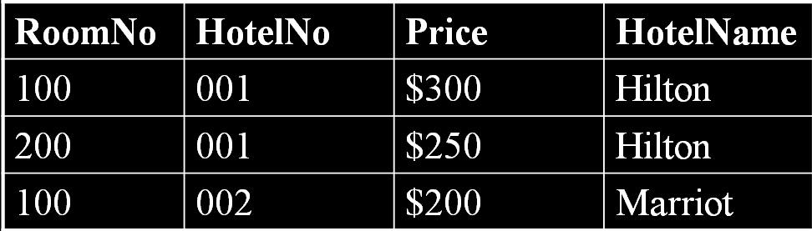

**FDs**

* **If A and B are attributes (or attribute sets) of relation R, B is functionally dependent on A (denoted A→B), if each value of A in R is associated (at any time) with exactly one value of B in R.**

**To change nested relations to 1NF:**

* **Remove nested relation attributes into a new relation**
* **Propagate the primary key into it**
* **If multi-level nested, unnest relation into a set of 1NF relations**

**2NF - A relation that is in 1NF and every non-key attribute is fully functionally dependent on the key (i.e., PK or secondary key)**