## Lecture 11 group practice

## List superkey, candidate key, and non-key attributes (non-key attribute: not part of key) from the below table (assuming movie_ID is unique for each movie). Superkeys don’t need to be exhaustive

## 

1. List full FDs, partial FDs (i.e., FD but not full), trivial FDs. Partial FDs and Trivial FDs don’t need to be exhaustive



1. in 2NF? In 3NF? Why? If not, how to get to 3NF?
2. 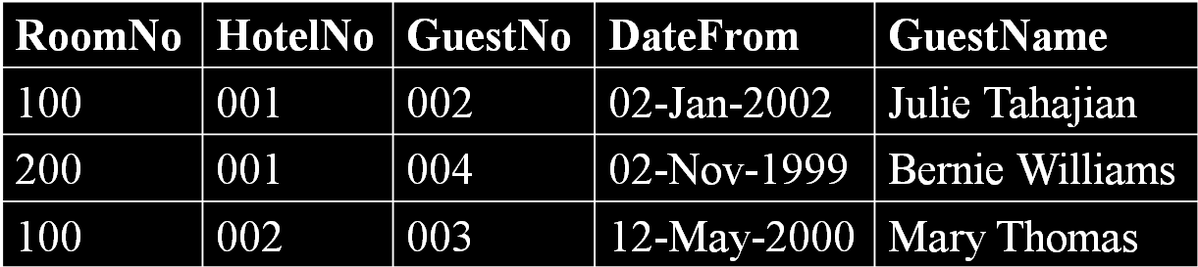
3. 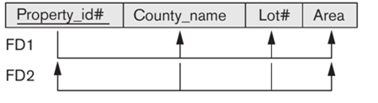
4. 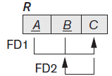
5. In BCNF?



1. Assuming the following FDs hold, which normal form is it in? How to get to BCNF?



**FDs**

* **If A and B are attributes (or attribute sets) of relation R, B is functionally dependent on A (denoted A→B), if each value of A in R is associated (at any time) with exactly one value of B in R.**

**To change nested relations to 1NF:**

* **Remove nested relation attributes into a new relation**
* **Propagate the primary key into it**
* **If multi-level nested, unnest relation into a set of 1NF relations**

**2NF - A relation that is in 1NF and every non-key attribute is fully functionally dependent on the key (i.e., PK or secondary key)**

**3NF - R is in 3NF if it satisfies 2NF *and* every non-key attribute of R is directly (i.e., non-transitively) dependent on the key**

* **If 2NF but not 3NF: non-key attribute determines non-key attribute**

**BCNF - A relation is in BCNF if and only if every determinant is a candidate key**

* **Stricter than 3NF: 3NF allows a key attribute to be functionally dependent on attribute(s) that is not a candidate key**

**Decompose to certain NF (denoted as XNF, i.e., 2NF, 3NF, BCNF)**

* **Look for a nontrivial functional dependency X->Y violates XNF (generally add to the right side Y as many attributes as are functional determined by left X)**
* **Break to two overlapping relation schemas: {X+others} & {X+Y}**
* **Loop through the process as needed**