## Lecture 15 group practice

1. Check whether the following schedules have problem and why?

S1:

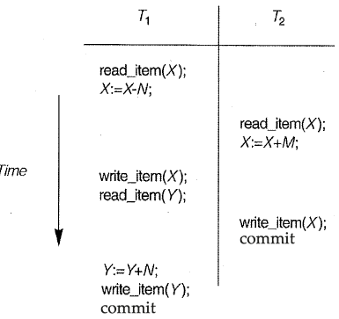

S2:

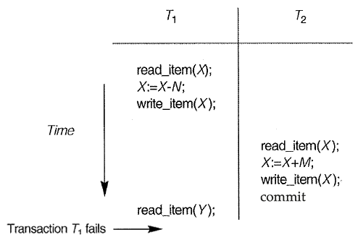

S3:

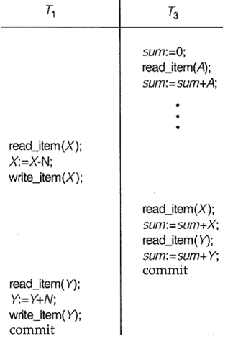

1. Identify conflict operations from the following schedule

r1(x); w1(x); r2(x); w2(x); r1(y);

1. Draw precedence graph for S1 in Q1