**Lecture 2 notes & practice**

ER notations:

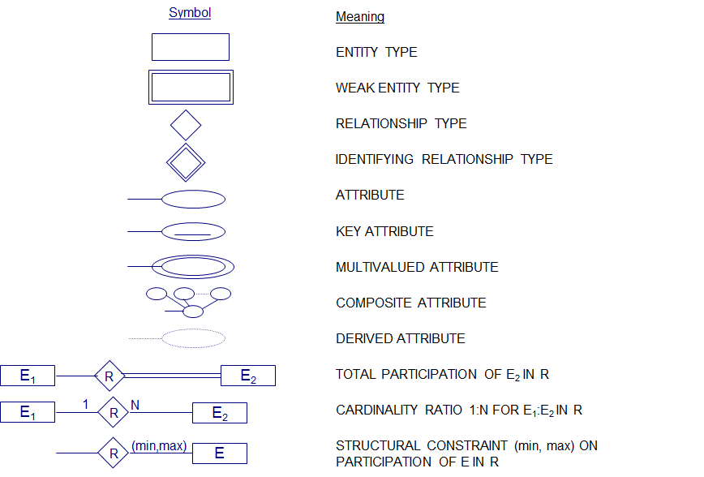

1. Draw E/R diagram for entity type STUDENT

Assume in a university database, the attributes of STUDENT are name, SSN, DOB, age, earned degrees (each earned degree should contain degree awarded, school name, start date, end date), current department