Lecture 7 Group Practice – Relational data model

1. Identify **Superkey, candidate key, primary key** for the following relation (table)

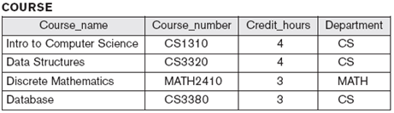 (assume each course has unique course name)

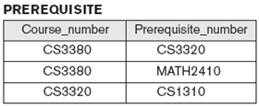

1. Diagrammatically display referential integrity constraints: Directed arc from each foreign key to the relation it references

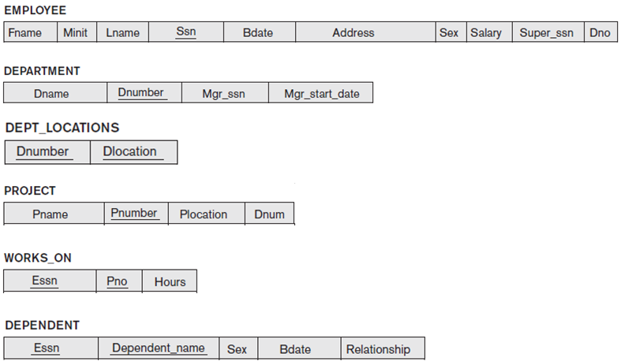

1. Giving the following database, find at least one example update operation for each constraint violation (i.e., domain, key, entity integrity, referential integrity)

