**Group practice to prepare for final exam**

**Problem solving.**

**1.** for the relation TEST below, list the tables (including heading and data) resulted from each query.

|  |  |
| --- | --- |
| Meal | age |
| 1 | null |
| 2 | null |
| Null | null |
| Null | 10 |
| 4 | 12 |
| 2 | 12 |

**Query 1:** select count(age) from TEST;

**Query 2:** select age, count(age) from TEST group by age;

**2.** Consider the schema and sample data shown below. Assume the Class values in the STUDENT table can only be 1, 2, 3 or 4, which means freshman, sophomore, junior, or senior, respectively. Answer the following questions.

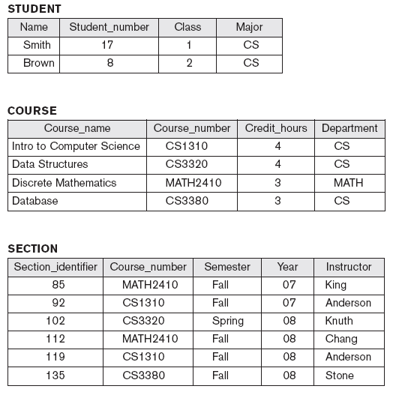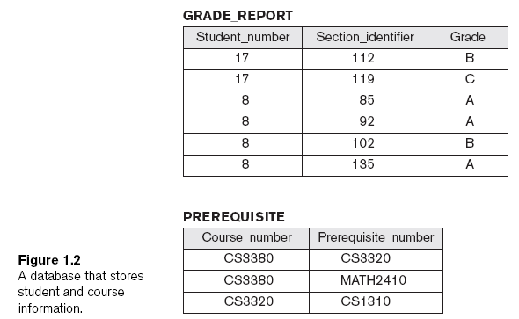

a. Write SQL script to generate PREREQUISITE table, assuming all the other tables have been correctly generated. Need to include primary key and foreign key constraints in the declaration.

b. Check if the syntax is correct in the following queries. If yes, list the tables (including heading and data) resulted from the query. If not, point out the error(s) and suggest the way to correct it(them).

1. select Name from STUDENT order by Name;
2. SELECT Name, Section_identifier, Grade FROM STUDENT, GRADE_REPORT;
3. SELECT Student_number, Section_identifier FROM GRADE_REPORT WHERE Grade = (SELECT Grade FROM GRADE_REPORT WHERE Student_number=8);

c. Write SQL queries to answer the following questions.

1. Retrieve the names of all courses taught by professor King in year 07 or 08.
2. Change the Class of STUDENT 'Smith' to 2.
3. Delete the record for the student whose name starts with letter ‘S’.

3. Normalization and normal forms

a. Consider a relation R(A, B, C, D, E) with the following dependencies:

A,B -> C

C, D -> E

C -> A

i) discuss why attributes A, B, D together should be the primary key of R

[hint: prove A, B, D -> C, E by using some of the Armstrong’s inference rules:

IR1. (**Reflexive**) If Y *subset-of* X, then X -> Y

IR2. (**Augmentation**) If X -> Y, then XZ -> YZ

IR3. (**Transitive**) If X -> Y and Y -> Z, then X -> Z]

ii) discuss why R is not in 2NF.

iii) if decompose R to R1(A, B, C) and R2(A, B, D, E), discussed whether this decomposition is going to generate spurious tuples.

1. Discuss why R1(A, B, C) is in 3NF but not BCNF. Then discuss what normal form R2(A, B, D, E) is in

c. Consider the relation: **R(Doctor#, Patient#, Date, Diagnosis, Treat_code, Charge)**

In this relation, a tuple describes a visit of a patient to a doctor along with a treatment code and daily charge. Assume that diagnosis is determined (uniquely) for each patient by a doctor on a certain day (i.e., **Doctor#, Patient#, Date -> Diagnosis**). Assume that each diagnosis determines a unique treatment code and a treatment code has a fixed charge.

i) Is this relation in 1NF? 2NF? 3NF? BCNF? If not, list the things that violate the condition(s) of the particular normal form(s), respectively.

ii) If it is not in BCNF, normalize it to BCNF. List the steps and the final relations.

4. B+ tree:

* 1. Given the following B+ tree, please list the order of the leaf node and internal node.

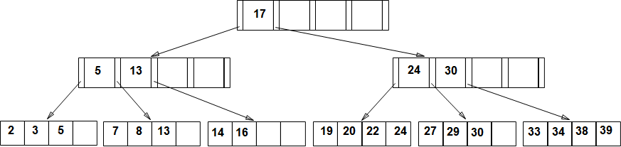

* 1. Assume we need to insert 23, 35, 28, 26 into the above B+ tree, show the resulting B+ tree.