Group practice 11

## List superkey, candidate key, and non-key attributes from the below table (assuming movie_ID is unique for each movie). Superkeys don’t need to be exhaustive

## 

Note: I will use abbreviation: m#, t, y, f, l below and use ( ) as separator

* + Superkey: (m#) (t, y) (m#, t) (m#, f) (m#, t, y) (t, y, f) …
  + Candidate key: (m#) (t, y)
  + Non-key attribute: (f) (l)

1. List full FDs, partial FDs, trivial FDs. Partial FDs and Trivial FDs don’t need to be exhaustive



* + Full: (t, y -> f, l, m#) (m# -> f, l, t, y)
  + Partial: (t, y, m# -> f, l) (t, y, f -> m#, l) …
  + Trivial: (t, y -> t) (f, l -> f) (f, l -> f, l) …

1. in 2NF? In 3NF? Why? If not, how to get to 3NF?
2. 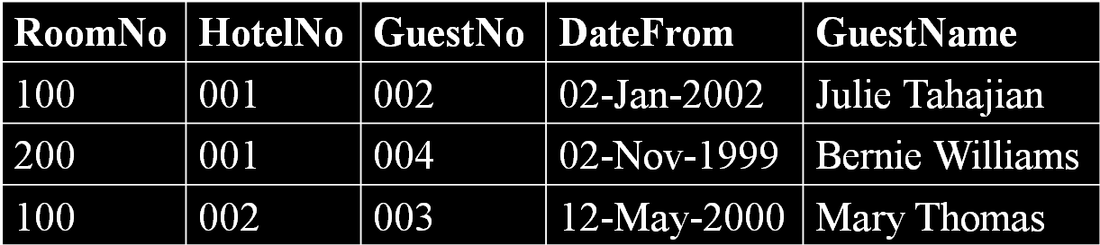

**Not in 3NF. Because GuestNo->GuestName (non-key determine non-key)**

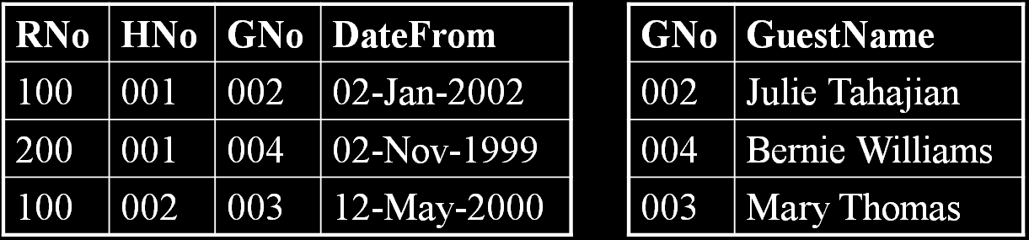

1. 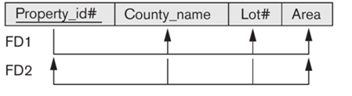

**In 3NF. Because (County_name, Lot#) is a key**

1. 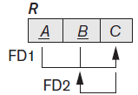

**In 3NF because B is a key attribute (i.e., part of the key)**

1. **In BCNF?**



**Not in BCNF becausue BCNF requires all determinant be a key but C is not a key**

1. Assuming the following FDs hold, which normal form is it in? How to get to BCNF?



1NF

Violate 2NF: FD2, FD3, FD4.

From FD2 & FD3, Results in:

BCNF

 BCNF

 BCNF

**FDs**

* **If A and B are attributes (or attribute sets) of relation R, B is functionally dependent on A (denoted A→B), if each value of A in R is associated (at any time) with exactly one value of B in R.**

**To change nested relations to 1NF:**

* **Remove nested relation attributes into a new relation**
* **Propagate the primary key into it**
* **If multi-level nested, unnest relation into a set of 1NF relations**

**2NF - A relation that is in 1NF and every non-key attribute is fully functionally dependent on the key (i.e., PK or secondary key)**

**3NF - R is in 3NF if it satisfies 2NF *and* every non-key attribute of R is directly (i.e., non-transitively) dependent on the key**

* **If 2NF but not 3NF: non-key attribute determines non-key attribute**

**BCNF - A relation is in BCNF if and only if every determinant is a candidate key**

* **Stricter than 3NF: 3NF allows a key attribute to be functionally dependent on attribute(s) that is not a candidate key**

**Decompose to certain NF (denoted as XNF, i.e., 2NF, 3NF, BCNF)**

* **Look for a nontrivial functional dependency X->Y violates XNF (generally add to the right side Y as many attributes as are functional determined by left X)**
* **Break to two overlapping relation schemas: {X+others} & {X+Y}**
* **Loop through the process as needed**