## Lecture 14 group practice

1. Build B+ tree, with Pint = 3, Pleaf = 2
   1. 1, 5, 7, 3, 8, 12, 9, 6
   2. 12, 9, 6, 7, 1, 5, 8, 3
2. The resulting tree is the same as the B+ tree for 8, 5, 1, 7, 3, 12, 9, 6 (the intermediate steps are different but the final tree is the same)



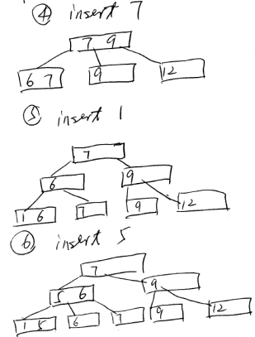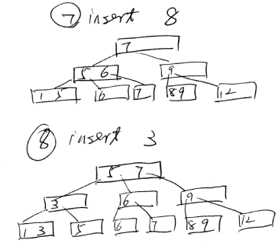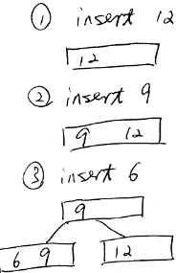

1. Build B+ tree, with Pint = 5, Pleaf = 4
   1. 1, 5, 7, 3, 8, 12, 9, 6
   2. 12, 9, 6, 7, 1, 5, 8, 3



b.



1. B+ tree efficiency: Assume disk block size B = 512; key size K = 9; data pointer size Pd = 7; tree pointer size Pt = 6
   1. Calculate Pint & Pleaf
   2. Assuming this B+ tree has 4 levels (root as level 1), maximally how many items can be indexed by it?

(Pint*Pt)+(Pint-1)*K <= B

6Pint+9(Pint-1)<=512

Pint = 34

Pleaf*(Pd+K)+Pt<=B

16Pleaf+6<=512

Pleaf = 31

Maximally: 34^3 * 31 = 1,218,424