Practice to prepare for final exam

**Problem solving.**

**1.** for the relation TEST below, list the tables (including heading and data) resulted from each query.

|  |  |
| --- | --- |
| Meal | age |
| 1 | null |
| 2 | null |
| Null | null |
| Null | 10 |
| 4 | 12 |
| 2 | 12 |

**Query 1:** select count(age) from TEST;

count(age)

3

**Query 2:** select age, count(age) from TEST group by age;

age count(age)

null 0

10 1

12 2

**2.** Consider the schema and sample data shown below. Assume the Class values in the STUDENT table can only be 1, 2, 3 or 4, which means freshman, sophomore, junior, or senior, respectively. Answer the following questions.

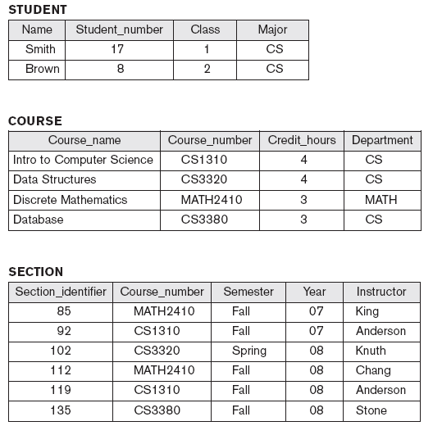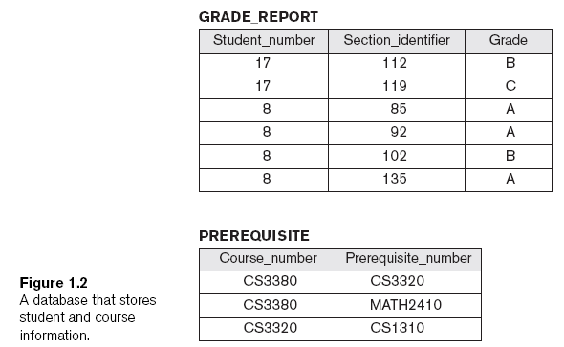

a. Write SQL script to generate PREREQUISITE table, assuming all the other tables have been correctly generated. Need to include primary key and foreign key constraints in the declaration.

Create table PREREQUISITE

(Course_number varchar(15),

Prerequisite_number varchar(15),

Primary key(Course_number, Prerequisite_number),

Foreign key (Course_number) references COURSE(Course_number),

Foreign key (Prerequisite_number) references COURSE(Course_number));

b. Check if the syntax is correct in the following queries. If yes, list the tables (including heading and data) resulted from the query. If not, point out the error(s) and suggest the way to correct it(them).

1. select Name from STUDENT order by Name;

correct

Name

Brown

Smith

1. SELECT Name, Section_identifier, Grade FROM STUDENT, GRADE_REPORT;

Wrong, need where clause

Or if consider it’s correct, the result will be the product between tables STUDENT and GRADE_REPORT, so there are 12 rows of results

1. SELECT Student_number, Section_identifier FROM GRADE_REPORT WHERE Grade = (SELECT Grade FROM GRADE_REPORT WHERE Student_number=8);

= cannot be used in nested query directly (i.e., = cannot be applied directly to compare set values)

c. Write SQL queries to answer the following questions.

1. Retrieve the names of all courses taught by professor King in year 07 or 08.

SELECT Course_Name

FROM COURSE, SECTION

WHERE COURSE.Course_number=SECTION.Course_number AND Instructor='King'

AND (Year='07' OR Year='08')

Another way:

SELECT Course_name

FROM COURSE

WHERE Course_number IN ( SELECT Course_number

FROM SECTION

WHERE Instructor='King' AND (Year='07' OR Year='08') )

1. Change the Class of STUDENT 'Smith' to 2.

UPDATE STUDENT

SET CLASS = 2

WHERE Name='Smith'

1. Delete the record for the student whose name starts with letter ‘S’.

DELETE FROM STUDENT

WHERE Name like ‘S%’;

3. Normalization and normal forms

a. Consider a relation R(A, B, C, D, E) with the following dependencies:

A,B -> C

C, D -> E

C -> A

i) discuss why attributes A, B, D together should be the primary key of R

[hint: prove A, B, D -> C, E by using some of the Armstrong’s inference rules:

IR1. (**Reflexive**) If Y *subset-of* X, then X -> Y

IR2. (**Augmentation**) If X -> Y, then XZ -> YZ

IR3. (**Transitive**) If X -> Y and Y -> Z, then X -> Z]

Because A,B -> C

C, D -> E

So A, B, D -> C, D (augmentation)

So A, B, D -> C, E (transitive)

ii) discuss why R is not in 2NF.

Because A, B, D is primary key, but A,B -> C so non-key attribute C partially dependent on key, not in 2NF

iii) if decompose R to R1(A, B, C) and R2(A, B, D, E), discussed whether this decomposition is going to generate spurious tuples.

No. because the decomposition is based on FD that violates the normal form rule

iv) Discuss why R1(A, B, C) is in 3NF but not BCNF. Then discuss what normal form R2(A, B, D, E) is in

because A,B -> C

A, B is the primary key, in 2NF

C -> A so C is non-key attribute determines key attribute so in 3NF

But C is not key so it is not in BCNF

R2 is in BCNF (A, B, D is key, E fully dependent on key and E determines nothing)

c. Consider the relation: **R(Doctor#, Patient#, Date, Diagnosis, Treat_code, Charge)**

In this relation, a tuple describes a visit of a patient to a doctor along with a treatment code and daily charge. Assume that diagnosis is determined (uniquely) for each patient by a doctor on a certain day. Assume that each diagnosis determines a unique treatment code and a treatment code has a fixed charge.

i) Is this relation in 1NF? 2NF? 3NF? BCNF? If not, list the things that violate the condition(s) of the particular normal form(s), respectively.

Primary key: Doctor#, Patient#, Date

In 1 NF

Functional dependency: Doctor#, Patient#, Date -> Diagnosis, Treat_code, Charge (**so in 2NF**)

Diagnosis -> Treat_code

Treat_code->Charge

(**not in 3NF** because non-key attribute determines non-key attribute)

Not in 3NF so **not in BCNF**

ii) If it is not in BCNF, normalize it to BCNF. List the steps and the final relations.

Decompose

Based on the rules violated FD: Diagnosis -> Treat_code, Treat_code->Charge, decompose to

(Diagnosis, Treat_code, Charge) & (Doctor#, Patient#, Date, Diagnosis)

Then (Diagnosis, Treat_code, Charge) decompose to (Diagnosis, Treat_code) & (Treat_Code, Charge)

4. B+ tree:

1. Given the following B+ tree, please list the order of the leaf node and internal node.

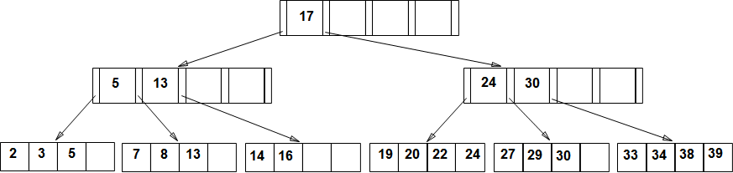

Pint = 5; Pleaf = 4

1. Assume we need to insert 23, 35, 28, 26 into the above B+ tree, show the resulting B+ tree.

After inserting 23, 35, 28, we get:

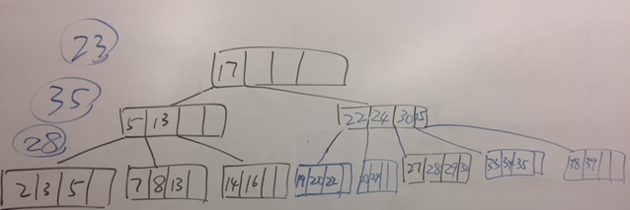

After inserting 26, we get:

