**Lecture 1 notes & practice**

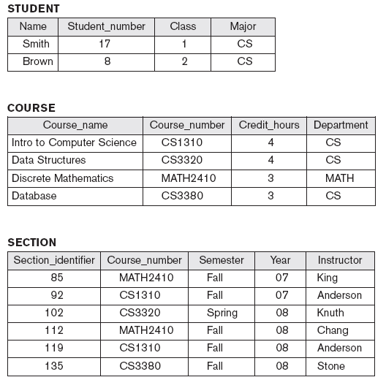

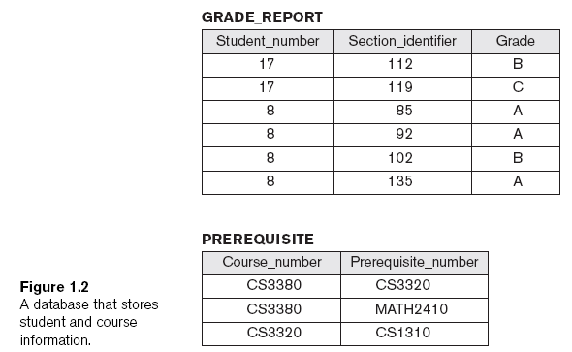

A sample database application – how to proceed?

* The company is organized into DEPARTMENTs. Each department has a name, number and an employee who *manages* the department. A department may have several locations. We keep track of the start date of the departmentmanager.
* Each department *controls* a number of PROJECTs*.* Each project has a name, number and islocated at a single location.
* We store each EMPLOYEE’s name, social security number, address, salary, sex, and birthdate. Each employee works for one department but may work on several projects. We keep track of the number of hours per week that an employee currently works on each project. We also keep track of the direct supervisor of each employee.
* We want to keep track of the DEPENDENTs of each employee for insurance purpose. We keep each dependent’s name, sex, birthdate, and relationship to employee.