Group practice 10

1. **FD**
2. For Staff relation below, check whether the follow FDs are Correct or not

staffNo -> salary (correct)

salary -> staffNo (incorrect)

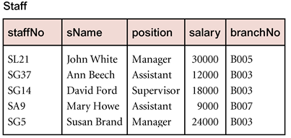

1. Find FDs in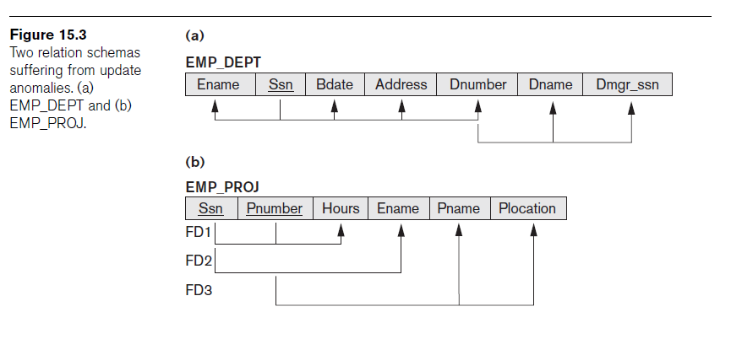

**{Ssn} -> {Ename}**

**{Pnumber} -> {Pname, Plocation}**

**{Ssn, Pnumber} -> {Hours} and more**

1. **Nested table to 1NF**

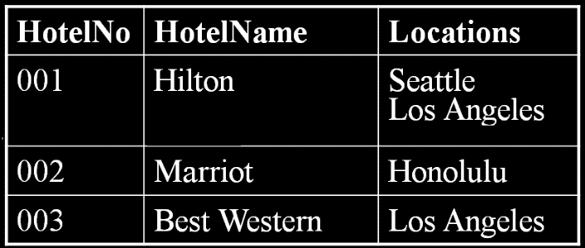

**1NF:**

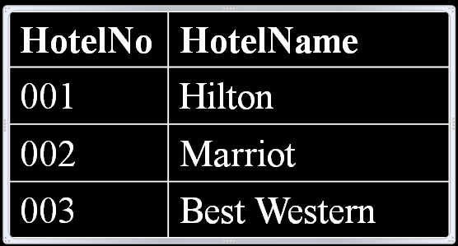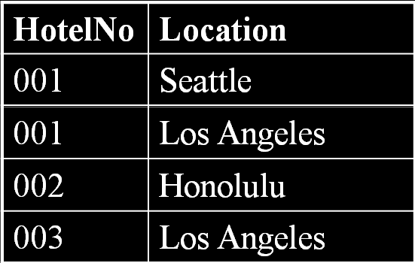

1. **in 2NF? Why? If not, how to get to 2NF?**

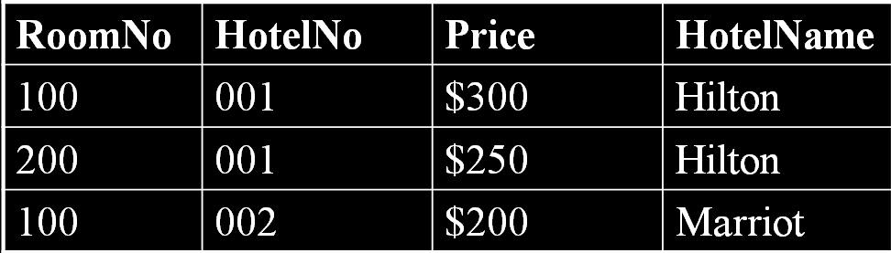

**Not. Because HotelNo-> HotelName, so HotelName is not fully dependent on Key (RoomNo, HotelNo)**

