Lecture 4 Group Practice – Relational data model

1. Identify **Superkey, candidate key, primary key** for the following relation (table)

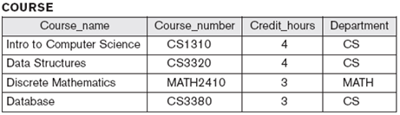 (assume each course has unique course name)

Candidate key: {Course_name} {Course_number}

Primary key: {Course_number} //note: it’s OK to pick {Course_name} instead of {Course_number}

Superkey: {Course_name} {Course_number} {Course_name, Course_number} {Course_number, Credit_hours} … //key or key + anything can be superkey

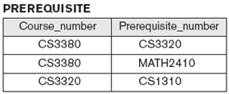

Candidate key: {Course_number, Prerequisite_number}

Primary key: {Course_number, Prerequisite_number}

Superkey: {Course_number, Prerequisite_number}

1. Diagrammatically display referential integrity constraints: Directed arc from each foreign key to the relation it references

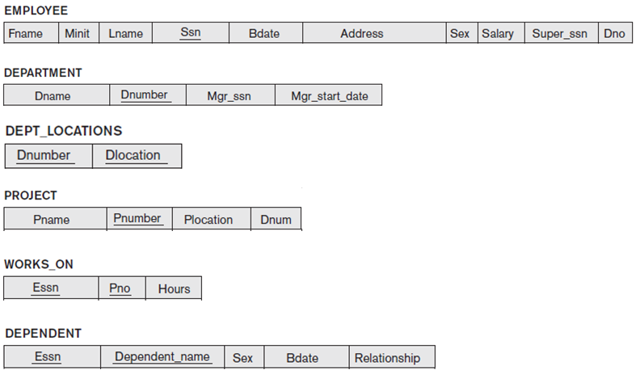

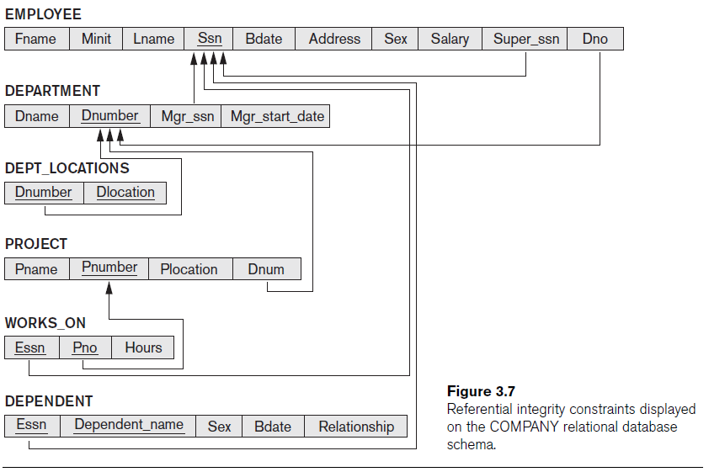

1. Giving the following database, find at least one example update operation for each constraint violation (i.e., domain, key, entity integrity, referential integrity)



e.g., insert {111, X, Smith, 123456789, 1990-01-01, 123 Campus Dr., F, 45000, 999999999, 3} into EMPLOYEE, violates

domain constraint: 111 for Fname

key constraint: 123456789 for Ssn (duplicated)

referential interity constraint: 999999999 for Super_ssn (no such PK value); 3 for Dno (no such PK value)

update Ssn of John Smith to Null: violate Entity Integrity constraint (PK value cannot be null)