CSS 475A Database Systems

Homework 4 (25 possible points) [5% of final grade]

Due by: May 27 (Sunday) 11:59 pm to Canvas

1. [15 points] An agency called Instant Cover supplies part-time/temporary staff to hotels within Scotland. The table shown in Figure 1 lists the time spent by agency staff working at various hotels. The NIN is unique for every member of staff. hNo is unique for each hotel and its location.

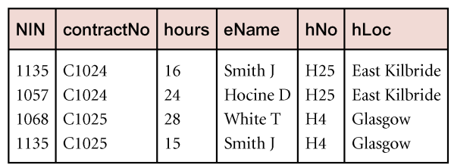
Figure 1: Instant Cover’s contracts

- The table shown in Figure 1 is susceptible to update anomalies. Provide an example to show insertion anomaly. Provide another example to show deletion anomaly.

insert NIN is 1234 and eName is Brown A. (If I try to add, it has insertion anomaly because there is no information about hotel number, and it is the key, so it must not be the null)
delete NIN is 1135 and eName is Smith J. (If I try to delete, it has deletion anomaly because there are two tuples that NIN is 1135, so it can be deleted important data which must not delete)

- List the non-trivial functional dependencies in the table shown in Figure 1. State any assumptions you make about the data shown in this table.

(NIN -> eName)
(hNo -> hLoc)
(NIN, hNo -> contractNo, hours, eName, hNo, hLoc)

- Modify the table to be in Boyce-Codd normal form.

NIN | eName

hNo | hLoc

NIN | hNo | contractNo | hours

- Display the data in Figure 1 using the tables in Boyce-Codd normal form.

NIN | eName
1135 | Smith J
1057 | Hocine D
1068 | White T

hNo | hLoc
H25 | East Kilbride
H4 | Glasgow

NIN | hNo | contractNo | hours
1135 | H25 | C1024 | 16
1057 | H25 | C1024 | 24
1068 | H4 | C1025 | 28
1135 | H4 | C1025 | 15

2. [10 points] B+ tree
a) Assume we use B+ tree to index the relation Movie(m#, title, year, country) based on m#. if block size is 16 bytes, search key size is 2 bytes, tree pointer size is 4 bytes and data point size is 3, calculate the order of leaf node and internal node.

The order of leaf node and internal node is 2 and 3.

b) Assume the order of leaf node and internal node is 2 and 3, respectively. Build a B+ tree assuming the values of m#: 1, 7, 5, 8, 9, 6, 3, 12 are inserted sequentially.
