Operating system: Windows 10

Bash version: 5.2

Python version: 3.11

I used Rstudio for writting the python codes in question 3, need to install the reticulate library;

import xml.etree.ElementTree as ET

import pandas as pd

import re

1.1.

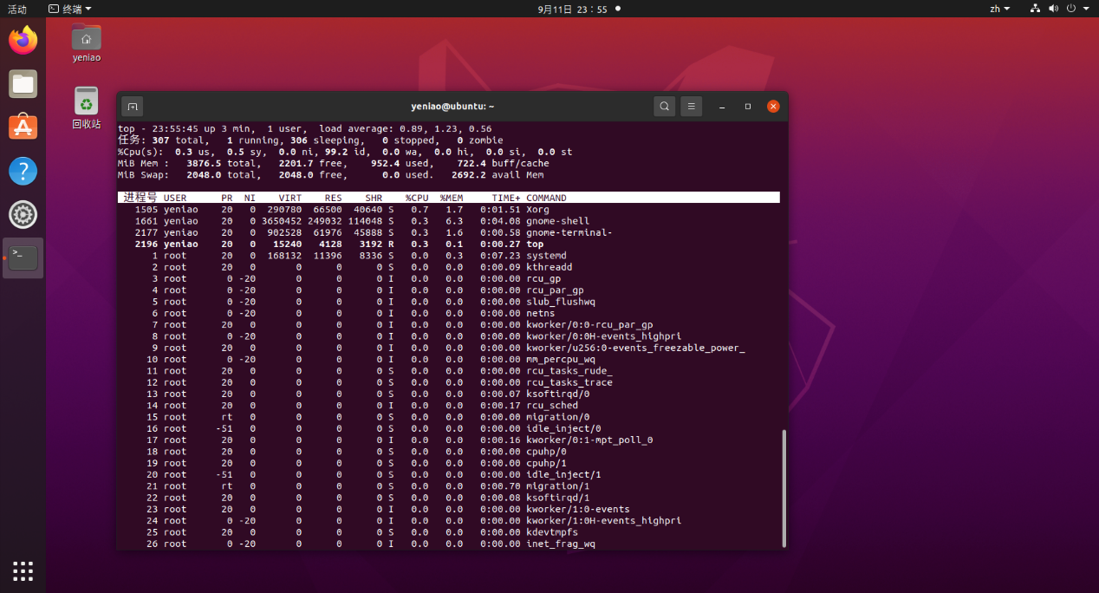

1.2.

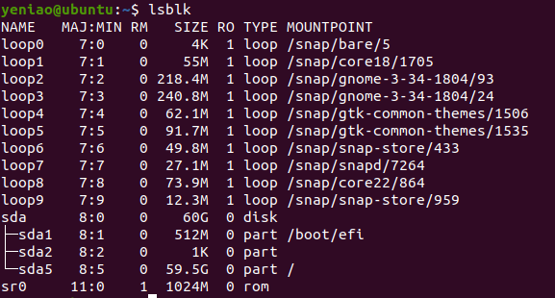

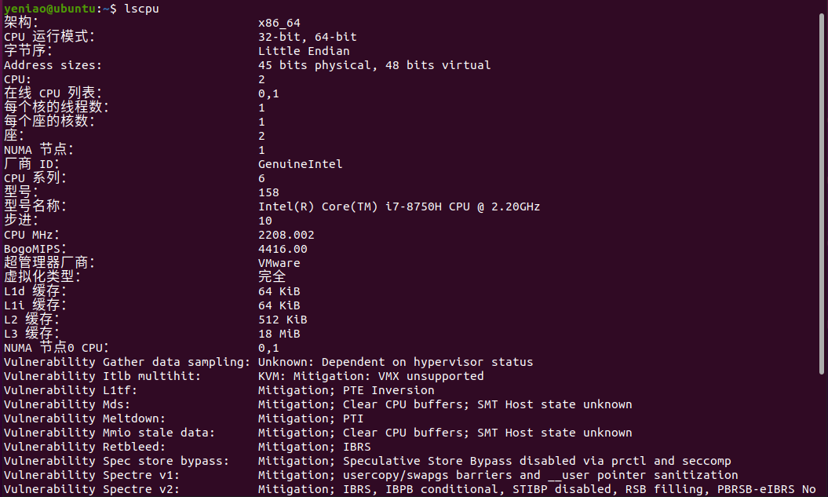

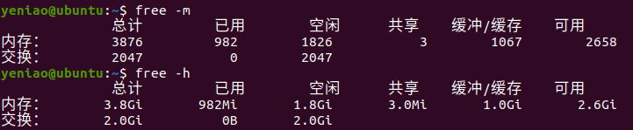

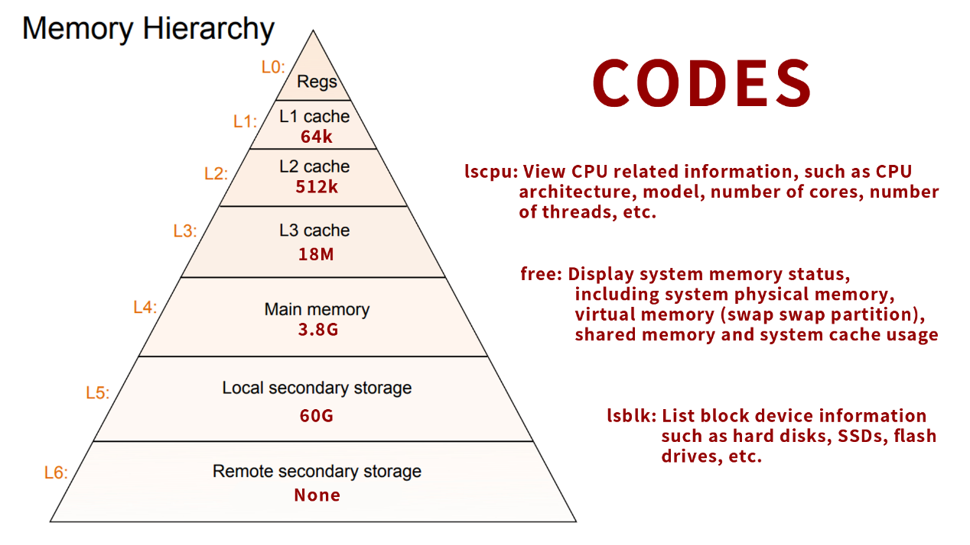

1.3. Open the cdvar path and view the last 50 lines of the tree diagram:

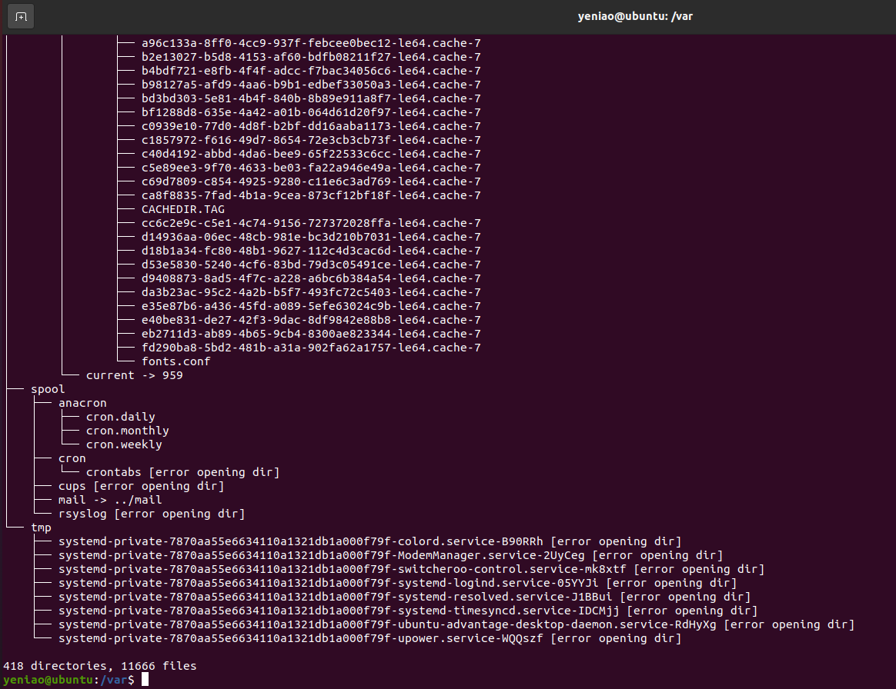

2. codes:

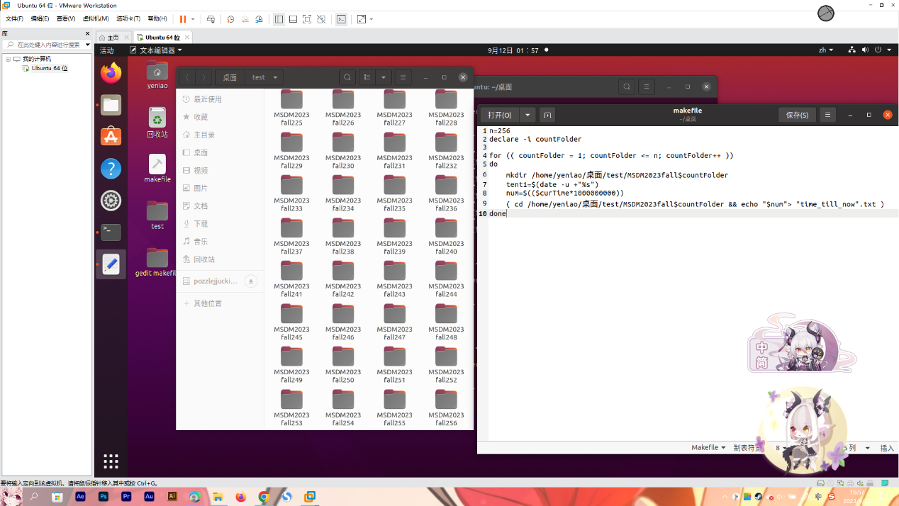

Each file’s content

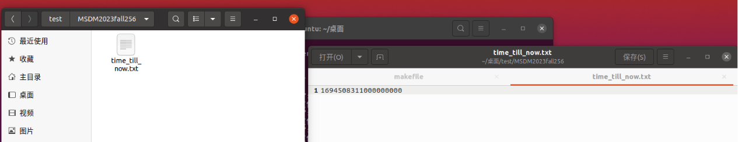

3.Please check the hw1.q3.py and hw1.q3.html files in the zip.

4. https://ksye6.github.io/ksye6/