**MSDM5004 HW2 solution**

**Q1**

First get $D, L, U$

$$D=\left(\begin{matrix}4 & 0 & 0 \\ 0 & 3 & 0 \\ 0 & 0 & 5\end{matrix}\right) U=\left(\begin{matrix}0 & -1 & 1 \\ 0 & 0 & -1 \\ 0 & 0 & 0\end{matrix}\right) L=\left(\begin{matrix}0 & 0 & 0 \\ 1 & 0 & 0 \\ -2 & -2 & 0\end{matrix}\right)$$

**Part (1) – Jacobi method**

1. Compute the coefficient $D^{-1}\left(L+U\right)$ and $D^{-1}b$
$$D^{-1}\left(L+U\right)=\left(\begin{matrix}0 & -\frac{1}{4} & \frac{1}{4} \\ \frac{1}{3} & 0 & -\frac{1}{3} \\ -\frac{2}{5} & -\frac{2}{5} & 0\end{matrix}\right) D^{-1}b=\left(\begin{matrix}\frac{3}{4} \\ -2 \\ \frac{4}{5}\end{matrix}\right)$$

2. Iteration by $x^{\left(k\right)}=D^{-1}\left(L+U\right)x^{\left(k-1\right)}+D^{-1}b$, begin from $x^{\left(0\right)}=\left(\begin{matrix}0 \\ -1 \\ 0\end{matrix}\right)$

$$x^{\left(1\right)}= \left(\begin{matrix}1 \\ -2 \\ \frac{6}{5}\end{matrix}\right) \\ x^{\left(2\right)}= \left(\begin{matrix}0 & -\frac{1}{4} & \frac{1}{4} \\ \frac{1}{3} & 0 & -\frac{1}{3} \\ -\frac{2}{5} & -\frac{2}{5} & 0\end{matrix}\right)\left(\begin{matrix}1 \\ -2 \\ \frac{6}{5}\end{matrix}\right)+ \left(\begin{matrix}\frac{3}{4} \\ -2 \\ \frac{4}{5}\end{matrix}\right)=\left(\begin{matrix}\frac{31}{20} \\ \frac{31}{15} \\ \frac{6}{5}\end{matrix}\right)≈\left(\begin{matrix}1.55 \\ -2.0667 \\ 1.2\end{matrix}\right)$$

**Part (2) – Gauss Siedel**

1. Compute the coefficient ${\left(D-L\right)}^{-1}U$ and ${(D-L)}^{-1}b$
$${\left(D-L\right)}^{-1}U=\left(\begin{matrix}0 & -\frac{1}{4} & \frac{1}{4} \\ 0 & -\frac{1}{12} & -\frac{1}{4} \\ 0 & \frac{2}{15} & 0\end{matrix}\right) , {\left(D-L\right)}^{-1}b=\left(\begin{matrix}\frac{3}{4} \\ -\frac{7}{4} \\ \frac{6}{5}\end{matrix}\right)$$

2. Iteration by $x^{\left(k\right)}= {\left(D-L\right)}^{-1}Ux^{\left(k-1\right)}+{(D-L)}^{-1}b$, begin from $x^{\left(0\right)}=\left(\begin{matrix}0 \\ -1 \\ 0\end{matrix}\right)$

$$x^{\left(1\right)}= \left(\begin{matrix}1 \\ -\frac{5}{3} \\ \frac{16}{15}\end{matrix}\right) \\ x^{\left(2\right)}= \left(\begin{matrix}0 & -\frac{1}{4} & \frac{1}{4} \\ 0 & -\frac{1}{12} & -\frac{1}{4} \\ 0 & \frac{2}{15} & 0\end{matrix}\right)\left(\begin{matrix}1 \\ -\frac{5}{3} \\ \frac{16}{15}\end{matrix}\right)+ \left(\begin{matrix}\frac{3}{4} \\ -\frac{7}{4} \\ \frac{6}{5}\end{matrix}\right)=\left(\begin{matrix}\frac{43}{30} \\ -\frac{169}{90} \\ \frac{44}{45}\end{matrix}\right)≈\left(\begin{matrix}1.4333 \\ -1.8778 \\ 0.9778\end{matrix}\right)$$

**Q2**

Note that $L_{∞}$ norm of a vector $x$ is ${\left\|x\right\|}_{∞}=\max\left\{\left|x_{1}\right|, \left|x_{2}\right|, …\left|x_{n}\right|\right\}$

**Part (1) – Gauss Siedel**

A = [4,1,1,-1;

1,4,-1,-1;

1,-1,3,1;

-1,-1,1,5];

b = [-3,-2,2,5].';

D = diag(diag(A));

U = -triu(A,1);

L = -tril(A,-1);

g1 = inv(D-L)*U;

g2 = inv(D-L)*b;

esp = 1/1000;

x0 = [0,0,0,1].';

x1 = 100*ones(4,1);

while norm(x1-x0, Inf) >= esp

x1 = x0;

x0 = g1*x0 + g2;

end

disp(x0)

**Console display:**

-0.753059796800029

0.040886583057744

0.691516167015457

0.719262123848452

**Part (2) – SOR**

A = [4,1,1,-1;

1,4,-1,-1;

1,-1,3,1;

-1,-1,1,5];

b = [-3,-2,2,5].';

w = 1.2;

D = diag(diag(A));

U = -triu(A,1);

L = -tril(A,-1);

g1 = inv(D-w*L)*((1-w)*D+w*U);

g2 = w*inv(D-w*L)*b;

esp = 1/1000;

x0 = [0,0,0,1].';

x1 = 100*ones(4,1);

while norm(x1-x0, Inf) >= esp

x1 = x0;

x0 = g1*x0 + g2;

end

disp(x0)

**Console display:**

-0.753455643103498

0.041243058029276

0.691714074061100

0.719166490715922

**Q3**

f = @(x) sin(x)/x^2;

h = 1e-2;

x0 = 3;

% Computing derivative

df = @(x,h) (f(x+h)-f(x-h))/2/h;

disp("derivative: " + df(x0,h))

% Checking order of numerical scheme

n = 10;

df_array = zeros(n,1);

order_array = zeros(n-2,1);

for i = 1:n

df_array(i) = df(x0, h);

h = h/2;

end

for i = 1:n-2

order_array(i) = log2((df_array(i)-df_array(i+1))/(df_array(i+1)-df_array(i+2)));

end

disp("order of numerical scheme:")

disp(order_array)

**Console display:**

derivative: -0.12045

order of numerical scheme:

2.000011018672592

2.000003167886757

1.999996899588639

2.000031336607194

1.999758626038902

2.000290539479766

1.999433147986543

1.995473184108702

**Q4**

**Part(1) – Forward Euler method**

f = @(t,y) (t*y-y^2/2)/t^2;

a = 1;

b = 3;

h = 1/128;

t_array = linspace(a,b,(b-a)/h+1);

y_array = zeros(1,length(t_array));

y_array(1) = 4;

for i = 1:(b-a)/h

y_array(i+1) = y_array(i) + h*f(t_array(i), y_array(i));

end

plot(t_array, y_array)

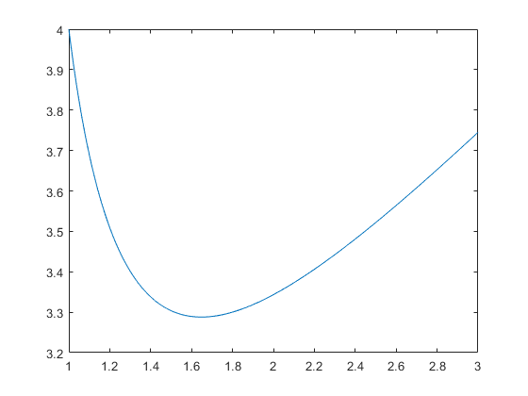

**Part(2) – Backward Euler method**

First you need to derive the actual scheme:

$$\frac{y_{i+1}-y_{i}}{h}=\frac{t_{i+1}y_{i+1}-\frac{y_{i+1}^{2}}{2}}{t_{i+1}^{2}}$$

$$⇒y_{i+1}=\frac{-\left(t_{i+1}^{2}-ht_{i+1}\right)±\sqrt{{\left(t_{i+1}^{2}-ht_{i+1}\right)}^{2}+2ht_{i+1}^{2}y_{i}}}{h}$$

Given in the initial point $y_{0}=4>0$, we should expect that $y_{1}$ is still very close to $4$, thus $>0$ when $h$ is taken arbitrarily small. Therefore, +ve sign should be taken.

f = @(t,y,h) (-(t^2-h*t)+sqrt((t^2-h*t)^2+2*h*t^2*y))/h;

a = 1;

b = 3;

h = 1/128;

t_array = linspace(a,b,(b-a)/h+1);

y_array = zeros(1,length(t_array));

y_array(1) = 4;

for i = 1:(b-a)/h

y_array(i+1) = f(t_array(i+1), y_array(i), h);

end

plot(t_array, y_array)

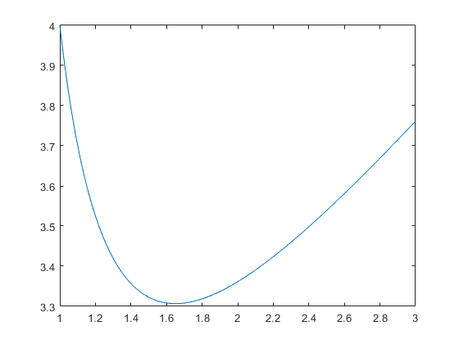

**Part(3) - 4-th order Runge-Kutta method**

f = @(t,y) (t*y-y^2/2)/t^2;

a = 1;

b = 3;

h = 1/128;

t_array = linspace(a,b,(b-a)/h+1);

y_array = zeros(1,length(t_array));

y_array(1) = 4;

for i = 1:(b-a)/h

z1 = f(t_array(i), y_array(i));

z2 = f(t_array(i)+h/2, y_array(i)+h*z1/2);

z3 = f(t_array(i)+h/2, y_array(i)+h*z2/2);

z4 = f(t_array(i)+h, y_array(i)+h*z3);

y_array(i+1) = y_array(i) + h/6*(z1+2*z2+2*z3+z4);

end

plot(t_array, y_array)

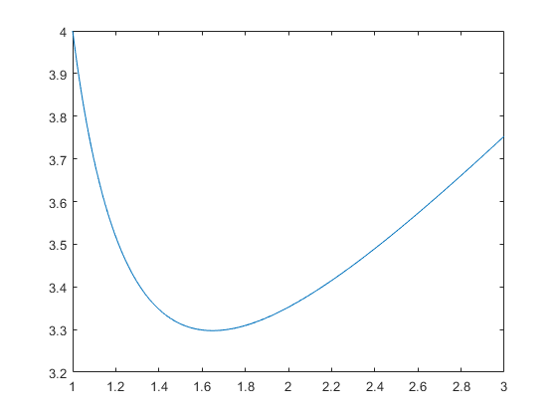

**Q5**

Taylor expansion to time part

$$U\left(t+Δt,x\right)=U\left(t,x\right)+Δt{\left.\frac{∂U}{∂t}\right|}_{\left(t,x\right)}+\frac{1}{2}{\left(Δt\right)}^{2}{\left.\frac{∂^{2}U}{∂t^{2}}\right|}_{\left(t,x\right)}+O\left({\left(Δt\right)}^{3}\right) \\ U\left(t-Δt,x\right)=U\left(t,x\right)-Δt{\left.\frac{∂U}{∂t}\right|}_{\left(t,x\right)}+\frac{1}{2}{\left(Δt\right)}^{2}{\left.\frac{∂^{2}U}{∂t^{2}}\right|}_{\left(t,x\right)}-O\left({\left(Δt\right)}^{3}\right)$$

Therefore

$$\frac{U\left(t+Δt,x\right)-U\left(t-Δt,x\right)}{2Δt}={\left.\frac{∂U}{∂t}\right|}_{\left(t,x\right)}+O({\left(Δt\right)}^{2})$$

Taylor expansion to position part

$$U\left(t,x+Δx\right)=U\left(t,x\right)+Δx{\left.\frac{∂U}{∂x}\right|}_{\left(t,x\right)}+\frac{1}{2}{\left(Δx\right)}^{2}{\left.\frac{∂^{2}U}{∂x^{2}}\right|}_{\left(t,x\right)}+\frac{1}{6}{\left(Δx\right)}^{3}{\left.\frac{∂^{3}U}{∂x^{3}}\right|}_{\left(t,x\right)}+O\left({\left(Δx\right)}^{4}\right) \\ U\left(t,x-Δx\right)=U\left(t,x\right)-Δx{\left.\frac{∂U}{∂x}\right|}_{\left(t,x\right)}+\frac{1}{2}{\left(Δx\right)}^{2}{\left.\frac{∂^{2}U}{∂x^{2}}\right|}_{\left(t,x\right)}-\frac{1}{6}{\left(Δx\right)}^{3}{\left.\frac{∂^{3}U}{∂x^{3}}\right|}_{\left(t,x\right)}+O\left({\left(Δx\right)}^{4}\right)$$

Therefore

$$\frac{U\left(t,x+Δx\right)-2U\left(t,x\right)+U\left(t,x-Δx\right)}{{\left(Δx\right)}^{2}}={\left.\frac{∂^{2}U}{∂x^{2}}\right|}_{\left(t,x\right)}+O\left({\left(Δx\right)}^{2}\right)$$

So truncation error is

$$\frac{U\left(t+Δt,x\right)-U\left(t-Δt,x\right)}{2Δt}-\frac{U\left(t,x+Δx\right)-2U\left(t,x\right)+U\left(t,x-Δx\right)}{{\left(Δx\right)}^{2}}= O\left({\left(Δt\right)}^{2}\right)+ O\left({\left(Δx\right)}^{2}\right)$$