**MSDM5004 Project 1 solution**

**Q1**

**(i-ii) Numerical solutions by explicit scheme**

J = 20;

dx = 0.05;

N = 51;

dt = 0.0012; %[0.0012,0.0013];

x = linspace(0,1,J+1);

gd = zeros(N+1,J+1);

u0 = @(x) (x<=0.5).*(2*x) + (x>0.5).*(2-2*x);

gd(1,:) = u0(x);

mu = dt/dx^2;

for n = 1:N

for j = 2:J

gd(n+1,j) = gd(n,j) + mu*(gd(n,j+1) - 2*gd(n,j) + gd(n,j-1));

end

end

time = [1, 2, 26, 51];

for i = 1:4

subplot(4,1,i);

plot(x, gd(time(i),:))

ylim([0, 1.1])

tt = {'$$t=', num2str(time(i)-1),'$$', '$$\Delta t\quad\quad$$ with $$\Delta t=$$', num2str(dt)};

title(join(tt(1:3+(i>1)*2)),'interpreter','latex');

end

For $Δt=0.0012$:

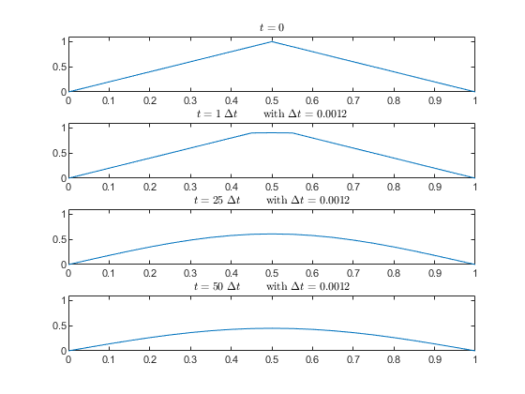

For $Δt=0.0013$:

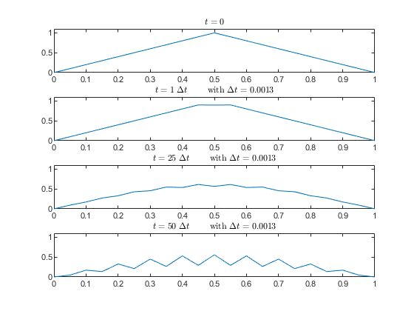

For $Δt=0.006$:

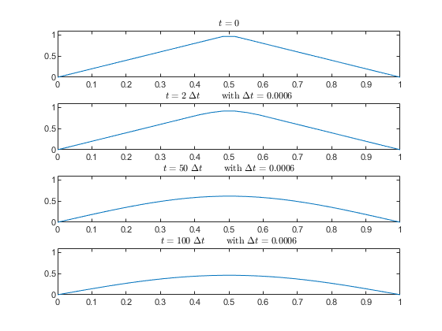

Difference from using $Δt=0.0012$ at the same $t$. Blue: $Δt=0.0012$, orange: $Δt=0.0006$.

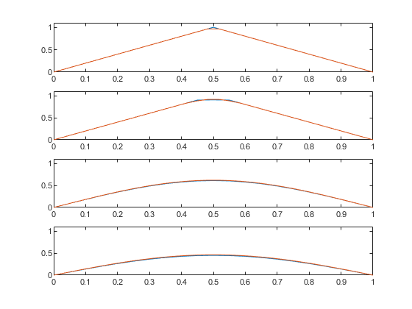

**(iii) Crank-Nicolson Method**

From

$$U_{j}^{n+1}-U_{j}^{n}=\frac{μ}{2}\left[ \left(U_{j+1}^{n+1}-2U_{j}^{n+1}+U_{j-1}^{n+1}\right)+\left(U_{j+1}^{n}-2U_{j}^{n}+U_{j-1}^{n}\right)\right]$$

Numerical scheme:

$$-\frac{μ}{2}U_{j-1}^{n+1}+ \left(1+μ\right)U_{j}^{n+1}-\frac{μ}{2}U_{j+1}^{n+1}=\frac{μ}{2}U_{j-1}^{n}+ \left(1-μ\right)U_{j}^{n}+\frac{μ}{2}U_{j+1}^{n}$$

Identify the tridiagonal matrix system as

$$\left(\begin{matrix}1+μ & -\frac{μ}{2} & & & 0 \\ -\frac{μ}{2} & 1+μ & -\frac{μ}{2} & & \\ & ⋱ & ⋱ & ⋱ & \\ & & -\frac{μ}{2} & 1+μ & -\frac{μ}{2} \\ 0 & & & -\frac{μ}{2} & 1+μ\end{matrix}\right)\left(\begin{matrix}U_{1}^{n+1} \\ U_{2}^{n+1} \\ ⋮ \\ U_{J-2}^{n+1} \\ U_{J-1}^{n+1}\end{matrix}\right)=\left(\begin{matrix}\frac{μ}{2}U_{0}^{n}+ \left(1-μ\right)U_{1}^{n}+\frac{μ}{2}U_{2}^{n} \\ \frac{μ}{2}U_{1}^{n}+ \left(1-μ\right)U_{2}^{n}+\frac{μ}{2}U_{3}^{n} \\ ⋮ \\ \frac{μ}{2}U_{J-3}^{n}+ \left(1-μ\right)U_{J-2}^{n}+\frac{μ}{2}U_{J-1}^{n} \\ \frac{μ}{2}U_{J-2}^{n}+ \left(1-μ\right)U_{J-1}^{n}+\frac{μ}{2}U_{J}^{n}\end{matrix}\right)$$

Thomas algorithm: For the system

$$\left(\begin{matrix}b_{1} & c_{1} & & & 0 \\ a_{2} & b_{2} & c_{2} & & \\ & ⋱ & ⋱ & ⋱ & \\ & & a_{n-1} & b_{n-1} & c_{n-1} \\ 0 & & & a_{n} & b_{n}\end{matrix}\right)\left(\begin{matrix}x_{1} \\ x_{2} \\ ⋮ \\ x_{n-1} \\ x_{n}\end{matrix}\right)=\left(\begin{matrix}d_{1} \\ d_{2} \\ ⋮ \\ d_{n-1} \\ d_{n}\end{matrix}\right)$$

Denoting

$$c_{i}^{'}=\left\{\begin{matrix}\frac{c_{i}}{b_{i}} & \text{for} i=1 \\ \frac{c_{i}}{b_{i}-a_{i}c_{i-1}^{'}} & \text{for} i=2,3,…n-1\end{matrix}\right.$$

$$d_{i}^{'}=\left\{\begin{matrix}\frac{d_{i}}{b_{i}} & \text{for} i=1 \\ \frac{d_{i}-a_{i}d_{i-1}^{'}}{b_{i}-a_{i}c_{i-1}^{'}} & \text{for} i=2,3,…n\end{matrix}\right.$$

The solution is then by back substitution:

$$x_{n}=d_{n}^{'} \\ x_{i}=d_{i}^{'}-c_{i}^{'}x_{i+1} \text{for} i=1,2,…,n-1$$

**Code:**

J = 20;

dx = 0.05;

N = 51;

dt = 0.0012; %[0.0012, 0.0013, 0.012];

x = linspace(0,1,J+1);

gd = zeros(N+1,J+1);

u0 = @(x) (x<=0.5).*(2*x) + (x>0.5).*(2-2*x);

gd(1,:) = u0(x);

mu = dt/dx^2;

a = -mu/2;

b = (1+mu);

c = -mu/2;

ci = zeros(J-2,1);

ci(1) = c/b;

for j=2:J-2

ci(j) = c/(b-a*ci(j-1));

end

d = zeros(J-1,1);

di = zeros(J-1,1);

for n=1:N

for j=2:J

d(j-1) = mu/2*gd(n,j-1) + (1-mu)*gd(n,j) + mu/2*gd(n,j+1);

end

di(1) = d(1)/b;

for j=2:J-1

di(j) = (d(j)-a*di(j-1))/(b-a*ci(j-1));

end

gd(n+1,J) = di(J-1);

for j=2:J-1

gd(n+1,J-j+1) = di(J-j) - ci(J-j)*gd(n+1,J-j+2);

end

end

time = [1, 2, 26, 51];

for i = 1:4

subplot(4,1,i);

plot(x*J, gd(time(i),:))

ylim([0, 1.1])

tt = {'$$t=', num2str(time(i)-1),'$$', '$$\Delta t\quad\quad$$ with $$\Delta t=$$', num2str(dt)};

title(join(tt(1:3+(i>1)*2)),'interpreter','latex');

end

For $Δt=0.0012$:

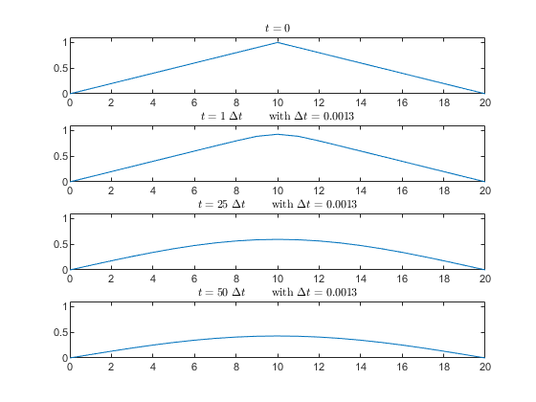

For $Δt=0.0013$:

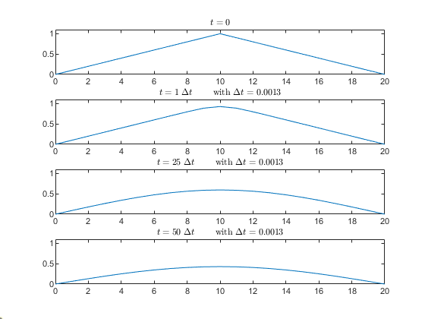

For $Δt=0.012$:

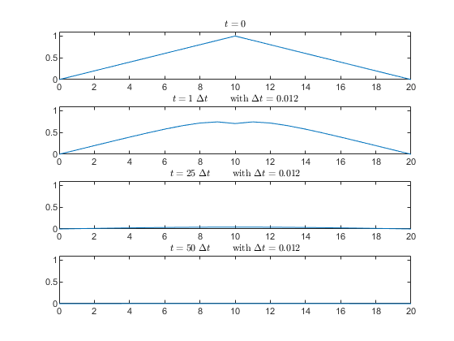

**Q2**

The exact solution should be $u_{0}\left(x-t\right)= \left\{\begin{aligned}1 \\ 0\end{aligned} \begin{matrix}x≤t \\ x>t\end{matrix}\right.$. Therefore at $t=0.5$ the discontinuity should appear at $x=0.5$.

**Code for upwind method:**

dt = 0.0025; %[0.01, 0.0025]

N = int32(0.5/dt);

dx = dt*2; % nu=dt/dx=0.5

J = int32(2/dx);

a = 1;

% a=1 > 0 so should use scheme (2) in lecture notes

x = linspace(-1,1,J+1);

u0 = @(x) (x<=0).*1;

gd = u0(x);

for n = 1:N

for j = J:-1:2

gd(j) = gd(j) - a*dt/dx*(gd(j)-gd(j-1));

end

end

% exact solution

u = @(x,t) u0(x-t);

plot(x,gd(:),'b');

hold on

plot(x,u(x,0.5))

hold off

**Code for Lax Wendroff method:**

dt = 0.01; %[0.01, 0.0025]

N = int32(0.5/dt);

dx = dt*2; % nu=dt/dx=0.5

J = int32(2/dx);

a = 1;

x = linspace(-1,1,J+1);

u0 = @(x) (x<=0).*1;

gd = u0(x);

gd_temp = gd;

for n = 1:N

for j = 2:J

gd_temp(j) = gd(j) - a*nu/2*(gd(j+1)-gd(j-1)) + a^2*nu^2/2*(gd(j+1)-2*gd(j)+gd(j-1));

end

gd = gd_temp;

end

% exact solution

u = @(x,t) u0(x-t);

plot(x,gd(:),'b');

hold on

plot(x,u(x,0.5))

hold off

Upwind method, $Δt=0.01$ (left) and $Δt=0.0025$ (right)

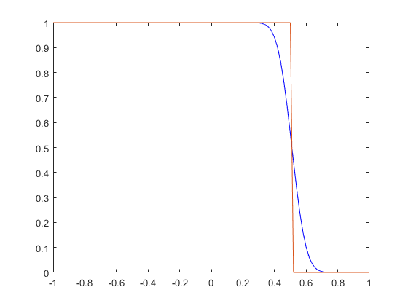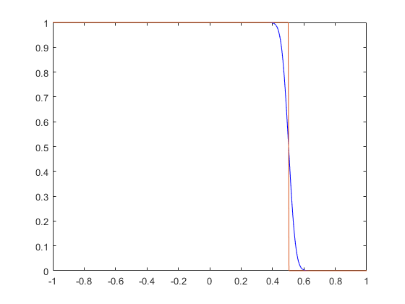

Lax-Wendroff method, $Δt=0.01$ (left) and $Δt=0.0025$ (right)

