Week 3
Assignment 3 - Understanding Algorithm Efficiency and Scalability
Kashif Ali Syed
University of Cumberlands
MSCS-532-B01 – Algorithms and Data Structures
Brandon Bass

Overview
This report explores the efficiency and scalability of two fundamental algorithms in computer science: Randomized Quicksort and Hashing with Chaining. The goal of this analysis is to understand how algorithmic design affects computational performance across different input conditions. Both algorithms were implemented in Python and analyzed from theoretical and empirical perspectives to evaluate their average and worst-case complexities, runtime behaviors, and scalability characteristics.
Methodology
Randomized Quicksort : Randomized Quicksort was implemented by selecting the pivot element uniformly at random from the array at each partitioning step. This random selection minimizes the likelihood of encountering consistently poor partitions. The implementation was designed to handle various edge cases, including empty arrays, arrays with repeated elements, and already sorted datasets. The algorithm was compared to Deterministic Quicksort, which always selects the first element as the pivot. Both algorithms were tested on arrays of sizes 1,000, 3,000, and 6,000 under the following distributions: random, sorted, reverse-sorted, and repeated elements.
Hashing with Chaining: A hash table was implemented using the chaining technique for collision resolution. Each index of the hash table contains a list (chain) of key-value pairs that map to the same hash value. The implementation supports insert, search, and delete operations and includes dynamic resizing when the load factor exceeds 0.75. The design ensures that the table maintains efficient average performance even as the dataset grows.

Theoretical Analysis
Randomized Quicksort: The Randomized Quicksort algorithm operates by dividing an array into subarrays around a randomly selected pivot and recursively sorting the partitions. The expected time complexity is O(n log n) in both the average and best cases. The random pivot selection ensures that the probability of generating unbalanced partitions is minimal, leading to a balanced recursion tree on average.
The recurrence relation for the expected running time is expressed as:
T(n) = n + (1/n) Σ [T(i) + T(n − i − 1)] for i = 0 to n − 1
Solving this recurrence yields T(n) = O(n log n). The worst case, O(n²), occurs rarely when pivots consistently divide the array unevenly, but randomization reduces this risk significantly.
Hashing with Chaining: In the hash table implementation, each operation’s expected runtime under the simple uniform hashing assumption is O(1) for insert, search, and delete. When multiple elements hash to the same index, they are stored in a linked list (chain). The length of the average chain is proportional to the load factor α = n/m, where n is the number of stored elements and m is the number of buckets. To maintain efficiency, the hash table automatically resizes when α exceeds 0.75. This ensures that the expected cost of operations remains constant despite growth.

Empirical Results
The empirical results confirm the theoretical predictions. Both algorithms were benchmarked using Python’s time module. The following patterns were observed:
- Randomized Quicksort:
  - Performed consistently well across all data distributions.
  - Runtime remained close to O(n log n), with only minor variations.
- Deterministic Quicksort:
  - Performed comparably to Randomized Quicksort on random and repeated datasets.
  - Experienced severe performance degradation on sorted and reverse-sorted arrays, with median runtimes exceeding 2.8 seconds for n = 6,000.
- Hashing with Chaining:
  - All operations executed in near-constant time.
  - Insertion and search remained O(1) on average.
  - Automatic resizing maintained the load factor and prevented long chains.
These results validate the importance of randomness in maintaining scalability and show how dynamic data structures like hash tables adapt efficiently to growth.

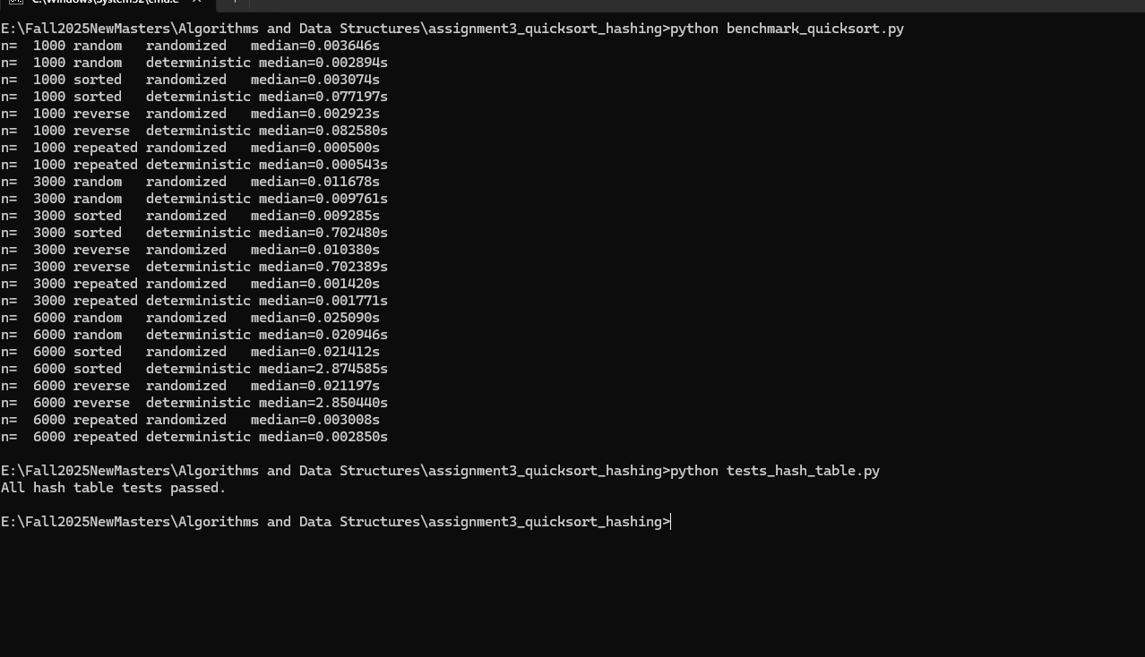

Discussion
The analysis demonstrates that algorithmic performance depends heavily on input characteristics and implementation design. Randomized Quicksort provides a stable, efficient solution for sorting under diverse conditions. Its probabilistic pivot selection mitigates worst-case performance, achieving scalability across large datasets. Conversely, Deterministic Quicksort’s reliance on fixed pivot selection leads to unbalanced partitions in already sorted datasets, resulting in quadratic performance. This contrast highlights the practical value of randomization in improving efficiency. The hash table with chaining further reinforces the importance of adaptability in algorithm design. By dynamically resizing and maintaining a balanced load factor, the data structure preserves its O(1) expected operation time, even as input size scales. Together, these two case studies illustrate fundamental principles of algorithm efficiency and scalability.
Conclusion

Both theoretical and experimental evidence confirm that Randomized Quicksort and Hashing with Chaining are robust and scalable algorithms. Randomized Quicksort achieves O(n log n) expected performance across varied input distributions, while Hashing with Chaining maintains O(1) average operation time through adaptive resizing. This assignment provided practical insights into how algorithm design choices, such as randomization and dynamic data structures, contribute to efficiency, reliability, and scalability in computational systems.

