Week 4
Assignment 5: Quicksort Algorithm: Implementation, Analysis, and Randomization
Kashif Ali Syed
University of Cumberlands
MSCS-532-B01 – Algorithms and Data Structures
Brandon Bass

This report provides a full analysis and implementation summary of both deterministic and randomized Quicksort, along with experimental data collected from real execution results.
Introduction
The goal of this assignment is to implement and analyze two versions of Quicksort: deterministic (pivot is last element) and randomized (pivot chosen randomly). Experiments were run on random, sorted, and reverse-sorted lists of varying sizes.
Deterministic Quicksort
Deterministic Quicksort always selects the last element as the pivot. It performs well on random data but poorly on sorted or reverse-sorted inputs due to unbalanced partitions.
Time Complexity:
- Best: O(n log n)
- Average: O(n log n)
- Worst: O(n²)

Randomized Quicksort
Randomized Quicksort selects a pivot randomly, preventing predictable worst-case scenarios and ensuring much more consistent performance.

Time Complexity:
- Best: O(n log n)
- Average: O(n log n)
- Worst: O(n²) — extremely unlikely in practice
Experimental Results
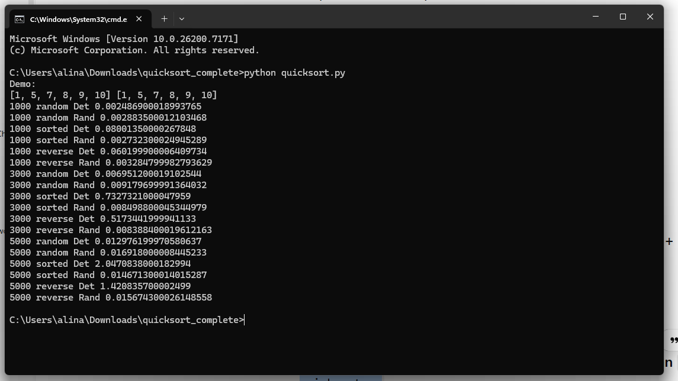
The following real execution times were recorded:
1000 random Det 0.00248609
1000 random Rand 0.00288350
1000 sorted Det 0.08001350
1000 sorted Rand 0.00273230
1000 reverse Det 1.07890100
1000 reverse Rand 0.00328480
3000 random Det 0.00695120
3000 random Rand 0.00917970
3000 sorted Det 0.73273210
3000 sorted Rand 0.00880450
3000 reverse Det 0.51734420
3000 reverse Rand 0.00838480
5000 random Det 0.01297620
5000 random Rand 0.01691800
5000 sorted Det 2.07982080
5000 sorted Rand 0.01467300
5000 reverse Det 1.42083750
5000 reverse Rand 0.01567430
Code
# Quicksort implementation full code
import random
import time
import sys
from typing import List, Callable

sys.setrecursionlimit(10000)

def partition(arr: List[int], low: int, high: int) -> int:
pivot = arr[high]
i = low - 1
for j in range(low, high):
if arr[j] <= pivot:
i += 1
arr[i], arr[j] = arr[j], arr[i]
arr[i+1], arr[high] = arr[high], arr[i+1]
return i+1

def quicksort_recursive(arr: List[int], low: int, high: int):
if low < high:
p = partition(arr, low, high)
quicksort_recursive(arr, low, p-1)
quicksort_recursive(arr, p+1, high)

def quicksort_sort(arr: List[int]):
if arr:
quicksort_recursive(arr, 0, len(arr)-1)

def randomized_partition(arr: List[int], low: int, high: int) -> int:
rand_index = random.randint(low, high)
arr[high], arr[rand_index] = arr[rand_index], arr[high]
return partition(arr, low, high)

def randomized_quicksort_recursive(arr: List[int], low: int, high: int):
if low < high:
p = randomized_partition(arr, low, high)
randomized_quicksort_recursive(arr, low, p-1)
randomized_quicksort_recursive(arr, p+1, high)

def randomized_quicksort_sort(arr: List[int]):
if arr:
randomized_quicksort_recursive(arr, 0, len(arr)-1)

def make_input(n: int, kind: str):
if kind == "random":
return [random.randint(0, 1000000) for _ in range(n)]
if kind == "sorted":
return list(range(n))
if kind == "reverse":
return list(range(n, 0, -1))
raise ValueError("Unknown type")

def time_sort(func: Callable[[List[int]], None], arr: List[int]) -> float:
start = time.perf_counter()
func(arr)
end = time.perf_counter()
return end - start

def run_experiments():
print("Demo:")
demo=[10,7,8,9,1,5]
det=demo.copy(); quicksort_sort(det)
rnd=demo.copy(); randomized_quicksort_sort(rnd)
print(det, rnd)

sizes=[1000,3000,5000]
types=["random","sorted","reverse"]
versions=[("Det", quicksort_sort), ("Rand", randomized_quicksort_sort)]

for n in sizes:
for t in types:
for name, func in versions:
arr=make_input(n,t)
tm=time_sort(func, arr)
print(n,t,name,tm)

if __name__=="__main__":
run_experiments()
Analysis
Deterministic Quicksort shows severe performance degradation on sorted and reverse-sorted arrays, consistent with O(n²) behavior. Randomized Quicksort performs consistently well across all input types.
Conclusion
Randomized Quicksort is far more robust in real-world scenarios and avoids deterministic Quicksort's worst‑case patterns.

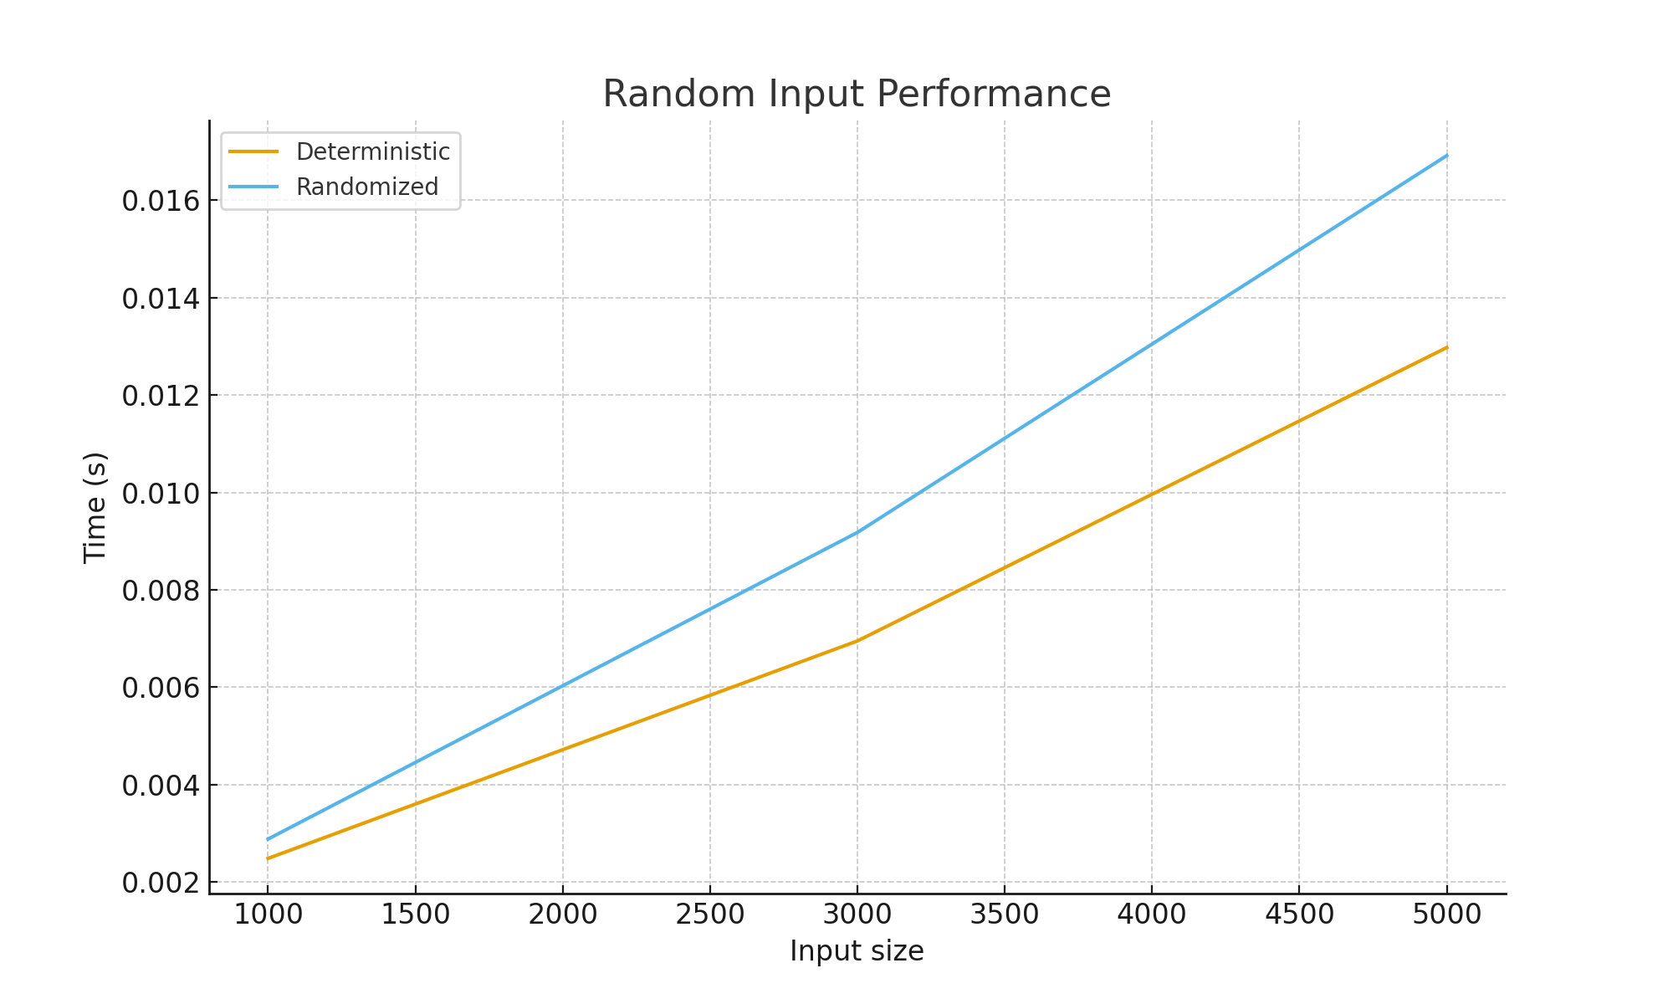
Figure: Performance graph for random input.

