Week 5
Project: Advanced Shell Simulation with Integrated OS Concepts
Deliverable 3
Kashif Ali Syed
University of Cumberlands
MSCS-630-A01 – Advanced Operating System
Dr. Primus Vekuh

Introduction:
This deliverable extends the custom shell from Deliverables 1 and 2 by adding memory management and process synchronization features. The memory management portion simulates paging, page faults, memory allocation, memory deallocation, and two page replacement algorithms: First-In-First-Out (FIFO) and Least Recently Used (LRU). The synchronization portion demonstrates the Producer-Consumer problem using semaphores and a mutex to control access to a shared buffer.
Implementation Overview
The updated shell file is named myshell_d3.py. It keeps the previous shell and scheduling features while adding new commands for memory and synchronization. The main memory commands are meminit, alloc, access, memstatus, free, memclear, fifo_demo, and lru_demo. The synchronization command is sync_demo. These commands simulate how an operating system controls memory frames, handles page faults, replaces pages when memory is full, and protects shared resources during concurrent execution.
Memory Management: Paging System
Paging was implemented by dividing simulated physical memory into fixed-size frames. Each loaded page is stored inside a frame with information about the process name, page number, loaded time, and last-used time. The shell tracks which pages belong to each process and shows memory usage with the memstatus command. This is similar to how a real operating system uses page tables to track the relationship between virtual pages and physical frames.

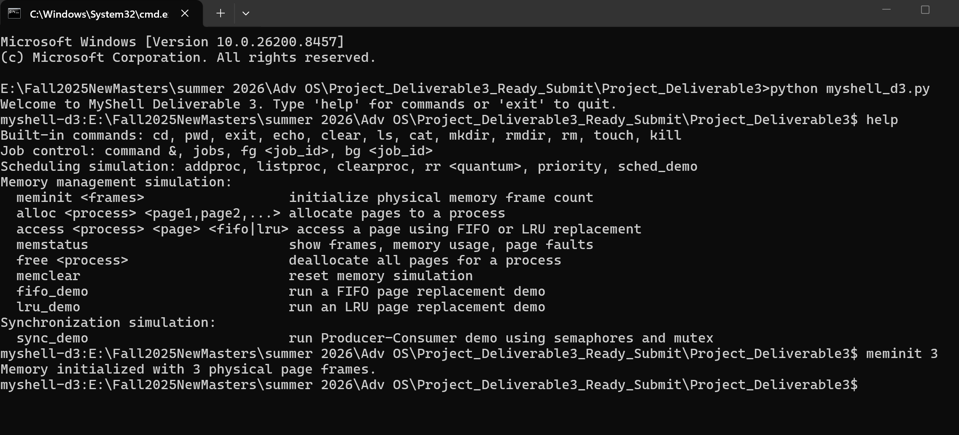
Figure 1: Memory initialization using meminit 3.
The memory initialization command creates a fixed number of physical page frames. In the test run, memory was initialized with three frames. This gives the shell a small memory size so that memory overflow and page replacement can be demonstrated clearly.
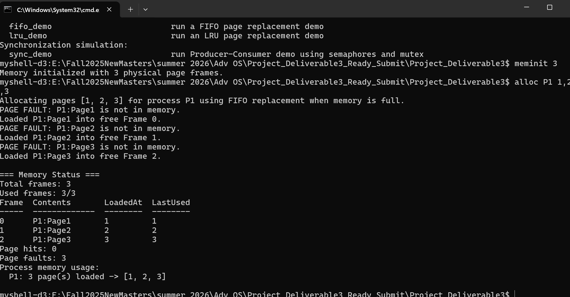Figure 2: Memory allocation using alloc P1 1,2,3 and memory status output.
The allocation test assigned pages 1, 2, and 3 to process P1. Each page caused a page fault because the pages were not already loaded in memory. Since empty frames were available, the shell loaded each page into a free frame. The memory status output shows the pages loaded into frames and displays the current number of page faults. This demonstrates basic memory allocation using paging.
FIFO Page Replacement and Page Faults
A page fault occurs when a process requests a page that is not currently loaded in memory. When memory still has free frames, the page is loaded into an empty frame. When memory is full, the shell must remove an existing page and replace it with the requested page. In FIFO page replacement, the oldest loaded page is removed first.
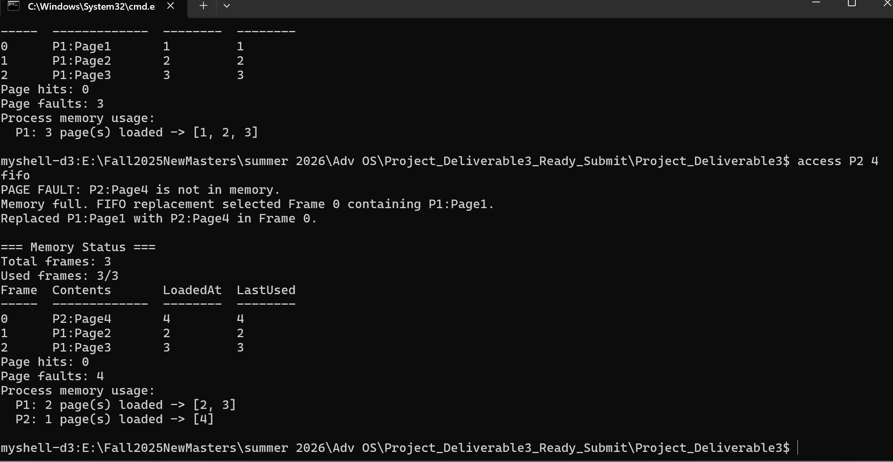
Figure 3: FIFO page replacement after accessing P2 Page 4.
In the FIFO test, memory was already full with pages from process P1. When process P2 requested page 4, the shell reported a page fault. Because no free frame was available, FIFO selected the page that had been in memory the longest and replaced it with P2 Page 4. This shows how FIFO handles memory overflow by removing the oldest page first.
LRU Page Replacement
LRU page replacement removes the page that has not been used for the longest time. The shell tracks a last-used timestamp for every page. Whenever a page is accessed successfully, its last-used value is updated. When memory is full, LRU selects the page with the oldest last-used value.
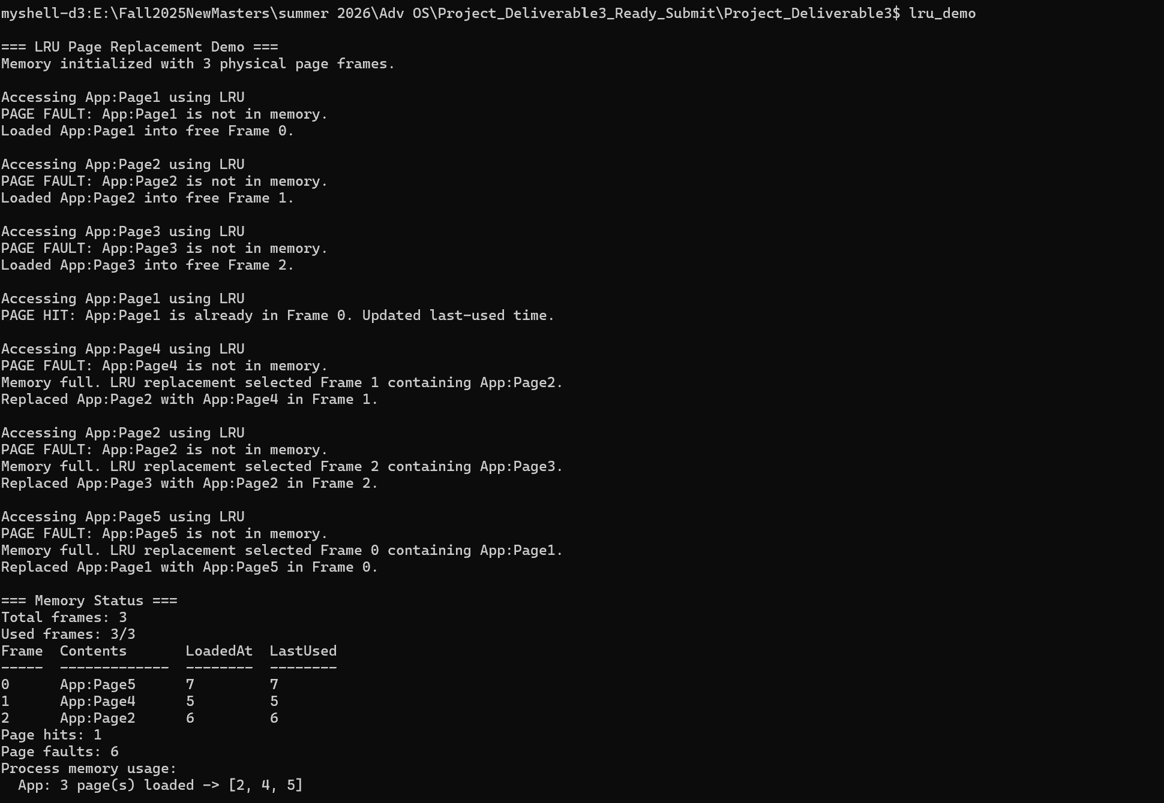
Figure 4: LRU page replacement demonstration using lru_demo.
The LRU demo shows a sequence of page accesses where one page is accessed again before memory overflows. Because that page was recently used, LRU avoids replacing it at first. Instead, the least recently used page is selected as the victim. This behavior is more intelligent than FIFO because it considers recent access history, not only loading order.
Memory Deallocation and Usage Tracking
The free command deallocates all pages belonging to a selected process. This simulates how an operating system releases memory when a process terminates or no longer needs memory. The shell then updates the memory status and process usage records. Page fault counters and page hit counters are also tracked to help analyze performance.
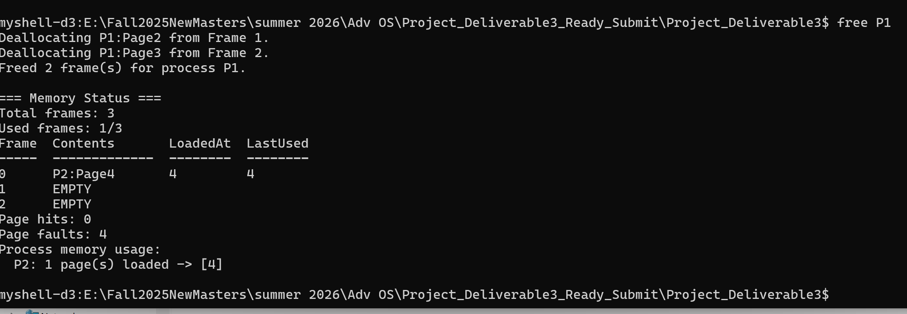
Figure 5: Memory deallocation using free P1.
After running free P1, the shell removes all frames used by process P1 and marks those frames as empty. This demonstrates memory deallocation and shows how memory can be returned to the system for future use.

Process Synchronization: Producer-Consumer
The synchronization feature was implemented using the classical Producer-Consumer problem. In this problem, a producer adds items to a shared buffer while a consumer removes items from that same buffer. Without synchronization, both threads could access the buffer at the same time and cause a race condition. The shell prevents this by using a mutex and two semaphores.
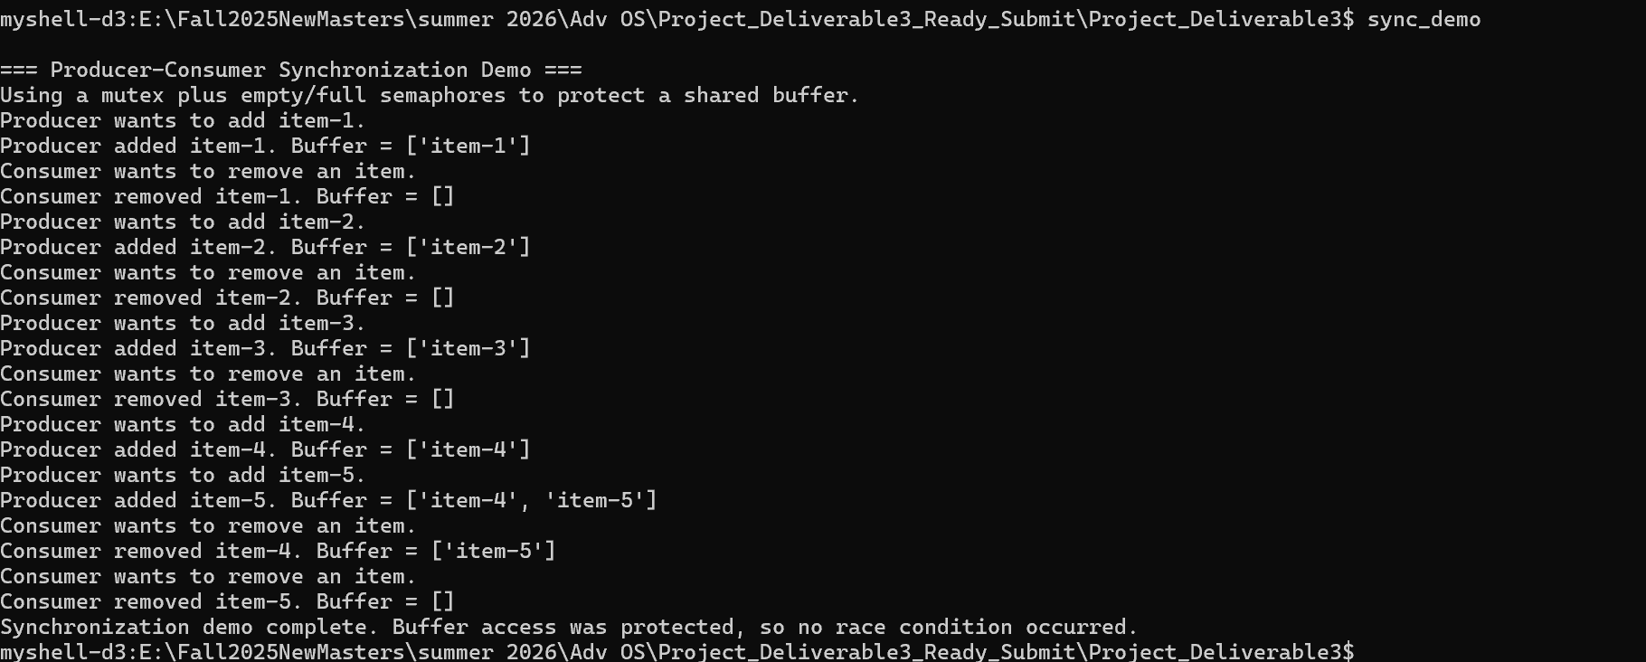
Figure 6: Producer-Consumer synchronization demo using sync_demo.
The mutex protects the shared buffer so only one thread can change it at a time. The empty semaphore prevents the producer from adding items when the buffer is full. The full semaphore prevents the consumer from removing items when the buffer is empty. This ensures proper access control, prevents race conditions, and avoids invalid buffer operations.
Comparison to a Real Operating System
A real operating system uses page tables, physical frames, page faults, and page replacement algorithms to manage memory. This shell uses a simplified model of those same ideas. Instead of managing real hardware memory, it stores page information in Python data structures. The FIFO and LRU algorithms simulate how an operating system might choose which page to remove when memory is full. The Producer-Consumer demo also reflects real operating system synchronization because mutexes and semaphores are commonly used to protect shared resources between threads and processes.
Performance Analysis
The page fault count is the main performance measurement in this simulation. A page hit means the requested page was already in memory, while a page fault means the page had to be loaded. FIFO is simple, but it may remove pages that will be needed again soon. LRU is usually better because it uses recent access history to make replacement decisions. In the demo, LRU tracks which pages were used most recently and replaces the least recently used page when memory overflows. Memory usage is also tracked by showing how many frames are used and which pages are loaded for each process.
Challenges and Improvements
One challenge was keeping the memory simulation simple while still showing real operating system concepts. Another challenge was making FIFO and LRU behave differently in a way that is easy to demonstrate with screenshots. Synchronization also required careful use of semaphores and a mutex so the Producer-Consumer demo would not create race conditions. A future improvement would be adding more detailed page tables, per-process virtual address spaces, and additional replacement algorithms such as Clock or Optimal replacement.

Conclusion
Deliverable 3 successfully adds memory management and process synchronization to the custom shell. The shell simulates paging, page faults, memory allocation, memory deallocation, FIFO page replacement, and LRU page replacement. It also demonstrates process synchronization using the Producer-Consumer problem with semaphores and a mutex. These features show how operating systems manage memory and coordinate concurrent processes to maintain stability, avoid race conditions, and use resources efficiently.

