Week 2
Lab 1: Word Frequency Counter Using Multithreading
Kashif Ali Syed
University of Cumberlands
MSCS-630-A01 – Advanced Operating System
Dr. Primus Vekuh

The purpose of this lab was to understand how multithreading works in operating systems. The program reads a text file, divides the file into multiple segments, and assigns each segment to a separate thread. Each thread processes its assigned section independently and counts the frequency of words. After all threads complete execution, the main thread combines the intermediate results into one final consolidated word-frequency count.
Program Design and Structure
The program was developed using Python and the threading module. The user provides two inputs: the text file name and the number of segments or threads. The file contents are read and divided into equal parts based on the number of threads entered. Each thread executes the count_words() function. Inside this function, the thread converts text into lowercase, extracts words using regular expressions, and stores word counts using Python’s Counter data structure. The intermediate results are saved into a shared dictionary.
Multithreading Implementation
Multithreading was implemented using Python’s threading.Thread() class. Each thread processes a separate file segment concurrently. The main thread starts all worker threads and uses join() to wait until every thread finishes execution. Once all threads complete execution, the main process combines the results from all threads into one final word-frequency count. This demonstrates concurrent processing and thread synchronization.

Challenges Encountered
One challenge encountered during development was splitting the text file evenly between threads. Since the file was divided using character ranges, some words were split between segments. This caused partial words to appear in intermediate thread outputs. However, the program still correctly demonstrated multithreading and concurrent execution.
Code:
import threading
from collections import Counter
import re

# Function for each thread
def count_words(segment, thread_id, results):
words = re.findall(r'\b\w+\b', segment.lower())
word_count = Counter(words)

print(f"\nThread {thread_id} Intermediate Count:")
for word, count in word_count.items():
print(f"{word}: {count}")

results[thread_id] = word_count

# Main program
def main():
filename = input("Enter text file name: ")
num_threads = int(input("Enter number of segments/threads: "))
# Read file
with open(filename, "r") as file:
text = file.read()

# Split text into segments
segment_size = len(text) // num_threads
segments = []

start = 0
for i in range(num_threads):
end = start + segment_size

if i == num_threads - 1:
end = len(text)

segments.append(text[start:end])
start = end

threads = []
results = {}

# Create threads
for i in range(num_threads):
thread = threading.Thread(
target=count_words,
args=(segments[i], i + 1, results)
)

threads.append(thread)
thread.start()

# Wait for all threads
for thread in threads:
thread.join()

# Combine final counts
final_count = Counter()

for result in results.values():
final_count.update(result)

print("\nFinal Consolidated Word Count:")
for word, count in final_count.items():
print(f"{word}: {count}")
if __name__ == "__main__":
main()
Sample output:
Operating systems are important.
Operating systems manage processes and threads.
Threads improve performance.
Processes and threads work together.

Screenshot:
Figure 1 below shows the Python source code implemented in OnlineGDB.
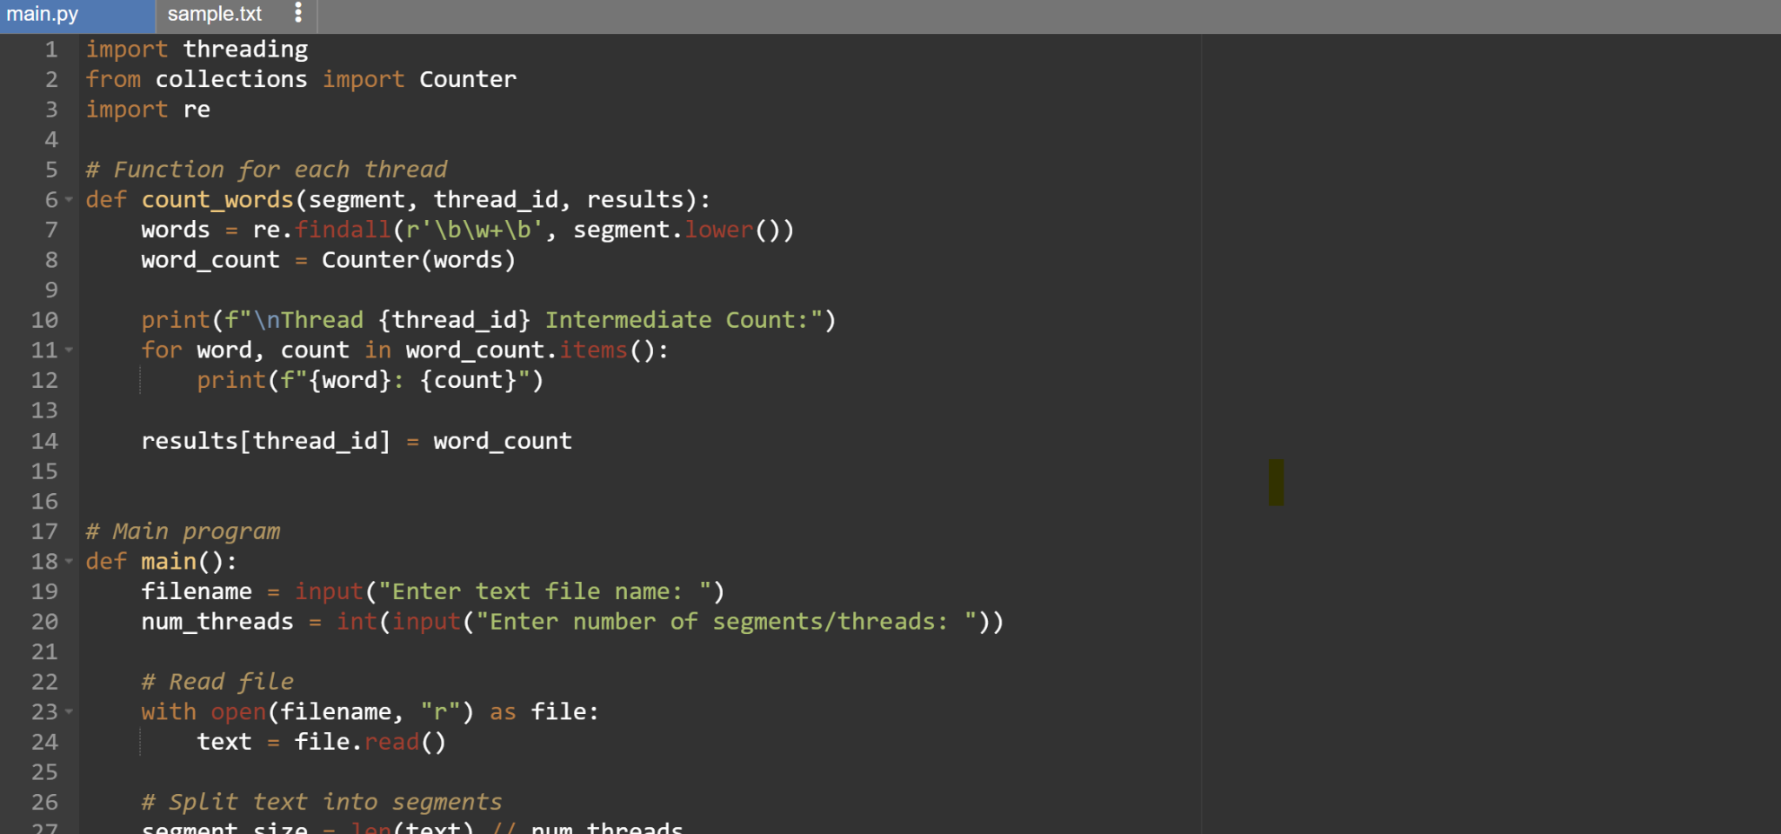
Figure 2 below shows the execution of the program and the intermediate and final word-frequency counts.
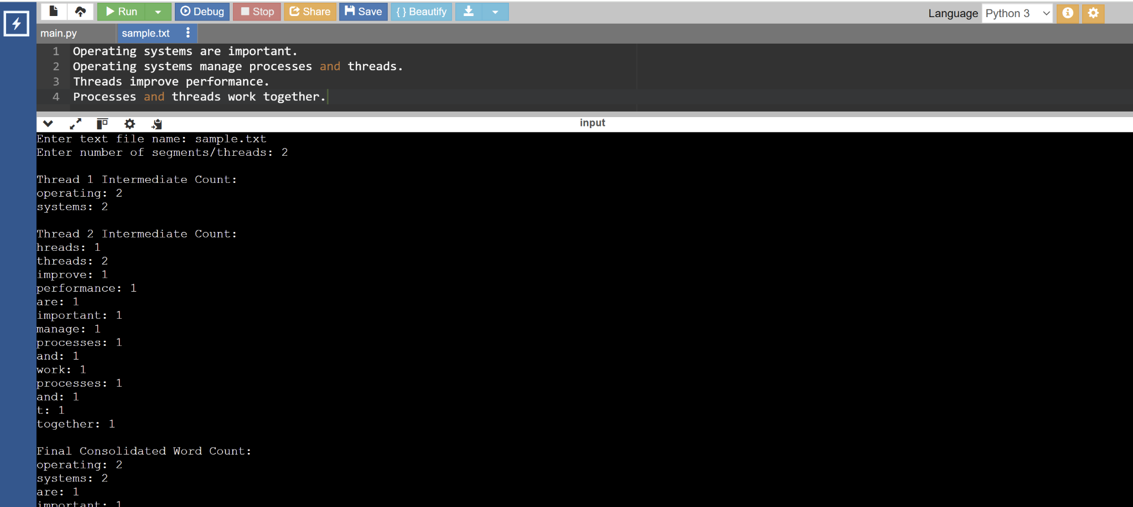

Output Explanation:
The program displayed intermediate word-frequency counts for each thread separately. Each thread processed a different file segment independently. After all threads completed execution, the main thread consolidated all results into one final word-frequency count.
The output confirms that multithreading was successfully implemented because multiple threads processed file segments concurrently.
This screenshot shows the successful execution of the multithreaded word-frequency counter program in OnlineGDB. The program accepted sample.txt as the input file and divided the file into 2 segments using 2 threads. Each thread independently processed its assigned segment and displayed intermediate word-frequency counts. Thread 1 processed the first segment of the file, while Thread 2 processed the second segment. After both threads completed execution, the main thread consolidated the intermediate results into one final word-frequency count.
The output demonstrates concurrent processing because multiple threads executed simultaneously to process different parts of the text file. It also shows synchronization using join(), where the main thread waited for all worker threads to finish before generating the final consolidated result.

