電通二乙微處理器實驗 實驗結報

實驗名稱 | MCS Cloud
組別 | 1 | 組員 | 薛華慶

- 實驗目的
利用雲端控制
- 實驗步驟
01控制LED並檢視狀態
02 將電阻值上傳
- 程式碼
1.
#include <LWiFi.h>
#include "MCS.h"

char _lwifi_ssid[] = "AA201-2G";
char _lwifi_pass[] = "iteaa201";
MCSDevice mcs("DuH3qJzm", "0rET0hA6xyVaXEcJ");

MCSControllerOnOff LED("Control");
MCSDisplayOnOff remote("LED2");

void setup()
{
Serial.begin(9600);

Serial.println("Connect to Wifi");
while (WiFi.begin(_lwifi_ssid, _lwifi_pass) != WL_CONNECTED) {
Serial.println("Wifi Reconnecting..");
delay(1000);
}

Serial.println("Connect to MCS...");
while (!mcs.connected()) {
Serial.println("MCS Reconnecting..");
mcs.connect();
}
Serial.println("MCS Connected!");
mcs.addChannel(LED);mcs.addChannel(remote);
pinMode(7, OUTPUT);
}

void loop()
{
while (!mcs.connected()) {
mcs.connect();
if (mcs.connected()) {
Serial.println("MCS Reconnect");
}
}
mcs.process(1000);

if (LED.value() == 1) {
digitalWrite(7, HIGH);

} else {
digitalWrite(7, LOW);

}

delay(200);

}
2.
#include <LWiFi.h>
#include "MCS.h"

char _lwifi_ssid[] = "AA201-2G";
char _lwifi_pass[] = "iteaa201";
MCSDevice mcs("DmmAd7ze", "3orms5gQCnSBr4TP");

MCSDisplayInteger Temp("R");

void setup()
{
Serial.begin(9600);

Serial.println("Connect to Wifi");
while (WiFi.begin(_lwifi_ssid, _lwifi_pass) != WL_CONNECTED) {
Serial.println("Wifi Reconnecting..");
delay(1000);
}

Serial.println("Connect to MCS...");
while (!mcs.connected()) {
Serial.println("MCS Reconnecting..");
mcs.connect();
}
Serial.println("MCS Connected!");

mcs.addChannel(Temp);

}

void loop()
{
while (!mcs.connected()) {
mcs.connect();
if (mcs.connected()) {
Serial.println("MCS Reconnect");
}
}
mcs.process(1000);

int sensor = analogRead(3);
Temp.set(sensor);
Serial.println("Add sensor value.");
delay(200);
}
- 實驗結果及分析
成功將數值上傳以及控制開關
- 心得討論
對未來的專研來說是個很棒的工具
- 修正電路圖
1
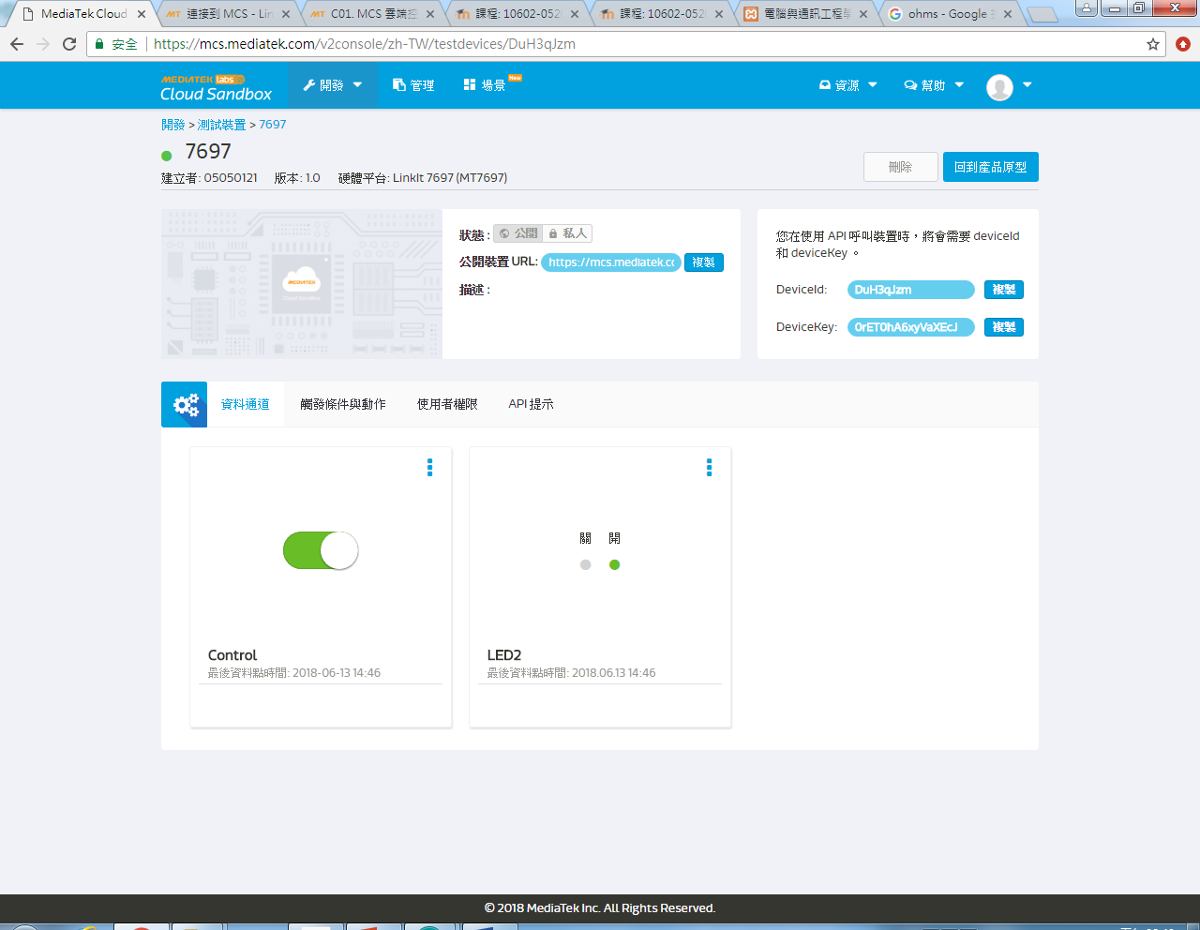
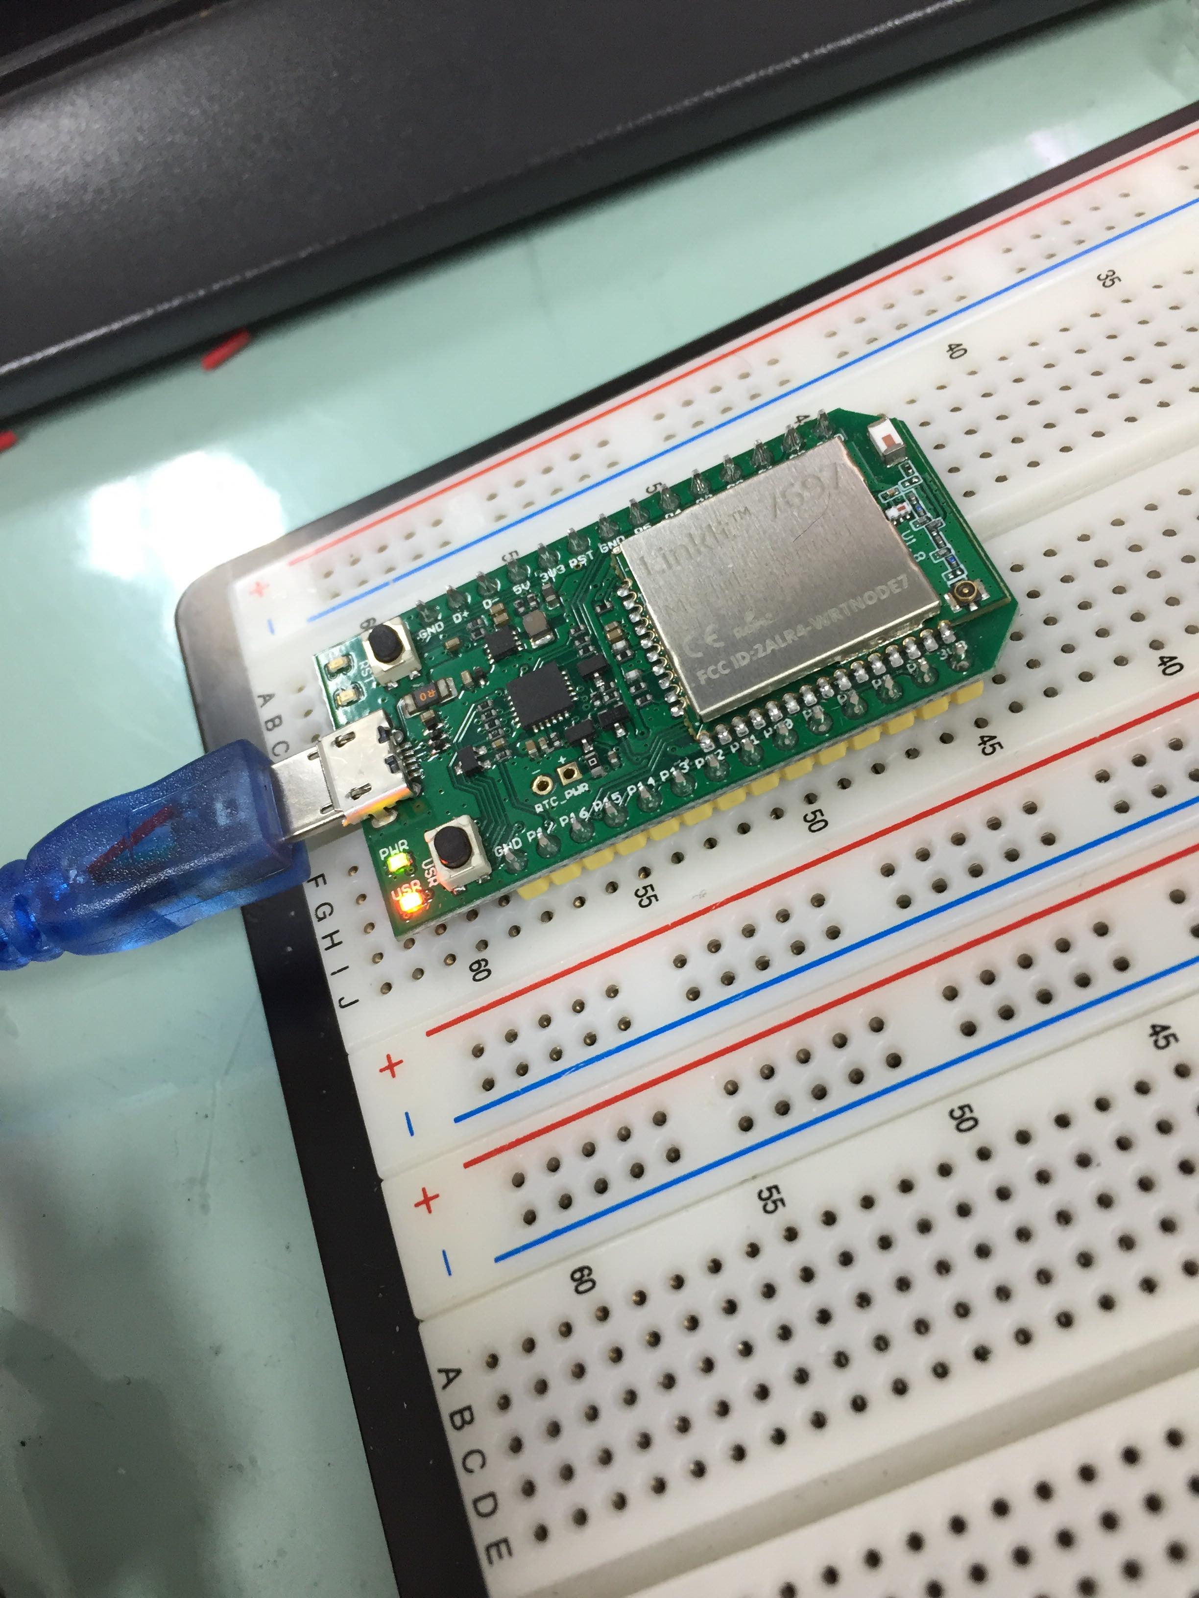
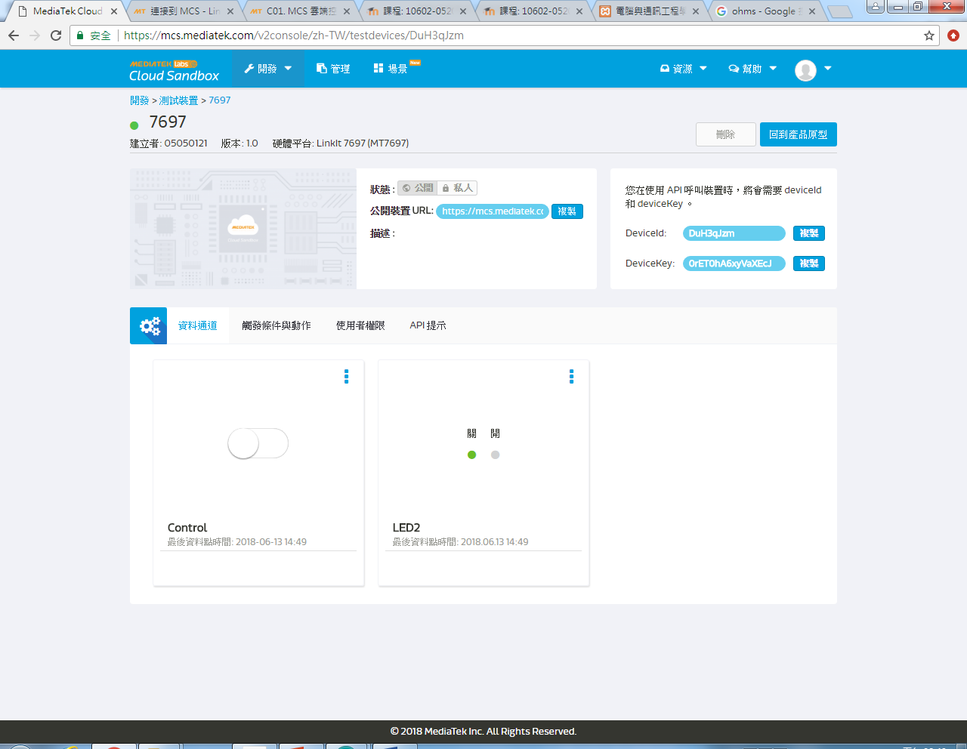

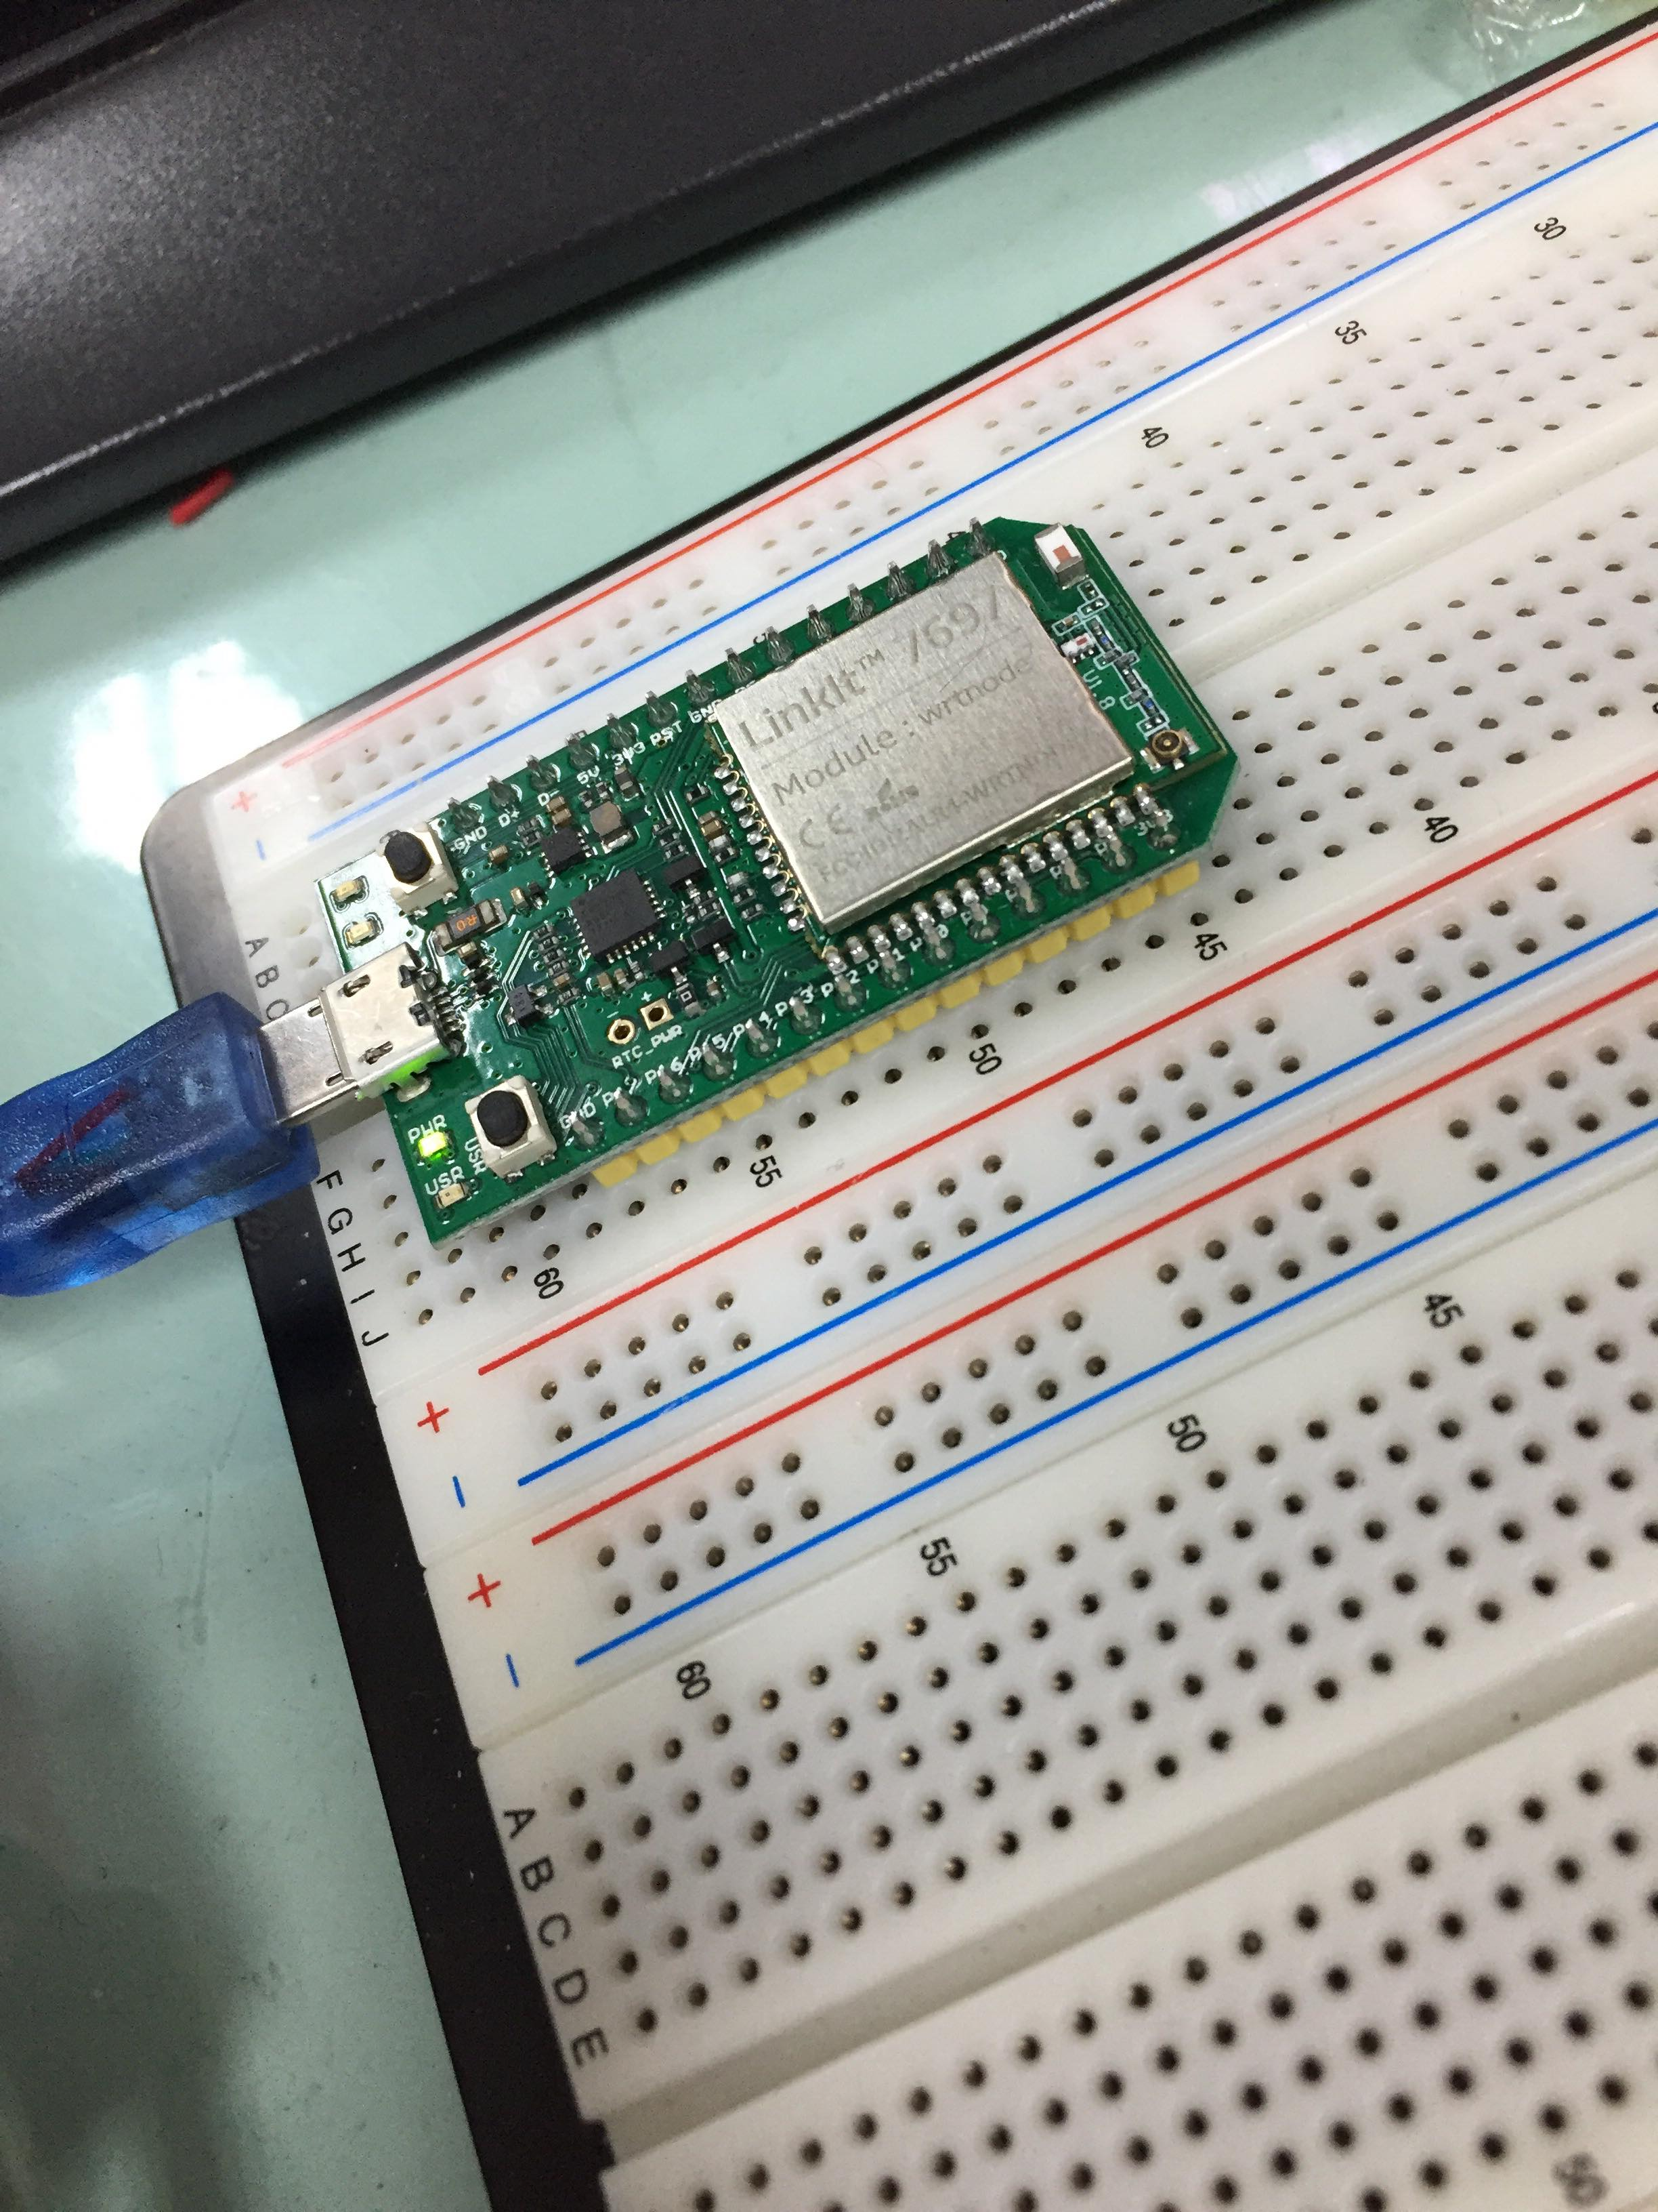
2
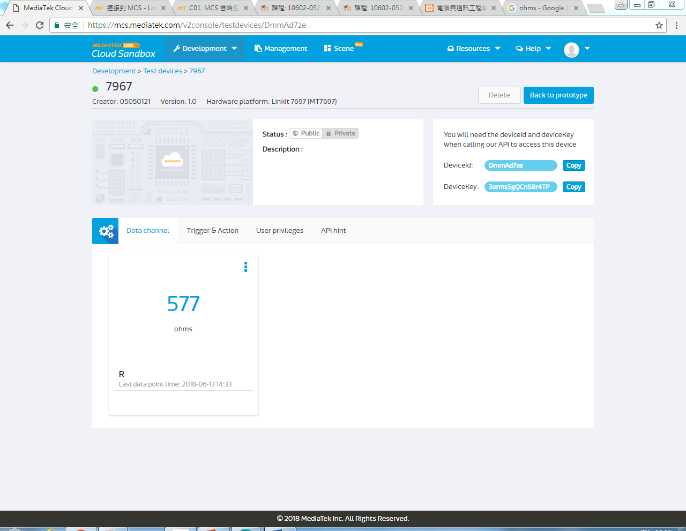
- 修正程式碼

