電通二乙微處理器實驗 實驗結報

實驗名稱 | 4*4鍵盤
組別 | 1 | 組員 | 薛華慶

- 實驗目的
1 . 4x4 鍵盤之按鍵值經由串列傳輸，顯示在 PC 上
2. 4x4 鍵盤之按鍵值顯示在七段顯示器上

- 實驗步驟
將4x4鍵盤依序 接在麵包板上 (左列 右行 並從中間依序1～4)
利用 Keypad.h將鍵盤數值依序輸入至程式中

- 程式碼
1.
#include<Keypad.h>
const byte Rows = 4;//行
const byte Cols = 4;//列

// Value
char keys[Rows][Cols] = {
{'F','E','D','C'},
{'B','3','6','9'},
{'A','2','5','8'},
{'0','1','4','7'}
};
//Pins
byte rowPins[Rows] = {5,4,3,2};
byte colPins[Cols]= {11,10,9,8};
//make object
Keypad keypad =
Keypad(makeKeymap(keys),rowPins,colPins,Rows,Cols);

void setup() {
// put your setup code here, to run once:
Serial.begin(9600);
}

void loop() {
// put your main code here, to run repeatedly:
if(Serial.available()){

char k = keypad.getKey();

if(k != NO_KEY){
Serial.println(k);
}

}

}
2.
#include<Keypad.h>
//--------------------------------------
byte ledPins[]={12,13,14,15,16,17,6};
byte num[10]={
B0111111,//0 GFEDCBA
B0000110,//1
B1011011,//2
B1001111,//3
B1100110,//4
B1101101,//5
B1111101,//6
B0000111,//7
B1111111,//8
B1101111 //9
};
//----------------------------------------

const byte Rows = 4;//行
const byte Cols = 4;//列

// Value
char keys[Rows][Cols] = {
{'F','E','D','C'},
{'B','3','6','9'},
{'A','2','5','8'},
{'0','1','4','7'}
};
//Pins
byte rowPins[Rows] = {5,4,3,2};
byte colPins[Cols]= {11,10,9,8};
//make object
Keypad keypad =
Keypad(makeKeymap(keys),rowPins,colPins,Rows,Cols);

//-----------------------------------------------------

void setup() {
// put your setup code here, to run once:
Serial.begin(9600);
pinMode(7,OUTPUT);
int i;
for(i=0;i<8;i++)
pinMode(ledPins[i],OUTPUT);

}

void loop() {
// put your main code here, to run repeatedly:

char k=keypad.getKey();
if(k!=NO_KEY){
int Value=k-48,i;
Serial.println(k);

for(i=0;i<7;i++){
if(bitRead(num[Value],i))
digitalWrite(ledPins[i],1);
else
digitalWrite(ledPins[i],0);
}

}

}

- 實驗結果及分析

1.

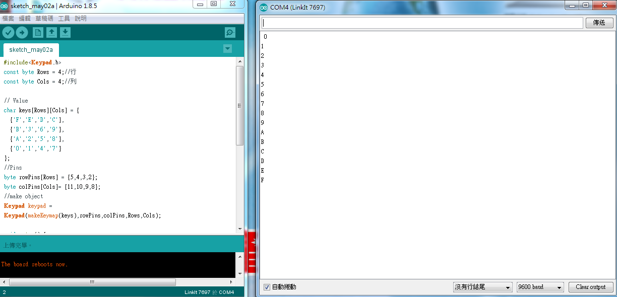

2.
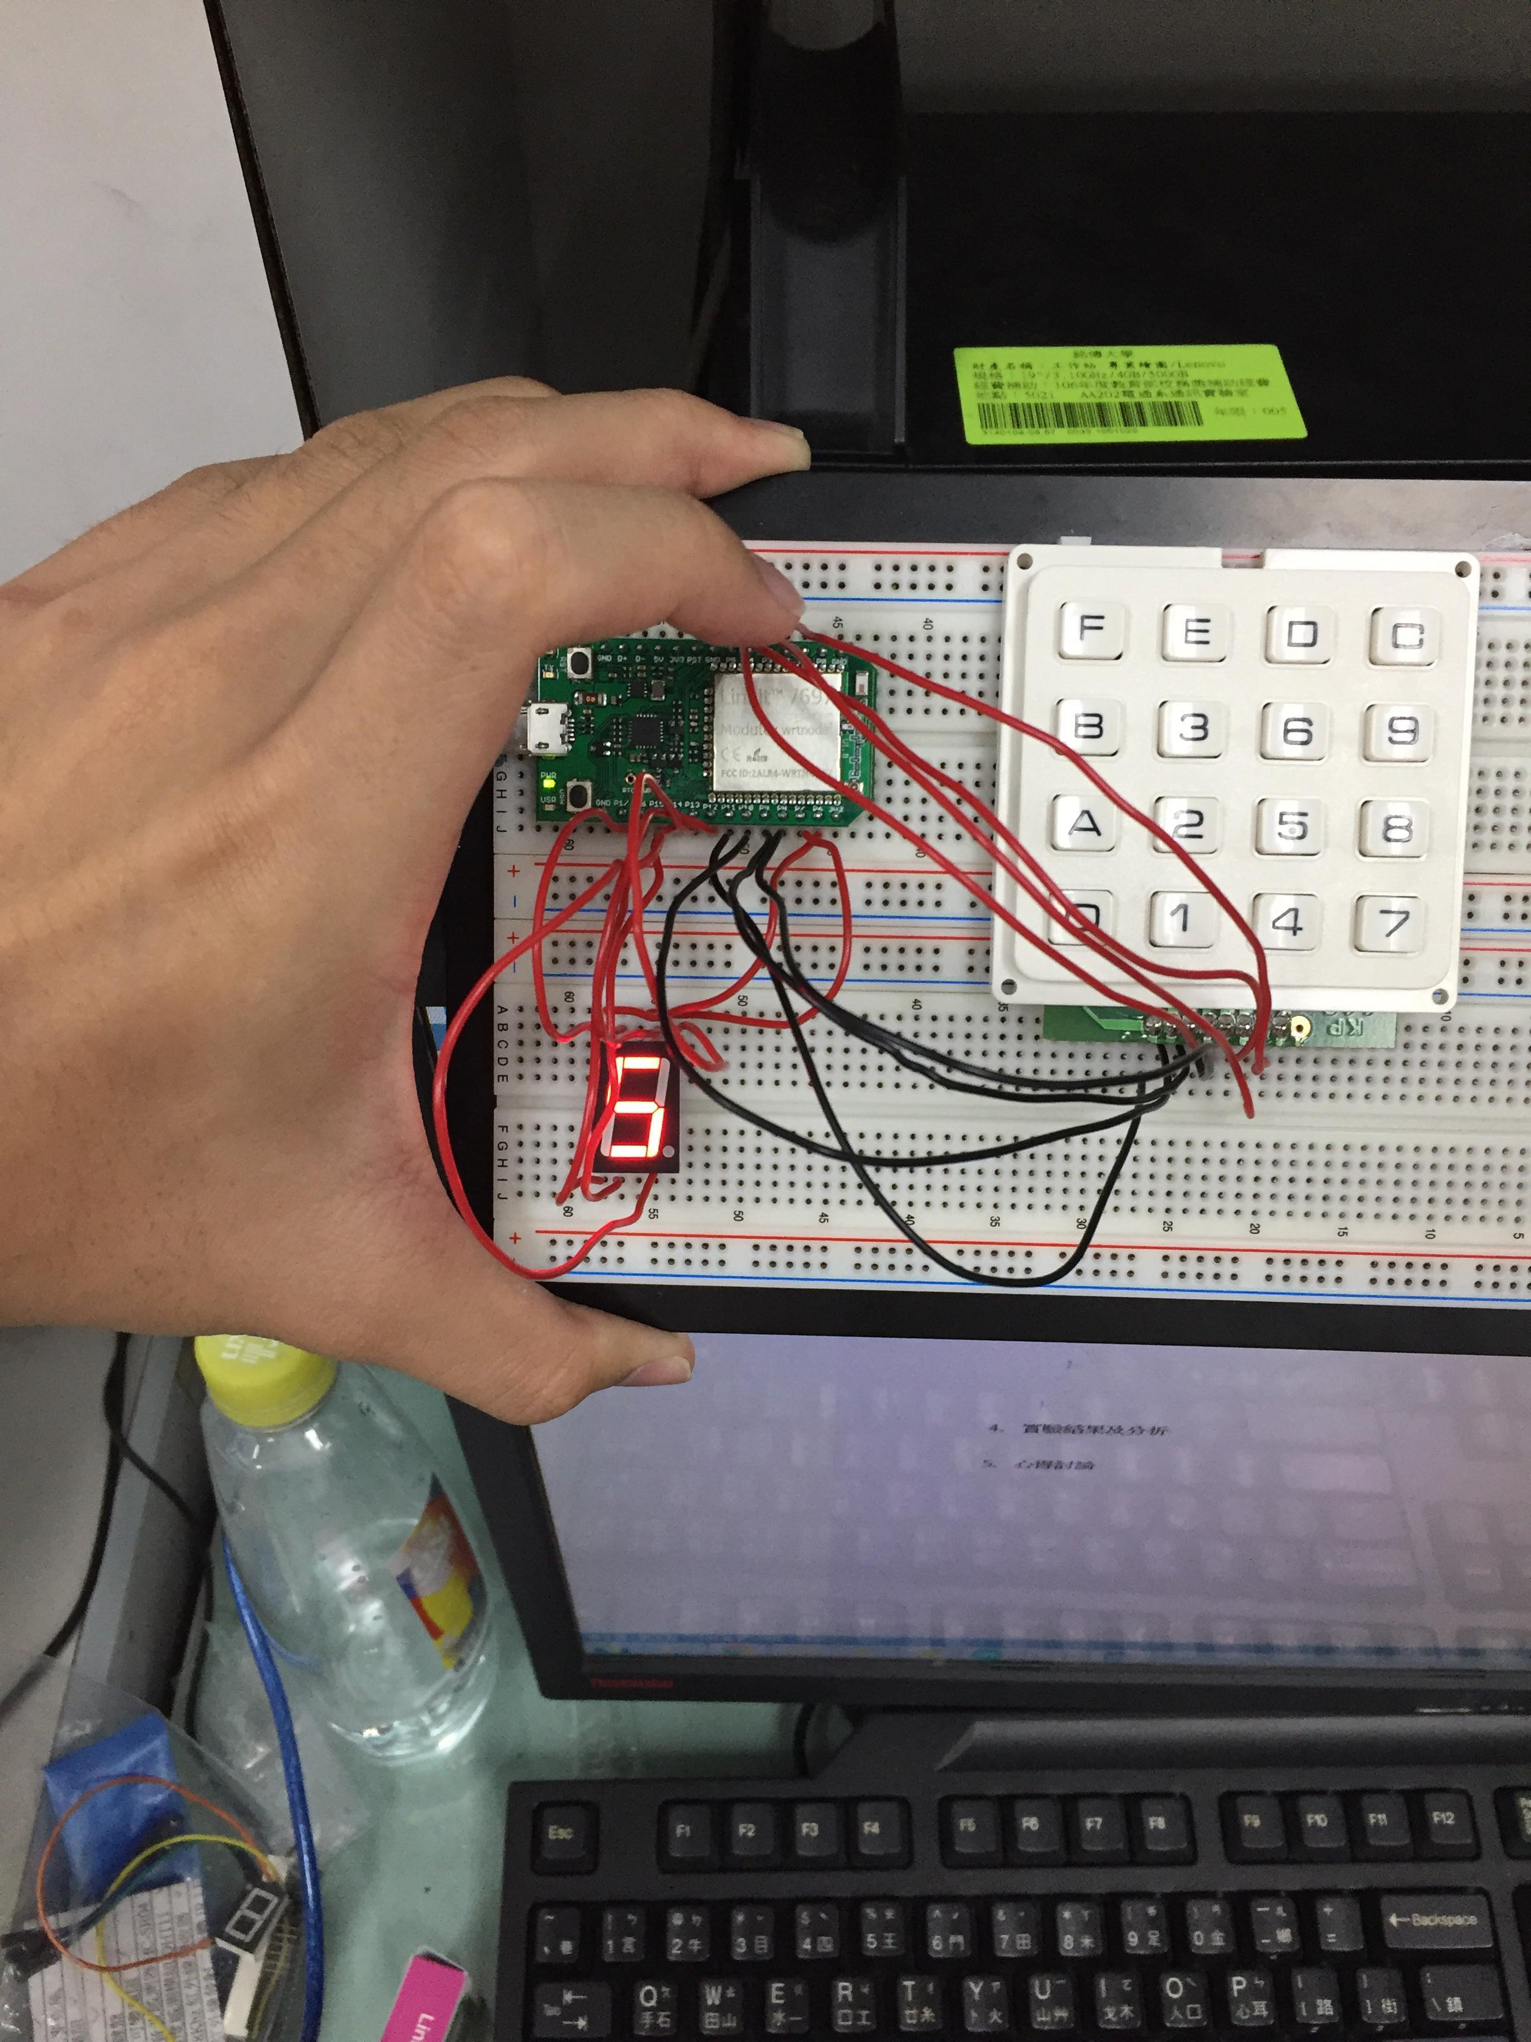

- 心得討論

人生有幾次是可以這麼快做完的…
- 修正電路圖
- 修正程式碼

