**CTfastrak Application Product Backlog**

**Team VTD**

**Karthigaa Vijayakumar, Kevin Daley, Khuong Tong**

**Refined User Stories**

*[1] Find Closest Bus Stop*

Story: As a Google API map service I need to calculate the route and display the route to the riders. The rider is provided with a visual representation of the route.

Pre-Condition/ Post-Condition: Riders have shared their location or destination and the Google API has found the closest bus stop are pre-Condition and there is no post-condition.

Further Breakdown: The user story does not need any further breakdown.

*[2] Show/Calculate Route*

Story: As a JSON live data feed, I need to provide live data about the location of CTfastrak buses. This allows the riders to easily see where all the location of all the buses.

Pre-Condition/ Post-Condition: The Application should have done JSON request for when the rider’s request for view bus information are pre-Condition and there is no post-condition

Further Breakdown: This story does not need any further break down.

*[3] Provide Live Data*

Story: As a JSON live data feed, I need to provide live data about the location of CTfastrak buses. This allows the riders to easily see where all the location of all the buses.

Pre-Condition/ Post-Condition: The Application should have done JSON request for when the rider’s request for view bus information are pre-Condition and there is no post-condition

Further Breakdown: This story does not need any further break down.

*[4] Accept JSON Requests*

As a JSON live data feed, I need to accept the request from your application so I can provide CTfastrak bus data. This data will be needed for the applications live services.

Pre-Condition/ Post-Condition: Pre-conditions are riders should have opted to view bus information through our application. There are no post-conditions.

Further Breakdown: This story could be broken down to receive request and process request.

*[5] Share Location*

Story: As a rider I want to share my current location with the application. I want the application to use my current location to find the nearest bus stop, calculate the route, and display other detailed information.

Pre-Condition/ Post-Condition: There are no pre-conditions. The ability to view find the closest bus stop and view trip/route information are both post-conditions.

Further Breakdown: This user story may be broken down into the methods of input. Depending on the variety and differences between the input types it may be recommended to split this user story.

*[6] Choose Location*

Story: As a rider I want to select a location from the application. I want the application to use my location information to find the nearest bus stop, calculate my route, and show other detailed information.

Pre-Condition/ Post-Condition: The pre-condition is to not be out of range. The ability to view find the closest bus stop and view trip/route information are both post-conditions.

Further Breakdown: This user story may also be broken down by method of input. It may be necessary to split this story depending on the types of input.

*[7]  Data Intersection*

Story: As a rider, it is necessary to be informed of transit system details that are both static (like stop names and addresses, routes numbers) and dynamic (like bus numbers and estimated arrival times). I want to click on transit system components and be provided a display of these details.

Pre-Condition/ Post-Condition: The rider has selected on a CTfastrak map object. The post conditions are that the rider has been provided the latest information concerning the map object of interest and the display has changed to show this information.

Further Breakdown: This user story relates all the actors in this system; the rider who is querying the system, the real-time data service which receives requests and returns data about CTfastrak, and the mapping API which bridges the other two by interpreting the rider’s map click as coordinates to be used when querying the real-time data service and formatting the real-time data that is returned.

*[8] View Service Alerts*

Story: As a rider I want to view the details of a service alert notification. I want to see if the alert affects any of their plans and make any adjustments necessary.

Pre-Condition/ Post-Condition: Accept JSON request and provide live data are pre-conditions. No post-conditions are required.

Further Breakdown: This story should not require further breakdown.

*[9] View Trip/Route*

Story: As a rider I want to view the route I will be traveling to reach my destination. I want to know the route I must take, the distance, and estimated travel time.

Pre-Condition/ Post-Condition: Share location, choose location, find closest bus stop, and show/calculate route are all pre-conditions. No post-conditions are necessary.

Further Breakdown: This story is simple enough that further break-down would lead to defining the implementation.

*[10] View Schedule*

Story: As a rider I want to see the full bus schedule. I want access to all the bus schedules for trip planning.

Pre-Condition/ Post-Condition: View bus information is a pre-condition. There are no post-conditions.

Further Breakdown: This story is simple enough that further break-down would go beyond the usefulness of a user story.

*[11] Zoom/Pan Map*

Story: As a rider, it is important to be able to visually verify geographic areas to start and end trips. The application should allow for map navigation (zoom and pan) so that it can be explored at different scales.

Pre-Condition/ Post-Condition:  There are no pre-conditions. The post-condition is that the map has changed.

Further Breakdown: Zoom and Pan are not considered as two separate functions of the map because technically speaking they are doing the same thing which is requesting new map image tiles.

*[12]  Out of Range*

As a rider, it is important to know if using the transit system at a given time is a viable option. The application should alert me when I am beyond a certain distance from the transit system and adjust the interface accordingly.

Pre-Condition/ Post-Condition:  The pre-conditions are that the rider is either offering their current location as input or has entered an address and that the location or address are not near the CTfastrak area. The post-condition is that the trip variable (starting point or destination) that was being manipulated by the rider has not changed. The rider is informed of invalid input.

Further Breakdown: This user story is an extension of [6] Choose Location and may be split into a starting point scenario and a destination scenario but the workflow is the same for each.

**Story Sizes**

|  |  |  |
| --- | --- | --- |
| **Story Number** | **Story Name** | **Fibonacci Size** |
| 1 | Find the Closest Bus Stop | 3 |
| 2 | Calculate/Show Route | 8 |
| *3* | *Live Data* | *3* |
| *4* | *Accepts the JSON Request* | *3* |
| 5 | Share Location | 2 |
| 6 | Choose Location | 2 |
| *7* | *Data Intersection* | *8* |
| 8 | View Service Alert | 1 |
| 9 | View Trip/Route | 5 |
| 10 | View Schedules | 2 |
| *11* | *Zoom/Pan on Map* | *1* |
| 12 | Out of Range | 3 |

**Implementation for First Iteration**

The first iteration of this project will focus on getting the basic functionality of the application online. Of top priority is the ability to show live data on a Google API map. User story [4] *Accept JSON Requests* will be implemented in this iteration. The JSON requests are necessary to obtain the live data from CTfastrak. User story [3] *Live Data* will be implemented along with the JSON requests. These two stories work in tandem to request and provide CTfastrak data for the rest of the application. Implementation of [7] *Data Intersection* will display the Google API map. This provides the context for displaying the live data. User story [11] *Zoom/Pan Map* will be implemented to allow users more control of their view.

After the first iteration the application should be able to display a Google API map. In the background the application will send out JSON requests and accept the live data. The application will interpret the live data and have the ability to display some of the live information. The ability to show the current location of the buses on the map will be included in this iteration. Further iterations will provide the ability to display all of the live data from the JSON requests.

**Non-functional Requirements**

* The application must be intuitive and easy to use. The user can calculate a trip within 10 clicks.
* The application must not be intrusive and protect privacy. The only personal information requested will be the rider’s location.
* The application must be fast and responsive. Each function should complete within 5 seconds. The user can interrupt any process.
* The application must be reliable. The application should be able to handle high volumes of request.
* The application must be robust. The application will able to provide all live CTfastrak data.
* The application must be mobile friendly. The application will be able to adjust to a minimum screen resolutions of 480x800.
* The application must follow legal documentation. The application will not cross any limitations defined by Google or CTfastrak.

**Diagram 1: Map Overview**

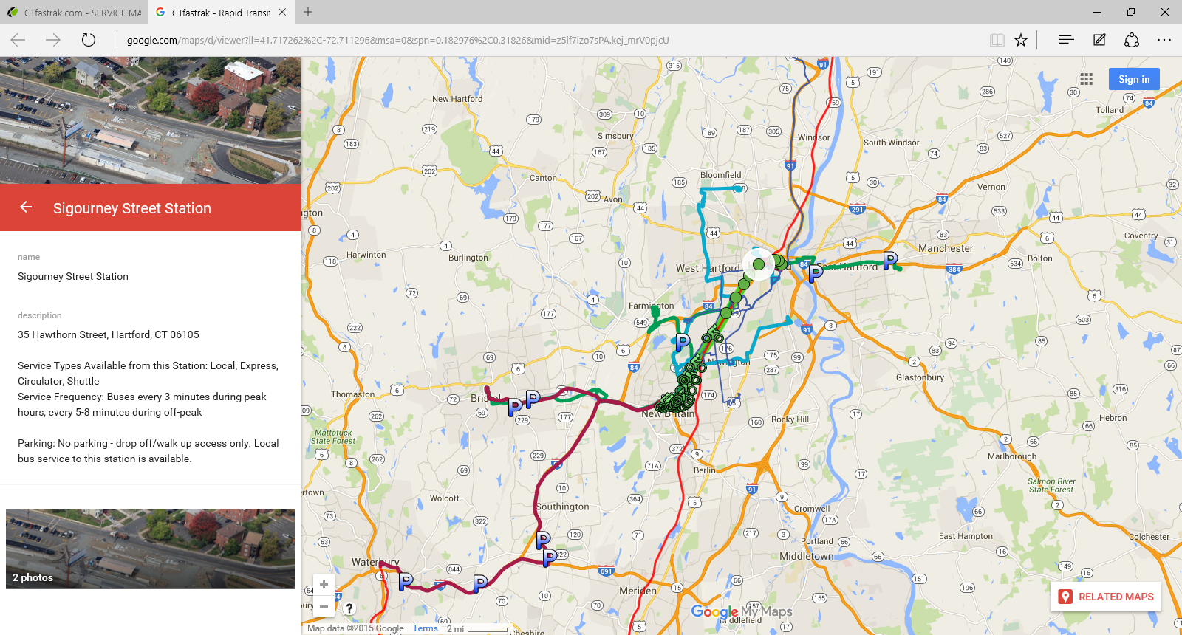

**Diagram 2: Detailed Route**

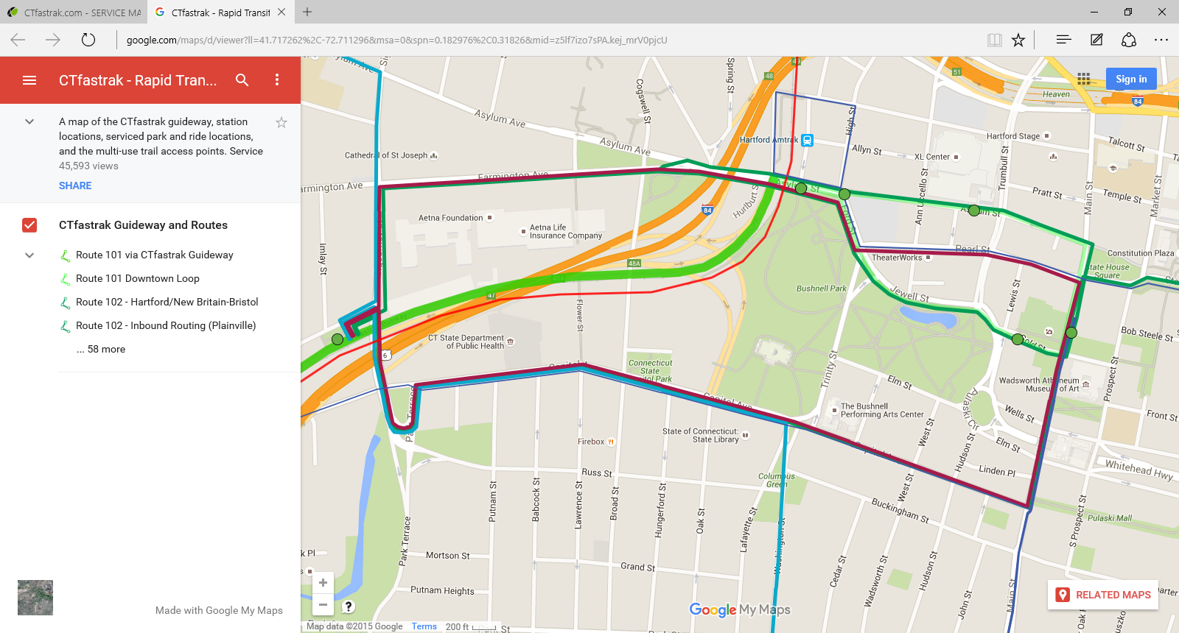

Starting Station: Travelers

Next Departure: 1:30

Ending Station: Sigourney Street

Estimated Arrival: 1:36

**Diagram 3: Hidden Side-bar**

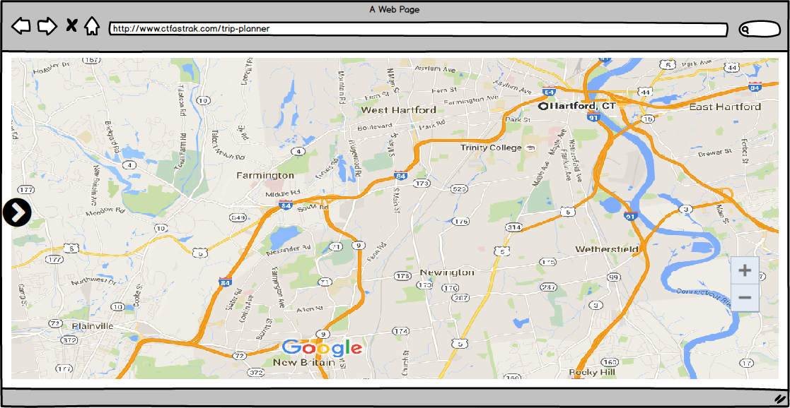

**Diagram 4: Trip Side-bar**

