DESIGN NOTES, WIREFRAMES & SYSTEM ARCHITECTURE COMPENDIUM
BlueHawk Civic Nexus
Autonomous Edge-AI Street Rover (H.A.W.K.)
&
GIS Urban Governance Grid (BlueBridge)
Proactive Emergency Threat Alerting and Sustainable Municipal Action

THEME 4  Governance & Civic Technology |  | THEME 7  AI, GIS & Emerging Technologies |  | SDGs  3 | 9 | 11 | 16

6  Core sections |  | 10  Figures & diagrams |  | 4  UI wireframes |  | 12  Month roadmap

Submitted to | MY Bharat Portal: "Upload any other design documentation" (supporting the 7-slide pitch deck)
Framework | Ministry of Youth Affairs & Sports (MoYAS) and IIT Bombay VBYLD 2027 Framework
Team / State | BlueHawk Civic Nexus | Uttar Pradesh
Lead Innovator | Aravind K. T., B.Tech Electrical Engineering (Class of 2028), Indian Institute of Technology Kanpur, Hall of Residence 5 | AISHE Code: U-0517
Document | Version 1.0 | 22 October 2026 | Design Notes, Wireframes & System Architecture

Portfolio: https://sites.google.com/view/aravind-k-t-iitk/
Live App: https://bluehawk-civic-nexus.streamlit.app
GitHub: https://github.com/kt2141/BlueHawk-Civic-Nexus

Contents
Section | Title | What it covers
1 | Executive Summary & System Vision | The dual crisis, the unified H.A.W.K.-Nexus paradigm, design principles, closed-loop concept
2 | Hardware Engineering & Embedded Specifications | H.A.W.K. platform, power architecture, reference pin map, state machine and C++ logic, evaluation routines, failure-analysis log
3 | Software, AI Classifier & GIS Spatial Grid | Ingestion pipeline, dual-triage routing (Path A / Path B), PostGIS data model, heatmap scoring, feedback cycle, security
4 | UI/UX Wireframes & Dashboard Specifications | Rover telemetry tab, citizen portal, GIS heatmap and triage register, Youth Action Log
5 | Scalability, Feasibility & Deployment Roadmap | 12-month phased blueprint, KPIs, risk register, scaling plan
6 | Innovator Credentials & Verification References | Academic, award and delegation dossier; official links
A | Annexure: Document Notes | Reference-design conventions, glossary, AI-use disclosure

HOW TO READ THIS COMPENDIUM
Every section pairs a design decision with its engineering rationale. Figures are provided as diagrams and as text layouts so the content survives plain-text review. Items marked Reference design (pin allocation, firmware, database schema, scoring weights) are the documented baseline architecture; the as-built source is in the public repository.

LIST OF FIGURES
Fig. | Title | Section
1 | Closed-loop operating cycle | 1
2 | End-to-end layered system architecture | 1 / 3
3 | H.A.W.K. hardware and power block diagram | 2
4 | Differential-drive state machine | 2
5 | Dual-triage decision flow (Path A / Path B) | 3
6 | Wireframe 1: Rover telemetry & vision feed | 4
7 | Wireframe 2: Citizen omni-channel reporting portal | 4
8 | Wireframe 3: GIS ward heatmap & triage register | 4
9 | Wireframe 4: Youth-Led Dialogue Circles action log | 4
10 | 12-month deployment roadmap | 5

1. Executive Summary & System Vision
EXECUTIVE BRIEF
BlueHawk Civic Nexus joins two proven building blocks into one accountable civic system: H.A.W.K., a low-cost autonomous street-patrol rover that senses and sees at the edge, and BlueBridge, an AI/NLP classification engine on a PostgreSQL/PostGIS spatial grid that turns every observation into a located, prioritized, trackable action. Youth-Led Peace & Dialogue Circles close the loop on the ground.

1.1 The Dual Crisis in Urban & Vulnerable Wards
Urban and semi-urban wards face two problems at once, and treating them separately is why neither gets fixed. One is loud and visible; the other is quiet and structural.
Dimension | Visible crisis | Invisible crisis
What it is | Uncollected garbage, drainage blockages, waterlogging | Governance system gaps and inadequate street-level security monitoring in vulnerable corridors
How it shows up | On the street, in photos, in complaints | In missing data, unlinked complaint channels, late or no response
Who feels it | Residents, sanitation crews, health workers | Residents in vulnerable corridors, police control rooms, ward officials
Core failure | Reactive cleanup with no prioritization | No shared, geo-referenced picture; no feedback to the citizen

THE DWIVIDHTA (DESIGN DUALITY) FRAMEWORK
Every alert carries two halves. Technology precision: an AI flag, a GIS coordinate and a timestamp. Community empathy: a Youth-Led Peace & Dialogue Circle that verifies, explains and builds trust. An item is closed only when both halves are satisfied.

1.2 The Unified H.A.W.K.-Nexus Paradigm
The paradigm closes the loop between three layers that are usually built in isolation:
- Autonomous edge sensing: the rover patrols managed corridors, detects hazards and threats with on-board and edge-node vision, and tags them with location.
- Cloud GIS routing: BlueBridge classifies each item, indexes it spatially, and routes it automatically: emergencies to the Police Control Room, municipal hazards to the ward heatmap and crews.
- Grassroots civic execution: crews and Youth-Led Dialogue Circles act, verify and report back, refreshing the public dashboard.
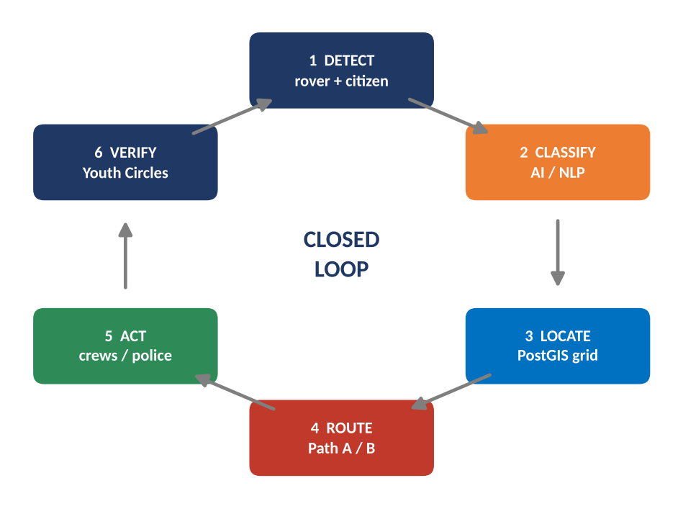
Figure 1. Closed-loop operating cycle: detect, classify, locate, route, act, verify.
End-to-end data path in text form:
H.A.W.K. ROVER --------+ +--> PATH A: EMERGENCY THREAT
(sensors + edge vision)| +-----------+ +----------+ | live alert + target tracking
+---->| AI / NLP |-->| PostGIS |--+ --> POLICE CONTROL ROOM (PCR)
| | TRIAGE | | GRID | |
CITIZEN WEB / MOBILE --+ +-----------+ +----------+ +--> PATH B: MUNICIPAL HAZARD
(omni-channel intake) ward heatmap + sanitation routes
^ --> CREWS + YOUTH ACTION LOG
| |
+---- Dialogue Circle verification <-- public dashboard refresh <----+

1.3 Design Principles
Principle | What it means in this design
Low cost, modular | Arduino / ESP32 class hardware; each module (drive, sensing, vision, uplink) is replaceable on its own.
Open source | Python, OpenCV, YOLO, Streamlit and PostgreSQL/PostGIS; no licence barrier for municipalities.
Human in the loop | Low-confidence detections go to a review queue; emergency alerts are verified at the PCR before dispatch.
Privacy by design | Inference at the edge; only geotagged event records and short evidence clips are stored; role-based access.
Community verified | Dialogue Circles verify closure on the ground, so dashboards reflect lived reality.
Fail-safe | The rover defaults to STATE_STOP on sensor fault, low battery or thermal cut-off.

1.4 Alignment
Item | Alignment
Themes | Theme 4: Governance & Civic Technology | Theme 7: AI, GIS & Emerging Technologies
UN SDGs | SDG 3 (health: fewer waste and waterlogging hazards) | SDG 9 (innovation and infrastructure) | SDG 11 (sustainable cities) | SDG 16 (strong, transparent institutions)
Programme | Ministry of Youth Affairs & Sports (MoYAS) and IIT Bombay VBYLD 2027 Framework

2. Hardware Engineering & Embedded Specifications
H.A.W.K. module. The hardware foundation is a 4-wheel mobile platform built around an Arduino Uno R3, extended with an edge computer-vision node so that detections happen on the rover instead of in the cloud.
REFERENCE DESIGN NOTICE
The pin allocation, firmware listing, power-rail values and test criteria below form the documented reference design for H.A.W.K. They are written to be reproducible. The as-built firmware and wiring are published in the public repository; where the two differ, the repository is authoritative.

2.1 Platform Overview
Chassis | 4-wheel differential-drive mobile platform (left pair / right pair driven together)
Main controller | Arduino Uno R3 (ATmega328P), runs sensing loop and drive state machine
Motor driver | Adafruit Motor Shield (stacked on the Uno) driving 4 DC motors
Proximity sensing | HC-SR04 ultrasonic range sensing; dual IR line/proximity sensors for close-range and edge detection
Environmental sensing | UV sensor(s)
Actuators | Metal-gear servos (sensor scanning / pan)
Edge vision | ESP32-CAM or Raspberry Pi Zero 2W running OpenCV + YOLO bounding-box detection; telemetry link to the Uno
Power | 11.1 V (3S) Li-Ion battery bank with buck converters for logic, servo and vision rails
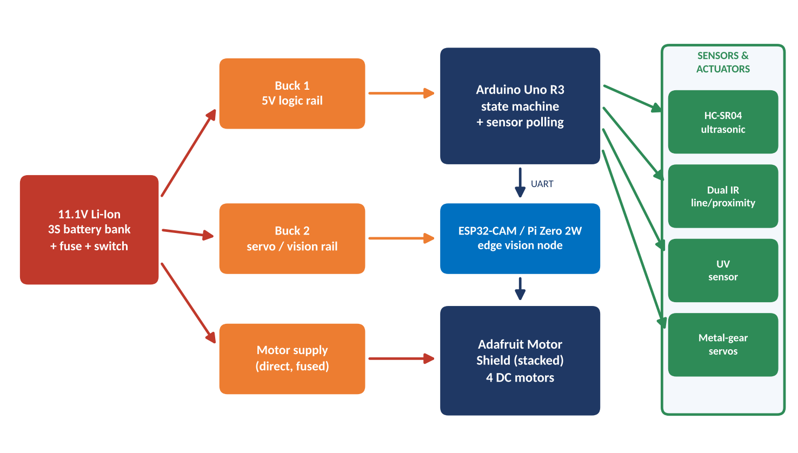
Figure 2. H.A.W.K. hardware and power block diagram.

2.2 Mechanical & Electrical Schematic Breakdown

Reference pin allocation
The Adafruit Motor Shield (V1 / AFMotor) reserves D3, D4, D5, D6, D7, D8, D11 and D12 for motor PWM and its shift-register, and D9/D10 for the two servo headers. The remaining pins are allocated to sensing as follows.
Function | Arduino pin | Notes
DC motors M1 to M4 | Shield-managed (D3, D5, D6, D11 PWM; D4, D7, D8, D12 shift register) | M1+M2 = left side, M3+M4 = right side
Servo (scan) | D9 (shield SER2) | Attached only while scanning (thermal protection)
HC-SR04 TRIG / ECHO | A0 / A1 | Digital use of analog pins; 30 ms echo timeout
IR left / right | A2 / A3 | Digital read, LOW = obstacle detected
UV sensor | A4 | Analog read, reported in telemetry
Battery monitor | A5 | Resistor divider from pack; drives low-voltage fail-safe
Vision link (UART) | D2 (RX) / D13 (TX) | SoftwareSerial to ESP32-CAM / Pi Zero 2W

Power management
Rail | Source | Feeds | Protection / design rule
Battery bus | 11.1 V Li-Ion 3S pack | All rails | Main fuse + master switch; common ground; do not discharge below about 9.0 V (3.0 V per cell)
5 V logic | Buck converter 1 | Arduino, sensors, IR, UV | Decoupling capacitors close to sensors; kept separate from motor noise
Servo / vision | Buck converter 2 | Servos, ESP32-CAM / Pi Zero 2W | Dedicated rail so servo surges and camera boot current do not reset the controller
Motor supply | Battery bus (fused) | Adafruit Motor Shield | Fuse sized above running current and below wiring limit; flyback handled by driver

2.3 Embedded C++ State Machine Logic
Differential drive is implemented as a four-state machine. Sensing runs every loop iteration; transitions are evaluated from the latest ultrasonic and IR readings.
State | Entry action | Leaves when
STATE_STOP | Both sides released | Path clear > FORWARD; else the clearer side > TURN_LEFT / TURN_RIGHT. Held while a fault is active.
STATE_FORWARD | Both sides driven forward | Ultrasonic below threshold, or either IR sees an obstacle > STOP
STATE_TURN_LEFT | Left side reverse, right side forward | Turn time elapsed > FORWARD (re-evaluate)
STATE_TURN_RIGHT | Left side forward, right side reverse | Turn time elapsed > FORWARD (re-evaluate)

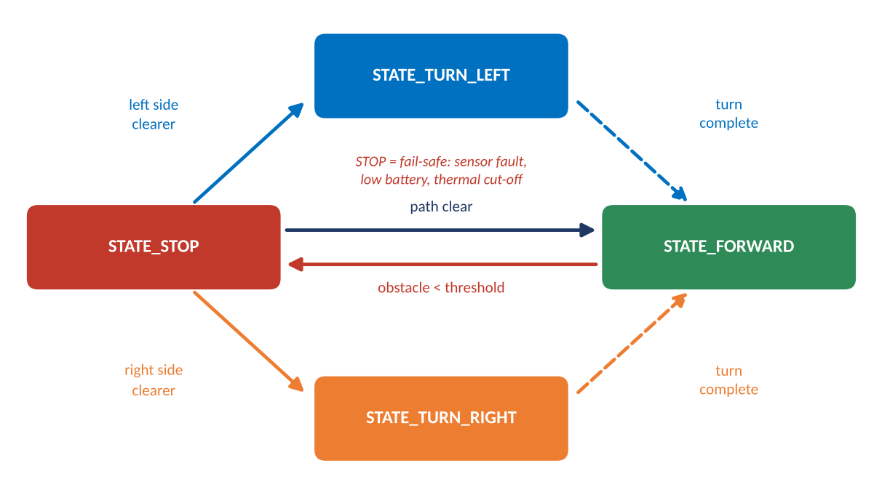
Figure 3. Differential-drive state machine with fail-safe stop.
Reference firmware listing (Arduino C++):
#include <AFMotor.h> // Adafruit Motor Shield V1 library
#include <Servo.h>
#include <SoftwareSerial.h>

// ---- Reference pin allocation (confirm against as-built firmware) ----
const uint8_t PIN_TRIG = A0, PIN_ECHO = A1; // HC-SR04
const uint8_t PIN_IR_L = A2, PIN_IR_R = A3; // dual IR, LOW = obstacle
const uint8_t PIN_UV = A4, PIN_BATT = A5; // UV sensor, battery divider
SoftwareSerial visionLink(2, 13); // RX, TX to ESP32-CAM / Pi Zero 2W
AF_DCMotor m1(1), m2(2), m3(3), m4(4); // left: M1,M2 right: M3,M4
Servo scanServo; // shield SER2 -> D9

enum State { STATE_STOP, STATE_FORWARD, STATE_TURN_LEFT, STATE_TURN_RIGHT };
State state = STATE_STOP;
uint32_t stateSince = 0;

const uint16_t OBSTACLE_CM = 25; // tunable
const uint8_t DRIVE_SPEED = 180; // 0-255
const uint16_t TURN_MS = 450;
const uint16_t BATT_MIN_RAW = 600; // set from divider ratio (about 9.0 V on 3S)

uint16_t readCm() {
digitalWrite(PIN_TRIG, LOW); delayMicroseconds(2);
digitalWrite(PIN_TRIG, HIGH); delayMicroseconds(10);
digitalWrite(PIN_TRIG, LOW);
unsigned long us = pulseIn(PIN_ECHO, HIGH, 30000UL);
return us ? us / 58 : 999; // 999 = no echo
}
void setSide(AF_DCMotor &a, AF_DCMotor &b, int v) {
uint8_t d = v > 0 ? FORWARD : (v < 0 ? BACKWARD : RELEASE);
a.setSpeed(abs(v)); b.setSpeed(abs(v)); a.run(d); b.run(d);
}
void drive(int l, int r) { setSide(m1, m2, l); setSide(m3, m4, r); }
bool faultActive() { return analogRead(PIN_BATT) < BATT_MIN_RAW; }

void enter(State s) { // entry actions
state = s; stateSince = millis();
switch (s) {
case STATE_STOP: drive(0, 0); break;
case STATE_FORWARD: drive(DRIVE_SPEED, DRIVE_SPEED); break;
case STATE_TURN_LEFT: drive(-DRIVE_SPEED, DRIVE_SPEED); break;
case STATE_TURN_RIGHT: drive(DRIVE_SPEED, -DRIVE_SPEED); break;
}
}

void setup() {
pinMode(PIN_TRIG, OUTPUT); pinMode(PIN_ECHO, INPUT);
pinMode(PIN_IR_L, INPUT); pinMode(PIN_IR_R, INPUT);
Serial.begin(9600); visionLink.begin(9600);
enter(STATE_STOP);
}

void loop() {
uint16_t cm = readCm();
bool blockL = digitalRead(PIN_IR_L) == LOW;
bool blockR = digitalRead(PIN_IR_R) == LOW;
if (faultActive() && state != STATE_STOP) enter(STATE_STOP); // fail-safe
switch (state) {
case STATE_FORWARD:
if (cm < OBSTACLE_CM || blockL || blockR) enter(STATE_STOP);
break;
case STATE_STOP:
if (faultActive()) break;
if (cm >= OBSTACLE_CM && !blockL && !blockR) enter(STATE_FORWARD);
else if (!blockL) enter(STATE_TURN_LEFT);
else if (!blockR) enter(STATE_TURN_RIGHT);
break;
case STATE_TURN_LEFT:
case STATE_TURN_RIGHT:
if (millis() - stateSince > TURN_MS) enter(STATE_FORWARD);
break;
}
visionLink.print(state); visionLink.print(','); visionLink.println(cm); // telemetry
delay(30);
}

2.4 Evaluation Routines
Each routine has a defined procedure and acceptance criterion. Measured values are recorded in the test log kept with the repository.
Routine | Procedure | Acceptance criterion
Ultrasonic calibration | Compare readings against a tape-measured target at fixed distances | Readings stable and within the sensor's rated tolerance
Obstacle-stop test | Drive at DRIVE_SPEED toward a fixed obstacle | Rover enters STATE_STOP before contact on every run
IR edge / proximity test | Present obstacles to the left and right IR sensors separately | Correct side detected; correct turn direction chosen
Thermal soak test | Run continuous patrol with scanning servo active; check servo and driver temperature | No thermal shutdown; temperature stabilizes within safe limits
Battery cut-off test | Lower supply to the cut-off threshold on a bench supply | Rover enters and holds STATE_STOP
Vision accuracy test | Run labelled test frames through the edge detector | Precision and recall recorded per class; thresholds tuned to minimize false emergency alerts
Endurance patrol | Repeated managed-corridor patrol over a full battery | Completes patrol without manual intervention; telemetry uplink continuous

2.5 Iterative Engineering & Failure Analysis Log
# | Problem observed | Root cause | Corrective action | Outcome
1 | Heavy mild-steel wheels made the platform sluggish and strained the drive motors | Wheel mass and rotational inertia exceeded the comfortable torque envelope of the small DC gear motors | Replaced with rugged rubber/plastic wheels | Lower motor load, better traction, more responsive turns
2 | Servo wear and heating under continuous load | Servo held position or jittered continuously, sustaining high current and heat | Thermal protection upgrade: detach servo when idle, limit scan duty cycle, dedicated servo rail, cool-down interval | Servo runs cooler; wear reduced; no thermal shutdowns in soak testing

2.6 Key Design Decisions & Trade-offs
Decision | Choice | Rationale | Trade-off and how it is handled
Main controller | Arduino Uno R3 | Simple, robust, widely supported; ideal for deterministic sensing and drive control | Limited compute, so vision runs on a separate edge node
Vision at the edge | ESP32-CAM / Raspberry Pi Zero 2W | Low cost and power; detections happen on the rover, so only results are uplinked | Small models only; lightweight YOLO configuration and confidence thresholds with human review
Drive layout | 4-wheel differential drive | Mechanical simplicity and in-place turns suit narrow corridors | Skid on turns; handled with rubber/plastic wheels and short turn intervals
Power | 11.1 V Li-Ion 3S + buck converters | Headroom for motors with standard, available cells; clean separate rails | Needs low-voltage cut-off and fusing, both built into the design
Default behaviour | STATE_STOP on any fault | A stopped rover is safe in public space | Patrol pauses until the fault clears or an operator intervenes

ENGINEERING TAKEAWAY
Both failures were resolved by reducing load and managing duty cycle, not by adding cost. That keeps H.A.W.K. inside its low-cost, replicable design envelope.

3. Software, AI Classifier & GIS Spatial Grid
BlueBridge module. BlueBridge is the software and governance grid: ingestion, AI/NLP classification, spatial indexing, routing and the dashboards officials and citizens use.
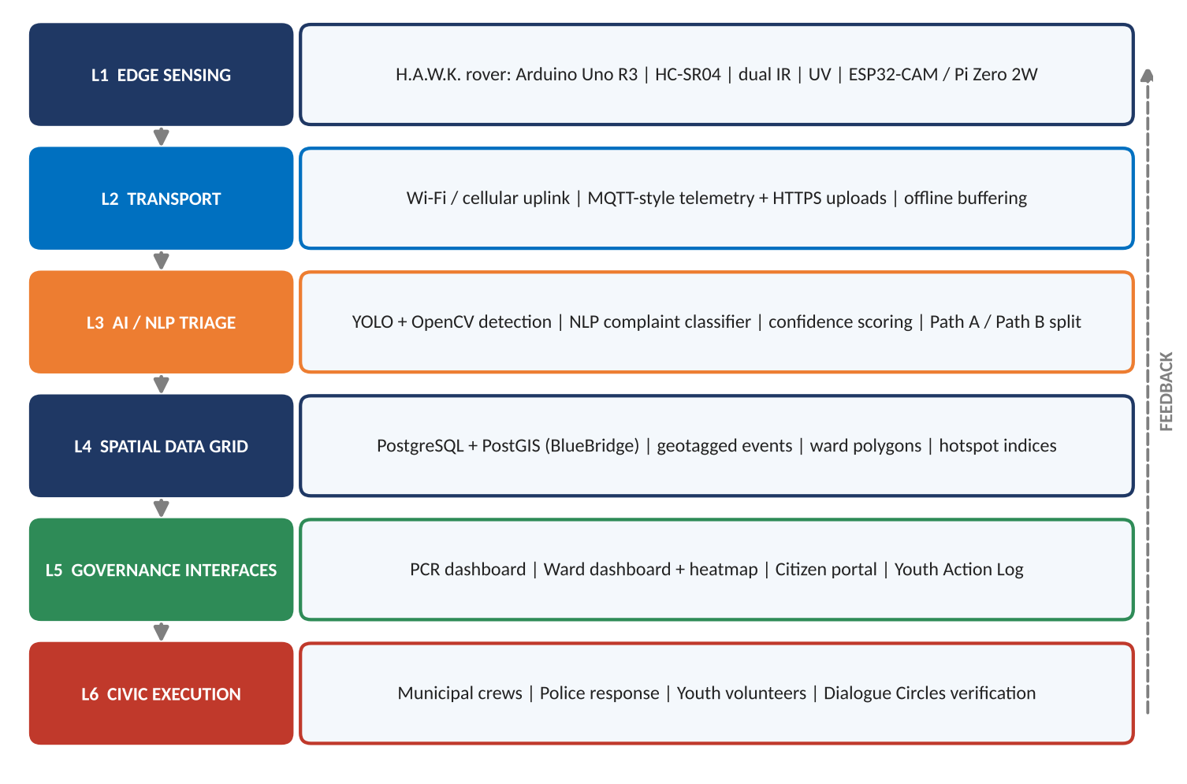
Figure 4. End-to-end layered system architecture (reference design).

3.1 Multi-Modal Ingestion Pipeline
Channel | Content | Pre-processing | Tagged with
H.A.W.K. telemetry | State, range, IR, UV, battery | Validated and time-stamped on the rover | Rover ID, location, time
H.A.W.K. video / frames | Camera frames with bounding boxes | YOLO + OpenCV on the edge node; only detections and short evidence clips uplinked | Location, confidence, class
Citizen web portal | Text, photo, location | NLP classification, duplicate check | GPS pin or address, time
Citizen mobile app | Text or voice note, photo, auto GPS | Speech-to-text where used, then NLP | GPS pin, time
Helpline text (optional) | Short messages | NLP classification; location asked back if missing | Address / landmark

3.2 Dual-Triage Routing Engine
Every ingested item passes through one triage engine that outputs a class, a confidence score and a path.
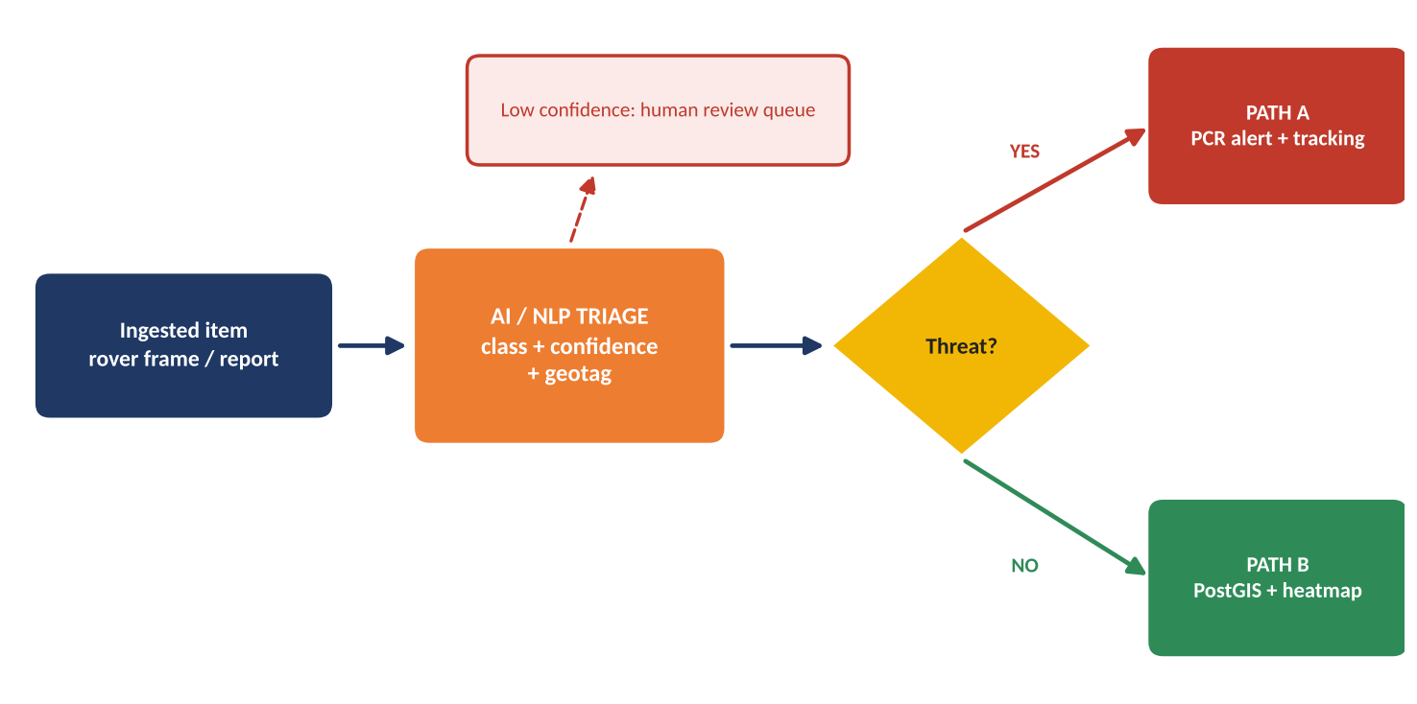
Figure 5. Dual-triage decision flow. Low-confidence items go to a human review queue.

Path A: Emergency threats
- Real-time bounding-box detection from the rover's edge vision node.
- Alert routed directly to the Police Control Room (PCR) dashboard with the frame, location, time and active target-tracking.
- PCR operator verifies before dispatch (human in the loop); false positives are logged to retrain the model.

Path B: Municipal hazards
- Automated PostgreSQL/PostGIS spatial mapping of every garbage, drainage or waterlogging item.
- Green-to-red hotspot visualization per ward, with automatic priority sanitation route generation for crews.
- Status updates flow back to the citizen and to the Youth Action Log.

3.3 PostGIS Spatial Data Model
Table | Purpose | Key fields
ward | Ward boundary polygons | ward_id, name, geom (MultiPolygon, SRID 4326)
event | Every geotagged hazard or threat | source, class, path, confidence, status, ward_id, reported_at, resolved_at, geom (Point)
class_weight | Severity weight per class | class, path, weight (tunable by the ward office)
rover_telemetry | Rover health and trail | rover_id, state, battery, range, geom, time
youth_action | Youth Action Log entries | event_id, circle_id, action, outcome, verified_at
app_user | Role-based access | role (citizen, crew, PCR operator, ward officer, admin)

Reference schema and hotspot query:
CREATE EXTENSION IF NOT EXISTS postgis;

CREATE TABLE ward (
ward_id serial PRIMARY KEY, name text NOT NULL,
geom geometry(MultiPolygon, 4326) NOT NULL);

CREATE TABLE class_weight (class text PRIMARY KEY, path char(1), weight real);

CREATE TABLE event (
event_id bigserial PRIMARY KEY,
source text CHECK (source IN ('rover','citizen_web','citizen_app')),
class text NOT NULL, -- litter, drain_block, waterlogging, person ...
path char(1) CHECK (path IN ('A','B')),
confidence real, status text DEFAULT 'open',
ward_id int REFERENCES ward,
reported_at timestamptz DEFAULT now(), resolved_at timestamptz,
geom geometry(Point, 4326) NOT NULL);
CREATE INDEX event_geom_gix ON event USING GIST (geom);

-- Raw hotspot score per ward (open Path B items, older items weigh more)
SELECT w.ward_id, w.name,
SUM(c.weight * (1 + EXTRACT(EPOCH FROM now() - e.reported_at) / 604800)) AS raw_score
FROM ward w
JOIN event e ON ST_Contains(w.geom, e.geom) AND e.path = 'B' AND e.status <> 'resolved'
JOIN class_weight c ON c.class = e.class
GROUP BY w.ward_id, w.name;

3.4 Ward Sustainability Heatmap Scoring
Each ward receives a normalized 0 to 100 score from its open Path B items, weighted by class severity and age. Weights are configuration, not code, so ward offices can tune them.
Band | Score | Colour | Operational meaning
Healthy | 0 to 20 | Green | Routine schedule
Watch | 21 to 40 | Light green / yellow | Monitor; include in next planned round
Elevated | 41 to 60 | Orange | Prioritize in next route
Critical | 61 to 100 | Red | Immediate crew dispatch; escalate to ward officer

3.5 The Closed-Loop Feedback Cycle
Step | Event | System response
1 | Municipal action update | Crew marks the item resolved with photo proof; status changes in PostGIS
2 | Public dashboard refresh | Ward heatmap, scorecard and the citizen's tracker update automatically
3 | Youth Dialogue Circle verification | Circle confirms on the ground, records the outcome in the Youth Action Log; only then is the item closed for good (or re-opened)

3.6 Security, Privacy & Governance Controls
Area | Control
Access | Role-based access (citizen, crew, PCR operator, ward officer, admin); PCR view limited to Path A items
Privacy | Edge inference; store detections and short evidence clips, not continuous video; retention limits set by the ward office
Integrity | Immutable event timestamps; every status change audit-logged
Transparency | Public dashboard shows ward-level counts and resolution status, not personal data
Model quality | Confidence thresholds, human review queue, and periodic retraining from verified outcomes
Technology stack | YOLO + OpenCV (vision), NLP models (complaint text), Python, Streamlit (dashboards), Pandas / NumPy (analytics), PostgreSQL / PostGIS (spatial database); live app and source are public

4. UI/UX Wireframes & Interactive Dashboard Specifications
Four interfaces cover the full loop. Each is shown as a wireframe and as a text layout, followed by its component specification. All values in the wireframes are illustrative layout data, not measured results.
UX PRINCIPLES
One-glance status (colour-coded, green to red), mobile-first citizen reporting in Hindi and English, accessible contrast and large touch targets, and no personal data on public screens.

4.1 Autonomous Rover Telemetry & Vision Feed
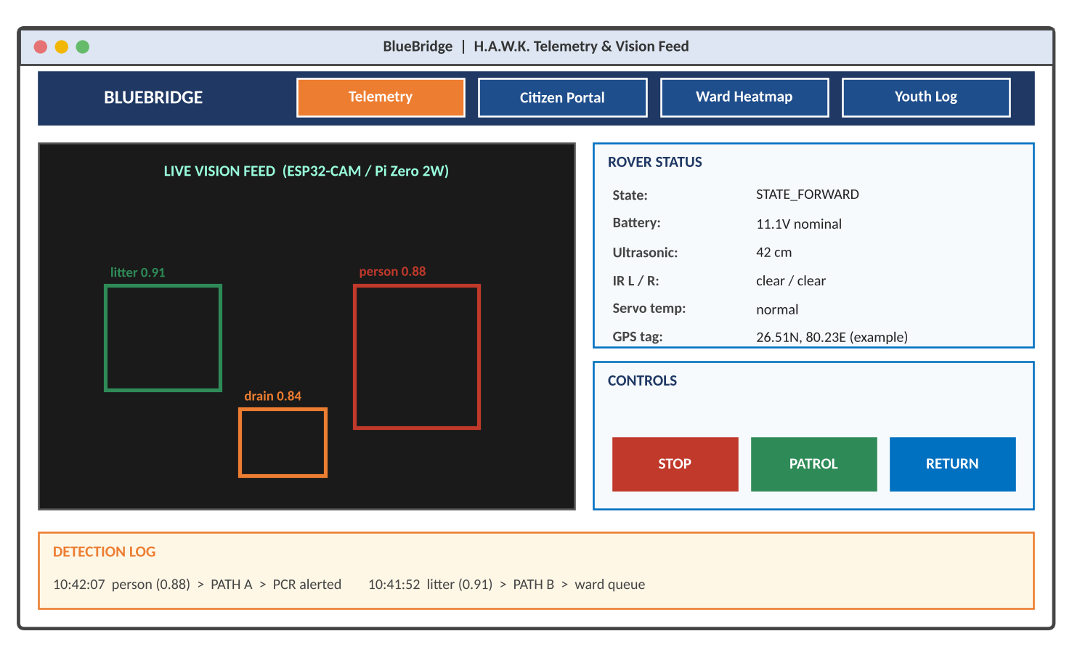
Figure 6. Wireframe 1: H.A.W.K. telemetry and live vision feed.
+-----------------------------------------+----------------------------------------------+
| BLUEBRIDGE | [Telemetry] Citizen Portal Ward Heatmap Youth Log |
+-----------------------------------------+----------------------------------------------+
| LIVE VISION FEED (bounding boxes) | ROVER STATUS: state | battery | range |
| [litter .91] [person .88] [drain .84] | CONTROLS: [STOP] [PATROL] [RETURN] |
+-----------------------------------------+----------------------------------------------+
| DETECTION LOG: time | class | confidence | path | action |
+-----------------------------------------+----------------------------------------------+

Component | Behaviour
Live vision feed | Streams the edge-node frame with bounding boxes and class + confidence labels
Rover status | Current state (STATE_*), battery, ultrasonic range, IR left/right, servo temperature, location tag
Controls | STOP (immediate fail-safe), PATROL, RETURN; commands authenticated and logged
Detection log | Time-ordered detections with the path taken (A to PCR, B to ward queue)

4.2 Citizen Mobile / Web Omni-Channel Reporting Portal
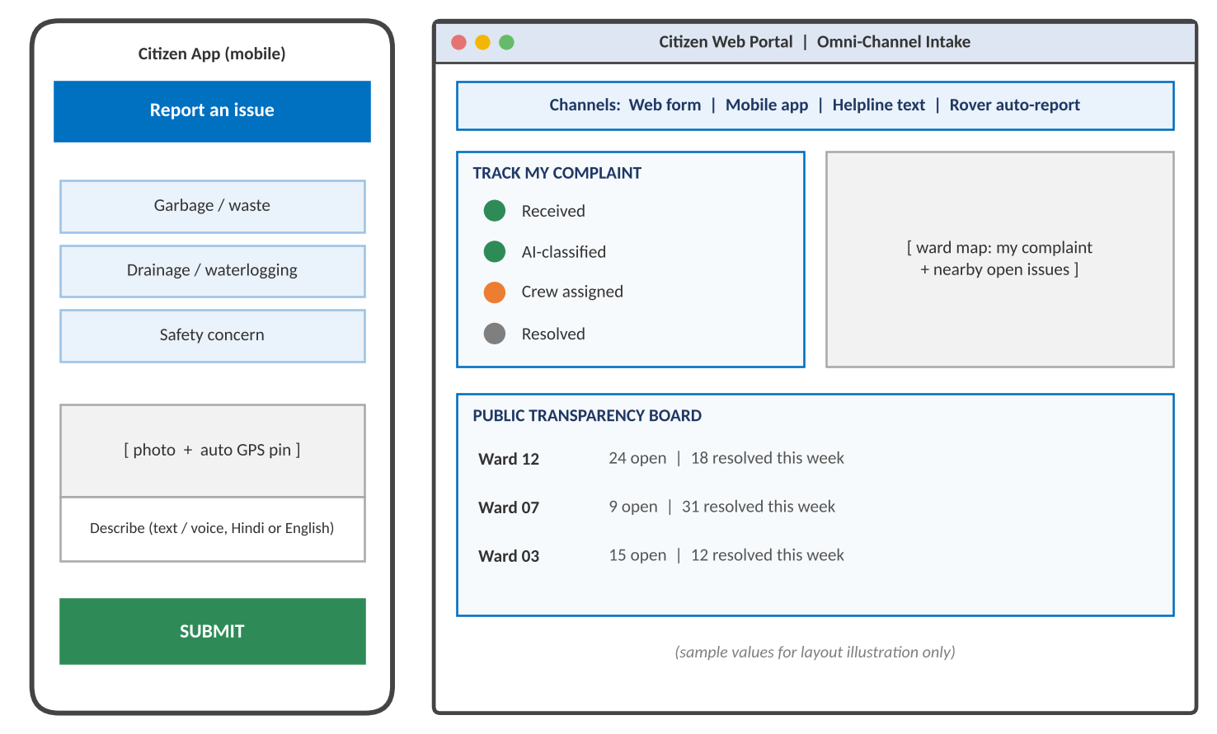
Figure 7. Wireframe 2: citizen mobile app and web portal.
+--------------------------------+-------------------------------------------------------+
| PHONE: Report an issue | WEB: Web form | App | Helpline | Rover auto-report |
+--------------------------------+-------------------------------------------------------+
| [Garbage] [Drainage] [Safety] | TRACK: Received>Classified>Crew>Resolved |
| [photo + GPS pin] [text/voice] | WARD MAP: my complaint + nearby open issues |
| [ SUBMIT ] | TRANSPARENCY BOARD: ward | open | resolved this week |
+--------------------------------+-------------------------------------------------------+

Component | Behaviour
Issue picker | Garbage / waste, drainage / waterlogging, safety concern; free text or voice in Hindi or English
Photo + auto location | Camera capture with automatic GPS pin; manual pin adjustment
Complaint tracker | Received, AI-classified, crew assigned, resolved, with notifications
Transparency board | Ward-level open and resolved counts; no personal data

4.3 Live GIS Ward Heatmap & Automated Triage Register
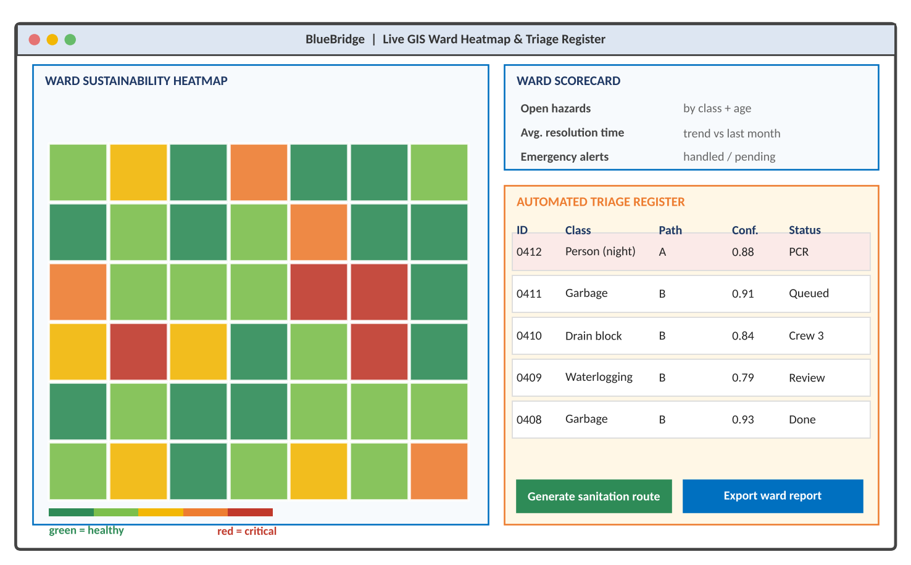
Figure 8. Wireframe 3: ward heatmap, scorecard and triage register.
+------------------------------------+---------------------------------------------------+
| GIS WARD HEATMAP (green > red) | SCORECARD: hazards, resolution time, alerts |
+------------------------------------+---------------------------------------------------+
| [ ward grid coloured by score ] | TRIAGE: ID | class | path | conf | status |
| green = healthy, red = critical | [Generate sanitation route] [Export ward report] |
+------------------------------------+---------------------------------------------------+

Component | Behaviour
Ward heatmap | Green-to-red tiles or ward polygons from the scoring model; click to drill into items
Ward scorecard | Open hazards by class and age, average resolution time and trend, emergency alerts handled and pending
Triage register | Every AI decision with class, path, confidence and status; Path A rows highlighted; low-confidence rows marked Review
Actions | Generate priority sanitation route; export ward report for officials

4.4 Youth-Led Peace & Dialogue Circles Action Log
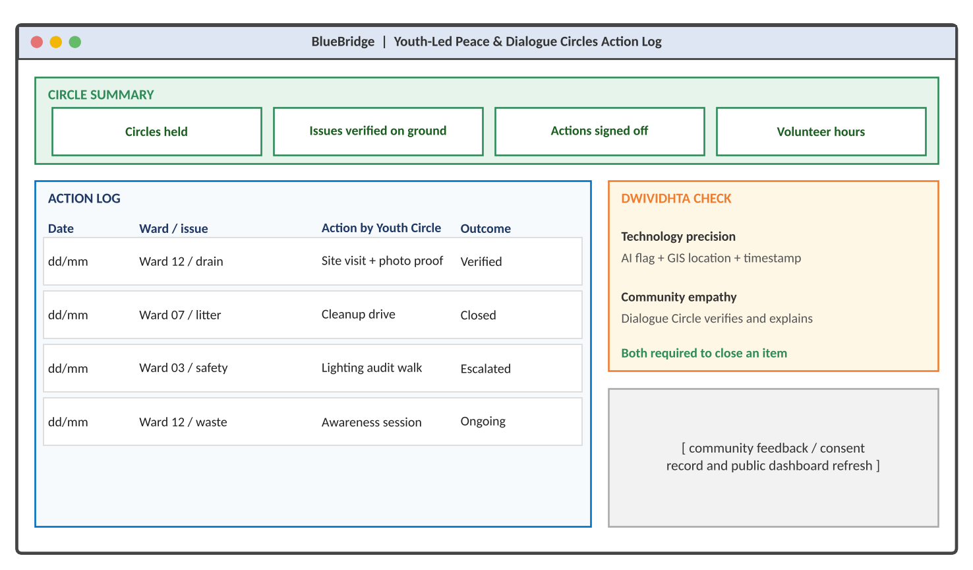
Figure 9. Wireframe 4: Youth Action Log and the Dwividhta check.
+------------------------------------------+---------------------------------------------+
| CIRCLE SUMMARY: circles held | issues verified | actions signed off | volunteer hours |
+------------------------------------------+---------------------------------------------+
| ACTION LOG: date|ward|action|outcome | DWIVIDHTA: AI flag + GIS + timestamp |
| (rows of verified community actions) | Circle verifies + explains; both close |
+------------------------------------------+---------------------------------------------+

Component | Behaviour
Circle summary | Circles held, issues verified on the ground, actions signed off, volunteer hours
Action log | Date, ward and issue, action by the Youth Circle (site visit, cleanup, audit walk, awareness session), outcome
Dwividhta check | Shows both halves for each item: technology evidence and community verification; closure needs both
Community record | Feedback and consent notes; feeds the public dashboard refresh

5. Scalability, Feasibility & Deployment Roadmap

5.1 Feasibility Snapshot
LOW COST  Arduino / ESP32 modular parts |  | OPEN SOURCE  PostGIS + Python stack |  | WORKING  Live app + public repo

5.2 Phased Implementation Blueprint (Months 1 to 12)
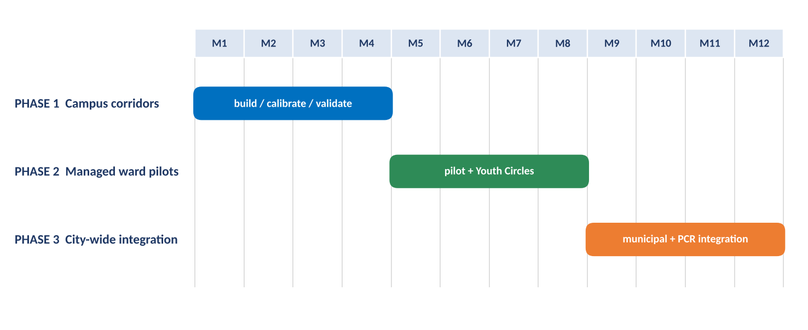
Figure 10. 12-month phased deployment roadmap.
Phase | Months | Scope | Key deliverables | Exit criteria
1: Campus corridors | 1 to 4 | Managed campus corridors; controlled terrain and connectivity | Calibrated rover fleet; edge detector tuned; citizen portal live for the campus; PCR demo dashboard | Stable patrols; detection precision and recall recorded; Path A and Path B routing verified end to end
2: Managed ward pilots | 5 to 8 | One or more managed wards with the ward office | Ward polygons loaded; heatmap and triage register in daily use; Youth Dialogue Circles started; sanitation route generation | Measured response-time change versus baseline; community adoption; false-alarm rate within agreed limit
3: City-wide integration | 9 to 12 | Municipal and Police Control Room integration | Integration with municipal complaint systems and PCR workflows; multi-ward dashboards; operator training; public transparency board | Sustained operation across wards; municipal sign-off; documented SOPs

5.3 Key Performance Indicators
KPI | Target / measure | How it is measured
Municipal cleanup time | 25 to 40% faster (projected target, to be validated in pilot) | Median time from report to resolution versus ward baseline
Emergency response time | 25 to 40% faster (projected target, to be validated in pilot) | Time from Path A alert to PCR acknowledgment and dispatch
Triage quality | Precision and recall per class, false-alarm rate | Labelled test set plus PCR verification outcomes
Citizen engagement | Reports per ward, repeat-reporter rate, tracker views | Portal analytics
Community verification | Share of closed items verified by Dialogue Circles | Youth Action Log

5.4 Risk Analysis & Mitigation
Risk | Likelihood | Impact | Mitigation strategy
Terrain obstacles and hardware wear | Medium | Medium | Restrict initial deployments to managed campus and ward corridors; rubber/plastic wheels; scheduled maintenance; modular spares
Public adoption friction | Medium | High | Pair rover patrols with Youth-Led Peace & Dialogue Circles to build trust; transparent public dashboard; simple bilingual reporting
False-positive emergency alerts | Medium | High | Confidence thresholds; human review queue; PCR verification before dispatch; retraining from false-positive logs
Edge data privacy | Medium | High | On-device inference; store only detections and short clips; role-based access; retention limits; no personal data on public screens
Connectivity gaps | Medium | Medium | Offline buffering on the rover; sync on reconnection; patrol-route planning around dead zones
Battery and thermal limits | Low | Medium | Low-voltage cut-off; servo duty-cycle limits; thermal soak testing; patrol length matched to battery

5.5 Scalability Plan
Layer | How it scales
Rovers | Add rovers per corridor; identical low-cost build; fleet view in telemetry tab
Edge vision | Inference stays on each rover, so cloud load does not grow with video volume
Database | PostGIS partitioned by ward; GIST spatial indexes; read replicas for dashboards
Dashboards | Role-based views per ward, zone and city; stateless Streamlit front end behind a load balancer
Governance | Youth Circles replicate ward by ward using a standard Action Log template

6. Innovator Credentials & Verification References

6.1 Academic & Institutional Profile
Name | Aravind K. T.
Programme | B.Tech in Electrical Engineering (Class of 2028)
Institution | Indian Institute of Technology Kanpur, Hall of Residence 5
AISHE Code | U-0517
State | Uttar Pradesh (project registration)

6.2 National & International Accolades
Recognition | Detail
Devbhoomi Rashtriya Ratna Puraskar 2025 | National Award for Outstanding Contribution to Youth Welfare
Youth Leadership Outstanding Awardee | Top 50 Youth Leaders in Asia-Pacific, Seoul
United Nations Social Forum 2025 | Officially accredited delegate, Palais des Nations, Geneva
i-SEA Fellow 2026 | Nanyang Technological University (NTU), Singapore
My Bharat Budget Quest 2026 | National Finalist, top among 13 lakh+ participants
Global Youth Festival 2026 (Paris) | Fully funded delegate selection

6.3 Leadership, Certifications & Roles
Role / credential | Detail
Former Secretary | Public Policy & Opinion Cell, IIT Kanpur
Founder | Youth-Led Peace & Dialogue Circles (Karnataka); the grassroots engine of the Dwividhta framework
UPG Sustainability Champion | Sustainability leadership recognition
UNESCO APCEIU GCED Certified | Global Citizenship Education certification
Official ICSC Ambassador | Ambassador role

6.4 Official Verification Links
Resource | URL
Digital portfolio (Google Sites) | https://sites.google.com/view/aravind-k-t-iitk/
Live Streamlit web app | https://bluehawk-civic-nexus.streamlit.app
Public GitHub repository | https://github.com/kt2141/BlueHawk-Civic-Nexus

Annexure A: Document Notes

A.1 Reference-Design Conventions
- Reference design items (pin allocation, firmware listing, rail values, schema, scoring bands and weights, test criteria) describe the baseline architecture and are meant to be reproducible and tunable.
- As-built wiring and code are in the public GitHub repository, which is authoritative where details differ.
- Dashboard values in wireframes are illustrative layout data. No measured outcomes are claimed in this document.
- The 25 to 40% improvement is a projected target to be validated in the managed pilot.

A.2 Glossary
Term | Meaning
H.A.W.K. | The autonomous edge-AI street patrol rover (hardware module)
BlueBridge | The AI/NLP classification and PostGIS GIS governance grid (software module)
Dwividhta | The Design Duality framework: technology precision plus community empathy
PCR | Police Control Room
Path A / Path B | Emergency-threat routing to the PCR / municipal-hazard routing to the ward heatmap and crews
PostGIS | Spatial extension for PostgreSQL used for geotagged indexing and ward queries
YOLO | Real-time object-detection model family used for bounding-box detection
MoYAS | Ministry of Youth Affairs & Sports
VBYLD | Viksit Bharat Young Leaders Dialogue (as referenced in the programme framework)

A.3 AI-Use Disclosure
The core classification engine uses YOLO/OpenCV (vision) and NLP models (text). Hardware design, Arduino firmware and governance frameworks are the innovator's original work. Generative AI was used to help draft and format this compendium; the innovator is responsible for its technical content.

