Human Resources Attrition and Retention Analysis

Introduction
This report is an in-depth analysis of HR information of the organization including the demographics of employees, attrition and retention. The conclusions are supposed to aid the organization in its exit strategy by determining the value of workforce to prospective acquirers. The data under analysis covers the entire history of the organization employees since 1999, though mostly concentrating on active employees (Status: Current) and former employees (Status: Former) to differentiate between the active workforce composition and attrition patterns. Tableau was used to create all visualizations, which can be found all over this report.

1. Current Employee Demographics
There are 1,233 active staff members in the organization as of now with a total workforce of 1,470 employees recorded with the organization and 237 employees have left the organization which translates to 16.1% attrition rate. Current employees are aged between 38 on average with an average monthly salary of $6,833. These general statistics indicate a mid-career professionally established workforce which is good news to the prospective acquirers of an organization that is stable.
The HR Analytics Dashboard (Figure 1) gives a summary in an overview of the overall workforce composition and major measures. Dashboard was chosen as it integrates various dimensions of data such as department, age group, job satisfaction, income and gender to a single interactive visual which allows quick evaluation of health of the workforce.
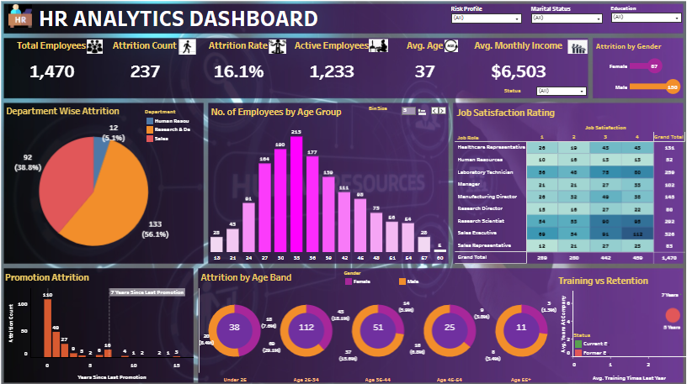
Figure 1. HR Analytics Dashboard – Overall Workforce Summary (All Filters)

1a. Demographic Visualizations
Demographic data were presented in two types of charts, a pie chart was used to show the distribution of departments and a histogram was used to show the distribution of the age groups. The pie chart is a good way of showing proportional relationships and the departmental size could be easily compared by a single look at the pie chart. The age group histogram gives the shape of the distribution of the workforce with the concentration by decade, which is important in predicting the future attrition waves due to retirement or career change of the workforce.
The Research and Development department has the highest number of workers with 56.1% out of the total workforce, Human Resources with 38.8 and Sales with 5.1 (Figure 1). The age distribution table (Figure 1, center) indicates that the biggest group of employees is included in the age range of 30-36 which proves the predominance of the mid-career workforce. This age group is usually a productive group of employees with many years to offer and this is very favorable as far as acquisition is concerned.
Other interesting demographic dimensions are marital status filtered dashboard. The number of employees who drop out is extremely high among single workers (25.5) as compared to married workers (12.5) and divorced workers (10.1). The level of education is also related to attrition using education-filtered dashboards: the attrition rate is only 18.2% among employees with a high school diploma, whereas the rate among the doctorate holders is only 10.4%- it indicates that the higher the educational level, the higher the retention.

2. Attrition Analysis
The data that was filtered to former employees (Status: Former) was used to conduct the attrition analysis. The five factors that are most important linked to the departure of employees, timing patterns and training-retention relationship are discussed in the following subsections.

2a. Five Top Reasons for Attrition.
- Poor wages: The average monthly earnings of former employees were $4,787, as opposed to the current employees $6,833 - a significant difference between payment which indicates compensation as one of the main pull factors to competitor organizations.
- Absence of recent promotion figure illustrates that most of those who left the company (110 people) had not been promoted at all in the previous year prior to their leaving and the other 49 people had only had to wait a year. Lack of career growth is an established force of attrition.
- High-risk profile: When the dashboard is filtered to only show employees with a high risk, 250 employees with an attrition rate of 13.2% and a higher average income of $8,493 are displayed, indicating that even employees with a high salary in a risky job are more at risk of flying due to workload, stress, or market competition.
- Marital status (single): Single workers have the highest attrition rate of 25.5% - more than twice that of married employees - probably due to the lack of personal commitments limiting their ability to switch jobs, and their greater susceptibility to external influences.

2b. Years Since Last Promotion
The Figure Promotion Attrition shows the association between the recency of promotion and attrition. The data demonstrates a sharp peak on zero years since the last promotion (110 departures) and the second peak on seven years (16 departures). This paradoxical conclusion (that most employees turn over either right after or without a promotion) can be attributed to unmet expectations after a promotion cycle or even decisions taken in parallel with decisions on promotions. This high turnover rate in the second year indicates that those employees who could withstand two years after being promoted were likely to be determined.

2d. Years of Employment Before Leaving
The average length of stay was about 4.7 years with former employees having been with the organization before leaving. This agrees with the observation that the 26–34 age group is most susceptible to quit since workers who entered in their mid-twenties normally arrive at this juncture in their early thirties. The organization needs to remember that five-year mark is a significant inflection point where retention interventions are the most required.

3. Retention Analysis

3a. Likelihood of Future Attrition
Comparing the present-day employee demographics with potential risk factors of attrition shows that there are some worrying trends. The single employees (470 individuals) among the current employees (38.1 percent of the active workforce) have the highest attrition rate (25.5 percent) historically but a proportion of 38.1 percent constitute a great percentage of the total employees. Equally, undergraduate degree-holders have 473 active staff that has a history of attrition rate of 17.3%. The historical attrition rate of the low-risk employee group (1,135 employees) is 16.3 which implies that the highest risk group volume wise is in the low-risk employee group.
Considering these trends, it can be expected that a significant portion of the existing workforce say 15-18 per cent of the active workforce would be under high risk of leaving the company in the near future, especially those who are single, recently promoted (or not promoted) and those in the 26-34 age bracket.

3b. Employee Stability and Acquisition Value
The attrition statistics show a conflictual yet, still, manageable situation to the prospective buyers. On the one hand, the overall attrition rate of 16.1% is not insignificant and shows that the organization has suffered significant losses in terms of talents. Conversely, the median experience of the present employees of about 7 years along with the median age of 37 years and high proportion of the mid-career professionals is indicative of underpinning stability.
To an interested acquirer, the issue of greatest concern will be post-acquisition attrition- the behavior by employees to quit after a change of ownership due to uncertainty, cultural changes or to be stolen by a competitor. The segment which is the most susceptible to this is the single employee segment and the young age group. An active retention package revealed in the due diligence process such as retention bonuses, career development promises and open dialogue regarding organizational survival will be crucial to leverage on the perceived workforce value.

4. Actionable Steps to Prevent Future Attrition

Action 1: Implement a Structured Promotion and Career Pathway Program
The statistics always list unchanging promotion schedules as a top-ranking attrition initiator. The company must put in place a clear career ladder with set standards, schedule and pay milestones of each position. The succession planning conversations should focus on employees within the 26-34 age group (the most at-risk group). Studies on organizational behavior are always able to show that perceived advancement opportunity is among the best predictors of commitment among employees (Allen and Meyer, 1990). Formalization of a pathway minimizes vagueness and offers the employees a motive to remain interested towards the future of the organization.

Action 2: Expand and Differentiate the Training Investment
The Training vs. Retention analysis supports that the more the training is done, the longer the tenure is. The organization ought to raise the average number of training per employee per year- especially the high-risk groups like individual workers and those who are undergraduate. The difference between the training programs should be based on the career stage: employees in the initial career stages can be trained in technical skills, whereas middle-level employees are better trained in leadership and cross-functional skills.

Action 3: Develop a Targeted Retention Bonus Structure for High-Risk Segments
Since the acquisition happened, the organization should look into a time-limited retention bonus program directly addressing the employees of the most risky demographic groups: single employees, under 35 years, newly-promoted employees who were not promoted with a raise and those working in the Sales department (the department with the highest departmental turnover). Bonuses based on a vesting plan -available only in case the employee is still employed after a specified post-acquisition period- have been found to greatly decrease the turnover in M&A situations (Krug & Aguilera, 2005). This is not only a way to reduce the risk of attrition in the short term, but it also enhances the workforce stability message to potential customers.

Conclusion
The workforce at the organization is relatively stable and the organization has an experienced workforce with a middle career employee base, competitive pay and has been shown to retain employees with higher education and married ones. Nevertheless, the 16.1% turnover rate, the lack of dispersion of quitting among the 26–34 age group and high risk of the single-employee group were reasons that needed to be addressed. Through systematic career opportunities and increased training opportunities, as well as application of retention benefits prior to the acquisition process, the organization can significantly boost its perceived value, as well as minimize the likelihood of turnover after the acquisition process by potential acquirers.

References
Allen, N. J., & Meyer, J. P. (1990). The measurement and antecedents of affective, continuance, and normative commitment to the organization. Journal of Occupational Psychology, 63(1), 1–18. https://doi.org/10.1111/j.2044-8325.1990.tb00506.x
Krug, J. A., & Aguilera, R. V. (2005). Top management team turnover in mergers and acquisitions. Advances in Mergers and Acquisitions, 4, 121–149. https://doi.org/10.1016/S1479-361X(04)04006-4
Society for Human Resource Management. (2022). Employee job satisfaction and engagement: Revitalizing a changing workforce. SHRM. https://www.shrm.org

