Some FAQ for Capcode V2.0.x in eclipse

How to get the default Display ?
The best way is to get if from the PlatformUI.getWorkbench()
IWorkbench wb = PlatformUI.getWorkbench();
if (wb != null){
display = wb.getDisplay();
}
a tool function is ready in net.sf.capcode.plugin.core.ui.tools.DisplayTools
Display d = DisplayTools.getDisplay()
It is important not to call Display.getDefault() because this may create a new Display and in some environment (mac OS, linux) swt does not implement multiple display

How to run a command by program
Get the Handler Service from the workbench
IWorkbench wb = PlatformUI.getWorkbench();
IHandlerService handlerService = (IHandlerService) wb.getService(IHandlerService.class);
try {
handlerService.executeCommand(AddCommPortCommand.ID, null);
} catch (Exception ex) {
}

How to run a parameterized command by program
Exemple with how to display a view :
IWorkbench wb = PlatformUI.getWorkbench();
ICommandService commandService = (ICommandService) wb.getService(ICommandService.class);
IHandlerService handlerService = (IHandlerService) wb.getService(IHandlerService.class);
Command showView = commandService.getCommand("org.eclipse.ui.views.showView");
IParameter viewIdParm = showView.getParameter("org.eclipse.ui.views.showView.viewId");
Parameterization parm = new Parameterization(viewIdParm, viewID);
ParameterizedCommand parmCommand = new ParameterizedCommand(showView, new Parameterization[] { parm });
handlerService.executeCommand(parmCommand, null);

How to implement a drop down menu from a toolbox button
Taken from the charts plugin. net.sf.capcode.plugin.charts
Objective :
To have a « scale » button proposing pre-defined scale values.
The plugin.xml should have :
a command definition for the the handler of the event (command.scaleHandler)
a command paramater associated to the command (parameter.scale)

<command
categoryId="net.sf.capcode.command.category.chartsManagement"
defaultHandler="net.sf.capcode.plugin.charts.commands.ScaleHandlerCommand"
id="net.sf.capcode.command.scaleHandler"
name="command Scale Handler">
<commandParameter
id="net.sf.capcode.parameter.scale"
name="chart scale"
optional="true"
values="net.sf.capcode.plugin.charts.commands.ScaleValues">
</commandParameter>
</command>

create a menu contribution to the main toolbar.
Add a command to this toolbar with the net.sf.capcode.command.scaleHandler ID.
<menuContribution
locationURI="toolbar:org.eclipse.ui.main.toolbar?after=additions">
<toolbar
id="net.sf.capcode.charts.toolbars.chartsToolbar">
<command
commandId="net.sf.capcode.command.scaleHandler"
icon="icons/ruller20.gif"
id="net.sf.capcode.dropDown.scale"
style="pulldown">
</command>
</toolbar>
</menuContribution>

add as many menu contribution as required (one per menu item):
the menu contribute to the dropDown scale net.sf.capcode.dropDown.scale
Define the command :
the command Id refers to the handler of the command : net.sf.capcode.command.scaleHandler
define also a parameter net.sf.capcode.parameter.scale with the required values :
world, global, large, regional, harbour, port
this will be these values that will be used by the handler to set the appropriate scale.

<menuContribution
locationURI="menu:net.sf.capcode.dropDown.scale">
<command
commandId="net.sf.capcode.command.scaleHandler"
id="net.sf.capcode.charts.commandScaleWorld"
label="World"
style="push">
<parameter
name="net.sf.capcode.parameter.scale"
value="world">
</parameter>
</command>
...
<command
commandId="net.sf.capcode.command.scaleHandler"
id="net.sf.capcode.charts.commandScalePort"
label="Port"
style="push">
<parameter
name="net.sf.capcode.parameter.scale"
value="port">
</parameter>
</command>
</menuContribution>
</extension>
</plugin>

public class ScaleValues implements IParameterValues {
public static class TextAndDoubleItem {
String text;
double value;
public TextAndDoubleItem(String s, double v) {
text = s;
value = v;
}

public String toString() {
return text;
}
}

public static final TextAndDoubleItem[] zoomLevel = new TextAndDoubleItem[] {
new TextAndDoubleItem("world", 1 / 25000.0),
new TextAndDoubleItem("global", 1 / 10000.0),
new TextAndDoubleItem("very large", 1 / 1000.0),
new TextAndDoubleItem("large", 1 / 500.0),
new TextAndDoubleItem("regional", 1 / 200.0),
new TextAndDoubleItem("approach", 1 / 100.0),
new TextAndDoubleItem("harbour", 1 / 10.0),
new TextAndDoubleItem("port", 1 / 5.0) };
static final Map<String, Double> values = new HashMap<String, Double>();
static{
for (TextAndDoubleItem td : zoomLevel) {
values.put(td.text, td.value);
}
}

public static double getScale(String key){
return (values.get(key));
}

@Override
public Map<String,Double> getParameterValues() {
return values;
}

public class ScaleHandlerCommand implements IHandler {

@Override
public void addHandlerListener(IHandlerListener handlerListener) {
}

@Override
public void dispose() {
}

@Override
public Object execute(ExecutionEvent event) throws ExecutionException {
//get the parameter (should return "world, or "harbour", or "port"
String v = event.getParameter("net.sf.capcode.parameter.scale");
// get the related scale
double scale = ScaleValues.getScale(v);
// program the projection with the scale
IChartsServices chartsServices = net.sf.capcode.core.services.Services.getChartsService();
if (chartsServices != null){
chartsServices.setProjectionScale(scale);
}
return null;
}

@Override
public boolean isEnabled() {
return true;
}

@Override
public boolean isHandled() {
return true;
}

@Override
public void removeHandlerListener(IHandlerListener handlerListener) {
}

}

Set the automatic update manager

Configuration
Check that the feature net.sf.capcode.feature.eclipseCore contains the following features :
<includes
id="org.eclipse.equinox.p2.user.ui"
version="0.0.0"
search-location="both"/>
<includes
id="org.eclipse.equinox.p2.core.feature"
version="0.0.0"/>
<includes
id="org.eclipse.equinox.p2.extras.feature"
version="0.0.0"/>
<includes
id="org.eclipse.equinox.p2.rcp.feature"
version="0.0.0"/>
<includes
id="org.eclipse.equinox.p2.user.ui"
version="0.0.0"/>
<includes
id="org.eclipse.rcp"
version="0.0.0"/>

check that the product configurations are in the project containing the p2.inf file.
For capcode, all product configuration files are in net.sf.capcode.rcp
the file p2.inf should also be in this project.
Edit the p2.inf as follow :
instructions.configure=\
addRepository(type:0,location:http${#58}//sourceforge.net/projects/capcode/files/update);\
addRepository(type:1,location:http${#58}//sourceforge.net/projects/capcode/files/update);

Edit the plugin_customization.ini file as follow :
org.eclipse.ui/SHOW_PROGRESS_ON_STARTUP = true
# configure the update UI
# user can see and manipulate repositories in the install wizard
org.eclipse.equinox.p2.examples.rcp.cloud/repositoriesVisible=false
# restart policy after install or update (see possible values in org.eclipse.equinox.p2.ui.Policy.restartPolicy())
org.eclipse.equinox.p2.examples.rcp.cloud/restartPolicy=1
# show only latest versions when browsing for updates
org.eclipse.equinox.p2.examples.rcp.cloud/showLatestVersionOnly=true
# software should be grouped by category by default
org.eclipse.equinox.p2.examples.rcp.cloud/groupByCategory=true
# show only groups (features)
org.eclipse.equinox.p2.examples.rcp.cloud/showAllBundlesAvailable=false
# do not show only the install roots in the installed software list
org.eclipse.equinox.p2.examples.rcp.cloud/showAllBundlesInstalled=false
# do not drilldown into requirements in the wizards, just show the high level things
org.eclipse.equinox.p2.examples.rcp.cloud/showDrilldownRequirements=false
# check for updates on startup
org.eclipse.equinox.p2.ui.sdk.scheduler/enabled=true
org.eclipse.equinox.p2.ui.sdk.scheduler/schedule=on-startup

# remind the user every 4 hours
org.eclipse.equinox.p2.ui.sdk.scheduler/remindOnSchedule=true
# see AutomaticUpdatesPopup, values can be "30 minutes", "Hour", "4 Hours"
org.eclipse.equinox.p2.ui.sdk.scheduler/remindElapsedTime=30 minutes

# do not download updates before notifying the user
org.eclipse.equinox.p2.ui.sdk.scheduler/download=false

the product configuration plugins' start level should be defined as follow :
<configurations>
<plugin id="net.sf.capcode.rcp" autoStart="false" startLevel="5" />
<plugin id="org.eclipse.core.runtime" autoStart="true" startLevel="4" />
<plugin id="org.eclipse.equinox.common" autoStart="true" startLevel="2" />
<plugin id="org.eclipse.equinox.ds" autoStart="true" startLevel="2" />
<plugin id="org.eclipse.equinox.simpleconfigurator" autoStart="true" startLevel="1" />
<plugin id="org.eclipse.osgi" autoStart="true" startLevel="1" />
</configurations>

Do not try the functionnality within eclipse. Export the product and start the product from the generated directory.

Export the plugins and features to the update site

1) Check the definitions
The definition file is used to classify features by categories so that once the user selects new software to install from the capcode help menu, the proposed features will be organised by thema.
In project capcode managment (net.sf.capcode.managment) edit the fine capcodeCategories.xml
It should be something like :
<?xml version="1.0" encoding="UTF-8"?>
<site>
<feature url="features/net.sf.capcode.feature.core_2.0.0.jar" id="net.sf.capcode.feature.core" version="2.0.0">
<category name="net.sf.capcode.core"/>
</feature>
<feature url="features/net.sf.capcode.feature.basics_1.0.0.qualifier.jar" id="net.sf.capcode.feature.basics" version="1.0.0.qualifier">
<category name="net.sf.capcode.category.basic"/>
</feature>
<feature url="features/net.sf.capcode.feature.advanced_2.0.0.jar" id="net.sf.capcode.feature.advanced" version="2.0.0">
<category name="net.sf.capcode.category.advanced"/>
</feature>
<category-def name="net.sf.capcode.core" label="Capcode Core (required)">
<description>
required plugins to run capcode in eclipse
</description>
</category-def>
<category-def name="net.sf.capcode.category.basic" label="Capcode basic functions">
<description>
basics function of capcode (charting, NMEA aquisition, boat tracking)
</description>
</category-def>
<category-def name="net.sf.capcode.category.advanced" label="Capcode advanced functions">
<description>
specialized functions (routing, weather, AIS)
</description>
</category-def>
<category-def name="net.sf.capcode.category.regatta" label="Regatta">
<description>
functions for regatta
</description>
</category-def>
</site>

2) update the site :
Select File/Export... to deployable Features.
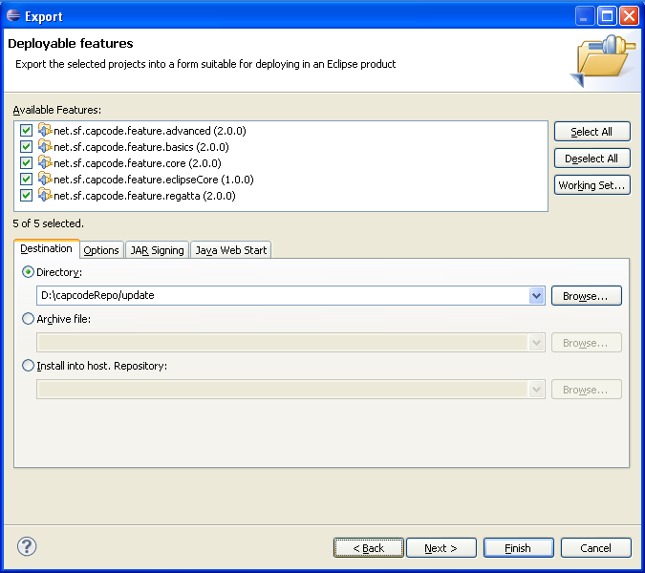
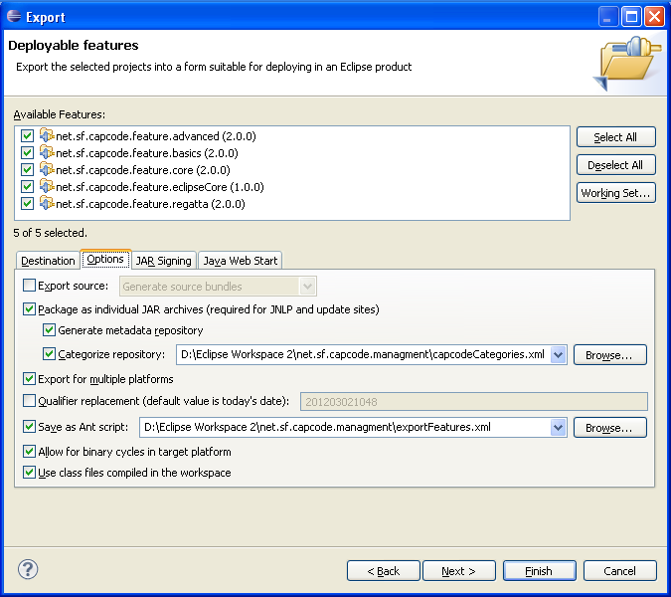
Select option and verify that the options are the same as :

Select Next and select the platforms to export to, then press finish.

3) Copy the folder update into sourceforge.net/projects/capcode/update
In project net.sf.capcode.managment launch the ant task publish.xml.
Enter your credential for sourceforge when asked.

